**COMPLEX PROBLEM: 1**

**NAME: Sarthak Bhatt UID: 22MCA20069**

**CLASS: MCA-8’A’ REACT**

**DATE: 21-06-2023**

* PROBLEM: Develop a currency converter application that allows users to input an amount in one currency and convert it to another. For the sake of this challenge, you can use a hard-coded exchange rate. Take advantage of React state and event handlers to manage the input and conversion calculations.
* SOLUTION:
* npx create-react-app currency-converter
* cd currency-converter
* npm install axios
* npm install react-dropdown
* npm install react-icons

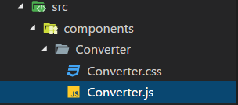

* Converter.js

* **Converter.css**

* OUTPUT:

