

**Placement Empowerment Program**

***Cloud Computing and DevOps Centre***

**Set Up a Virtual Machine in the Cloud** Create a free-tier Azure account. Launch a virtual machine and SSH into it.

Name: Bhavadharani S Department: CSE

***Introduction***

*Cloud computing enables businesses and developers to deploy and manage virtualized infrastructure efficiently. Microsoft Azure provides a scalable and cost-effective way to create Virtual Machines (VMs) for various workloads, from development to production environments.*

*This Proof of Concept (POC) demonstrates how to set up a Virtual Machine (VM) in Azure, configure it, and establish an SSH connection for remote access.*

***Overview***

*In this POC, we will:*

1. *Create an* ***Azure Free-Tier Account*** *(if not already done).*
2. *Launch a* ***Virtual Machine (VM)*** *using the Azure Portal.*
3. *Configure the VM with appropriate settings, such as OS, security rules, and SSH keys.*
4. *Establish an* ***SSH connection*** *to the VM from a local machine.*

*This process is essential for understanding cloud infrastructure management and virtualization in Azure.*

**Objectives**

*• Gain hands-on experience with* ***Azure Virtual Machines****.*

*• Learn how to configure* ***VM settings****, including authentication and networking.*

*• Understand how to* ***connect to a VM using SSH****.*

*• Explore the fundamental concepts of* ***cloud infrastructure*** *and* ***virtualization****.*

*• Ensure a secure and efficient cloud computing setup.*

**Importance of Virtual Machines in Cloud Computing**

***✅ Scalability***

*VMs allow businesses to scale applications quickly without investing in physical hardware.*

***✅ Cost-Efficiency***

*With pay-as-you-go pricing, organizations can optimize costs by provisioning only the necessary resources.*

***✅ Flexibility & Accessibility***

*Azure VMs support multiple OS options (Windows, Linux) and can be accessed from anywhere, enabling remote development and deployment.*

***✅ Security & Reliability***

*Azure provides built-in security features, automatic updates, and backup options, ensuring* ***high availability and disaster recovery****.*

***✅ Testing & Development***

*Developers can* ***test applications*** *in isolated environments without affecting production systems.*

**Step-by-Step Overview**

***Create a Virtual Machine in Azure***

1. ***Log in to*** [***Azure Portal***](https://portal.azure.com/)*.*
2. *In the search bar, type* ***Virtual Machines*** *and select* ***Virtual Machines*** *from the results.*
3. *Click* ***+ Create → Azure Virtual Machine****.*

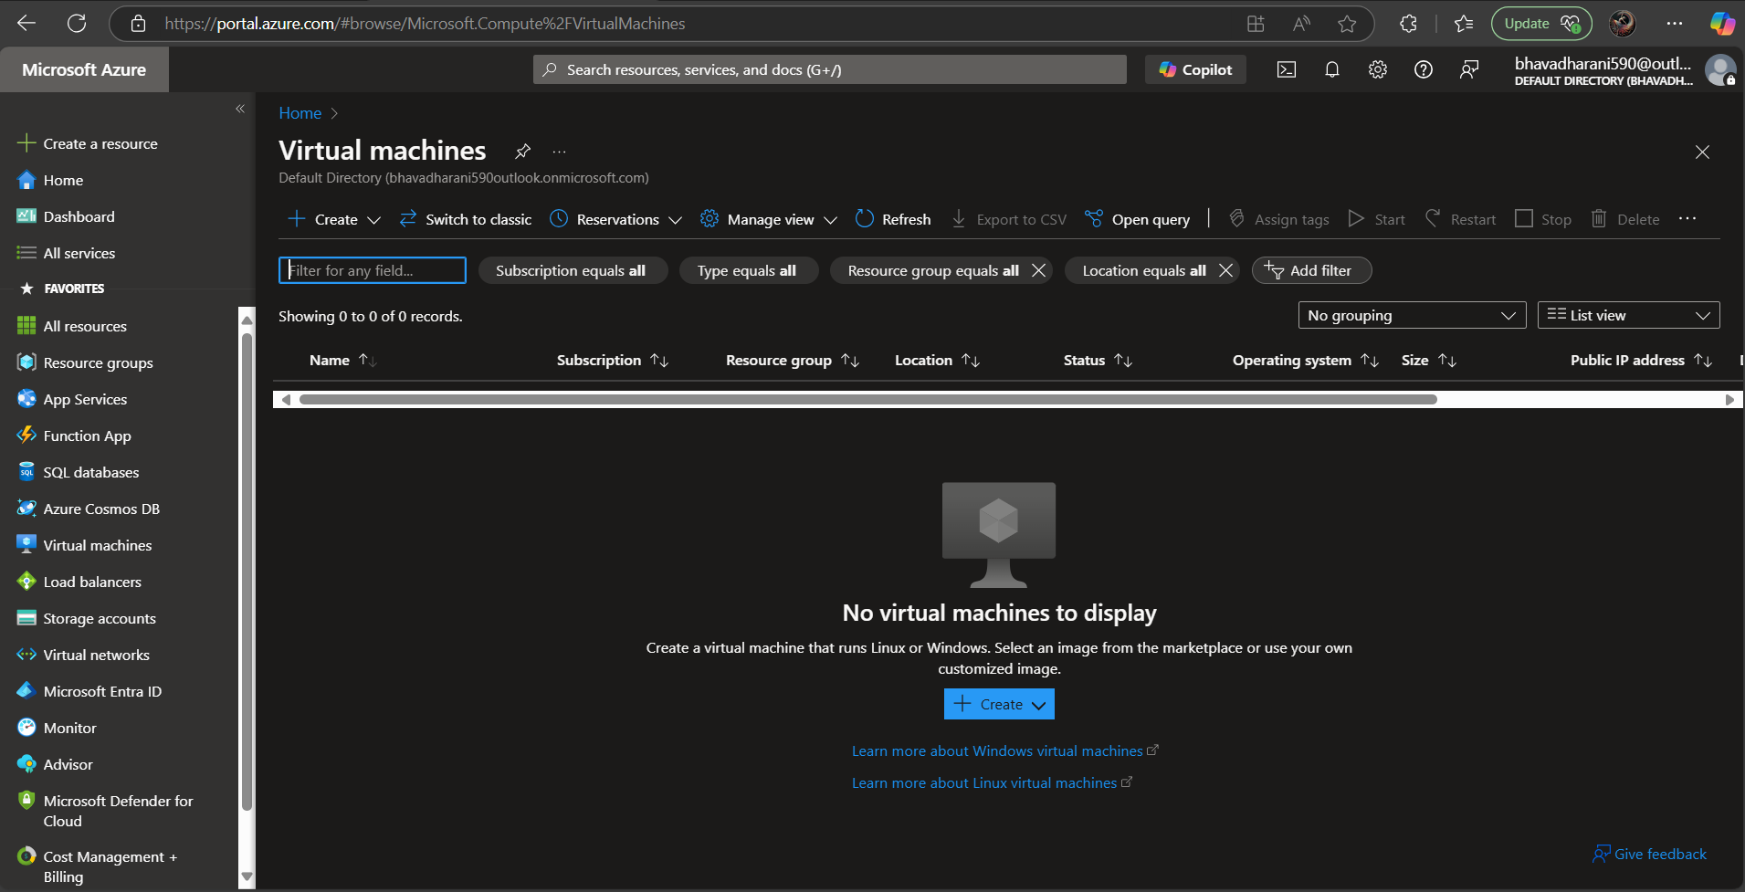

**Configure Basic Settings**

**Subscription**: Select the default free-tier subscription.  
 **Resource Group**: Click **Create new**, name it (e.g., MyResourceGroup).  
 **Virtual Machine Name**: Choose a name (e.g., MyAzureVM).  
 **Region**: Pick a nearby region (e.g., East US).  
 **Image**: Select **Ubuntu 22.04 LTS** (or Windows Server if preferred).

**Size**: Choose **Standard_B1s** (Free-tier eligible).

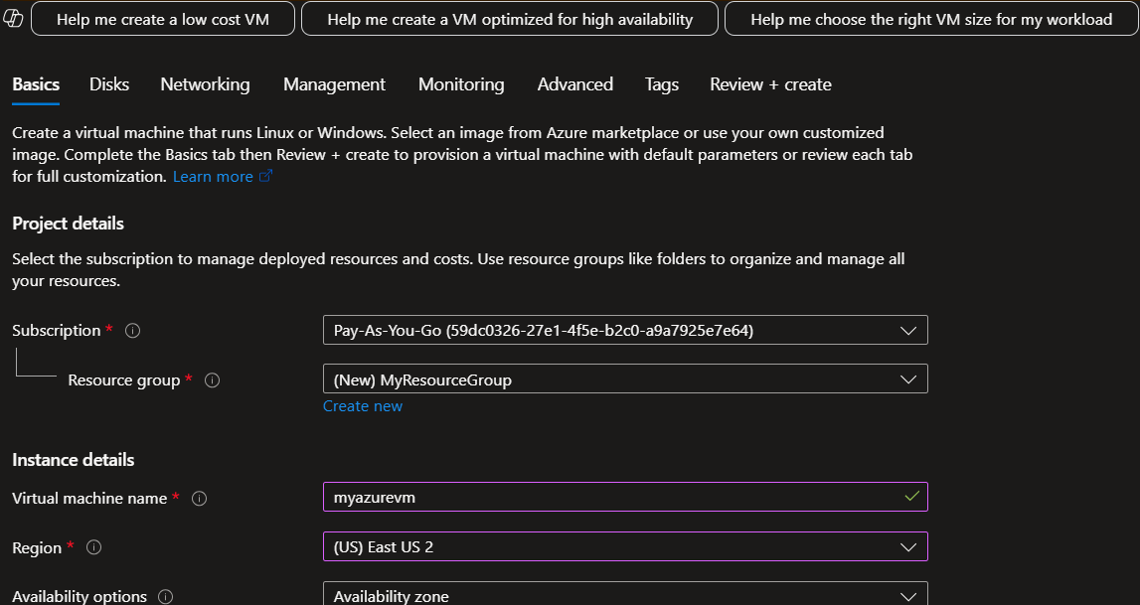

**Set Up Authentication (Login Credentials)**

**Authentication Type**: Select **SSH Public Key**.

**Username**: Choose a username (e.g., azureuser).🔹 **SSH Key**: Paste your public key (~/.ssh/id_rsa.pub).

* If you don’t have an SSH key, generate one:

*ssh-keygen -t rsa -b 2048*

* View your public key:

***cat ~/.ssh/id_rsa.pub***

* Copy and paste the key in Azure.

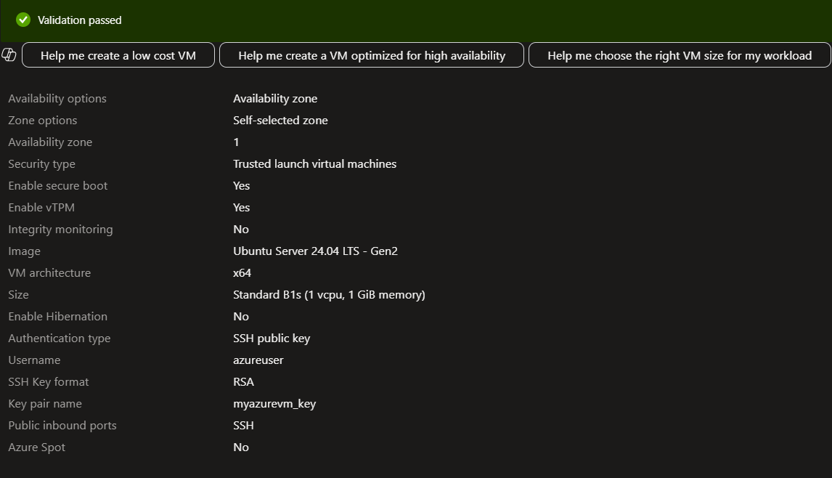

**Verify & Manage Your VM**

**✅ Update System Packages**

Run this inside the VM to update it:

***sudo apt update && sudo apt upgrade -y***

**✅ Install a Web Server (Optional)**

To test a web server, install **Nginx**:

sudo apt install nginx -y

Then, open a browser and visit:

http://<PUBLIC_IP>

You should see the default **"Welcome to Nginx"** page.

**✅ Stop, Start, or Delete the VM**

* **Stop the VM** (to avoid unnecessary usage):

az vm stop --resource-group MyResourceGroup --name MyAzureVM

* **Start the VM again**:

az vm start --resource-group MyResourceGroup --name MyAzureVM

* **Delete the VM (if no longer needed)**:

az vm delete --resource-group MyResourceGroup --name MyAzureVM --yes