

**Placement Empowerment Program**

***Cloud Computing and DevOps Centre***

**Use Cloud Storage in Azure Portal**

Name: Bhavadharani S Department: CSE

**Step-by-Step Overview**

***Step 1: Create a Storage Account***

1. *Go to the* [***Azure Portal***](https://portal.azure.com/) *and sign in.*
2. *Search for* ***"Storage accounts"*** *in the top search bar and click on it.*
3. *Click* ***"Create"*** *to create a new storage account.*
4. *Fill in the required details:*
   * ***Subscription****: Select your subscription.*
   * ***Resource Group****: Create a new one or select an existing one.*
   * ***Storage account name****: Choose a unique name (e.g., mycloudstorage).*
   * ***Region****: Select the region closest to you.*
   * ***Performance****: Choose* ***Standard*** *for general use or* ***Premium*** *for high-performance needs.*
   * ***Redundancy****: Select the redundancy type (e.g.,* ***LRS*** *- Locally Redundant Storage).*
5. *Click* ***"Review + Create"****, then* ***"Create"***

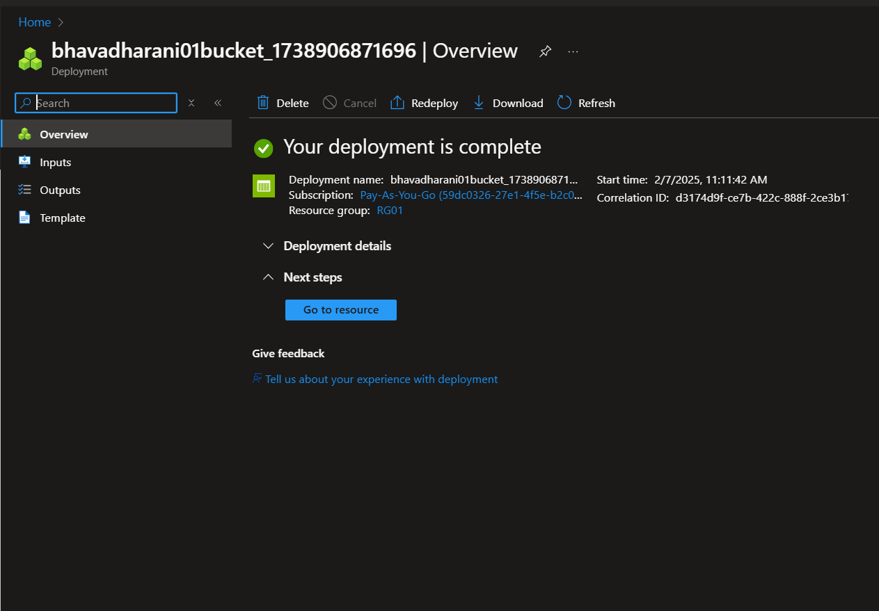

***Step 2: Create a Blob Container***

1. *After deployment, go to your* ***Storage Account****.*
2. *In the left menu, click* ***"Containers"*** *under the* ***Data storage*** *section.*
3. *Click* ***"+ Container"****, enter a name (e.g., my-container), and set the* ***Public access level****:*
   * ***Private (default)****: Only users with authentication can access it.*
   * ***Blob****: Allows anonymous read access for blobs.*
   * ***Container****: Allows anonymous read access for the entire container.*
4. *Click* ***"Create"****.*

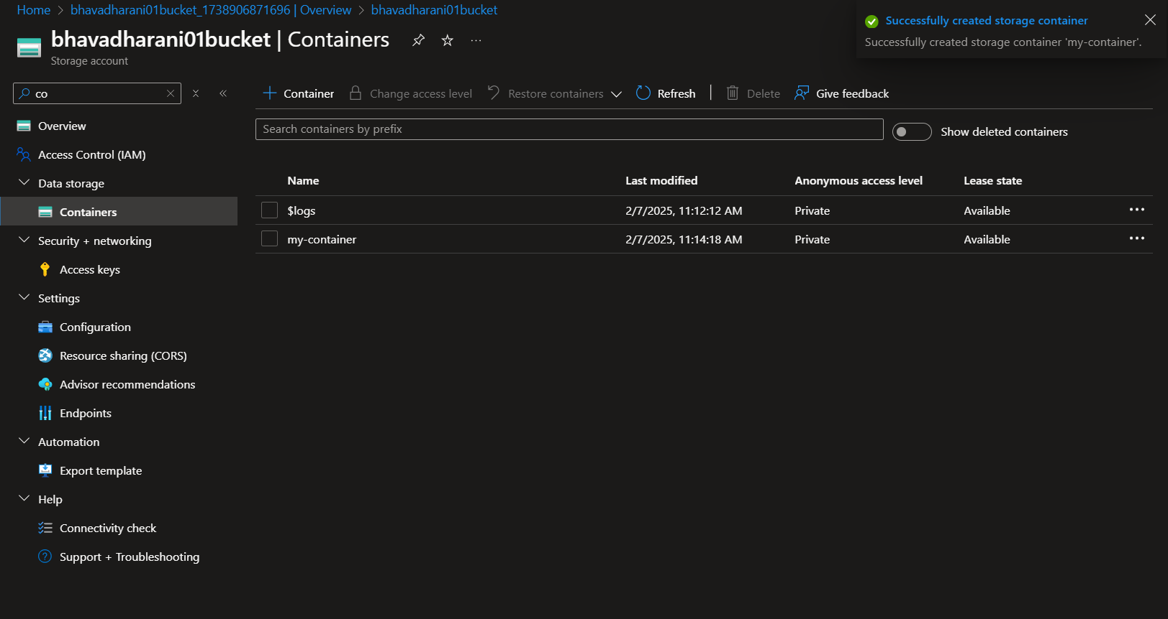

***Step 3: Upload Files to the Blob Container***

1. *Open the* ***Blob Container*** *you created.*
2. *Click* ***"Upload"****.*
3. *Click* ***"Browse for files"*** *and select the files to upload.*
4. *Click* ***"Upload"*** *to store files in Azure.*

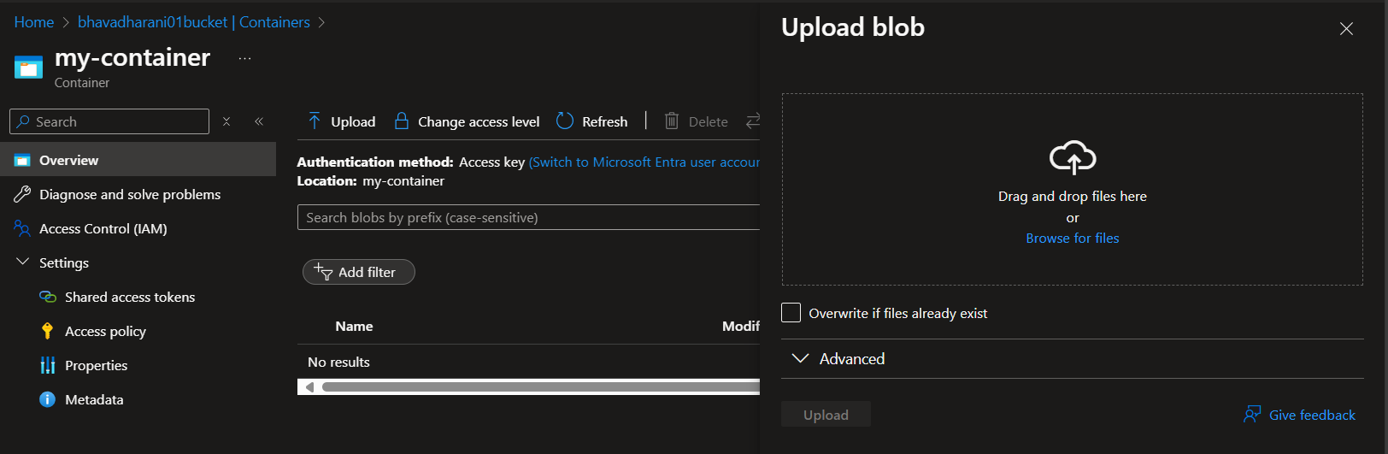

***Step 4: Download Files from the Blob Container***

1. *Open the* ***Blob Container*** *and find the uploaded file.*
2. *Click on the file and select* ***"Download"****.*
3. *The file will be downloaded to your local system.*

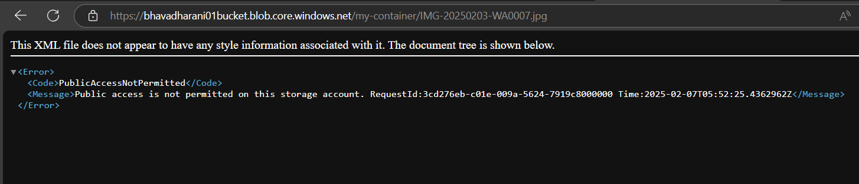

***Step 5: Configure Access Permissions***

***Role-Based Access Control (RBAC)***

1. *In the* ***Storage Account****, go to* ***"Access Control (IAM)"****.*
2. *Click* ***"Add" → "Add role assignment"****.*
3. *Choose a role:*
   * ***Storage Blob Data Reader*** *(Read-only access).*
   * ***Storage Blob Data Contributor*** *(Read and write access).*
   * ***Storage Blob Data Owner*** *(Full control).*
4. *Assign it to a user, group, or service principal.*
5. *Click* ***"Review + Assign"****.*

