

**Placement Empowerment Program**

***Cloud Computing and DevOps Centre***

***Set Up a Private Network in the Cloud Create a Virtual Private Cloud (VPC) with subnets for your instances. Configure routing for internal communication between subnets.***

Name: Bhavadharani S Department: CSE

*Step 1: Create Virtual Network (VNet)*

* *Open Azure Portal, search for “Virtual Network” and click “Create”*
* *Choose Subscription, Resource Group, Name, Region, & IPv4: 10.0.0.0/16*
* *Click "Create"*

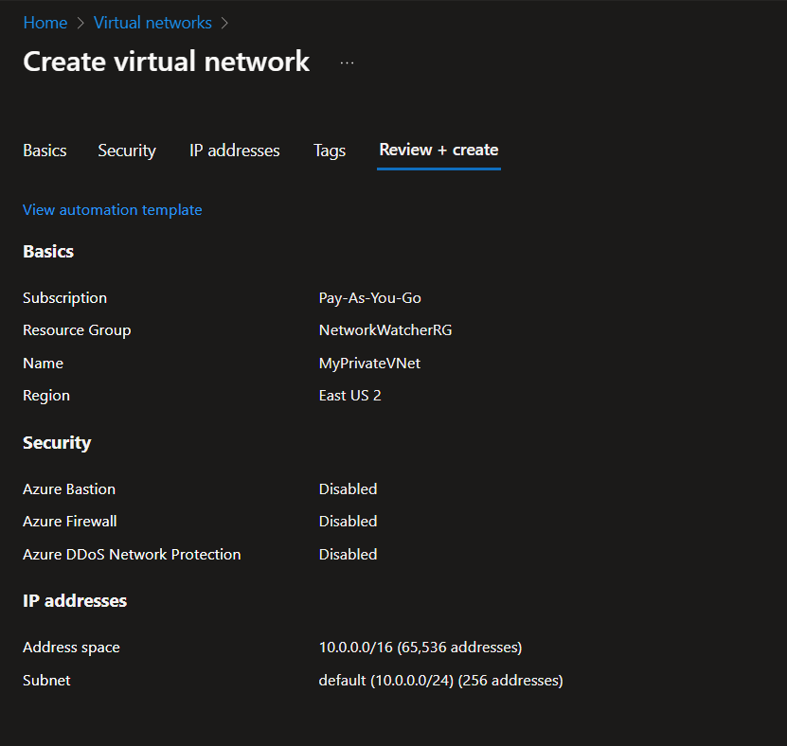

*Step 2: Create Subnets*

* *In the VNet, go to "Subnets", click "+ Add Subnet"*
* *Name subnet (e.g., AppSubnet), set address (10.0.1.0/24), click Save*
* *Repeat for another subnet*

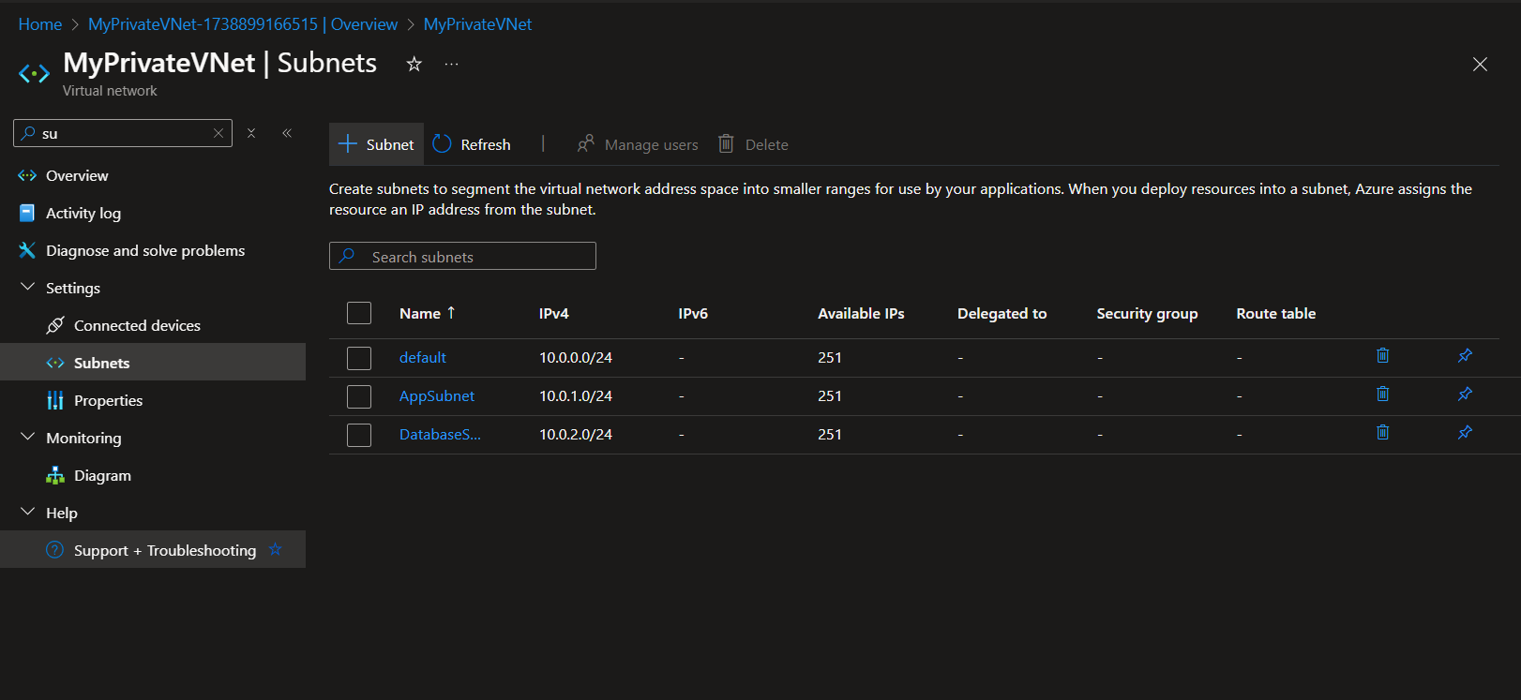

*Step 4: Configure Routing Between Subnets*

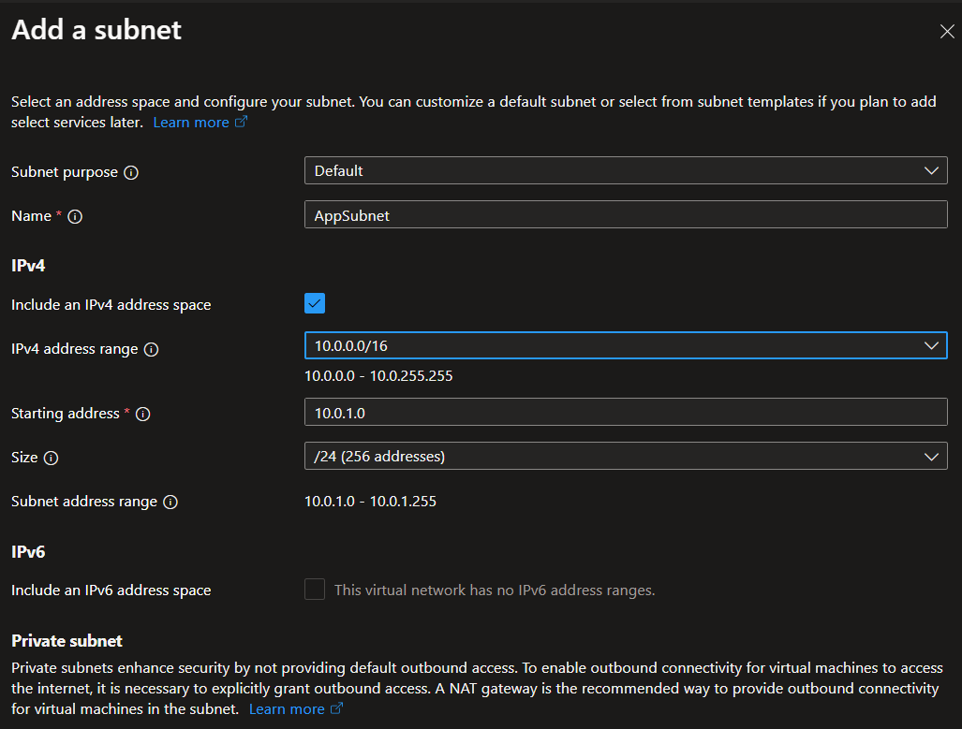

*Step 5: Deploy Instances (VMs) in Subnets*

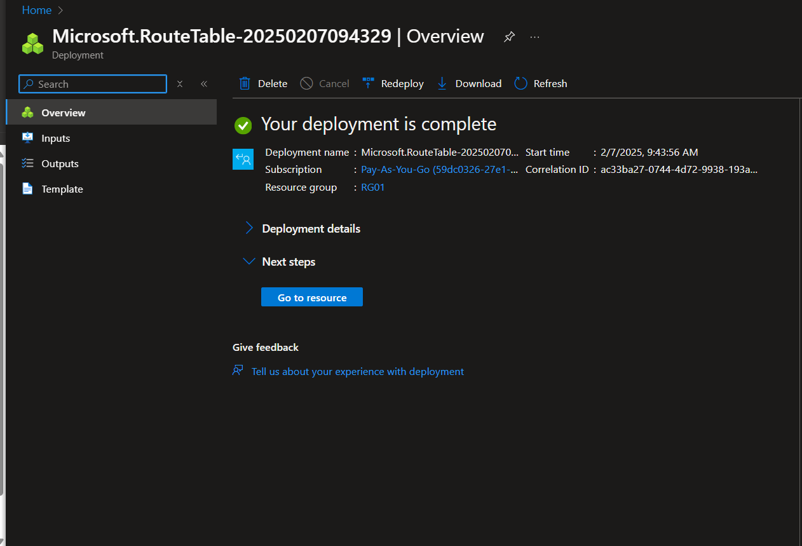

*Step 6: Test Communication SSH or RDP into a VM in AppSubnet. Try pinging another VM in DatabaseSubnet*