 

**Placement Empowerment Program**

***Cloud Computing and DevOps Centre***

Host a Static Website Locally: Set Up a Local Server Apache and Host a Simple HTML page with your name

Name: Bhavadharani S Department : CSE



**Introduction and Overview**

In this Proof of Concept (POC), we will explore how to locally host a static website using the Apache HTTP Server. The process includes setting up the web server, configuring it properly, and serving a basic HTML page. By following these steps, you will gain practical experience in configuring and running an Apache server, a crucial skill for web hosting and server administration.

**Objective**

The objective of this project is to:

1. Set up a local web server using Apache.
2. Configure the server to serve static files.
3. Create and host a basic HTML page that displays your name.

**Importance of Local Hosting**

Local hosting is a crucial skill for developers, as it enables them to test and experiment with web applications in a controlled environment. Some key advantages include:

* **Hands-On Learning:** Provides practical experience with server setup and configuration.
* **Testing Ground:** Allows for safe testing and debugging of websites before deploying them to a live server.
* **Offline Development:** Enables developers to work on web projects without the need for an active internet connection.

**Step-by-Step Overview**

Step1:

Search for "Apache Lounge" on Google and click the first link to access the official website.

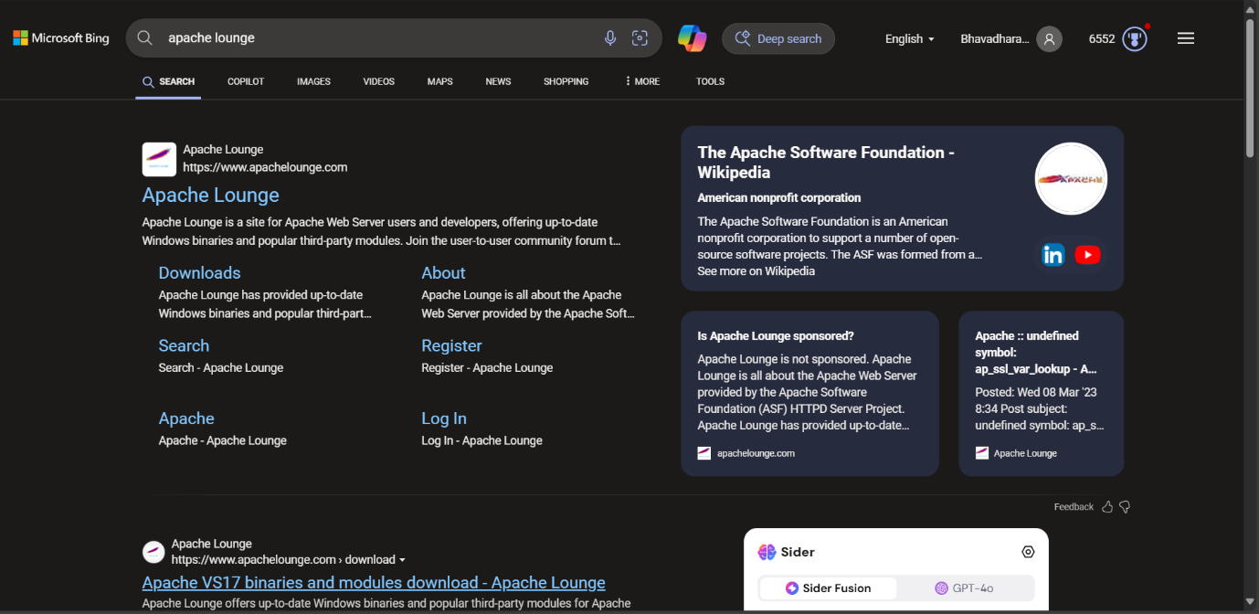

Step 2 :

Click on the "Downloads" option located on the left-hand side of the Apache Lounge website.

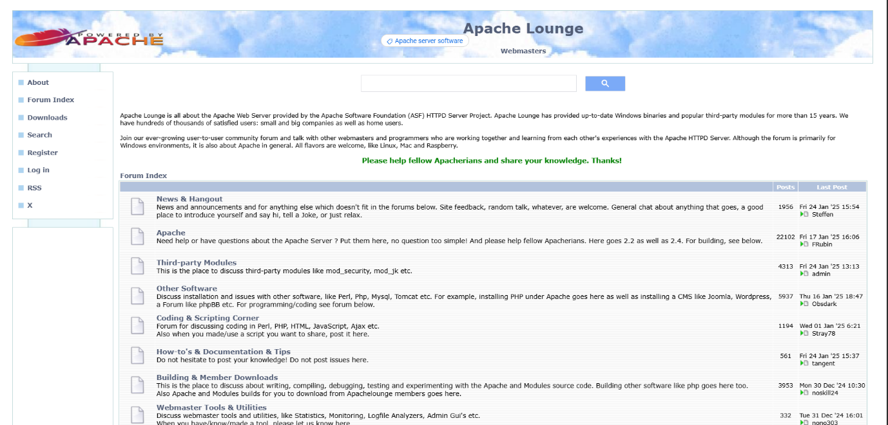

Step 3 :

Click on the link **"Apache 2.4.62-240904 Win64"** (Windows version), download the file, and extract all its contents.

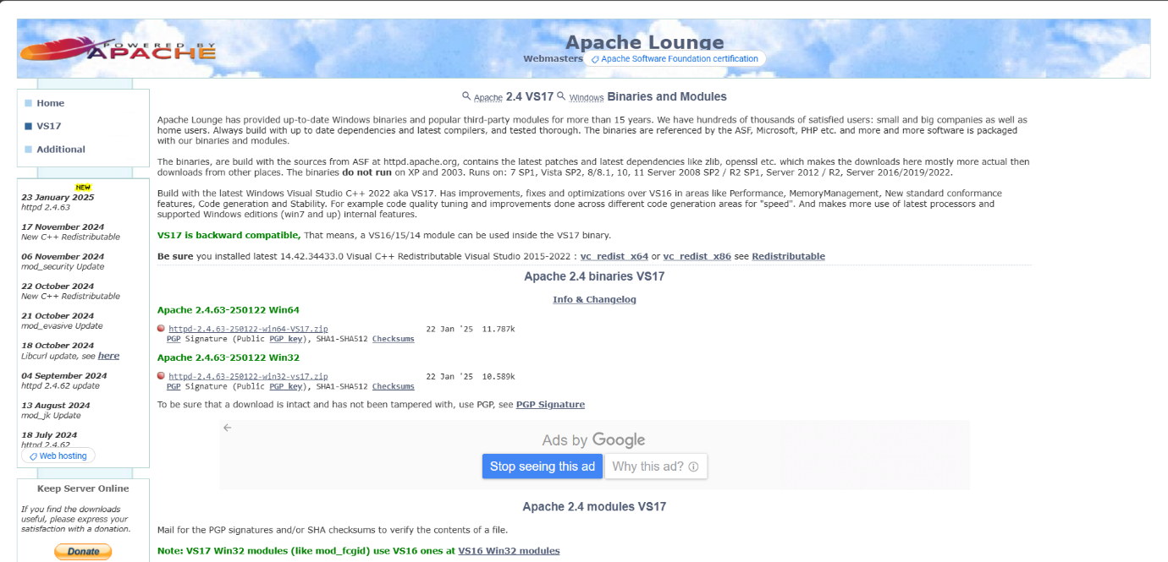

Step 4 :

Open Command Prompt as Administrator (Windows + R, type cmd, right-click and select 'Run as Administrator') and use the command cd C:\path\to\apache\bin to set the path to the Apache bin folder.

Screenshot 2025-01-22 155734.png

Step 5 :

Then Run the installation command :

**httpd.exe -k install**



Step 6 :

Navigate to the Apache folder you downloaded, go to the **conf** folder, and right-click on the httpd.conf file; select 'Edit with Notepad'

(Apache/conf/httpd.conf)

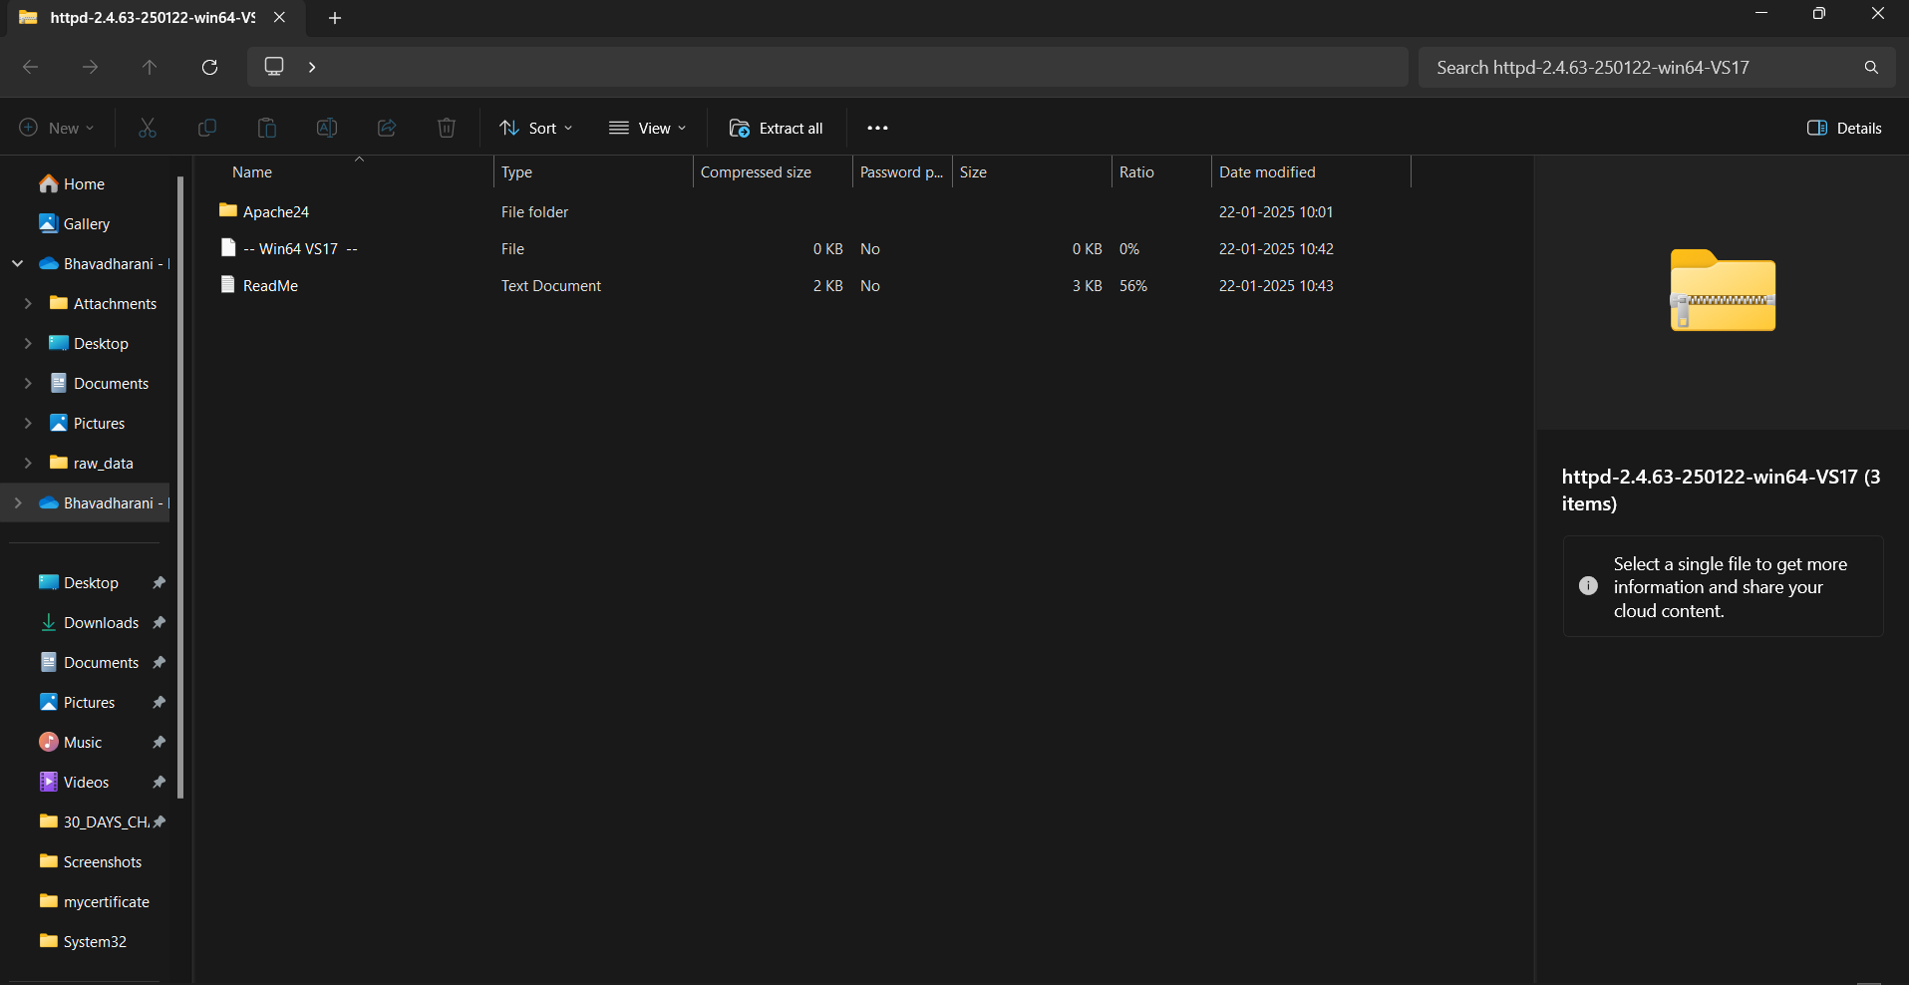

Step 7 :

Inside the **httpd.conf** file, replace the content with the provided configuration. Ensure you update the SRVROOT directive with your Apache installation path. This configuration defines the server’s root directory, listening port, modules, document root for serving web files, logging paths, and basic permissions, ensuring Apache serves content correctly from the specified htdocs directory.

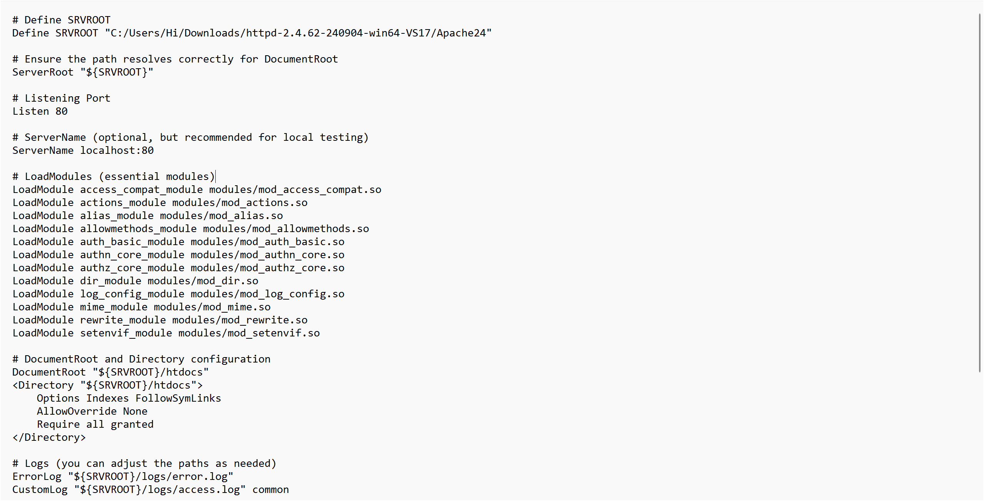

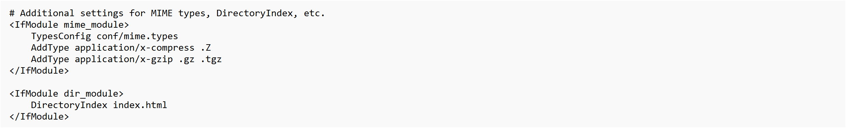

Step 9 :

Run the command **httpd.exe -k** start to start the Apache server.



Step10:

Go to the Apache folder, navigate to the **htdocs** folder, and find the **index.html** file. Right-click on it and select 'Edit with vscode'.

