 

**Placement Empowerment Program**

***Cloud Computing and DevOps Centre***

**Deploy your Static Website-Github**

**pages:** Host your local Git repository’s

static website directly using github pages.

Name: Bhavadharani S Department : CSE



**Introduction and Overview**

GitHub Pages is a free hosting service provided by GitHub that allows developers to host static websites directly from a Git repository. It is widely used for personal portfolios, project documentation, and small web applications. By using GitHub Pages, you can make your static website accessible on the internet without needing external hosting services.

**Objective**

The objective of this task is to host a static website using GitHub Pages by pushing a local Git repository containing HTML, CSS, and JavaScript files to GitHub. By completing this task, you will:

✅ Learn how to configure and publish a static website using GitHub Pages.  
✅ Understand how to push local project files to a remote GitHub repository.  
✅ Gain experience in version control and GitHub repository management.

**Importance of Deploying a Static Website Using GitHub Pages1. Free Hosting Solution**

GitHub Pages provides a completely free hosting service for static websites, eliminating the need for paid web hosting services. This makes it an ideal solution for developers, students, and small businesses.

2. Easy Deployment and Maintenance

With just a few Git commands, you can deploy your website instantly. Any updates or modifications can be pushed directly to the repository, making maintenance simple and efficient.

3. Version Control with Git

Since the website is hosted on GitHub, you automatically get version control using Git. This means you can track changes, revert to previous versions, and collaborate with others easily.

4. Custom Domain Support

GitHub Pages allows users to connect custom domains to their website, making it look more professional (e.g., www.yourwebsite.com instead of yourusername.github.io).

5. Secure and Reliable

GitHub Pages automatically provides HTTPS encryption, ensuring a secure connection between users and your website. Additionally, since GitHub's servers are highly reliable, your website has minimal downtime.

6. Great for Portfolios and Documentation

Many developers and designers use GitHub Pages to host:

* Personal portfolios
* Project documentation
* Blogs (with Jekyll support)
* Open-source project websites

7. No Backend Required

GitHub Pages is designed for static websites (HTML, CSS, JavaScript). Since it does not require backend services (like databases or servers), it is an excellent choice for simple and lightweight web applications.

**Step-by-Step Overview**

**Step 1: Prepare Your Static Website**

1. Create a new folder for your static website project.
2. Inside the folder, add your index.html, style.css, and any other necessary files (e.g., images, JavaScript).

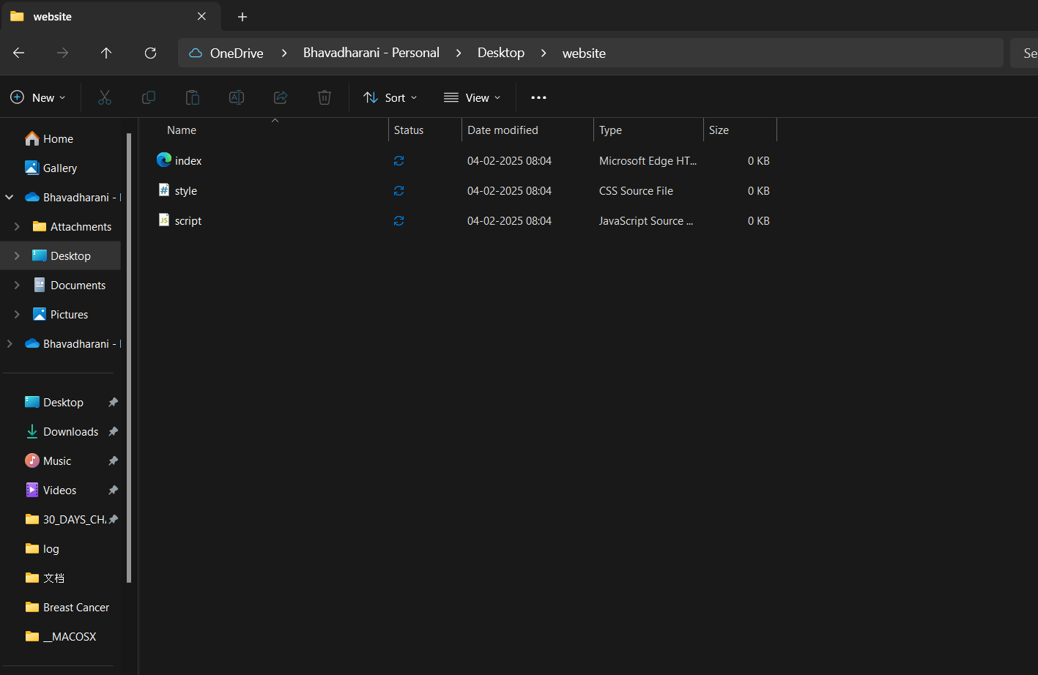

**Step 2:Step 2: Initialize a Local Git Repository**

1. **Open Command Prompt (Windows) or Terminal (Mac/Linux) and navigate to your project folder using:**

***cd path/to/your/project-folder***

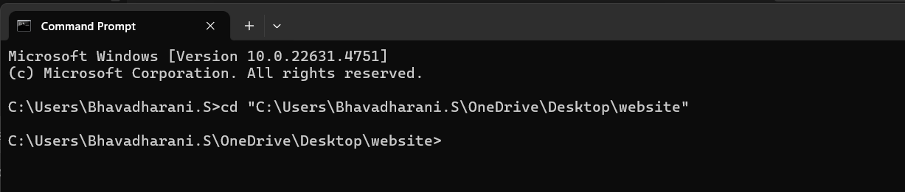

**Step 3:**

**Initialize a Git Repository (If Not Already Initialized)**

If this is the first time you're setting up Git for this folder, run:

***git init***

This will initialize a Git repository inside your **"website"** folder.

**Step 4: Add Files to Git**

**If you have new or untracked files, add them using:**

***git add .***

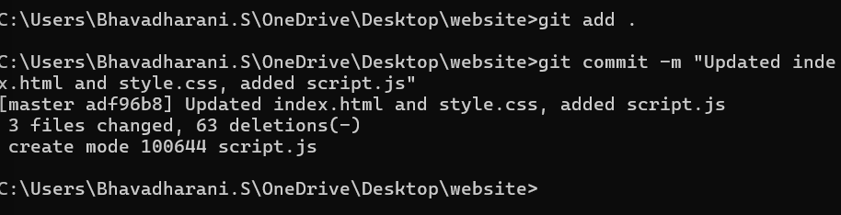

**Step 5:**

**Commit Your Changes**

***git commit -m "Initial commit or updated changes"***

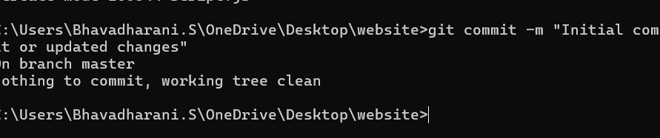

**Step 6:**

**Link to Your GitHub Repository (If Not Already Linked)**

**If you haven't linked your local repository to GitHub, do this:**

***git remote add origin <your-github-repo-url>***

**Step 7:**

**Push Code to GitHub**

***git branch -M main***

***git push -u origin main***

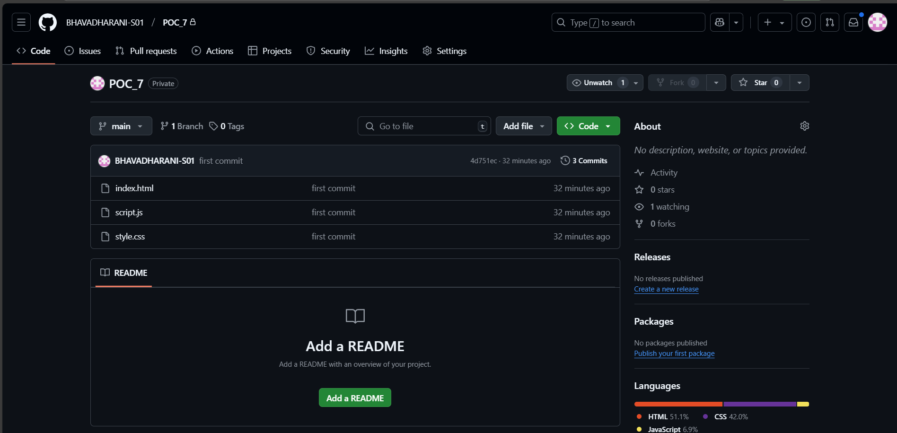

**Step 8:**

View Your Website

After a few minutes, your website will be available at:

