**SMART PUBLIC RESTROOM**

**ABSTRACT:**

In the cutting edge world, the advances are definitely grown, yet at the same time the cleanliness in our nation is under risk.The abstract of this paper is to deliver clean and hygiene toilets. All the public toilets should be clean and hygiene. In our country, our government has introduced the scheme called “Swachh Bharat” (Clean India). Keeping the toilets uncontaminated is the one of the objective of Clean India scheme. Thispaper can be helpful to encourage the clean India project. In future, it can show the major part in clean India scheme. In an Existing system, they are focused only on identifying the dirt in the toilets. In our proposed system, we have determined on keeping clean toilets, observing the sweeper’s working activities. It can dodge many syndromes. It may create the consciousness amongst people about the toilet management. Therefore, our development is to use safe and hygienic toilets. This paper is based on IOT and image-processing concepts using different sensors like smell sensor, IR sensor, sonic sensor, RFID reader. By using these sensors, we can create the smart toilets.

**OBJECTIVES:**

Project Objectives:

The project's primary objectives are to improve the public restroom experience, enhance cleanliness, and provide real-time information to users. It aims to achieve the following:

Enhanced Cleanliness: Implement sensors and monitoring systems to ensure cleanliness and hygiene in public restrooms.

Resource Efficiency: Use data from IoT sensors to optimize resource usage, such as water and paper products.

User Experience: Develop a mobile app to provide users with real-time information about restroom availability and cleanliness.

Sustainability: Promote environmentally friendly practices in public restrooms by minimizing waste and energy consumption.

IoT Sensor Setup:

The IoT sensor setup involves deploying various sensors within the restroom to collect data. The objectives for this component are as follows:

Occupancy Sensors: Install occupancy sensors to monitor how many people are currently using the restroom.

Toilet Flush Sensors: Implement sensors to monitor toilet flushes, helping to manage water usage efficiently.

Hand Sanitizer Dispenser Sensors: Equip sanitizer dispensers with sensors to track usage.

Air Quality Sensors: Use air quality sensors to monitor and improve the restroom environment.

Toilet Paper and Soap Dispenser Sensors: Deploy sensors to monitor the status of toilet paper and soap dispensers, ensuring timely refills.

Mobile App Development:

The mobile app aims to enhance the user experience and provide real-time information. The objectives include:

Real-time Information: Display information on restroom availability and cleanliness in real-time.

Navigation: Provide directions to the nearest smart public restrooms and restroom-related amenities.

Feedback Mechanism: Allow users to provide feedback and report issues, ensuring a responsive maintenance system.

Rewards System: Implement a rewards system to incentivize sustainable restroom usage.

Raspberry Pi Integration:

The Raspberry Pi serves as a central controller to manage data from IoT sensors, process information, and communicate with the mobile app. The objectives include:

Data Aggregation: Collect data from various sensors within the restroom and aggregate it for analysis.

Data Analysis: Implement code for analyzing the data to make decisions regarding restroom cleanliness and resource management.

Alerts and Notifications: Create an alert system to inform maintenance personnel about issues or low resources.

Data Transmission: Establish communication protocols between the Raspberry Pi, sensors, and the mobile app.

Code Implementation:

The code development will be a crucial part of the project, including:

Sensor Code: Write software for each sensor to collect data and transmit it to the Raspberry Pi. This code will vary based on the sensor type and communication protocol.

Raspberry Pi Code: Develop software to receive and process sensor data, trigger alerts, and communicate with the mobile app.

Mobile App Code: Create the mobile app with features like real-time data display, user feedback submission, and navigation to nearby smart public restrooms.

Database Management: Implement a database to store and retrieve data related to restroom availability, cleanliness, and resource levels.

Machine Learning or AI Algorithms: Utilize these technologies to make predictions and recommendations based on historical data.

The specific programming languages and frameworks used for each component may vary, but popular choices include Python, Node.js, Android Studio (for Android app development), Xcode (for iOS app development), and database management systems like MySQL or NoSQL databases.

Ultimately, the success of the project will depend on a well-planned and integrated system that optimizes public restroom management, enhances user experience, and promotes sustainability.

**INTRODUCTION:**

In our country, many people don't know how to use toilets properly. This can cause different diseases like Malaria, Hepatitis, Flu, Cholera, Streptococcus, Typhoid, and more. We want to teach people how to use and keep toilets clean and healthy. Our project uses smart technology like smell detectors, dirt sensors, sound sensors, RFID readers, and a database. We use these tools to make sure toilets stay clean and to educate people about this.

**Information Platform Web Interface**:

A user-friendly homepage with a search bar to find nearby smart public restrooms.

Quick access to essential features like restroom availability, ratings, and reviews.

Restroom Listings:

A list of nearby smart public restrooms with details like name, location, and current occupancy status.

Filters for sorting restrooms by distance, ratings, and accessibility features.

Restroom Details:

A detailed page for each restroom, including photos, accessibility information, occupancy status, and user reviews.

A map showing the restroom's exact location.

Restroom Availability:

Real-time occupancy information, indicating if the restroom is vacant, busy, or in need of cleaning.

Estimated wait times based on occupancy data.

User Reviews and Ratings:

User-generated reviews and ratings for each restroom.

Options to leave a review and rate the restroom after a visit.

Maintenance and Alerts:

A section for reporting issues, requesting maintenance, or notifying staff of problems.

Status updates on reported issues.

Accessibility Information:

Details about the restroom's accessibility features, such as braille signage or grab bars.

Information for users with specific accessibility needs.

Hygiene and Sustainability Information:

Data on water and energy savings, as well as cleanliness schedules.

Information to encourage sustainable and hygienic restroom use.

User Profile:

A user profile page for managing personal settings, viewing past visits, and accessing saved restrooms.

Mobile App Interface:

User Registration and Login:

An intuitive onboarding process, allowing users to register or log in using email or social media accounts.

Homepage:

A user-friendly dashboard displaying nearby restrooms and their occupancy status.

Quick access to essential features such as restroom availability and reviews.

Restroom Finder:

A map-based feature for locating nearby smart public restrooms.

Filters for searching by accessibility features, user ratings, and wait times.

Restroom Details:

A detailed page for each restroom, including images, occupancy status, and accessibility features.

One-touch navigation to the restroom using mobile device maps.

Restroom Availability:

Real-time information on restroom occupancy and estimated wait times.

Push notifications when a restroom becomes available.

User Reviews and Ratings:

Options to read and leave user reviews and ratings.

Integration with the mobile device's camera for adding photos to reviews.

Maintenance and Alerts:

A feature for reporting issues, requesting maintenance, and tracking the status of reported problems.

In-app messaging or notifications for issue updates.

Accessibility Information:

Details on accessibility features in each restroom.

Guidance for users with specific accessibility needs.

Hygiene and Sustainability Information:

Information on sustainability and cleanliness, encouraging eco-conscious and hygienic restroom use.

Reminders for handwashing and using touchless fixtures.

User Profile:

A user profile section for managing settings, viewing visit history, and accessing saved restrooms.

Preferences for receiving notifications and alerts.

Both the web-based information platform and mobile app should have a clean and intuitive design, prioritizing user experience and accessibility. Regular updates, user feedback mechanisms, and integration with the smart public restroom infrastructure will ensure that the interfaces stay up to date and user-friendly.

**WORKING PRINCIPLE:**

**Step 1 - Checking for Dirt**

* An IR sensor looks at the toilet to see if it's dirty.
* It uses pictures of clean toilets for comparison.
* After someone uses the toilet, the sensor checks the toilet bowl.
* If it finds dirt, it sets off an alarm.
* This reminds people to clean up and learn about toilet cleanliness.

**Step 2 - Detecting Bad Smells**

* In the second phase, a Figaro sensor sniffs for bad odors in the toilet.
* If it detects unpleasant smells, it tells the cleaner by sending an alert.
* The cleaner can use air fresheners to make the air smell better.

**Step 3 - Monitoring the Cleaner**

* A third phase involves an RFID reader.
* It keeps an eye on when the cleaner is in and out of the toilet.
* The cleaner shows their ID tag before and after cleaning.
* If the toilet is dirty, an alarm sounds, reminding the cleaner of their duty.
* This helps the cleaner understand their role in keeping the toilet clean and safe.

**Step 4 - Checking the Septic Tank**

* In the fourth phase, a sonic sensor checks how full the septic tank is.
* It has a set limit for the tank's depth.
* If the sewage reaches this limit, it sends a message to an organization.
* This message is sent using GSM technology for action.

**Step 5 - Raising Awareness**

* Through these activities, people become more aware of toilet cleanliness and maintenance.

**Step 6 - Realizing Responsibilities**

* The system also helps cleaners realize their roles and responsibilities.
* They ensure the toilet is clean and safe by getting rid of all the unwanted materials like dirt and bad smells.

**ARCHITECTURE OF THE PROPOSED SYSTEM:**

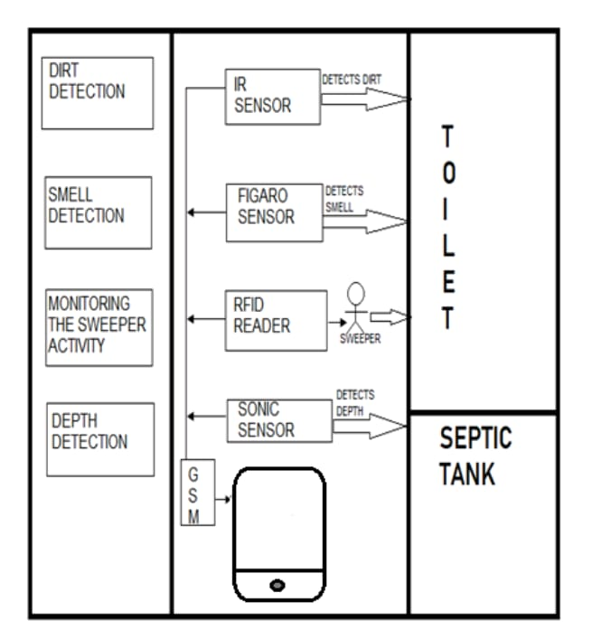

**HARDWARE REQUIREMENTS:**

* Microcontroller
* Power supply
* LCD display
* Buzzer
* Infrared sensor
* Sonicsensor
* Gassensor
* RFID
* GSMmodem

**SOFTWARE REQUIREMENTS:**

* Embedded C

**BLOCK DIAGRAM:**

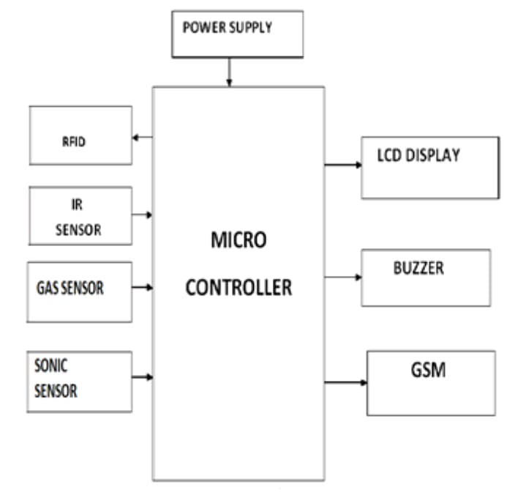

PROGRAM:

import time

class SmartRestroom:

def __init__(self):

self.occupied = False

self.toilet_paper_level = 100 # Initial toilet paper level (%)

self.soap_level = 100 # Initial soap level (%)

def detect_occupancy(self):

return self.occupied

def flush_toilet(self):

if self.occupied:

print("Flushing the toilet...")

time.sleep(2) # Simulating flushing time

print("Toilet is now empty.")

self.occupied = False

else:

print("Toilet is already vacant.")

def refill_toilet_paper(self):

print("Refilling toilet paper...")

time.sleep(2) # Simulating refill time

self.toilet_paper_level = 100

print("Toilet paper has been refilled to 100%.")

def dispense_soap(self):

print("Dispensing soap...")

time.sleep(2) # Simulating soap dispensing time

self.soap_level -= 10 # Simulate soap consumption

if self.soap_level < 0:

self.soap_level = 0

print("Soap has been dispensed.")

def monitor_resource_levels(self):

print(f"Toilet Paper Level: {self.toilet_paper_level}%")

print(f"Soap Level: {self.soap_level}%")

def run(self):

while True:

print("\nSmart Restroom Menu:")

print("1. Detect Occupancy")

print("2. Flush Toilet")

print("3. Refill Toilet Paper")

print("4. Dispense Soap")

print("5. Monitor Resource Levels")

print("6. Exit")

choice = input("Enter your choice: ")

if choice == '1':

self.occupied = not self.occupied

status = "occupied" if self.occupied else "vacant"

print(f"Toilet is now {status}.")

elif choice == '2':

self.flush_toilet()

elif choice == '3':

self.refill_toilet_paper()

elif choice == '4':

self.dispense_soap()

elif choice == '5':

self.monitor_resource_levels()

elif choice == '6':

print("Exiting the Smart Restroom. Goodbye!")

break

else:

print("Invalid choice. Please try again.")

if __name__ == "__main__":

smart_restroom = SmartRestroom()

smart_restroom.run()

**OUTPUT:**

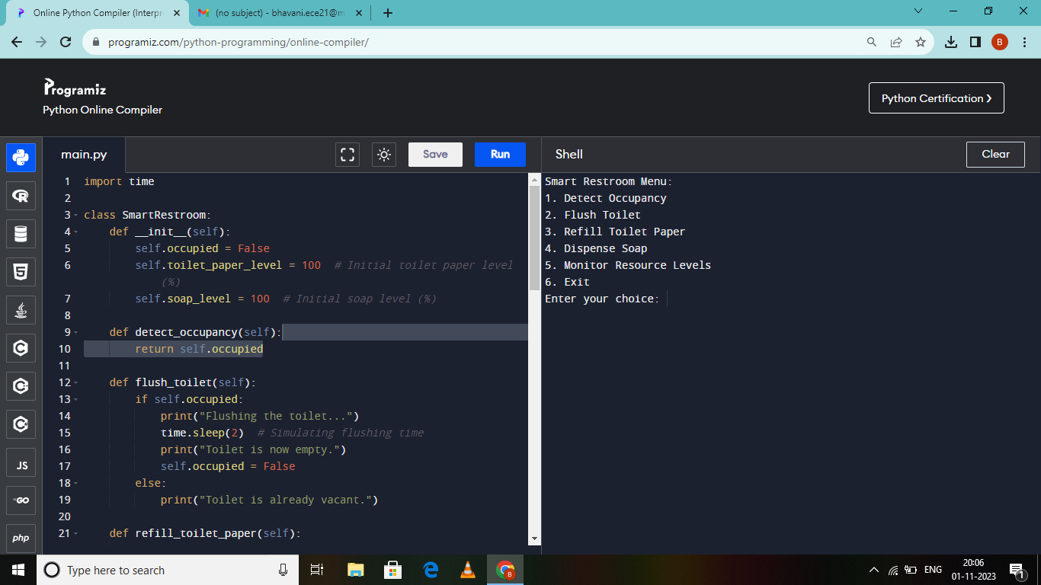

**WORKING MODEL:**

This is the module of the proposed system. Here the sensors are connected with the microcontroller.

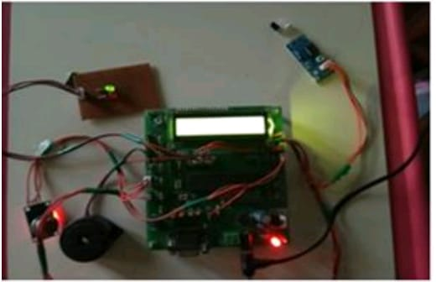

**DIRT DETECTION:**

It shows the dirt detection in the toilets.

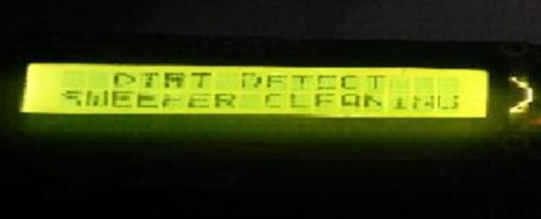

**SMELL AND DEPTH DETECTION:**

It shows the smell detection and depth detection.

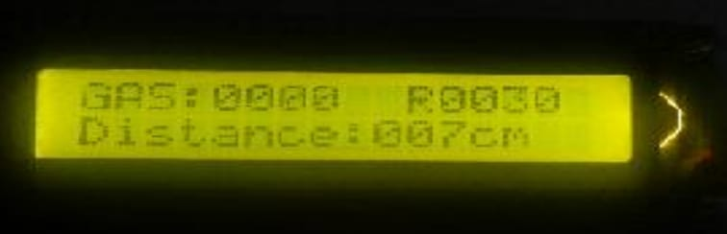

**MONITORING SWEEPER ACTIVITIES:**

It shows the sweeper activities.

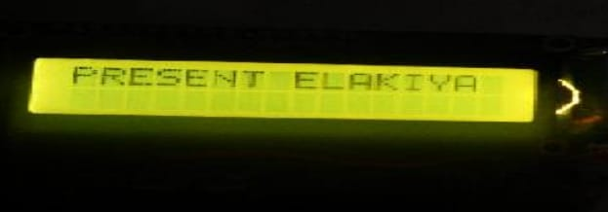

A real-time restroom information system, often referred to as a "smart public restroom," can greatly enhance user experience and restroom management in several ways. These systems leverage technology and data to provide a more convenient, efficient, and pleasant restroom experience for visitors while also streamlining maintenance and management for facility operators. Here are some key ways in which a real-time restroom information system can achieve these goals:

Occupancy Monitoring: Smart restroom systems can use sensors or cameras to monitor restroom occupancy in real-time. This information can be displayed on digital signs or mobile apps, allowing users to quickly identify available stalls or sinks. This reduces wait times and frustration, especially in high-traffic areas.

Predictive Queuing: By collecting data on restroom usage patterns, these systems can predict peak usage times and queues, enabling users to plan their visits accordingly. Facility operators can also allocate resources more effectively during peak hours.

Cleanliness and Maintenance Alerts: Sensors can detect when restroom facilities need cleaning or maintenance (e.g., emptying trash cans, replenishing supplies, or cleaning spills). Alerts can be sent to maintenance staff, ensuring that restrooms are always clean and well-maintained.

Accessibility Features: Smart public restrooms can offer accessibility features, such as automatically adjustable sinks, toilets, and hand dryers. These features cater to people with disabilities and enhance the overall inclusivity of the facility.

Resource Optimization: Real-time data can help facility managers optimize resource usage. For instance, they can adjust the lighting, HVAC, and water systems based on occupancy, reducing energy consumption and operational costs.

Hygiene Prompts: Restroom information systems can provide hygiene reminders or prompts for proper handwashing techniques, promoting better public health practices.

User Feedback and Ratings: Some systems allow users to provide feedback on restroom cleanliness and service quality through apps or kiosks. This feedback can help facility operators identify and address issues more promptly.

Water and Energy Conservation: Sensors can monitor water and energy usage, helping to identify and rectify leaks, inefficiencies, or wastage, leading to cost savings and environmental benefits.

Security and Safety: Real-time monitoring can enhance security by detecting and alerting authorities to unusual or potentially unsafe behavior. This can help ensure the safety of restroom users.

Data Analytics and Insights: The collected data can be used for analytics, enabling facility managers to make data-driven decisions to improve restroom operations and user experiences over time. They can also gather insights into user behavior and preferences.

Economic Benefits: A clean and well-maintained restroom can positively impact a business's reputation and customer satisfaction, potentially leading to increased customer loyalty and repeat visits.

Sustainability: Smart restroom systems can be designed with sustainability in mind, using water-saving fixtures and energy-efficient systems to minimize environmental impact.

In summary, a real-time restroom information system can significantly enhance the user experience and restroom management by providing convenience, cleanliness, accessibility, and efficiency while also optimizing resource usage and promoting sustainability. These systems benefit both users and facility operators, making public restrooms more pleasant and efficient spaces.

**ADVANTAGES:**

* Promotes awareness about proper toilet management.
* Helps prevent the spread of contagious diseases such as malaria, typhoid, cholera, streptococcus, asthma, and more.
* Improves hygiene and overall public health.
* Reduces health risks associated with unsanitary toilets.
* Enhances the well-being of communities by ensuring cleaner and healthier toilet facilities.

**CONCLUSION:**

Our project has a simple goal to teach people about the importance of cleanliness and proper sanitation. We're using the Internet of Things, a rapidly growing technology, to achieve this. By using our system, we hope to inspire everyone to be diligent about keeping toilets clean and practicing good hygiene. This not only helps maintain cleanliness but also prevents the spread of new contagious diseases that can result from unsanitary conditions. Remember, keeping things clean is essential for our well-being, so let's all do our part to stay safe and healthy.

**REFERENCES:**

[1] Xavier Gibert, Vishal M Patel, and Rama Chellappa, in their IEEE paper titled as “Deep Multi-Task Learning for Railway Track Inspection” Volume 18, Issue 1, Jan 2017, pp 153 – 167.

[2] S Mohamed Ashiq, K Karthikeyan, S Karthikeyan. “Fabrication of Semi- Automated Pressurized Flushing System in Indian Railway Toilet”, International Journal of Engineering and Advanced Technology (IJEAT), Volume-2, Issue-3, February2013.

[3] Dr. ManojHedaoo, Dr. SuchitaHirde ,Ms. Arshi Khan “Sanitation In Indian Railway Premises: A Great Cause Of Concern”, International Journal of Advanced Engineering Technology, Mar 2012, Volume 3, Issue 1, pp 50 -55.

[4] Dhanajay G Dange, Dattaprakash G Vernekar, Sagar D Kurhade, Prashant D Agwane, “Methodology for Design and Fabrication of Human Waste Disposal System for Indian Railway”, International Journal of Science Technology & Engineering, Volume 2, Issue 07, January2016, pp 14 – 19.

[5] Mesch, F., Puente Le´on, F. &Engelberg, T., Train-based location by detecting rail switches. Computers in Railways VII, eds. J. Allen, R.J. Hill, C.A. Brebbia, G. Sciutto & S. Sone, WIT Press, Southampton, pp. 1251– 1260, 2000.

[6] K. Osathanunkul, K. Hantarkul, P. Pramokchon, P. Khoenkaw and N. Tantitharanukul, “Design and Implementation of an Automatic Smart Urinal Flusher”,International Computer Science and Engineering