CROP DISEASE DETECTION USING

RMSPROP OPTIMIZER

Rajkumar Pandirajan

Assistant Professor

Department of Information and Technology

Kalasalingam Academy Of Research and Education, Krishnankoil-626126, Virudhnagar, India

[rajmtech17@gmail.com](mailto:rajmtech17@gmail.com)

A.Manoj Raj

Department of Computer Science and engineering

Kalasalingam Academy Of Research and Education, Krishnankoil-626126, Virudhnagar, India

[9922001020@klu.ac.in](mailto:9922001020@klu.ac.in)

Kalluru Bhavesh Shankar

Department of Computer Science and engineering

Kalasalingam Academy Of Research and Education, Krishnankoil-626126, Virudhnagar, India

[99220040083@klu.ac.in](mailto:99220040083@klu.ac.in)

J.Dileep

Department of Mechanical Engineering

Kalasalingam Academy Of Research and Education, Krishnankoil-626126, Virudhnagar, India

[99220040076@klu.ac.in](mailto:99220040076@klu.ac.in)

K.N.V.S.R.Abijith

Department of Computer Science and engineering

Kalasalingam Academy Of Research and Education, Krishnankoil-626126, Virudhnagar, India

[99220040078@klu.ac.in](mailto:99220040078@klu.ac.in)

S.Esai Sabaresen

Department of Mechanical Engineering

Kalasalingam Academy Of Research and Education, Krishnankoil-626126, Virudhnagar, India

[9922001025@klu.ac.in](mailto:9922001025@klu.ac.in)

Abstract: This project explores the use of CNNs in crop disease identification and classification, with reference to sustainable agriculture. We hope to improve disease detection by making it more accurate and efficient and using the advanced image processing techniques. So that that support rapid response and effective crop management. We employed a deep learning method where we built a TensorFlow and Keras based CNN model. We have used the RMSPROP (Root mean square propagation) optimizer to optimize. The data set used contained pictures of healthy crops as more as ones affected by various diseases, these were then grouped into training, validation and also test sets. To make our model more accurate and robust, data enhancement techniques like rotation, height shift, width shift, shear transformation, zooming and horizontal flipping were used. We scaled down the images for uniformity purposes while normalizing them to enhance their training effect. Convolutional layers in the CNN architecture had activation functions being ReLUs (Rectified Linear Units) so as to capture intricate patterns in the images; subsequently this was followed by max-pooling layers that eliminated unnecessary calculations and reduced dimensions. Dense layers made up of final layers led to multi-classification SoftMax output layer.

Keywords: Sustainable agriculture, Machine learning,

Image Recognition, Disease detection.

# **I.Introduction**

Critical components of global food security and environmental challenges, sustainable agriculture is more important. It seeks to ensure that the current food needs are met without imperilling the capability of future generations to meet their own needs, balancing economic viability, environmental health and social justice. Technological advances are a cornerstone for achieving these sustainability objectives by improving efficiency, reducing resource consumption and minimizing adverse environmental impacts[1].It is important that there should be sustainable agriculture, which helps to solve food security, environmental preservation and social equity. It focuses on ensuring that farming methods continue to be productive for the much more time along with minimum adverse effects on the environment and still remain economically viable. To realize these sustainability goals, incorporation of modern technology in agricultural practices is very important [2].

A TensorFlow and Keras based CNN model. The data set used to contained pictures of healthy crops as more as ones affected by various diseases. these were grouped into training, validation and also test sets. To make our model more accuracy and robust. data enhancement techniques like height shift, width shift, shear transformation, zooming and horizontal flipping were used. We scaled down the images for uniformity purposes while normalizing them to enhance their training effect [3].

Explore the uptake of sustainable farming practices and underscore how the tradition can be made better by integrating innovative technologies. As a result, our endeavor aligns with these thoughts by concentrating on the establishment of the convolutional neural network (CNN) for recognizing and identifying crop diseases automatically. We desire to develop a robust and accuracy model that can accurately analyze the plant ailments from images by using highly developed image processing techniques as more as deep learning algorithms [4].

Using cutting-edge techniques like image processing and deep learning to accurately diagnose and detect crop illnesses early on such invention. Early disease detection can lower the require for the chemical treatments, stop large crop losses, and promote overall crop health. Conventional disease diagnosis techniques, which depend on manual inspection, are frequently ineffective [5].

Support Vector Machines employing Histogram of Oriented Gradients features and a polynomial kernel function on currently other feasible option for detecting various plant diseases. This proposed method demonstrates strong performance, achieving a precision level of 94.6%, which surpasses other approaches[6].

Safety Drones can access hazardous or hard-to-reach areas, reducing the need for human intervention in risky situations. Privacy Concerns Increased drone usage raises concerns about invasion of privacy, as drones can capture footage without consent, leading to potential misuse of data[7].

The study investigated a Deep Neural Network (DNN) method enhanced by boost Up Robust Features. for apple foliar disease detection. This approach achieved a superior mean accuracy of 98.28% compared to other techniques, representing an accuracy improvement of 18.03%. Notably, the DNN with SURF exhibited better transferability compared to the metric model [8].

However, it's important to acknowledge limitations. The study focused solely on tomato leaf disease detection, and other more research is required to determine the effectiveness of this method on other plant parts like stems and branches. Additionally, the real-world applicability of the method might be influenced by factors beyond leaves [9].

A key advantage of the CNN model is that it bypasses the time-consuming and intricate process of manual feature extraction from images. This allows for to train the model directly on mobile devices. The results demonstrate that the transfer learning (TL) approach using pre-trained features achieves higher precision in cassava disease detection. Moreover, this work offers several benefits for digital devices, including affordability, fast processing times, and ease of deployment [10].

**II. Literature Review**

In this Paper, the goal of this systematic review is to present a thorough synopsis of the body of knowledge regarding agricultural sustainability indicators. This study aims to uncover common themes, trends, and gaps in the current understanding and execution of these indicators by synthesizing and analysing the findings from numerous studies [11] The ultimate objective is to support continued efforts to create strong, trustworthy, and context-specific indicators that can efficiently direct and track global sustainable agriculture practices.

In this Project, A few advantages of integrating IoT, Big Data, and AI in agriculture are better supply chain management, precision farming, and safer and higher-quality food. By using sensor data and AI algorithms to track crop growth, weather patterns, and soil health, precision farming techniques enable farmers to administer inputs like water, fertilizer, and pesticides more sustainably and precisely. These technologies help the food sector ensure the safety and integrity of food products by facilitating quality control, traceability, and contamination detection [12].

The authors tell, Dietary practices and consumer awareness on the influence of Spain's food system. Growing worries about food quality and environmental effect, along with the growth of the health and wellness movement, have increased demand for locally sourced, organic, and sustainably produced food. [13] Furthermore, national and EU policy measures have been essential in influencing the regulatory environment, encouraging sustainable practices, and tackling issues pertaining to resource management, public health, and climate change.

In these recent years, an era of sustainable smart agriculture has begun as an outcome of the tremendous changes in the agricultural industry brought about by the recent rapid advancements in technology. Smart sensors and sensing mechanisms are at the centre of this revolution. And combined with the big data analysis, they have the power to completely change conventional farming methods. With the help of these technologies, agricultural processes may be precisely monitored and managed in real time, improving resilience, productivity, and sustainability in the face of a variety of obstacles like resource shortages, climate change, and rising food demand [14].

This Literature reveals that, the integration of cutting-edge technologies like drones, also known as unmanned aerial vehicles (UAVs), is driving a technological revolution in the agriculture sector. Drones are becoming an indispensable instrument in contemporary agriculture, with a wide range of uses that production, sustainability, and efficiency. Drone adoption in agriculture signifies a significant shift away from the traditional farming and toward more automated, data-driven, and precise ways [15].

According to the author, agriculture has been a part of civilization for a very long time. It was created after people gave it some thought and realized that not every member of the community needed to produce food. Instead, people could produce excess food for their community with the aid of specialized labor, equipment, and methods. Since then, agriculture has developed steadily over time and taken on a crucial role in the coexistence of humans.

[16].

In this research area, the two primary forces behind automation in the agriculture sector are wireless sensor networks (WSN) and precision agriculture (PA). To make sure the crops will obtain accurately which it needs to maximize productivity and sustainability, PA uses specialized sensors and software. Retrieving actual weather, crop, and soil conditions from sensors positioned across the fields is part of PA. Crops can be seen in high definition through satellite or images form unmanned aerial vehicle, which is then processed to extract data for use in making decisions in the future [17].

The study addresses, how social media helped coordinate the demonstrations and refuted mainstream media narratives that frequently did not support the farmers [18]. The Farmers' Produce Trade and Commerce (Promotion and Facilitation) Act, the Farmers' Agreement on Price Assurance and Farm Services Act, and the Essential Commodities (Amendment) Act were the three laws that sought to liberalize the agricultural sector.

This paper defines about the definition of CRA given in the paper is probably a collection of techniques meant to decrease greenhouse gas emissions and adjusting the agricultural systems to climate extremes and variability. Emphasize the significance of agricultural perseverance in the escalating floods, droughts, and temperature fluctuations brought on by world-wide climate change [19].

The literature paper reveals that, today's agricultural practices, nanotechnology is predicted to become a major force in the future through its innovative applications. The application of nanotechnology in agriculture presents the strategy with great potential for addressing global challenges related to food production, safety, and security as well as environmental sustainability and climate change. Modern agriculture, food processing, food safety, the dairy and packing industries, packaging, transportation, and agricultural product quality control all makes highly use of nanotechnology. With the utilization of nanoparticles, it has the power to improve the efficiency and inventiveness of agriculture by precisely delivering nutrients to the right place at the right time [20].

**III. Methodology**

The pathways for the training, validation, and test datasets are first defined in order to prepare the dataset. The photos corresponding to each dataset are arranged in these directories. Next, the ImageDataGenerator class from Keras is used to conduct data enhancement, normalization. To improve the data quality. a number of transformations are used, including rescaling and rotation and width shift and height shift and shear, zoom, and horizontal flip. This strengthens the model and helps avoid overfitting. The only method used to equalize the image pixel values for the validation and test datasets is rescaling. A CNN model is constructed with the Keras Sequential API. A flattening layer (Flatten) to turn the 2D matrices into a 1D vector, pooling layers (MaxPooling2D) for down sampling, convolutional layers (Conv2D) for feature extraction, and dense layers (Dense) for classification make up the model. The RMSprop optimizer, accuracy as the performance metric, and the categorical_crossentropy loss function are made to train the model. To see the architecture, print the model summary.

**IV. Background**

The main theme of the project is used to detect the diseases of the plants. It trained based on the provided data set in this we provide a some set of diseased plants to the train the model. After upload an image to this it will predict the disease of the plant. Based on the Trained images It predicts the nature of the crop.

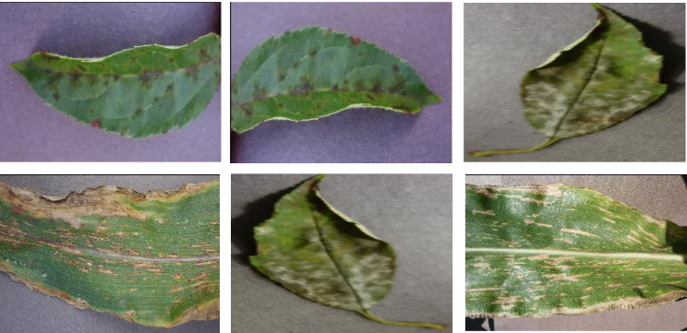

Fig 4.1. types of diseased plants

**V. Problem Statement and its evolution**

The problem statement evolves around the sustainable agriculture which provides a solution to the crops and plants. For this Sustainable agriculture project two departments combined and provide the solution.

The two Departments of CSE and BIO-TECH the problem is evolving. From CSE we have done the focus developing robust algorithms for the image processing and we have used the CNN .Designed scalable and efficient systems for the storage ,retrieval and management of large-scale image dataset needed. from BIO-TECH deepen understanding the plant pathology and studying of different crop disease and their symptoms and fungal diseases and explored the hyperspectral imagining techniques and their applications in disease and symptoms detection.

**Data Sets:**

We have used different crops as dataset to train the model. we have used Apple, Blueberry, cherry, Corn maize. from this we have trained our model.

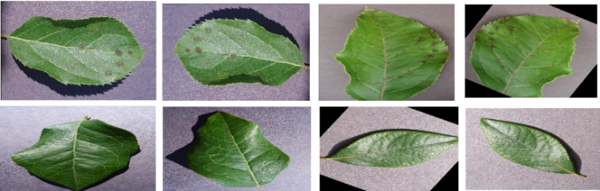

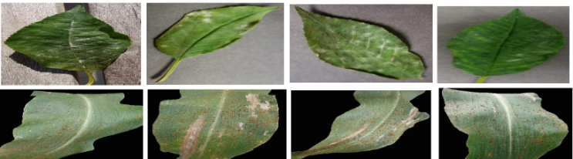

Fig 5.1. types of diseased plants

**VI. Implementation Output**

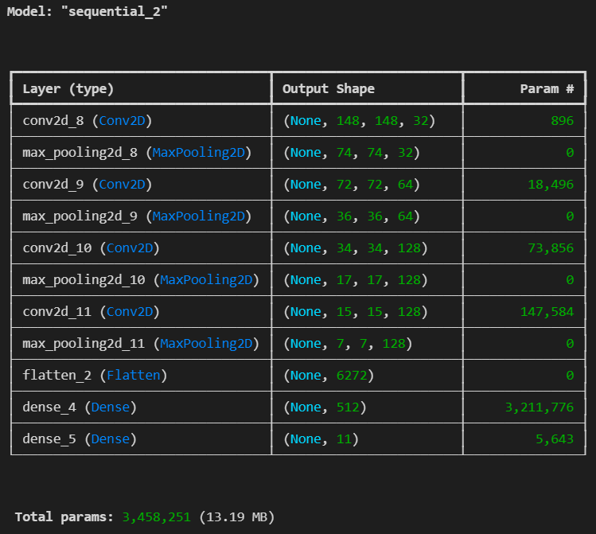

Fig 6.1. model - sequential

The above Implementation shows about the Model sequential that includes the Layer (type), Output shape and Param of the provided input i.e. provided image of the crop. based on the image it will categorize the above terms like which layer it is and shape of the image i.e. the plant or crop image and Param # means parameters is used to learn the complex patterns.

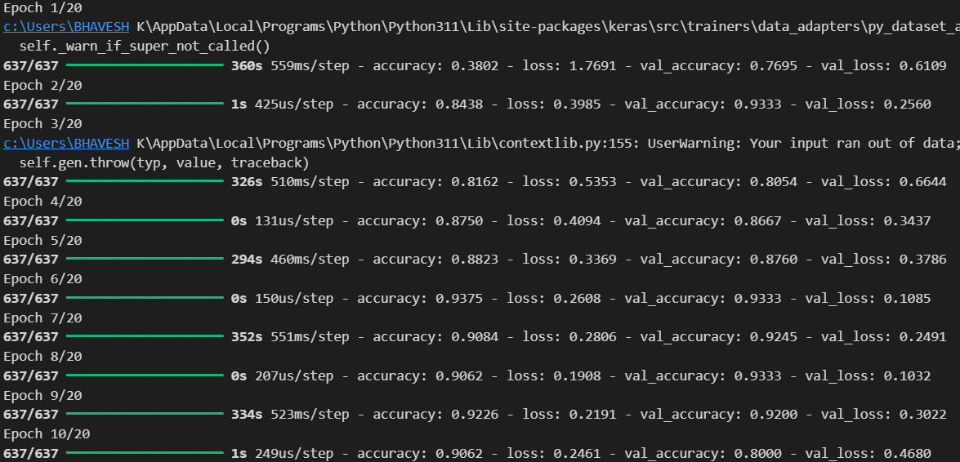



Fig 6.2: Epochs & accuracy

The above implementation shows the how the model is trained and how many epochs it taken .it show the Epochs, Accuracy, Validation accuracy and Validation loss. That based on the provided epochs. the model will be trained well and the accuracy will be increases. So that it is very easy to analyse the given Prompt i.e. image of the plant.

**VII. Flow Chart**

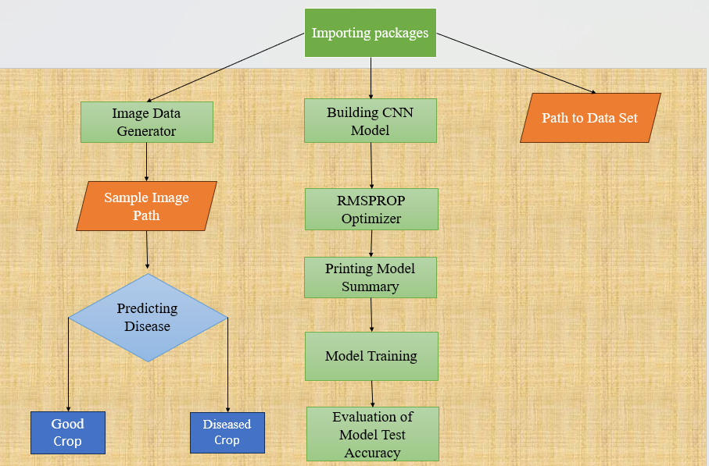

Fig 7.1. flow chart of Implementation

Table 1 : Epochs,Accuracy,Val_accuracy and Val_loss

|  |  |  |  |
| --- | --- | --- | --- |
| Epoch | Accuracy | Val_accuracy | Val_loss |
| 1 | 0.3802 | 0.7695 | 0.6109 |
| 2 | 0.8438 | 0.9333 | 0.2560 |
| 3 | 0.8162 | 0.8054 | 0.3477 |
| 4 | 0.8758 | 0.8867 | 0.3437 |
| 5 | 0.8823 | 0.9333 | 0.2369 |
| 6 | 0.9004 | 0.9245 | 0.2491 |
| 7 | 0.9062 | 0.9333 | 0.1032 |
| 8 | 0.9226 | 0.8000 | 0.3022 |
| 9 | 0.9062 | 0.8000 | 0.4688 |
| 10 | 1.0000 | 0.9333 | 0.2191 |

The above table explains about a model is being trained in machine learning, an epoch is one full cycle through the training dataset. The data set model runs for several iterations for each epoch, processing batches of data to modify weights and reduce errors. Measuring the percentage of the accuratley predicted instances among the all predictions the model made during training, accuracy is a metric. A high training accuracy shows how well the model is assimilating the information. The accuracy metric determined on a different validation dataset that wasn't used for training is known as validation accuracy. It helps identify overfitting by acting as a gauge of the model's performance on hypothetical data. The difference between the actual and predicted values on the validation set is measured as validation loss. A lower validation loss indicates that the data set model performs well when it is applied to fresh data. Tracking these metrics aids in optimizing the model's performance and fine-tuning it.

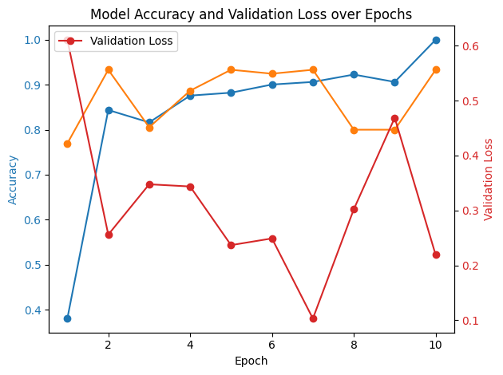

Fig : Graph for the Accuracy ,Epoch and Validation loss

The graph shows about the Model Accuracy and Validation accuracy and Validation loss on the Epochs.The accuracy is Increasing From Low to high on the provided Epochs the model will be trained well.we have used user 20 epochs to train the model.So the accuracy Will be good for the model.we have used the matplotlib to plot the Graph.

**VIII. Output**

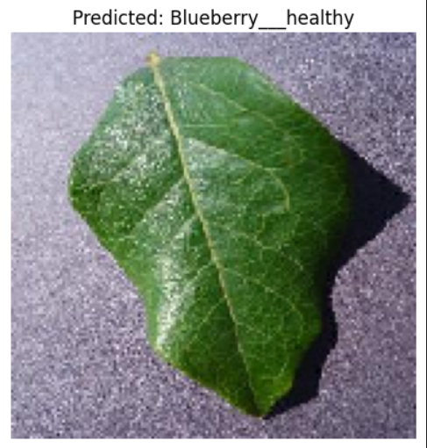

Fig 8.1: Output about Disease

The output explains about the final outcome of the Project crop disease detection using RMSPROP optimizer. After Providing an image to the model it has provided the output of the crop which is Blueberry__Healthy. The output came based on some main factors like Image classification, Trained data. The predicted label provides the class to which the leaf has assigned in this case “Blueberry” by “healthy” which provided the condition of the plant.

**IX. Conclusion**

A convolutional neural network (CNN) is successfully trained by your code to identify crop illnesses from pictures. The training, validation, and test datasets are first arranged into the appropriate folders. You use the ImageDataGenerator to apply a variety of data augmentation techniques, including rotation, width/height shifts, shear, zoom, and horizontal flips, to improve the model's generalization capabilities. During training, this step makes sure that given data set is exposed to a range of image changes. Multiple convolutional layers are used for increasing filter sizes (32, 64, and 128 in the CNN model architecture) are followed by a max-pooling layer to decrease the spatial dimensions. The output from the convolutional layers is flattened, and then a 512-unit dense layer is added before the final output layer, which classifies the images into their corresponding categories using SoftMax activation. Categorical cross-entropy loss, the RMSprop optimizer are used to assemble the model.

**X. Future work**

In future we work on the corrections from feedback we are going to work on the data sets model to save in the server. And we are Working on Hardware Which predict this disease in crop area and provide suitable pesticides.

**XI. References**

1. Bathaei, A.; et al. A Systematic Review of Agricultural Sustainability Indicators. Agriculture 2023, 13, 241. <https://doi.org/10.3390/agriculture13020241>
2. Saliu, Fluturim et al. (2023). A Review on the Impact of Sustainable Agriculture Practices on Crop Yields and Soil Health. International Journal of Information Technology. 2. 1-13.
3. Gupta, Niti, et al. "Sustainable Agriculture in India 2021." *Council on Energy, Environment and Water* (2021).
4. Coulibaly, et al. "Sustainable agricultural practices adoption." *Agriculture (Pol'nohospodárstvo)* 67.4 (2021): 166-176.
5. Mahesh, et al. (2023). Impact of Aatmanirbharta (Self-reliance) Agriculture and Sustainable Farming for the 21st Century to Achieve Sustainable Growth. International Journal of Applied Engineering and Management Letters (IJAEML), 7(2), 175-190. DOI: [*https://doi.org/1*](https://doi.org/1)
6. Hashni, et al. "Smart Farming Approaches Towards Sustainable Agriculture—A Survey." *Proceedings of Third International Conference on Intelligent Computing, Information and Control Systems: ICICCS 2021*. Singapore: Springer Nature Singapore, 2022.
7. Nisha Khatik , "Role of Plant Biotechnology in Agricultural Sustainability and Improvement of Crops," Universal Journal of Agricultural Research, Vol. 11, No. 6, pp. 929 - 936, 2023. DOI: 10.13189/ujar.2023.110601.
8. Singh, Rishikesh, et al. "Challenges and opportunities for agricultural sustainability in changing climate scenarios: a perspective on Indian agriculture." *Tropical Ecology* 60 (2019): 167-185.
9. Gupta, Niti, et al. "Sustainable Agriculture in India 2021." *Council on Energy, Environment and Water* (2021).
10. Kumar, et al. "Advances in Thermochemical Valorization of Agricultural Waste." *Agricultural Waste to Value-Added Products: Technical, Economic and Sustainable Aspects*. Singapore: Springer Nature Singapore, 2023. 159-176.
11. Bathaei, Ahmad & Streimikiene, Dalia. (2023). A Systematic Review of Agricultural Sustainability Indicators. Agriculture. 13. 241. 10.3390/agriculture13020241.
12. N. N. Misra, Y. Dixit, A. Al-Mallahi, M. S. Bhullar, R. Upadhyay and A. Martynenko, "IoT, Big Data, and Artificial Intelligence in Agriculture and Food Industry," in IEEE Internet of Things Journal, vol. 9, no. 9, pp. 6305-6324, 1 May1, 2022, doi: 10.1109/JIOT.2020.2998584
13. Parajuá Carpintero, Noelia. "Exploring Food System Transformations in Spain (1980-2021)." (2023).
14. Liu, Weilian. "Smart sensors, sensing mechanisms and platforms of sustainable smart agriculture realized through the big data analysis." *Cluster Computing* 26.5 (2023): 2503-2517.
15. Rejeb, Abderahman & Abdollahi, Alireza & Rejeb, Karim & Treiblmaier, Horst. (2022). Drones in agriculture: A review and bibliometric analysis. Computers and Electronics in Agriculture. 198. 107017. 10.1016/j.compag.2022.107017.
16. L.B., K. Survey on the Applications of Blockchain Agriculture. Agriculture 2022, 12,1333. <https://doi.org/10.3390/agriculture12091333>
17. Shafi, U.; Mumtaz, R.; García-Nieto, J.; Hassan, S.A.; Zaidi, S.A.R.; Iqbal, N. Precision Agriculture Techniques and Practices: From Considerations to Applications. Sensors 2019, 19,3796. <https://doi.org/10.3390/s19173796>
18. Singh, Shamsher. "The farmers’ movement against three agricultural laws in India: A study of organisation." *Review of Agrarian Studies* 12.1 (2022): 161-173.
19. Kar, Shreya & Anshuman, Jyotishree & Kundu, Tanmay. (2024). Climate Resilient Agriculture and Sustainable Practices.
20. Garima Pandey,Challenges and future prospects of agri-nanotechnology for sustainable agriculture in India, Environmental Technology & Innovation, Volume 11, 2018, Pages 299-307, ISSN 2352-1864, https://doi.org/10.1016/j.eti.2018.06.012.