Nicholas D. Contini, *Undergraduate Student,* John H. Thomas, *Undergraduate Student*

Team Redhawk Report AAVC 2015

May 12, 2015

*Abstract*—The following is a report detailing Miami University’s entry vehicle in the Autonomous Aerial Vehicle Competition of 2015. All design specifications are provided at <http://www.flyaavc.org/rules>. To locate the ball the “right wall” method is used to move towards the second room. Upon reaching the second room the quadcopter will begin searching for the ball and alvar markers after reaching the back left corner of the room.

# Team Members

M

Iami’s team consists of three members: Nick Contini, John Thomas, and Braden Campbell. Work was divided as described. Nick Contini was the primary programmer for any image processing, as well as the primary contributor to code for the laser rangefinder and sonar modules. He also contributed to PWM code for the flight controller, assisted in quadcopter construction, and was a founding member of the project. John Thomas was the primary contributor to PWM code and our Raspberry Pi expert. John 3D printed any extra models that were needed as parts, and assisted in algorithm development. Braden Campbell was in charge of maintaining code and documenting the project.

Above: a diagram showing the search algorithm implemented in a representation of the competition field

# List OF Parts

The Following is the list of parts used in the creation of our autonomous robot including pricing:

* Raspberry Pi Model B – $44.95
* Arduino Mega ADK - $59.95
* Ardupilot 2.6 - $159.99
* ZIPPY Flightmax 3000mAh 3S1P 20C – $15.71
* 3DR DIY Quad Kit 2014 - $550.00
* HC-SR04 Sonar Modules (4) – $17.98
* [UT390B](http://dx.com/p/uni-t-ut390b-45m-laser-distance-meter-178482?Utm_rid=18166238&Utm_source=affiliate) Laser Rangefinder - $52.99
* Raspberry Pi Camera Board – $29.95
* Ourlink USB Wifi Dongle – $12.95
* 3D Printed Mounts - $3.00

# Search Algorithm

The search algorithm has been designed with simplicity in mind and is responsible for getting the vehicle through the obstacles into the second room where target acquisition begins. The vehicle starts by facing in the direction of the second room. It uses the right wall (or rightward obstacles) as a guidance landmark, and shifts left anytime an obstacle is sensed in front of the vehicles forward facing sensors. The algorithm finishes when the vehicle is in the second room and senses a wall on its left. This occurs since the drifting left mechanism will place the vehicle in the corner of the second room. Now, the algorithm moves into a target acquisition phase and the vehicle rotates180° (now facing inward on the room. The vehicle moves to its left (which looks into the center of the room). By taking pictures, the search algorithm attempts to find the ball (target). Once the ball is found, the quadcopter directs itself to the ball and hovers over the ball and begins searching for the ALVAR markers.

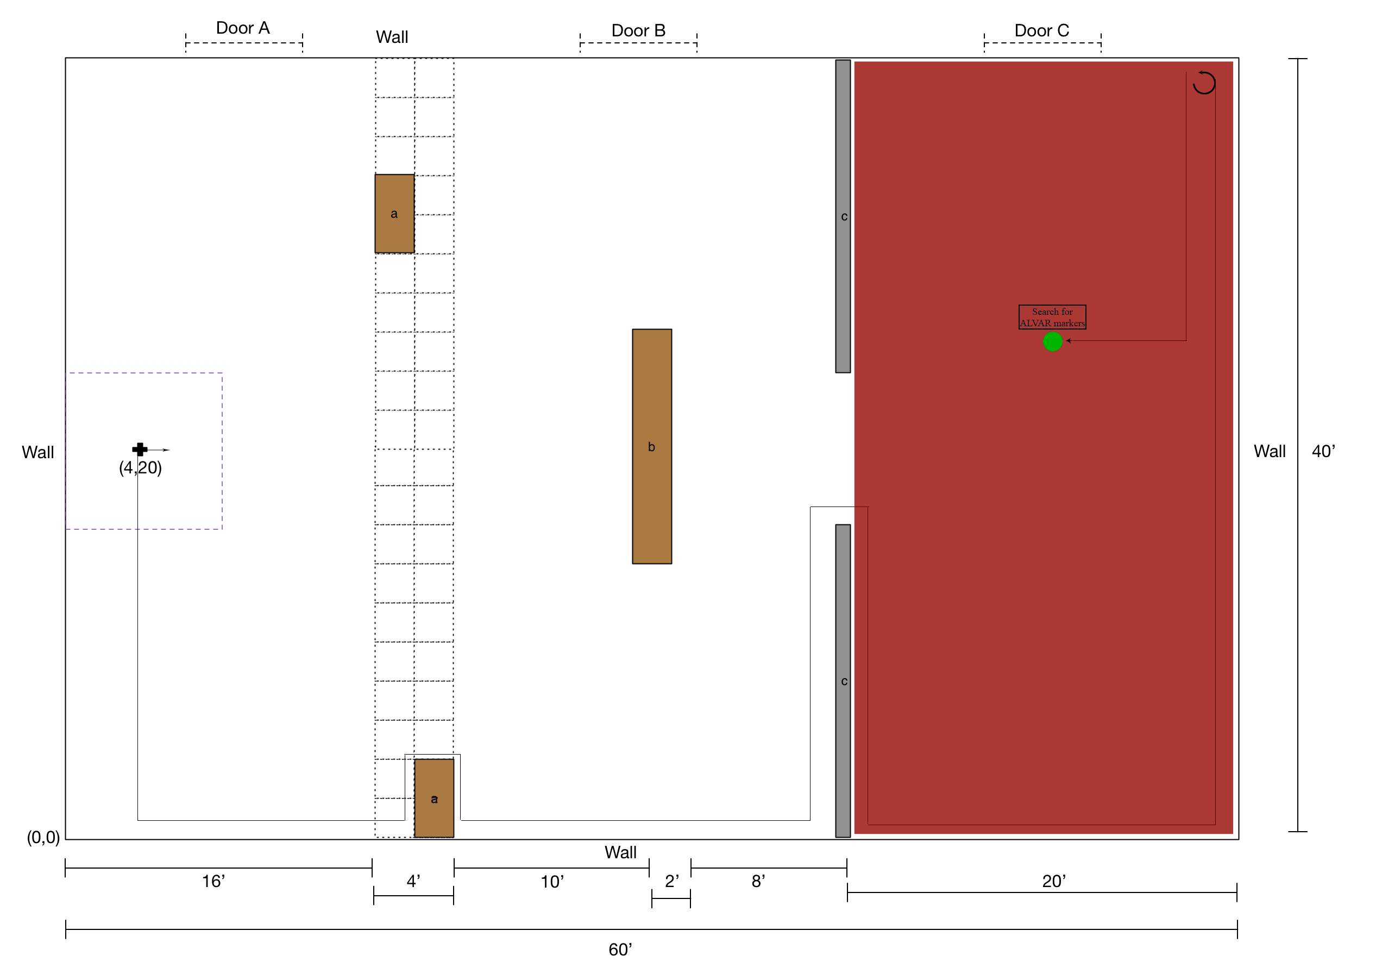Once an ALVAR is located, the vehicle will measure the distance to the ALVAR using the laser rangefinder. Finding a second ALVAR and distance, the algorithm uses the coordinates of the ALVARS as well as a system of distance formulas to find the ball’s coordinates within the room as shown:

$${d_{a1}}^{2}={(x_{q}-x_{a1})}^{2}+{(y_{q}-y_{a1})}^{2}$$

$${d_{a2}}^{2}={(x_{q}-x_{a2})}^{2}+{(y_{q}-y_{a2})}^{2}$$

$where d_{a1},{ x}_{a1}, y_{a1} are the distance, x coordinate, and y coordinate$ of ALVAR 1

$where d_{a2},{ x}_{a2}, y_{a2} are the distance, x coordinate, and y coordinate$ of ALVAR 2

$where{ x}_{q}, y_{q} are the x coordinate and y coordinate$ of the quadcopter/ball

# Image Processing

Target identification is executed on the ground station, and also is a simple approach. Using OpenCV C++ library, the image sent from the quadcopter is split from one three-channel image to three one-channel images, so that the program can manipulate the red, green, and blue channels independently. Since the target is green, the program’s objective is to filter out all color but. To accomplish this, the program averages the red and blue channels and subtract the result from the green channel. This effectively removes all white and near white pixels and dampens blue and red pixels. The program then uses OpenCV’s Hough Circles (citation?) feature to locate a circle. If a circle is found, we assume that this is the target, and the vehicle begins to search the room for ALVAR 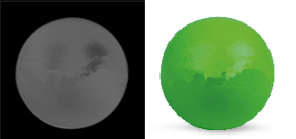markers.

Above: The input (left) and output (right) into the object detection algorithm

# Safety

In order to safely disarm the quadcopter in the event of a failure, two disarm mechanisms have been added. First, a software disarm feature has been added into the control algorithm that allows the ground station to send a kill command, which will put the quadcopter into a landing mode. From here the quadcopter will land. The second kill switch is a manual switch on the flight controller that when switched will also initiate the landing procedure.

To test the safety system, a controlled environment was set up where the quadcopter would navigate part of the course and these disarm mechanisms could be tested. For the software disarm feature, the quadcopter was allowed to follow a wall on it right side, and when the operator was ready, the kill command was sent from the ground station through wireless communication and the quadcopter initiated landing. This same test was performed with the manual kill switch located on the flight controller to make sure both mechanisms are working.

# Ground Station

Communication with the quadcopter is predominately done through SSH protocol over a private and secure WiFi network. Initially, the takeoff script is run from the ground station to begin the flight sequence. After takeoff, the quadcopter will operate on its own. In the event of a catastrophic failure, the operator of the ground station will can send a kill command over HTTP protocol to stop the quadcopter and initiate the landing sequence. When the ball has been found the Raspberry Pi will use the SCP protocol to send the image of the ball to the ground station for further processing.

Once the image of the ball has been received, the ground station will do further processing to isolate the ball in the image received. Commands are sent to the quadcopter over SSH to position the quadcopter over the ball and begin searching for the ALVAR markers. Once again, images will be sent to the ground station in order to detect the ALVAR markers. For each marker found, the quadcopter sends the coordinates corresponding to each marker and the distance measure.

# Vehicle Diagram

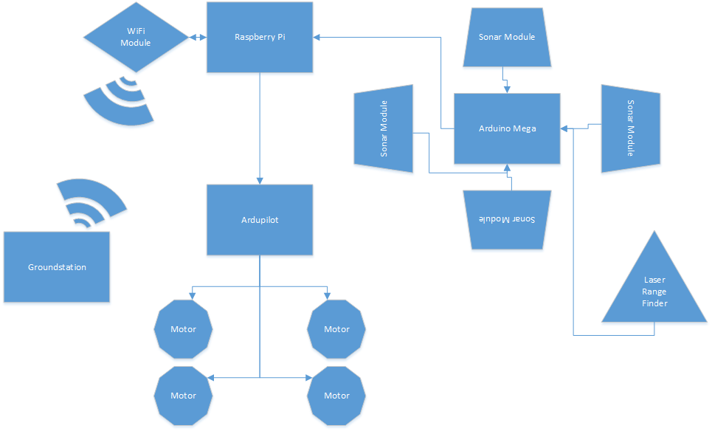

# Design

Since the quadcopter itself was purchased as a package, the main design of the frame was not changed much. The changes that were made are the addition of a second platform to hold the Raspberry Pi, four 3D printed brackets to hold the sonar modules, changing many of the nylon screws out for metal ones, and securing the laser range finder to the frame.

Sonar modules are used as the sensors for object avoidance due to their range and energy costs. Adding the four sonar modules towards the center on each of the sides of the center body of the quadcopter was done as it was perceived as the most logical position to be placed them. Having the sonars closer to the main body gives the pulse a greater range left to right as the signal travels out and helps to ensure that closer objects are detected. Initially, it was thought that the downdraft of the propellers may cause interference with the sonars but after tests were run it was evident that this was not the case.

We use a laser range finder (LRF) as the sensor for measuring distance to the alvar markers, and this ensures that we have an accurate measurement to help determine the coordinate system as accurate as possible. Placing the LRF facing frontward was done because the camera also faces this direction and this simplifies the use of these coordinating sensors. Using image processing on the images returned of the ALVAR markers, the program will be able to determine if the laser range finder is accurately pointing towards an ALVAR marker and adjust the facing direction if this is needed.

Navigating the rooms by following the right wall was the simplest and most effective way we came up with to navigate the two rooms. The quadcopter navigates facing the direction of the second room at all times so that the quadcopter only has to focus on going forward. In the case where an object should be found in its way in the first room, the quadcopter navigates around it since all boxes are known to be at least a 5 feet apart, which is plenty of room for the quadcopter to navigate through. When the quadcopter reaches a corner with a wall in front of it and to its left we term this the end condition of the navigation part of the algorithm. After detecting a wall after shifting left for some time, the quadcopter knows it is in the room with the ball and the search can begin for the ALVAR markers and ball.

Searching for the ball first from the corner of the room is the stronger option as the ALVAR markers should be easier to detect from above the ball. After locating the ALVAR markers from this position and measuring their distances from the ball a system of equations can be used to determine the ball’s position within the room. From this the local coordinate system of the room can be determined.

# Acknowledgement

We would like to thank the organizers of the competition for putting this competition together as well as Miami’s ECE department for funding the parts for our quadcopter. Although it has been quite a challenge working on this project we have definitely had fun and have learned a lot in the process.



**Nick Contini** A Junior Computer Engineering Undergraduate from Miami University. As original founder of the project, he started work on the Redhawk quadcopter in the summer of 2014. He has done numerous other projects including guitar pedals, CPU design, and game design. He has consistently made the President’s list and has been elected for Top Engineer and well as Undergraduate Summer Scholar. This summer he will work for Synchrony Financial’s IT department as part of their Business Leadership program. A December 2015 graduate, Nick is interested in parallel processing, game design, hardware design, and digital signal processing.

**John H. Thomas** is a Senior Computer Engineering Undergraduate at Miami University. John joined the project late in his junior year and continued with it for his senior design project. During his senior year he has held the position of President of Miami’s IEEE Student Branch. During his time as president, John has led multiple projects including but not limited to building a 3D printer from scratch, making RFID enabled door locks, and building arcade machines from Raspberry Pis. His greatest achievement is his RFID car start project, allowing him to start an older key styled car with newer RFID technology. Graduating this May, John will be looking to take an engineering position in the local Ohio area.