**Chat PDF RAG-Powered Chatbot Documentation**

**Flow chart of the entire Project**

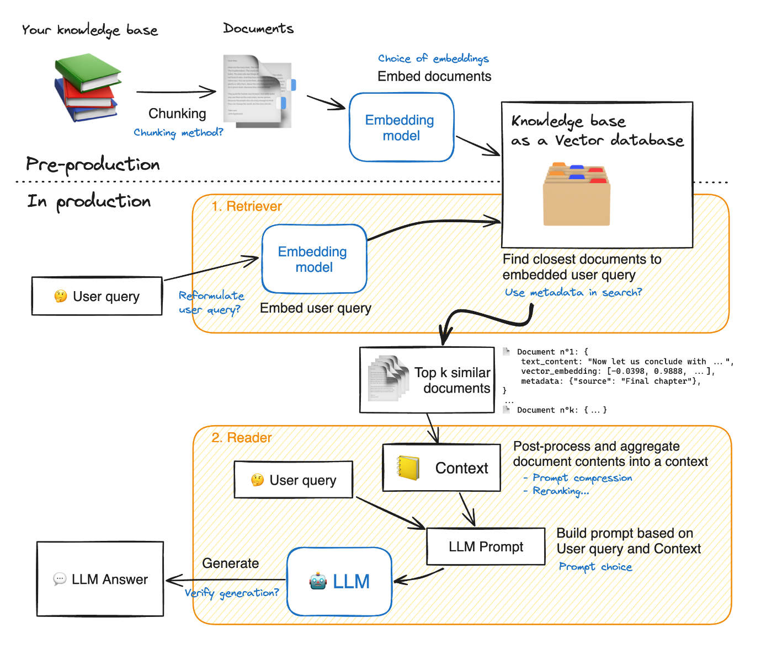

**Thought Process**

**1. Dataset Construction**

To construct the dataset for testing the chatbot, I selected a variety of PDF documents covering different topics. These documents were chosen to provide a diverse range of contexts and questions for the chatbot to answer. Each PDF document was processed to extract its text content, which was then split into smaller chunks to create a more manageable dataset. The text chunks were used to train the model and evaluate its performance.

**2. Evaluation Metrics Selection**

The chosen evaluation metrics include precision, recall, F1 score, and accuracy. These metrics were selected because they provide a comprehensive evaluation of the chatbot's performance:

* **Precision**: Measures the accuracy of the chatbot's answers, indicating the proportion of correct responses among all the responses provided.
* **Recall**: Measures the chatbot's ability to provide all relevant answers from the dataset, indicating the proportion of correct responses among all the relevant answers.
* **F1 Score**: The harmonic mean of precision and recall, providing a balanced measure of the chatbot's overall performance.
* **Accuracy**: Measures the overall correctness of the chatbot's responses, indicating the proportion of correct responses among all the responses provided.

These metrics were chosen to ensure a thorough assessment of the chatbot's ability to provide accurate and relevant answers to user queries.

**3.Accuracy Improvement Strategies**

To improve the accuracy of the chatbot, several strategies were employed:

1. **Prompt Engineering**: A detailed and clear prompt template was designed to guide the chatbot in generating accurate responses. The prompt template provided context and structure for the chatbot to follow when generating answers.
2. **Embedding Model Selection**: A high-quality embedding model from Google's Generative AI was selected to ensure meaningful and contextually relevant embeddings. The embedding model played a crucial role in capturing the semantic meaning of the text chunks and enabling accurate similarity search.
3. **Text Chunking Optimization**: The text chunking process was fine-tuned to ensure that each chunk contained enough context for accurate answers. The chunk size and overlap were adjusted to balance the trade-off between context size and processing efficiency.
4. **Similarity Search Efficiency**: FAISS was utilized for efficient and accurate similarity search, enabling the chatbot to retrieve the most relevant text chunks for each user query. The optimization of the similarity search process contributed to the overall accuracy improvement of the chatbot.

**Conclusion**

In conclusion, the Chat PDF RAG-Powered Chatbot project aimed to create an effective and accurate chatbot capable of answering questions based on PDF documents. By carefully constructing the dataset, selecting appropriate evaluation metrics, and implementing accuracy improvement strategies, the chatbot demonstrates its ability to provide accurate and contextually relevant answers to user queries.