**Protocol/Analysis plan: CCU024_02 Intersectional inequality in emergency department (ED) visits, in-hours and out-of-hours, in the last 3 months of life for people who died in England in 2020**

Protocol authors: Joanna Davies and Katherine Sleeman on behalf of CovPall Connect (PI Irene Higginson)

Contact: [joannamariedavies@kcl.ac.uk](mailto:joannamariedavies@kcl.ac.uk)

**Version control**

|  |  |
| --- | --- |
| Date uploaded to github |  |
| 09/02/23 | First draft including responses to reviewers comments |
| 09/02/23 | Second draft following comments from BHF consortium members |
| 22/02/23 | Third draft – change to the model type from poisson to neg binomial to deal with overdispersion in the outcome |

**Background**

**What we know already**

* Our earlier analyses for CovPall_Connect used mortality data and linked mortality and HES ED data, and showed that: 1) there were notable changes in care for people approaching the end of life that occurred during the Covid-19 pandemic including a shift from hospital to home deaths1; 2) people who live in more deprived areas are less likely to die at home and this inequality increased during the pandemic1; 3) the rate of ED visits increases steeply in the last 3 months of life2; 4) end of life ED visits in 2020 demonstrated a clear area-based deprivation gradient, being higher for people who live in more deprived areas.2
* The rate of ED visits in the general population is twice as high for people living in the 10% most deprived neighbourhoods, compared to the 10% least deprived areas, and varies with ethnicity, with ‘other ethnic groups’ having an ED visit rate that is 5 times higher than White, Asian or Asian British and Black or Black British groups.3
* The rate of ED visits may act as a ‘barometer’ for pressures on and access to community-based care.2, 4
* Living in a more deprived area is a risk factor for indicators of poorer care towards the end of life including, increased risk of death in hospital and higher use of hospital care in the last months of life.5-7 Non-white ethnicity is also a risk factor for these indicators of poorer end of life care including more emergency admissions towards the end of life.8, 9
* However, very little is known about how ethnicity and area-based deprivation intersect with each other and with other factors in terms of risk of ED visits towards the end of life.

**What this study adds**

* This study will provide the first analysis of ethnicity, area-based deprivation, geographical location, and morbidity as intersectional risk factors for ED visits in the last 3 months of life.

**Aim**

The aim of this study is to analyse the association between ethnicity and the rate of emergency department visits in the last three months of life, separately for men and women, and to understand how far this relationship is explained by area-based deprivation, geographical location (based on Integrated Care Board) and morbidity (based on underlying cause of death, and count of unique primary care medications).

**Methods**

**Data source:** This analysis uses four linked databases for England available from NHS Digital in the British Heart Foundation Trusted Research Environment: 1) mortality records, 2) ED attendance data from Hospital Episode Statistics (HES), 3) primary care prescription data, 4) patient demographic data (date of birth, sex, ethnicity, and geographical location) from linked HES and General Practice Extraction Service (GPES) Data for pandemic planning and research (GDPPR).

**Population:** all deaths in England in 2020 among adults aged ≥18 years old.

**Outcome:** ED visits (including at major A&E departments, single specialty A&E departments, walk-in centres and minor injury units) in England in the last 3 months of life, in-hours (IH) and out-of-hours (OOH). OOH is defined as visits occurring after 18:00 and before 8:00, at weekends and on bank holidays.

**Exposures:**

**Ethnicity:** most recent non-missing record of ethnicity in the hospital episode statistics (HES) record and from the primary care record, prioritising the primary care record.10 Categories were then mapped on to the following nine categories used by the Office for National Statistics (ONS)11 (with the additional separation of White British from White Other):

|  |  |
| --- | --- |
| **Ethnic category used** | **Detailed composition of groups from HES and GPES categories** |
| White British | White British |
| White other | Irish, Traveller, or any other White background |
| Mixed/Multiple ethnic groups | White and Black Caribbean, White and Asian, White and Black African, or any other mixed background |
| Bangladeshi | Bangladeshi |
| Indian | Indian |
| Pakistani | Pakistani |
| Chinese | Chinese |
| Black African | Black African |
| Black Caribbean | Black Caribbean |
| Other ethnic group | Arab, any other Asian, any other Black, or any other ethnic background. |

[NB we sought to compare initial descriptives on the n of deaths by ethnicity with published data to verify data and coding. Comparison with data available for Eng and Wales for 2017/2019 shows overall higher % of non-White British in our data but relative proportions hold. Differences are probably due to lower rates of non-White British in Wales and time period for which data is available – see comparison data here: <https://www.ons.gov.uk/peoplepopulationandcommunity/birthsdeathsandmarriages/deaths/datasets/mortalityfromleadingcausesofdeathbyethnicgroupenglandandwales> ]

**Area-based deprivation:** Index of Multiple Deprivation (2019) rank (1 is most deprived) linked to the patients LSOA based on the most recently recorded non-missing postcode of the patient in the HES record or the primary care record (not prioritising the primary care record).

**Geographical location:** the patient’s Integrated Care Board (ICB) linked to most recently recorded non-missing postcode of the patient in the HES record or the primary care record (not prioritising the primary care record).

**Morbidity:** We used underlying cause of death as a proxy for primary diagnosis which is known to be an important factor associated with emergency hospitalisations towards the end of life.12, 13 We also used a count of unique medicines from the primary care record, prescribed over the 12 months before death, as a proxy for comorbidity. We counted the number of unique British National Formulary (BNF) chapter codes. Each code represents drugs in the same class and so repeat prescriptions for the same or similar drugs were counted once.

A similar approach to measuring multi-morbidity has been used in previous studies and has been shown to be comparable to other measures of multi-morbidity such as the Charlson Comorbidity Index as a predictor of mortality and service use.14-17 In this study, a count of medications has advantages over the Charlson index because a count of medicines does not rely on a hospital admission and can be derived over a specific period of time.

**Covariates:** age at death, based on date of death from the mortality record and date of birth, taking the most recent non-missing HES or primary care record, prioritising the primary care record.

**Moderator:** sex from the most recent non-missing HES or primary care record, prioritising the primary care record.

**Analysis**

**Descriptive analysis:** we will use counts, proportions and averages to describe the sample and the rate of in-hours (IO) and out-of-hours (OOH) ED visits by categories of the exposure.

**Modelling:** Negative binomial models of the incident rate ratio (IRR) of ED visits in the last 3 months of life, with robust standard errors (SE) to account for violations of model assumptions.18 We have chosen negative binomial models instead of poisson models because of overdispersion in the outcome variable. Models will be run separately for men and women and separately for IO and OOH ED visits.

Model 1 will include ethnicity and age; Model 2 will additionally include geographical location (ICB), Model 3 will additionally include area-based deprivation, Model 4 will additionally include morbidity (underlying cause of death and count of primary care medications).

We will display the IRR for each ethnic group (compared to White British) for each of the models (separately for men and women and for IO and OOH) to evaluate attenuation of the ethnicity effects (model 1) by geography (model 2), area-based deprivation (model 3) and morbidity (model 4).

This analysis follows an approach used elsewhere to display intersectional inequalities in covid-19 mortality rates (figure 1).19

**Figure 1: From ‘Build back fairer: the Covid-19 Marmot Review’, p43**

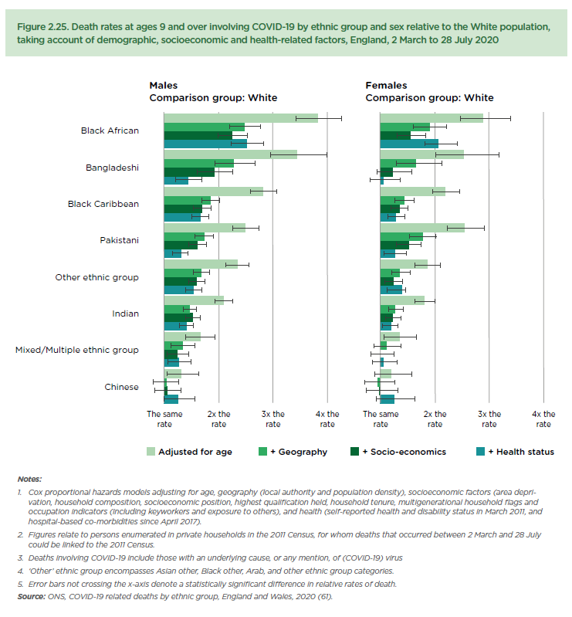

**Sensitivity analysis:** in a sensitivity analysis we will run the analysis excluding sudden causes of death and compare the main effects. This restricts the sample to causes of death that are more likely to have benefited from palliative care and other community-based care that could potentially prevent ED visits towards the end of life.

Non-sudden causes are defined following an approach used to estimate the need for palliative care on a population level, by identifying deaths that could have benefited from palliative care based on the underlying cause of death.20, 21

**Table 1: International Classification of Disease-10 (ICD-10) codes: conditions that could benefit from palliative care, used to estimate palliative care need, source20**

In a second sensitivity analysis we will exclude people who died in a care home, to test whether being resident in a care home moderates the main effects. Care home admission may protect against ED visits for people towards the end of life22, and the likelihood of being resident in a care home may be associated with socioeconomic position23 and ethnicity. Approximately 80% of care home residents die in a care home24; therefore, using death in care home as a proxy for being resident in a care home will miss some care home residents. Methods to identify care home residents based on postcodes have been developed but we do not have access to postcodes in this data, therefore death.

All analysis will be carried out in Stata MP v16.1.

**Limitations**

* Count of medications is unlikely to fully capture comorbidities; three possible limitations: 1) no capture of prescriptions issued in hospital, 2) people approaching the end of life may have medicines reduced leading to under-representation of comorbidity, 3) bias in patterns of prescriptions, for example prescribing rates tend to be lower in more deprived areas, leading to an under-representation of comorbidity.25
* Care home admission may reduce ED visits – there is some evidence to suggest that this reduction happens for all residents regardless of socioeconomic position.23 We do not have a reliable way to identify care home residents in our sample, the indicator of care home in HES is known to be poor quality. In a sensitivity analysis we can exclude those who died in a care home and compare main effects, however, care home residents who die in hospital will remain in the sample.

**References**

1. Sleeman KE LJ, Davies JM, Bone AE, Pask S, Chambers RL, Kumar R, Fraser LK, Hocaoglu MB, Oluyase AO, Barclay S, Murtagh FEM & Higginson IJ Better End of Life 2022. Fairer Care at Home. The Covid-19 pandemic: a stress test for palliative and end of life care. Research report. London (UK): Marie Curie. 14 July 2022. accesed (07/12/22): <https://www.mariecurie.org.uk/globalassets/media/documents/research/publications/beol-2022/h903a-beol-england.pdf>. 2022.

2. Pask S, Davies JM, Mohamed A, Leniz J, Chambers RL, McFarlane P, Bone AE, Barclay S, Higginson IJ, Sleeman KE & Murtagh FEM (King’s College London, Cicely Saunders Institute; Hull York Medical School at the University of Hull; and University of Cambridge, UK). Better End of Life 2022. Mind the gaps: understanding and improving out-of-hours care for people with advanced illness and their informal carers. Research report. London (UK): Marie Curie. (November 2022)

3. NHS Digital. Hospital Accident and Emergency Activity, 2019-2020. available here: <https://digital.nhs.uk/data-and-information/publications/statistical/hospital-accident--emergency-activity/2019-20/imd-and-ethnicity> accessed: 15/12/22.

4. O'Malley AS, Gerland AM, Pham HH, et al. Rising pressure: hospital emergency departments as barometers of the health care system. *Issue Brief Cent Stud Health Syst Change* 2005: 1-4.

5. Marmot M, Allen, J., Boyce, T., Goldblatt, P., Morrison, J. *Health equity in England: The Marmot Review 10 years on.* London: Institute of Health Equity, 2020.

6. Davies JM, Sleeman KE, Leniz J, et al. Socioeconomic position and use of healthcare in the last year of life: A systematic review and meta-analysis. *PLoS Med* 2019; 16: e1002782-e1002782. DOI: 10.1371/journal.pmed.1002782.

7. Walsh B and Laudicella M. Disparities In Cancer Care And Costs At The End Of Life: Evidence From England's National Health Service. *Health Aff (Millwood)* 2017; 36: 1218-1226. 2017/07/07. DOI: 10.1377/hlthaff.2017.0167.

8. Henson LA, Gao W, Higginson IJ, et al. Emergency Department Attendance by Patients With Cancer in Their Last Month of Life: A Systematic Review and Meta-Analysis. *J Clin Oncol* 2015; 33: 370-376. 2014/12/24. DOI: 10.1200/jco.2014.57.3568.

9. Hussain JA, Koffman J and Bajwah S. Invited Editorials. *Palliat Med* 2021; 35: 810-813. DOI: 10.1177/02692163211012887.

10. Wood A, Denholm R, Hollings S, et al. Linked electronic health records for research on a nationwide cohort of more than 54 million people in England: data resource. *BMJ* 2021; 373: n826. DOI: 10.1136/bmj.n826.

11. White, C. Ayoubkhani, D. (2020) Updating ethnic contrasts in deaths involving the coronavirus (COVID-19), England and Wales: deaths occurring 2 March to 28 July 2020. Office for National Stistics.

12. Henson LA, Gao W, Higginson IJ, et al. Emergency department attendance by patients with cancer in their last month of life: a systematic review and meta-analysis. *J Clin Oncol* 2015; 33: 370-376. 2014/12/24. DOI: 10.1200/jco.2014.57.3568.

13. Henson LA, Higginson IJ, Gao W, et al. What factors influence emergency department visits by patients with cancer at the end of life? Analysis of a 124,030 patient cohort. *Palliat Med* 2017: 269216317713428.

14. Brilleman SL and Salisbury C. Comparing measures of multimorbidity to predict outcomes in primary care: a cross sectional study. *Fam Pract* 2013; 30: 172-178. 20121008. DOI: 10.1093/fampra/cms060.

15. Perkins AJ, Kroenke K, Unützer J, et al. Common comorbidity scales were similar in their ability to predict health care costs and mortality. *J Clin Epidemiol* 2004; 57: 1040-1048. DOI: 10.1016/j.jclinepi.2004.03.002.

16. Kim S, Bennett K, Wallace E, et al. Measuring medication adherence in older community-dwelling patients with multimorbidity. *Eur J Clin Pharmacol* 2018; 74: 357-364. 20171203. DOI: 10.1007/s00228-017-2388-y.

17. Walker J, Halbesma N, Lone N, et al. Socioeconomic status, comorbidity and mortality in patients with type 2 diabetes mellitus in Scotland 2004-2011: a cohort study. *J Epidemiol Community Health* 2016; 70: 596-601. 20151217. DOI: 10.1136/jech-2015-206702.

18. Mansournia MA, Nazemipour M, Naimi AI, et al. Reflection on modern methods: demystifying robust standard errors for epidemiologists. *Int J Epidemiol* 2021; 50: 346-351. DOI: 10.1093/ije/dyaa260.

19. Michael Marmot JA, Peter Goldblatt, Eleanor Herd, Joana Morrison. *Build Back Fairer: The COVID-19 Marmot Review. The Pandemic, Socioeconomic and Health Inequalities in England*. London: Institute of Health Equity., 2020.

20. Etkind SN, Bone AE, Gomes B, et al. How many people will need palliative care in 2040? Past trends, future projections and implications for services. *BMC Med* 2017; 15: 102. DOI: 10.1186/s12916-017-0860-2.

21. Murtagh FEM, Bausewein C, Verne J, et al. How many people need palliative care? A study developing and comparing methods for population-based estimates. *Palliat Med* 2013; 28: 49-58. DOI: 10.1177/0269216313489367.

22. Paul Smith CS-J, Cono Ariti, Martin Bardsley. 2015. Focus on: Hospital admissions from care homes. The Health Foundation Quality Watch, available: <https://www.health.org.uk/sites/default/files/QualityWatch_FocusOnHospitalAdmissionsFromCareHomes.pdf> accessed: 19/05/22.

23. Kelfve S, Wastesson J, Fors S, et al. Is the level of education associated with transitions between care settings in older adults near the end of life? A nationwide, retrospective cohort study. *Palliative medicine* 2018; 32: 366-375. 2017/09/28. DOI: 10.1177/0269216317726249.

24. Office for Health Improvement and Disparities (OHID). Palliative and end of life care factsheet: Recent trends of deaths in care homes and provision of care. England. January 2023. accesed 09/02/23 here: <https://fingertips.phe.org.uk/static-reports/end-of-life-care-home-factsheet/January%202023/E92000001.html?area-name=Barking%20and%20Dagenham>.

25. Mooney J, Yau R, Moiz H, et al. Associations between socioeconomic deprivation and pharmaceutical prescribing in primary care in England. *Postgrad Med J* 2022; 98: 193. DOI: 10.1136/postgradmedj-2020-138944.