Version history

|  |  |  |
| --- | --- | --- |
| V0.1 | 16/02/22 | LZ provided skeleton protocol |
| V0.2 | 01/03/22 | RD, VW input on protocol |
| V0.3 | 30/03/22 | LZ incorporates feedback from C036 working group |
| V1.0 | 15/03/22 | Approved version uploaded on GitHub and Box |

# Authors

LZ, RD, VW, CCU036 working group and COVID IMPACT UK

# Title

The safety of COVID-19 vaccination for fertility and pregnancy outcomes

# Lay summary

Many young women and girls have been asking for better evidence on the long-term safety of COVID-19 vaccination, especially with regard to fertility and pregnancy health for future pregnancies.

We will study whether:

1)COVID-19 vaccination is safe for women’s fertility and future pregnancies;

2)some women are more at risk.

We will access anonymised NHS records of all English residents from testing, vaccination, GP, hospital and maternity services, through a secure platform. We will compare women’s fertility and future pregnancy outcomes according to whether they were vaccinated against COVID-19, to understand any risks and who is most at risk.

By better understanding the medium to long term safety of COVID-19 vaccination, this project has clear potential to benefit mothers and babies, while cutting NHS spending, e.g. by improving vaccine uptake rates and reducing the high costs associated with COVID-affected pregnancies. This could be achieved through evidence-based, clearer messages on the risk-benefit balance of COVID-19 vaccination to inform decision-making and prevent future COVID-19-exposed pregnancies.

To maximise public benefit, our team will feed into vaccination strategies.

# Background

There have been several reports of vaccine hesitancy in women of reproductive age, fuelled by both misinformation and lack of evidence around the longer term safety of vaccines with respect to fertility/pregnancy outcomes.

The linked datasets within the NHS Digital Trusted Research Environment provide the ideal source of real-world evidence to answer these important research questions. These will inform the UK pandemic response and lead the way in compiling international clinical guidelines and vaccination strategies, around what are top global priorities in maternal and reproductive health.

This project is perfectly aligned with COVID-IMPACT as it addresses research looking at “the impact of COVID-19 on other health conditions and health related risk factors”, specifically fertility and pregnancy outcomes.

# Research hypotheses

There could be safety issues in the medium-long term for women of reproductive age receiving COVID-19 vaccination, in terms of fertility and future pregnancy outcomes. Any vaccine-related risks may differ by vaccine type, doses regimen, individual characteristics (including maternal age, ethnicity and deprivation), or they may change with time.

# Research question

How do women who initiated a course of COVID-19 vaccination before pregnancy compare to those who remained unvaccinated, in terms of:

1. live births, (late) miscarriages requiring hospitalisation, and stillbirths (expressed as rates), and
2. pregnancy complications and adverse pregnancy outcomes (expressed as hazard ratios)?

*Note that given the relatively short length of follow-up since vaccines roll out, a woman can only contribute observation time to the exposed groups (whether she had 1 or 2 doses before pregnancy) or the unexposed group (if she had none).

Sensitivity analyses will include subgroup analyses by maternal age, ethnicity, deprivation, parity and previous adverse pregnancy outcomes. If power allows, analyses will be stratified by whether the second/third dose of the vaccine was received in pregnancy or outside of pregnancy, and according to specific vaccine types.

Results will be expressed in terms of absolute excess risk of certain outcomes in particular subgroups after COVID-19 vaccination compared to unvaccinated women. (Absolute excess risk is calculated using the estimated background risk pre-pandemic -see Main Analyses).

# Data sources

*(All data will be used up to the latest available stable release of data)*

***NHS Digital TRE for England***

* Primary care data (GP Data for Pandemic Planning and Research via General Practice Extraction Service, GPES);
* Secondary Use Service (SUS) hospital data;
* HES: Hospital Episode Statistics (Admitted Patient Care, Adult Critical Care, Outpatients, Accident & Emergency, APC Maternity file)
* Emergency Care Data Set (ECDS);
* Pillar 1 and Pillar 2 COVID-19 infection laboratory testing data;
* Office of National Statistics (ONS) death registration records;
* ICNARC: Intensive Care National Audit and Research Centre;
* CHESS: COVID-19 Hospitalisation in England Surveillance System;
* Medicines Dispensed in Primary Care (NHS BSA);
* Secondary Care Prescribed Medicines (EPMA);
* COVID-19 vaccination data (including adverse events).

# Study population

See Figure 1 in Appendix 1 for an overview of eligibility and recruitment

**Cohort 1 (to study fertility outcomes 1 to 4)**

Follow-up period:

* Primary analysis: 8th December 2020 (date of start of vaccine rollout) to 43 weeks before last data collection date

Patients will be included if they meet ALL the following criteria:

* An age of ≥18 and <=45 can be calculated on 8th December 2020
* Female sex
* Have a record in the primary care extract
* Alive on 8th December 2020

Enumerate and exclude the following individuals:

(cannot become pregnant)

* those with a history of hysterectomy
* those on hormone replacement therapy

(missing or implausible outcome data)

* those with a birth outcome record but missing gestational age
* those with a birth outcome but implausible gestational age (>=43 or <24 weeks)

**Cohort 2 (a sub-cohort of cohort 1, to study pregnancy outcomes 1, 4 to 14)**

Same as cohort 1, and additionally:

Enumerate and exclude the following individuals:

* those without pregnancy events/birth outcome record
* those with a pregnancy with date of pregnancy start T_p outside the interval 08.12.20<T_p<(latest data release-43weeks)
* those whose pregnancies lasted <12 weeks
* those with first dose during pregnancy (i.e. exclude if T_v1>T_p)

# Exposures

First dose analysis: AstraZeneca, Pfizer, Moderna

Full course (first and second dose) analysis:

|  |  |
| --- | --- |
| First dose | Second dose |
| AstraZeneca | AstraZeneca |
| Pfizer | Pfizer |
| Moderna | Moderna |

Booster dose analysis:

|  |  |
| --- | --- |
| First & Second dose | Booster |
| AstraZeneca & AstraZeneca | Pfizer or Moderna |
| (Pfizer & Pfizer) OR (Moderna & Moderna) | Pfizer or Moderna |

Cell counts for other vaccine type combinations will be examined to ensure the above reflects the majority of the data.

Pregnancies can be unexposed, or exposed to 1, 2 or 3 doses (these are all mutually exclusive categories). Exposed pregnancies are those where the vaccination course starts prior to the start of the pregnancy, such that T_v1<T_p where T_v1 is date of first dose and T_p is estimated date of pregnancy start (date(outcome)-gestational_age) (see ‘Main Analysis’ and ‘Appendix 1 – follow-up time for details).

# Outcomes

Primary analysis will consider the following outcomes in “any position” in hospital admissions (HES ‘Maternity file data’ in England), provided they occur in a pregnancy commencing after vaccination (pregnancy date of pregnancy start between 08.12.20 and 43 weeks prior to the last available update).

Analyses using the Maternity Services Data Set will be set out in detail in future amended protocols (data currently unavailable in the NHS Digital TRE as of Feb 2022).

Live births (separately and as a combined category):

1. Pre-term (live) birth (<37 weeks gestation)
2. Term (live) birth (>=37 weeks gestation)
3. All live births (1+2)

Miscarriage resulting in hospitalisation:

1. Late pregnancy loss (>=12 but <24 weeks gestation)

Perinatal deaths (separately and as a combined category):

1. Stillbirths (>=24 weeks gestation)
2. Neonatal deaths (after birth)
3. All perinatal deaths (4+5+6)

Adverse pregnancy outcomes (separately and as a combined category):

1. Pre-eclampsia
2. Hypertensive disorders of pregnancy (includes pre-eclampsia)
3. Gestational diabetes
4. Placental abruption
5. Small-for-gestational age baby
6. Any adverse pregnancy outcome (Any of 7-12)

Cardiovascular complications

1. Venous thromboembolism

# Potential confounders

This is an overview of all potential confounders we will gather. Prior to each exposure-outcome analysis, we will check for any imbalances in confounder distribution between exposure categories, and draw directed acyclic diagrams to guide the final a priori selection of confounders in each model.

Latest recorded in primary care before 8/12/20

1. Age
2. Calendar week of conception
3. Region
4. Deprivation
5. Twin or multiple pregnancy Vs singleton
6. Smoking status
7. Parity
8. Pre-pregnancy Body Mass Index
9. Most recently recorded ethnicity in primary care or hospital admissions (or other HES sources if available)

Any record in primary care and/or hospital admission data before 8/12/20

1. History of miscarriage
2. History of stillbirth
3. History of preeclampsia or gestational hypertension
4. History of gestational diabetes
5. History of preterm birth
6. History of depression/anxiety
7. History of pre-pregnancy hypertension
8. History of pre-pregnancy diabetes
9. History of DVT or PE
10. History of thrombophilia
11. History of chronic kidney disease
12. History of SARS-CoV2 infection before the 8th December 2020: positive antigen test from national lab data OR confirmed COVID-19 diagnosis in primary care/hospital admissions records

Prior medication from community dispensing data (binary variable ever/never) before the 8th December 2020:

1. Antiplatelets
2. Antihypertensives
3. Lipid lowering agents
4. Oral anticoagulants
5. Combined oral contraceptives

# Codelists

Link to GitHub phenotype file

# Main analyses

Initial descriptive statistics will be used to describe the demographic and clinical characteristics of the baseline cohort. Descriptive analyses will also include computing age-standardised rates of main outcomes by number of vaccine doses received, with first dose before pregnancy (including/excluding women receiving 2nd and/or booster vaccine in pregnancy).

Cohort 1 analyses

Outcome 3 PAUSED FOR NOW

We will compute age-standardised birth rates (total live births) in the exposed categories compared to the unexposed. Denominators from?!?

Cohort 2 analyses

Outcomes 1 and 4-14

Primary analysis:

* individual specific follow-up period will be censored at first of death, outcome event (delivery)
  + In light of emerging evidence highlighting the detrimental effects of a COVID infection in pregnancy on pregnancy outcomes, we will amend the models originally intended as 'main analyses' by adding censoring of all follow up time/events following a positive COVID test during pregnancy. This will be in addition to performing stratified analyses by prior COVID infection (before the start of pregnancy)
* follow-up time will start from week 13 after conception
* Pregnancies exposed to a first vaccine dose before pregnancy (T_v1>T_p), followed by any number of additional doses either before or during pregnancy, are compared to unexposed pregnancies.
* Pregnancies which are exposed during the pregnancy and not before are excluded from these analyses

We will split follow-up time for each pregnancy starting from 12 weeks after the date of pregnancy onset/conception (T_p+84 days), into 4-weeks gestational time periods until an event or birth (time periods: [84,112), [112,140), [140,168), [168,196), [196,224), [224,252), [252,280), [280,308)); see: Appendix 1: splitting follow up time). Each pregnancy will either contribute unexposed time, if the woman didn’t receive a COVID-19 vaccine before the pregnancy, or exposed time if she did, further categorised according to vaccine type as per ‘Exposures’ section. Women who received their first vaccine during pregnancy will be excluded from the analyses. We will tabulate numbers of outcome events (see: ‘Outcomes’), person-years of follow-up and rates of events in the unexposed and in the exposed for every 4-weeks gestational period following the first 12 weeks. If any of these time periods contains no events, we will collapse the time periods into [84,168), [168,252) and [252,308) prior to analysis.

We will fit Cox regression models with gestational age in days as time scale using the estimated start of pregnancy T_p as the origin for all analyses, with days after the first 12 weeks (day 84) contributing to observation time for each pregnancy. This is standard best practice for analysis of drug and vaccine safety in pregnancy. To ensure that all analyses account for changes with calendar time in rates of the outcome event, we will include calendar week of conception as a key covariate. Using this approach, we will estimate hazard ratios for pregnancy-related events after exposure, and by time since exposure.

Potential confounders (see: Potential Confounders) will be based on data recorded before the start of follow-up in each analysis. All models will be stratified by region so that risk sets are constructed within region, hence accounting for between-region variation in the baseline hazard.

We will estimate: (i) age and calendar week of conception adjusted and (ii) maximally adjusted HRs. We will exclude potential confounders with ≤2 occurrences at any level. If time permits, we will construct a propensity score that combines all the covariates into a single metric and adjust for this (using a restricted cubic spline), in addition to individual covariates to obtain maximally adjusted HRs. We will examine the fit of the restricted cubic splines used for age and propensity score.

We will analyse outcomes for which there are at least 400 events after vaccination (400 events within the context of ~10 million total sample size in England). If there are fewer than 400 events for any of the strata in subgroup analyses, including analyses by vaccine type, we will collapse categories (we might end up combining Pfizer and Moderna as mRNA vaccines, or drop the AstraZeneca vaccine category from some stratified analyses as the majority of included women were not eligible for this type of vaccine).

Absolute excess risk (in time intervals between vaccination and pregnancy conception) of particular outcomes for subgroups of interest will be calculated by applying hazard ratios to calculated incidence rates from 2019 data and subtracting these baseline rates. Cumulative excess risk may be plotted graphically by outcome or groups of outcome. These calculations will also be stratified by vaccine type (see Exposures).

Proposed outputs for this project are included as Appendix 2: proposed outputs.

# Sensitivity analyses

If numbers allow, we will stratify analyses by whether any vaccine dose following the first was administered before pregnancy or during pregnancy (e.g. (a) 1st dose and 2nd dose before pregnancy Vs unvaccinated (no booster), (b) 1st dose before pregnancy, 2nd dose during pregnancy Vs unvaccinated (no booster), (c) 1st dose and 2nd dose before pregnancy, booster during pregnancy Vs unvaccinated, (d) 1st dose before pregnancy, 2nd dose and booster during pregnancy Vs unvaccinated – if numbers don’t allow this, we will collapse to just a)+c) and b)+d)).

If there is sufficient power, we will also explore a subgroup analysis by refining the exposure by vaccine type (AstraZeneca, Pfizer and Moderna, or non mRNA Vs mRNA), and an additional stratification according to whether women received a Pfizer or Moderna booster.

All sensitivity analyses will depend on reaching 400 events in each group.

We will not analyse data on different waves separately, as the limited follow-up time won’t allow this.

## Subgroup analyses

If possible (e.g. >400 events in each analysis), we will repeat the main analyses to estimate stratified post-exposure hazard ratios for the most common outcomes (live births, preterm birth) as detailed below:

* Stratified by parity (women who have never had a birth and those with 1+ birth records)
* Stratified by age group (18-24 / 25-39 / 30-34 / 35-39 / 40-45, or broader age categories)
* Stratified by ethnicity (White / Asian or Asian British / Black or Black British / Mixed / Other Ethnic Groups)
* Stratified by deprivation score (women scoring 1-5 and 6-10)
* Stratified by whether also contracted SARS-CoV2 infection before/after vaccination (3 groups: no infection, infection before vaccination, infection after vaccination) (NB this analysis should not be adjusted for previous test positivity prior to vaccination)
* Stratified by whether exposure to vaccine was 3+ or <3 months prior to start of pregnancy

# Missing data

Individuals with missing age, or missing gestational age for pregnancy records, are excluded from the analysis by the study definition. We will include missing categories for smoking, ethnicity, parity and deprivation. All other covariates are defined using the presence versus absence of specific codes in the EHRs, so have no identifiable missing values. We will not use multiple imputation.

# Appendix 1: eligibility and follow-up time

Consider the following definitions:

*Time scale: days since day 84 of pregnancy (gestational age in days from 12 weeks onwards)*

* Exposure of interest: binary exposure with indicator I_E=[0,1]. A pregnancy becomes exposed following a pre-conception first dose vaccination, so if T_v1<T_p, then I_E=1.
* All pregnancies are either exposed or unexposed (see ‘Main Analysis’ for definitions).
* Outcome of interest: time to event D measured at T_D with indicator I_D(T_D)=[0,1] in days.
* Left-censoring such that pregnancies only contribute observation time after week 12 (i.e. I_D(T_D)=. for T_D<=T_p+84)
* Administrative (right) censoring time: set as day T_B=date of birth, death or receipt of another dose of vaccine in pregnancy after 12 weeks of gestation

Time periods: E1=[84,112), E2=[112,140), E3=[140,168), E4=[168,196), E5=[196,224), E6=[224,252), E7=[252,280), E8=[280,308)

Cox model in R: Coxph(Surv(T0, T1, I_D) ~ E1+E2+E3+E4+E5)

# 

**Figure 1. Eligible Pregnancies, Observed Pregnancy Days, and Exposure to Vaccines.**

Pregnancies in England lasting at least 12 weeks that occurred with start of pregnancy dates between 8 Dec 2020 and 4 August 2021were eligible for the study (i.e. if women had become pregnant at least 43 weeks before the date of latest data release). Eligible pregnancies were classified as involving maternal exposure to COVID-19 vaccines if the first vaccine of a vaccine course was administered prior to the date of pregnancy start. For a given pregnancy, days at risk were defined as pregnancy days after week 12 and until delivery. For simplicity, the figure shows all pregnancies as lasting 9 months.

# Appendix 2: proposed outputs

**Main paper**

Table 1: Baseline characteristics

Table 2: Descriptive age-standardised rates of main outcomes by how many doses were received, with first dose before pregnancy (over 5 columns: unvaccinated, then (a) 1st dose and 2nd dose before pregnancy (no booster), (b) 1st dose before pregnancy, 2nd dose during pregnancy (no booster), (c) 1st dose and 2nd dose before pregnancy, booster during pregnancy, (d) 1st dose before pregnancy, 2nd dose and booster during pregnancy)

Fig 1: All ages combined; all outcomes (separate panel per outcome);

Fig 2: Subgroup analyses (as forest plots)

Fig 3: Cumulative difference in absolute risk for key outcomes and vaccine types (possibly by subgroup)

Fig 4: age-standardised birth rate in exposed Vs unexposed

**Supplementary Material**

Sensitivity analyses

– repeat panels of Fig 1 stratified by timing of different doses of vaccine with respect to pregnancy: see page 7 description of a), b), c), d).

* Repeat panels of Fig 1 by type of vaccine and booster (see page 7)

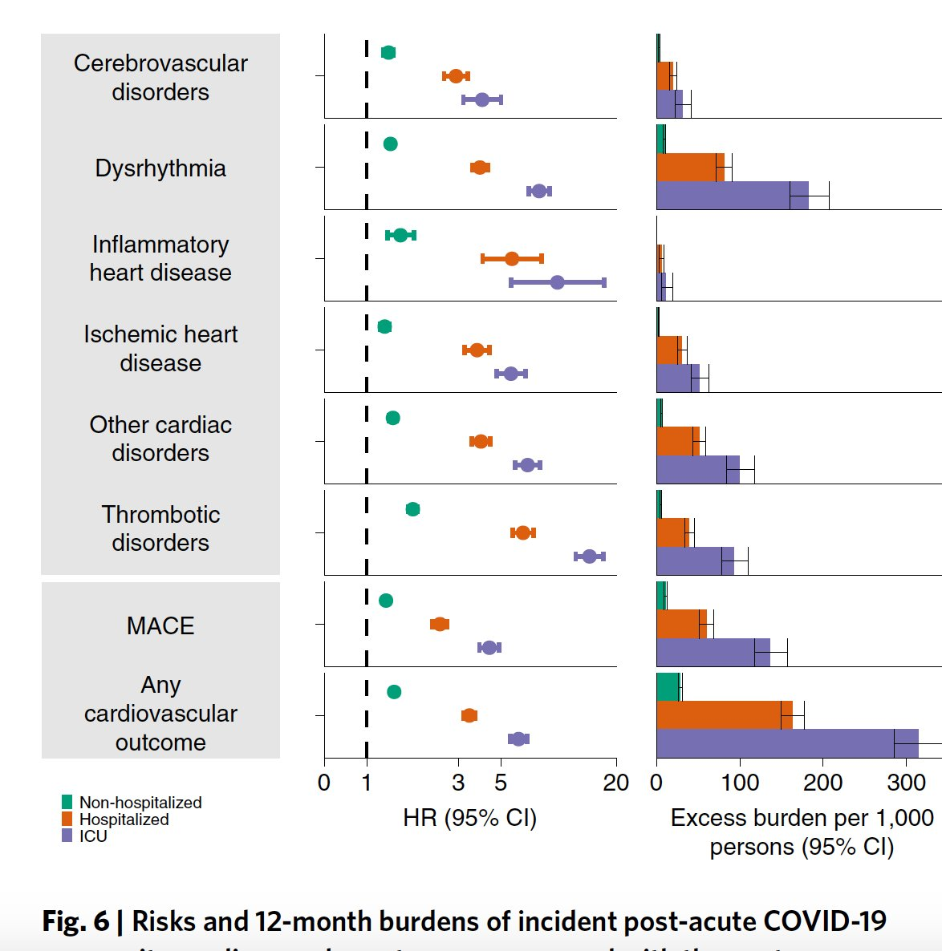

From <https://www.nature.com/articles/s41591-022-01689-3>

**References**

**useful** Ref <https://www.sciencedirect.com/science/article/pii/S0264410X21002619?via%3Dihub>

Our approach is the most robust of 3 approaches considered by UKHSRA in their report on safety of vaccines in pregnancy , as comparing to pre-pandemic unvaccinated cohorts entail large differences due to pandemic-related changes in maternity and healthcare provision ([https://assets.publishing.service.gov.uk/government/uploads/system/uploads/attachment_data/file/1036033/UKHSA-Covid-19-pregnancy-surveillance-protocol.pdf p14](https://assets.publishing.service.gov.uk/government/uploads/system/uploads/attachment_data/file/1036033/UKHSA-Covid-19-pregnancy-surveillance-protocol.pdf%20%20p14))

…despite experts reassuring women that vaccinations are in principle safe for their fertility (<https://www.bbc.co.uk/news/health-56012529>, <https://www.nature.com/articles/s41577-021-00525-y>), and issuing calls for rolling out vaccines to pregnant women globally, including their prioritisation as more vulnerable to COVID-10 (<https://www.thelancet.com/journals/lancet/article/PIIS0140-6736(21)00146-X/fulltext> ). In the UK, the majority of pregnant women did not receive the vaccine in the period xx-xx (data??), whereas women of reproductive age were more likely to be vaccinated outside of the pregnancy (x% vaccinated in period…). Several (?) studies showed more vaccine hesitancy regarding receiving the vaccine during compared to outside of pregnancy due to worries about impact on the pregnancy and the baby (eg <https://bmcpregnancychildbirth.biomedcentral.com/articles/10.1186/s12884-021-04321-3>, any other?). However, a January 2021 ‘Find out Now’ survey of attitudes towards the vaccine found that women aged 18-34 had the highest vaccine refusal rate at 27%, with many citing worries about fertility and pregnancies (ref <https://findoutnow.co.uk/blog/we-found-out-over-65s-vaccine-uptake-would-be-better/> ). (how does this compare with actual uptake data?)

Safety data for vaccination in pregnancy are available from an EHR record linkage study from Scotland based on 70k+ births, and show no association with adverse pregnancy outcomes. In contract, COVID infection in pregnancy was associated with x4 increased risk for stillbirth or neonatal death, and x2 increased risk of preterm birth (<https://www.nature.com/articles/s41591-021-01666-2.pdf>)

Based on HER linkages from 8 healthcare systems in the US (Vaccine safety datalink), there was no evidence of vaccines being associated with preterm birth or SGA (only live births included) - <https://www.cdc.gov/mmwr/volumes/71/wr/mm7101e1.htm#T1_down>

During COVID-19 infection in pregnancy, the placenta’s inflammatory response involves both maternal and foetal cells, although there was no direct evidence of the virus in placental tissue (<https://www.nature.com/articles/s41467-021-27745-z?utm_source=twitter&utm_medium=social&utm_content=organic&utm_campaign=CONR_JRNLS_AWA1_GL_SCON_SMEDA_NATUREPORTFOLIO> ) – what are the consequences of this? And does it mean placental infection is rare (ie not represented in this sample of 24 women?)

Evidence on both infection and vaccine effects in pregnancy (see living review), mostly from observational studies although ongoing trial evaluating effects of vaccines in pregnancy (<https://vaccine.ac.uk/research/preg-cov-trial/?_cldee=bHVpc2EuenVjY29sb0BnbWFpbC5jb20%3d&recipientid=lead-fbd05b865974ec1189410022481ad86b-a9ce626d764b4609a82cebce55a18eaa&esid=099ad499-977e-ec11-8d21-00224800d5fe> ). However limited evidence on effects on viability of pregnancy (eg fetal loss especially in early pregnancy, and total live births as a population measure of fertility). (except Norwegian paper on miscarriages by Magnus M).

Also little or no evidence on effects of infection/vaccination on FUTURE pregnancies (CHECK).

Other methods for identification of ongoing pregnancies based on EHRs in England (CPRD GOLD) - <https://onlinelibrary.wiley.com/doi/full/10.1002/pds.4811>. Good agreement with HES APC maternity file for hospital births, also estimates of hospital-based miscarriages ~12/13% similar to ONS estimates. Could use for future analyses? (eg are they working on validating this against MSDS?)

Vaccine safety datalink latest data https://www.cdc.gov/mmwr/volumes/71/wr/mm7101e1.htm#T1_down

Different outcomes by ethnicity:

Report on Ethnic inequalities in healthcare including maternity and neonatal care <https://www.nhsrho.org/publications/ethnic-inequalities-in-healthcare-a-rapid-evidence-review/>