Human Motion Recognition Using IMUs — Project #232
MATLAB - Simulink Challenge Project Hub
Author: Bhogala Srika

Problem Statement
Human Activity Recognition (HAR) using body-worn inertial measurement units (IMUs) enables automatic detection of physical activities such as walking, sitting, or climbing stairs from accelerometer and gyroscope signals. This capability has direct applications in wearable consumer devices, healthcare monitoring (e.g., detecting deteriorating gait due to medical conditions), and workplace safety (e.g., detecting movements likely to cause injury). This project implements a deep learning pipeline that classifies six activity types from raw smartphone IMU signals.

Dataset
This project uses the UCI Human Activity Recognition Using Smartphones Dataset (Anguita et al., 2013). It contains recordings from 30 subjects performing six activities — walking, walking upstairs, walking downstairs, sitting, standing, and laying — while carrying a waist-mounted smartphone. Data was collected using the phone's embedded accelerometer and gyroscope at a 50Hz sampling rate. The signals were pre-segmented into fixed-width windows of 128 readings (2.56 seconds) with 50% overlap. Nine inertial signal channels are provided per window: body acceleration, body angular velocity (gyroscope), and total acceleration, each measured along the x, y, and z axes.

Methodology
This project applies a 1D Convolutional Neural Network (1D-CNN) to classify human activities from smartphone IMU signals, following the general approach of Kiranyaz et al. (2015), who demonstrated 1D-CNNs as effective for extracting temporal patterns directly from raw time-series sensor data without hand-crafted features. The network takes all 9 inertial signal channels (body acceleration, body gyroscope, and total acceleration, each along x/y/z) as multi-channel input sequences of length 128. Two convolutional blocks (convolution + batch normalization + ReLU) extract local temporal features, followed by global average pooling to reduce dimensionality and limit overfitting, and fully connected layers that map features to the six activity classes (walking, walking upstairs, walking downstairs, sitting, standing, laying). Training used stochastic gradient descent with momentum (SGDM), a learning rate of 0.01, batch size 64, over 15 epochs. Input features were normalized channel-wise using training-set mean and standard deviation, applied identically to the test set to prevent data leakage.

Model Architecture
Input: 9-channel sequence, length 128 (sequenceInputLayer)
↓
1D Convolution (32 filters, kernel size 3) → Batch Normalization → ReLU
↓
1D Convolution (64 filters, kernel size 3) → Batch Normalization → ReLU
↓
Max Pooling (pool size 2) → Dropout (0.2)
↓
Global Average Pooling
↓
Fully Connected (32 units) → ReLU
↓
Fully Connected (6 units) → Softmax
↓
Output: 6-class activity prediction

Results
The model was trained for 15 epochs using SGDM optimization (learning rate 0.01, batch size 64) on a single CPU, completing in approximately 4-7 minutes. Final test accuracy reached 91.92%.

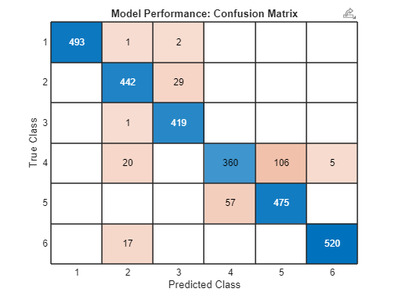

The confusion matrix shows the model performs strongly on most activity classes, with the main confusion occurring between adjacent or similar activities such as sitting vs. standing, and walking upstairs vs. walking downstairs — a pattern commonly seen in HAR literature, since these activity pairs produce visually similar accelerometer signatures.

Limitations & Future Work
- Training was conducted on a single CPU; GPU training could allow deeper architectures or more epochs within the same time budget.
- The model was evaluated only on the UCI HAR dataset; testing on other HAR datasets (e.g., HARTH) would help assess generalization.
- Future work could explore recurrent (LSTM) or attention-based (Transformer/Conformer) architectures, which have shown higher accuracy (95%+) on similar HAR benchmarks in recent literature.
- Cross-subject validation (training on some subjects, testing on entirely unseen subjects) was not separately analyzed beyond the dataset's built-in train/test split.

References
1. Anguita, D., et al. (2013). "A Public Domain Dataset for Human Activity Recognition Using Smartphones." ESANN 2013.
2. Kiranyaz, S., et al. (2015). "Real-Time Patient-Specific ECG Classification by 1D Convolutional Neural Networks." IEEE Transactions on Biomedical Engineering.
3. MathWorks, "Deep Learning Toolbox," [Online]. Available: https://www.mathworks.com/help/deeplearning/

