LAB 4 – Implementation of Branching, Merging & Workflow in Kaggle
Scholar No.: 25215011127

OBJECTIVE
To implement and demonstrate branching, merging, and structured workflow management in Kaggle using the USA Housing dataset.

DATASET DESCRIPTION
Dataset: USA Housing
Source: Kaggle Dataset
File Used: /kaggle/input/usa-housing/USA_Housing.csv
Problem Type: Regression
Target Variable: Price

TOOLS AND LIBRARIES USED
- Kaggle Notebook Environment
- Python
- Pandas
- NumPy
- Scikit-learn
- Linear Regression
- Random Forest Regressor

METHODOLOGY
- Base Setup: Dataset loading and exploration (Main Branch).
- Preprocessing Branch: Data cleaning, feature selection, scaling.
- Model Branch 1: Linear Regression training and evaluation.
- Model Branch 2: Random Forest training and evaluation.
- Merge Stage: Compare R² scores and select best model.

FLOWCHART
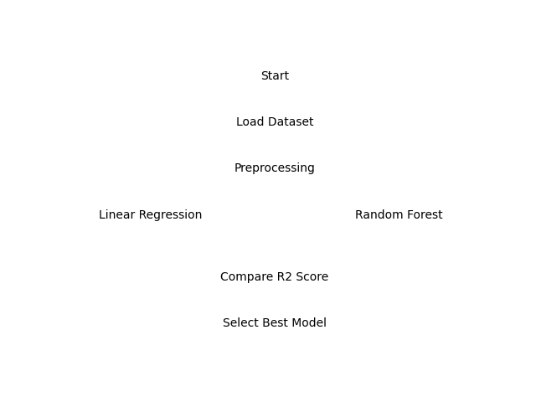

RESULT
Linear Regression R² Score: ~0.92
Random Forest R² Score: ~0.89
Best Performing Model: Linear Regression

CONCLUSION
Branching and merging concepts were successfully simulated in Kaggle using a modular notebook structure. Multiple regression models were developed independently and merged into a final optimized workflow. This demonstrates structured experiment tracking and workflow management within Kaggle.

