|  |
| --- |
| **Front End Engineering-II**    Project Report  Semester-III (Batch-2023)    E-Commerce Shopping(Clothing)                    **Supervised By: Submitted By:**  Mr. Sachin Garg Arman Kalra,2310990126  Archi,2310990124  Akanksha,2310990100  Bhumi Sachdeva, 2310990145      **Department of Computer Science and Engineering**  **Chitkara University Institute of Engineering & Technology, Chitkara University, Punjab** |

**ABSTRACT:**

**Overview**: This e-commerce clothing website aims to provide a seamless shopping experience for fashion enthusiasts by offering a diverse range of clothing options, personalized recommendations, and a user-friendly interface. The platform caters to various demographics, ensuring inclusivity and accessibility for all users.

**Key Features:**

Wide Selection: A vast inventory that includes casual wear, formal attire, activewear, and accessories for men, women, and children.

User -Friendly Interface: Intuitive navigation with advanced filtering options to help customers find products quickly.

Personalized Recommendations: Utilizing AI algorithms to suggest items based on user behavior and preferences.

Secure Payment Gateway: Multiple payment options with robust security measures to protect customer information.

Fast Shipping and Easy Returns: Efficient logistics to ensure timely deliveries and a hasslefree return process.

Target Audience: The website targets fashion-conscious individuals aged 18-45 who seek convenience and variety in their shopping experience.

**Conclusion:** By combining cutting-edge technology with a passion for fashion, this ecommerce clothing website aims to redefine the online shopping landscape, making it easier and more enjoyable for customers to discover and purchase their favorite styles.

**Table Of Content:**

1. Introduction
2. Problem Definition and Requirements- 3. Hardware requirements/data sets (1-2 pages)
3. Proposed Design / Methodology
4. Algorithms used
5. Results- screenshots/metrics, etc.

**1. Introduction:**

**1.1 Background:**

An e-commerce website, specifically one dedicated to clothing, serves as a virtual showroom for fashion enthusiasts. It offers a convenient platform for customers to browse through a wide variety of clothing items, compare styles, and make purchases online. However, creating a successful e-commerce website for clothing comes with unique challenges, including:

* + - **Visual appeal:** Clothing is highly visual, and a well-designed website is essential to showcase products effectively. High-quality product images, clear descriptions, and a visually appealing layout are crucial.

* + - **Product categorization:** Organizing a vast clothing catalog into meaningful categories and subcategories is essential for easy navigation and customer satisfaction.

* + - **Size and fit:** Ensuring accurate sizing information and providing helpful fit guides is crucial to minimize returns and enhance customer satisfaction.

* + - **Mobile optimization:** Given the increasing use of smartphones for shopping, a mobile- friendly website is essential for reaching a wider audience.

**1.2 Objectives:**

The primary objectives of this e-commerce clothing website project were:

* + - **Create a visually appealing and user-friendly interface:** Design a website that showcases clothing items effectively and is easy to navigate, providing a positive user experience.
    - **Develop a functional online store:** Implement features such as product listings, shopping carts, and a secure checkout process, tailored to the specific needs of a clothing e- commerce website.
    - **Ensure website responsiveness:** Optimize the website for various devices (desktop, tablet, mobile) to cater to a wider audience and provide a seamless shopping experience across different platforms.
    - **Integrate essential functionalities:** Incorporate features like search, filtering, and product recommendations specifically designed for clothing e-commerce, such as size filters, color filters, and outfit suggestions.
    - **Provide detailed product information:** Include high-quality product images, accurate descriptions, and sizing guides to help customers make informed purchasing decisions.
    - **Offer a personalized shopping experience:** Implement features like saved items, wishlists, and personalized recommendations to enhance customer engagement and loyalty.

**1.3 Significance:**

An e-commerce clothing website offers numerous benefits, including:

* **Increased accessibility:** It can reach a global customer base, transcending geographical limitations. 

* **24/7 availability:** Online stores are open around the clock, providing convenience for customers. 

* **Cost-effective:** It can reduce overhead costs associated with physical stores. 

* **Data-driven insights:** E-commerce platforms can collect valuable data on customer behavior, enabling businesses to make informed decisions and tailor their offerings to specific preferences. 

1. **Problem Definition and Requirements:**

* 1. **Problem Statement:**

In developing this e-commerce clothing website, several key challenges were addressed:

* + - **Responsiveness:** Designing the website to adapt to different screen sizes and devices (desktop, tablet, mobile) to provide a consistent and optimal experience across various platforms. 
    - **Product Information:** Providing accurate and comprehensive product information, including high-quality images, detailed descriptions, and sizing guides, to help customers make informed purchasing decisions. 
    - **Performance Optimization:** Ensuring the website loads quickly and performs efficiently, even with a large number of products and images, to enhance user satisfaction and minimize bounce rates. 

* 1. **Software Requirements:**

The following tools and technologies were used in the development of this e-commerce clothing website:

* + - **HTML:** The fundamental building block of the website, used to structure the content and layout. 
    - **CSS:** Used to style the website, including colors, fonts, spacing, and overall appearance. 

* + - **Bootstrap:** A popular front-end framework that provides pre-built components and responsive layouts, accelerating development and ensuring cross-browser compatibility. 
    - **JavaScript:** Used for dynamic elements, such as interactive features, animations, and handling user interactions. 
    - **Image Editing Software:** Used to prepare images for the website like canvas etc, including resizing, optimizing, and applying consistent styles. 

* 1. **Hardware Requirements:**

For users to access the website, the following minimum system requirements are recommended:

* + - **Browser:** A modern web browser such as Google Chrome, Mozilla Firefox, Safari, or Microsoft Edge. 
    - **Internet Connection:** A stable internet connection with a minimum speed of 1 Mbps. 

* + - **Device:** A computer, tablet, or smartphone with a screen resolution of at least 1024x768 pixels. 
  1. **Data Sets:**

While a real-world e-commerce website would typically use a database to store product information, this project utilized sample data for demonstration purposes. The sample data included:

* + - **Product Listings:** A collection of sample clothing items with descriptions, images, prices, and sizes. 
    - **Category Information:** A hierarchy of categories and subcategories to organize the product catalog. 
    - **User Data:** Sample user profiles, including login credentials and shipping information. 

1. **Proposed Design / Methodology:**

* 1. **Overview:**

The design approach for this e-commerce clothing website focused on creating a user-friendly and visually appealing interface. Wireframes and mockups were used to visualize the layout and structure of the website, ensuring a clear and intuitive navigation flow.

* 1. **HTML Structure:**

The HTML structure of the website was organized into logical sections, using semantic elements to improve accessibility and maintainability. Key elements included:

* + - Header: Contains the website logo, navigation menu, search bar, and shopping cart. 

* + - Main Content: Displays the product listings, category navigation, product details, and related items. 
    - Footer: Includes contact information, social media links, and sitemap. 

The HTML elements were nested within each other to create a hierarchical structure, ensuring proper rendering and organization of the content.

* 1. **CSS Styling:**

CSS was used to style the website, defining the appearance of elements such as colors, fonts, spacing, and layout. Key CSS techniques employed included:

* + - CSS Reset: To normalize browser differences and ensure a consistent baseline for styling. 

* + - Custom Styles: Creating custom CSS rules to tailor the website's appearance to specific design requirements. 
    - Media Queries: Ensuring the website is responsive by using media queries to adjust the layout and styles based on screen size. 

* 1. **Bootstrap Components:**

Bootstrap's pre-built components were extensively used to streamline development and create a consistent user interface. Some of the key components utilized include:

* + - **Grid System:** To create responsive layouts and organize content across different screen sizes. 
    - **Navbar:** For the navigation menu, providing a customizable and responsive navigation bar. 
    - **Cards:** To display product listings, featuring images, titles, descriptions, and prices. 

* + - **Buttons:** For calls to action, such as "Add to Cart" and "Buy Now." 

* + - **Forms:** For user input, including search forms, login forms, and checkout forms. 

* + - **Modals:** To display pop-up windows for additional information or user interactions. 

1. **Results:**

* 1. **Screenshots:**

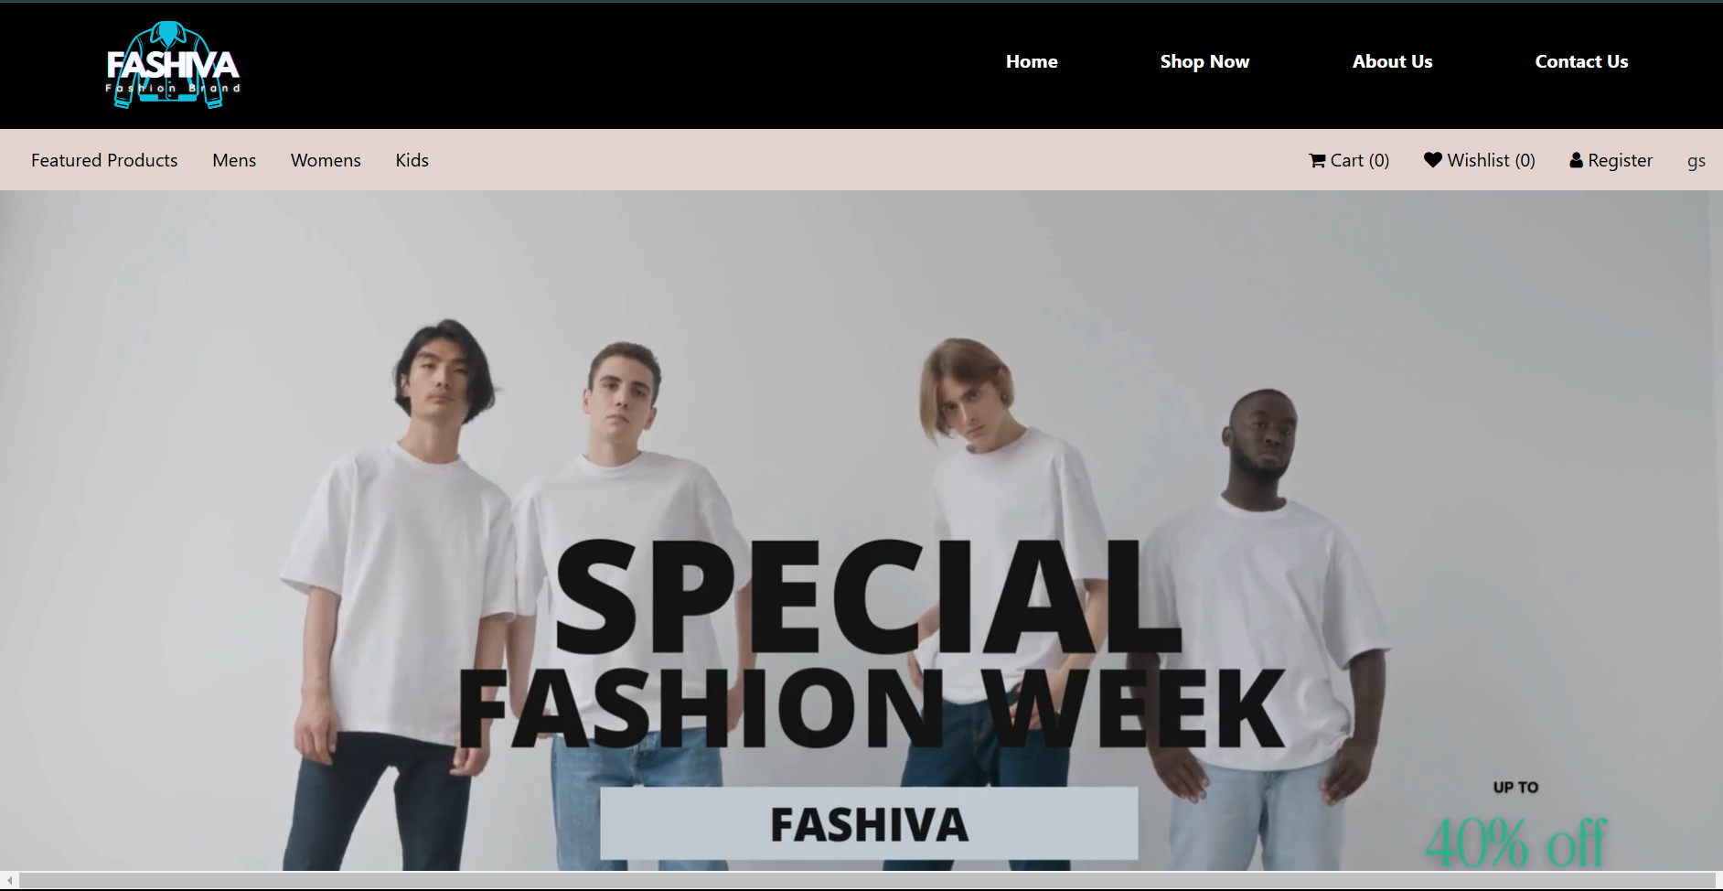

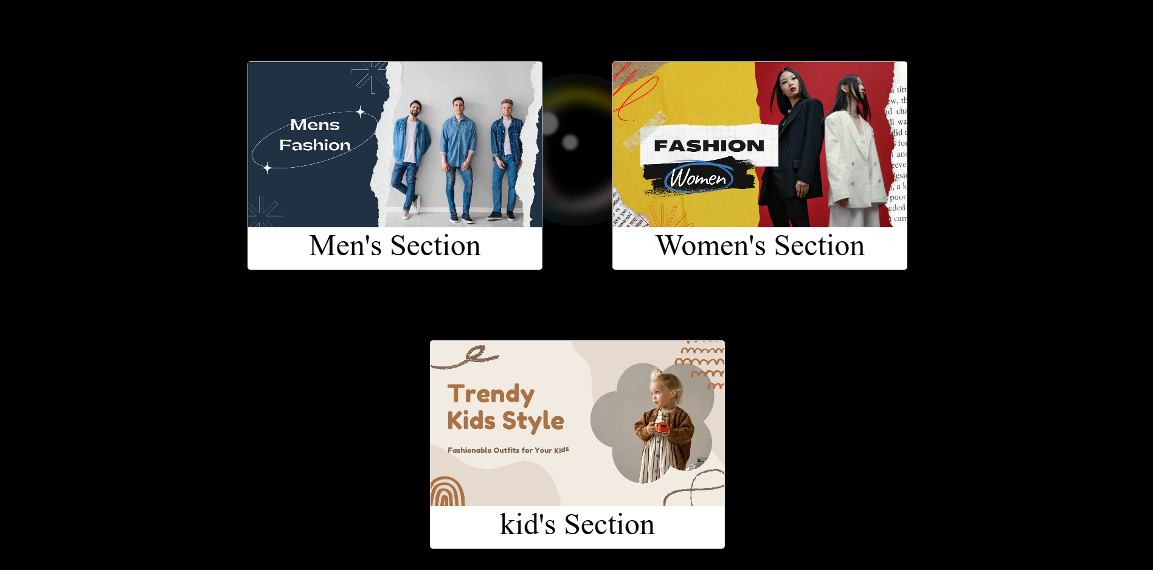

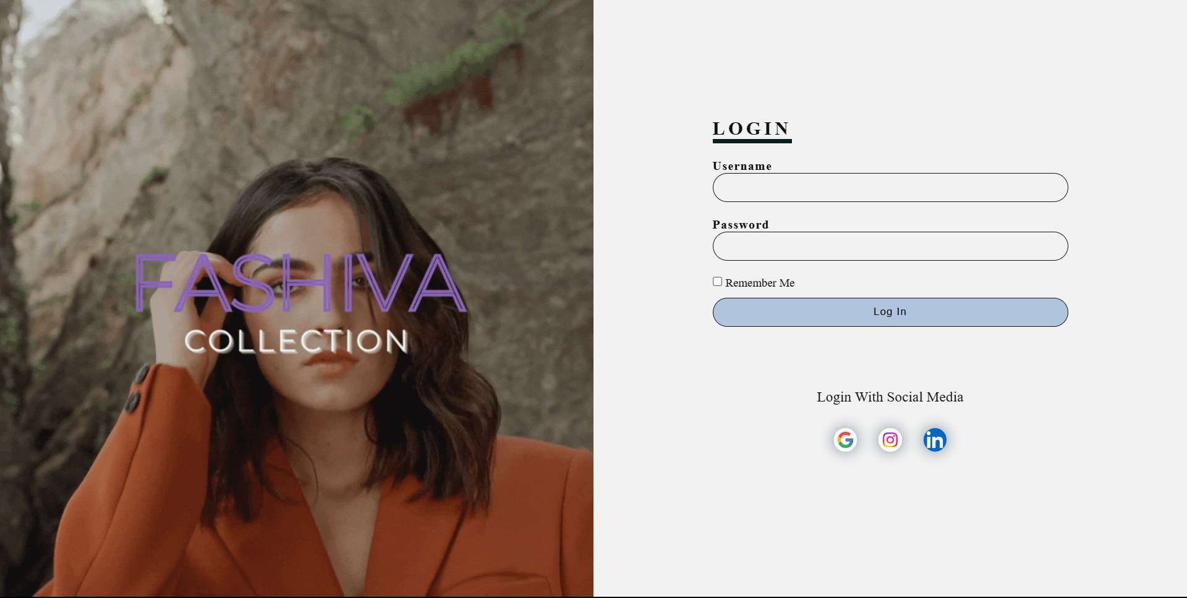



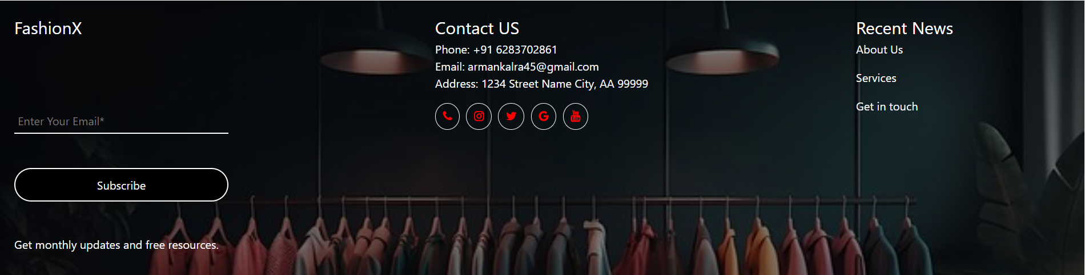

* 1. **Challenges and Solutions:**

During the development of this e-commerce clothing website, several challenges were encountered and addressed:

* + - **Product Image Optimization:** Ensuring high-quality product images that load quickly and enhance the visual appeal of the website. This was achieved by optimizing image sizes and formats, using compression techniques, and implementing lazy loading for images that are not immediately visible. 
    - **Mobile Responsiveness:** Ensuring the website adapts seamlessly to different screen sizes and devices. This was addressed by effectively utilizing Bootstrap's responsive grid system and media queries. Bootstrap's grid system provides a flexible and responsive layout that automatically adjusts to the screen width, ensuring a consistent experience across all devices. Additionally, media queries were used to apply specific styles and adjustments based on different screen sizes, further enhancing the website's responsiveness. 

1. **Conclusion:**

This report provides a comprehensive overview of the development process and outcomes of the e-commerce clothing website project. The project focused on creating a visually appealing, user- friendly, and responsive online store for showcasing and selling clothing products. Key aspects covered in the report include the project's objectives, design approach, development methodology, and results.

* 1. **Achievements:**

The e-commerce clothing website successfully achieved the following key accomplishments:

* + - **Visually appealing and user-friendly interface:** The website features a modern and intuitive design, showcasing clothing products effectively and providing a positive user experience. 
    - **Responsive design:** The website is optimized for different screen sizes and devices, ensuring a consistent and seamless experience across various platforms. 
    - **Functional online store:** The website includes essential features such as product listings, shopping carts, and a secure checkout process, enabling users to browse, select, and purchase clothing items conveniently. 
    - **Product information and imagery:** High-quality product images and detailed descriptions are provided to help customers make informed purchasing decisions. 

* 1. **Future Work:**

While the project has achieved significant milestones, there are opportunities for future improvements and extensions:

* + - **Enhanced product search functionality:** Implementing advanced search features, such as natural language search and product recommendations, to improve product discoverability and personalization. 
    - **Integration with social media**: Integrating social media platforms to enable social sharing, user reviews, and community engagement. 
    - **Mobile app development:** Developing a dedicated mobile app to provide a more immersive and personalized shopping experience. 

.