INVENTION DISCLOSURE FORM

S.No | DESCRIPTION
1 | TITLE
1 | Autonomous Medical Supply Delivery Robot for Hospitals
2 | EXISTING PROBLEM
2 | In hospitals, nurses and helpers walk medicines and supplies between the store or pharmacy and the wards. This takes time that belongs to patients, is slow and uneven at peak hours and during staff shortages, and lets the same people carry infection between wards, especially in outbreaks.  Existing delivery robots do not suit most hospitals. Commercial robots use map-based navigation and are proprietary and very costly. Camera and AI robots need a computer, training data and skilled set-up. Simple line followers follow one fixed route and cannot choose between several rooms. Low-cost robots usually sense obstacles only ahead, leaving the return journey unprotected.  Hospitals therefore lack an affordable, simple robot that staff can send to a chosen room and call back, without costly mapping, cameras or SLAM, and that is safe in both directions.
3 | EXISTING TECHNOLOGIES
3 | • Manual delivery: staff carry items; slow, uses nurse time, infection risk.  • Commercial robots (HOSPI, TUG): map-based navigation; proprietary and very costly.  • Camera / AI robots (YOLOv5, ROS2): camera reads room labels; need a computer and training.  • Basic line followers: follow one taped route; no room choice.
4 | INVENTION | Product | System |  | Method
5 | CURRENT STAGE | Idea |  | PoC | Product
6 | INVENTIVE STEP
6 | The invention is a low-cost autonomous delivery robot that finds a room selected by the nurse by counting floor columns with a single infrared sensor, turns into the room by a rule based on the room number, remembers the room, and returns home on command, with obstacle protection in both directions. It needs no camera, map, SLAM or computer.  Components and construction  1. Chassis: two-tier lightweight chassis with an enclosed supply compartment.  2. Drive: two rear 12 V DC gear motors (differential drive) and a front ball-transfer wheel that is passive and omnidirectional and only supports the load. Motors turning in the same direction and speed give straight or reverse motion; in opposite directions they rotate the robot on the spot.  3. Controller: Arduino UNO with a dual-channel H-bridge driver giving direction and PWM speed control.  4. Path sensor: one reflective infrared sensor facing the floor, digital output, which counts the tape columns on the floor.  5. Obstacle sensors: two infrared sensors, one at the front and one at the back, digital output.  6. Room selector: seven push buttons (rooms 1 to 6 and Home). A 16x2 I2C LCD shows the room, column count and status.  7. Power: rechargeable battery for the motors and electronics.  Inventive features  A. Column-count navigation: one IR sensor counts floor columns; the column number sets the distance to the room. This replaces a camera, SLAM or a sensor array.  B. Room-to-turn rule: each column serves one left room and one right room. At the selected column the robot turns right for an odd room and left for an even room. This replaces map-based path planning.  C. Stored-room return: the controller stores the selected room. On the Home command the robot reverses and takes the opposite turn back. This replaces a stored map and route planner.  D. Two-way obstacle guard: front and back IR sensors stop the robot for an obstacle in outward and return travel, and it resumes when the way is clear. This replaces forward-only sensing.  Technical effect  The robot reaches a chosen room and returns with no mapping, camera or computer. Set-up needs only tape columns on the floor, and the estimated cost is about Rs. 2,870. Novelty lies in combining features A, B and C, with D, in one hospital delivery robot.
7 | METHOD OF WORKING
7 | 1. The nurse presses a room switch (rooms 1 to 6) on the selector. The LCD shows the selected room, and the supplies are placed in the enclosed compartment.  2. The robot drives forward along the corridor. The path IR sensor counts each floor column it passes, and the LCD shows the column count.  3. At the column of the selected room, the controller stops forward motion and applies the room-to-turn rule: an odd room means a right turn and an even room means a left turn. Rooms 1 and 2 are on column 1, rooms 3 and 4 on column 2, and rooms 5 and 6 on column 3. The two motors run in opposite directions so the robot rotates on the spot into the room.  4. The robot enters the room and delivers the supplies. The controller stores the selected room.  5. When the Home switch is pressed, the robot reverses out and takes the opposite turn back, then returns to its starting point.  6. Throughout, the front and back IR sensors watch for obstacles. If one is detected the robot stops, and it resumes as soon as the way is clear. The front sensor protects outward travel and the back sensor protects the return.
8 | KEYWORDS
8 | Hospital delivery robot, column counting, IR navigation, room-turn rule, Arduino
9 | DRAWINGS
9 | 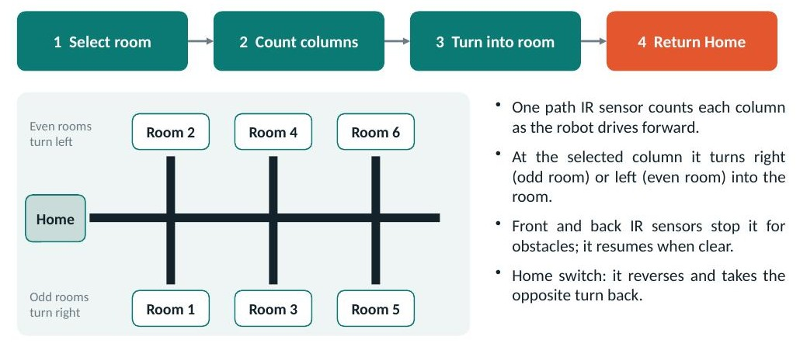  Fig. 1. Working steps and room layout: odd rooms turn right, even rooms turn left, Home at the start  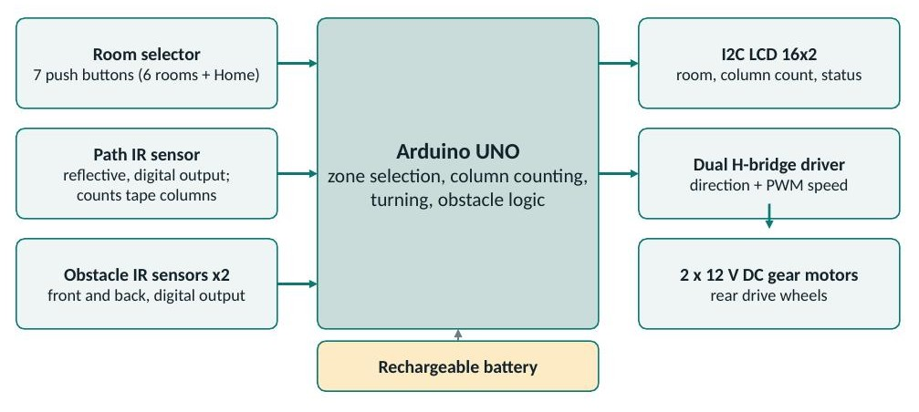  Fig. 2. System architecture (block diagram)  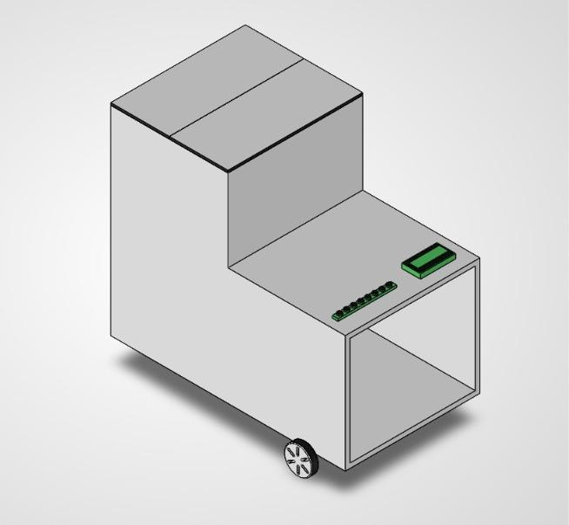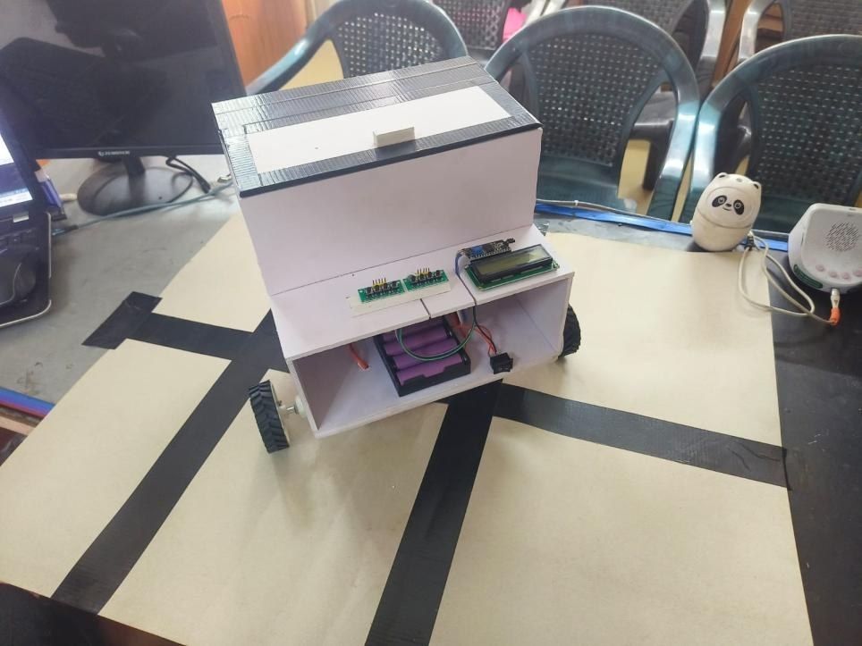  Fig. 3 (left). 3D CAD model. Fig. 4 (right). Prototype, isometric view  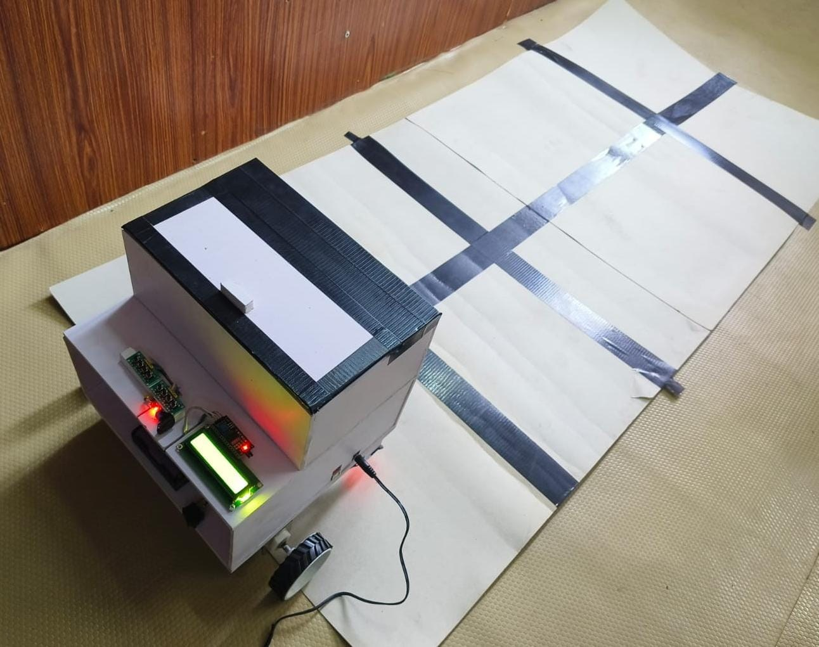  Fig. 5 Prototype on the test track  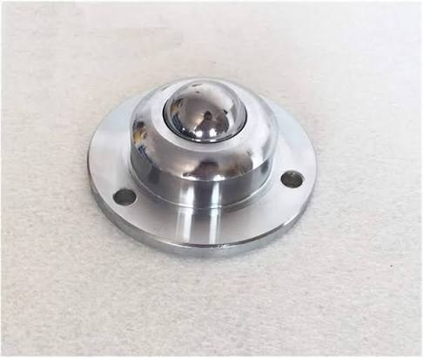  Fig. 6. Ball-transfer wheel used at the front of the robot
10 | ANY OTHER RELEVANT INFORMATION
10 | • Inventors: Bhuvanan M, Dharaneshwaran B, Aravinth R, Ambika B. Mentor: Mr. A. Kamalakkannan. Knowledge Institute of Technology, Salem.  • Working prototype built and tested on a 3-column track: room selection, column detection, room turning, obstacle stop and return Home.  • Estimated cost of the prototype: about Rs. 2,870.  • Other uses: hospitals, laboratories and isolation wards.  • The room can optionally be selected by a website dispatch request in place of the push buttons.

Declaration:

We hereby confirm that the information provided above are final and no further inventive steps beyond this scope will be included in future. Also, we confirm that the above information is true and correct to the best of our knowledge.

Date:
Place: Signature

