PRACTICAL REPORT

**[Course: Intelligent Mobile Development](https://github.com/walkman617/IMD)**

1. To design and develop your own app including the Create, Read, Update, and Delete (CRUD) features

See: Lesson 10: [Storing data with Room](https://google-developer-training.github.io/android-developer-fundamentals-course-concepts-v2/unit-4-saving-user-data/lesson-10-storing-data-with-room/10-1-c-room-livedata-viewmodel/10-1-c-room-livedata-viewmodel.html) ([Part A](https://developer.android.com/codelabs/android-training-livedata-viewmodel#0) and [Part B](https://developer.android.com/codelabs/android-training-room-delete-data#0)).

1. Send your report with the filename “StudentID-Name.doc/pdf” to **shiwx@nankai.edu.cn** before 20 DEC 2020.

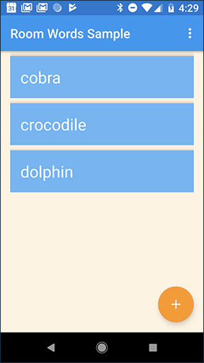 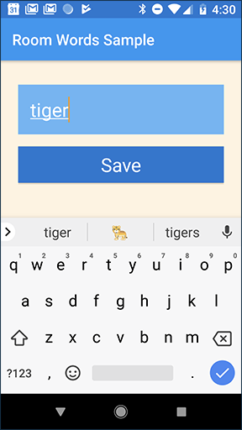 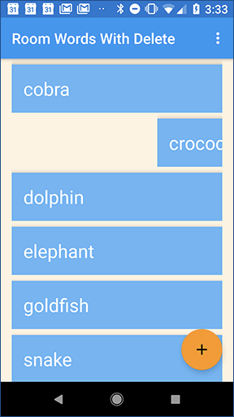

**Name:**

**Student ID:**

**Github:**

01 NOV 2020

# 

# INTRODUCTION

Summarize the main features in your app.

# SOLUTIONS

Summarize the tools and technologies for developing your app.

# DETAILS

Explain the design and implementation details which should include:

1. UI (User Interface) details
2. UE (User Experience) details
3. Database Interaction details

# SCREENSHOTS AND DESCRIPTIONS

|  |  |
| --- | --- |
| Screenshots | Descriptions |
|  |  |
|  |  |
|  |  |

# CONCLUSION

Summarize your project and give future expectations.

# REFERENCES

1. BOOKS, including eBOOKS & REFERENCE BOOKS
2. ARTICLES (JOURNAL, MAGAZINE, & NEWSPAPER)
3. ONLINE SOURCES
4. COURSE MATERIALS