How to create dll and make it available for Robot pull down menu

MS Visual Studio 10 C# example for any CPU

1. Use project template attached (MyAddin) or modify your project basing on data in attached one.
2. Reference to RobotOM should be set to …MyAddin\bin\Debug\Interop.RobotOM.dll

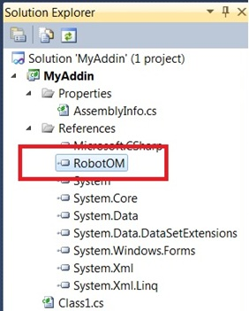

1. Set data: library – to create dll, any CPU

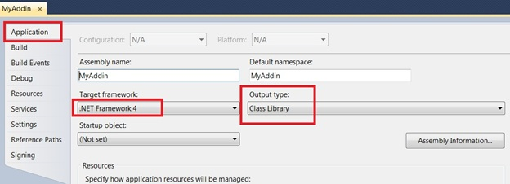

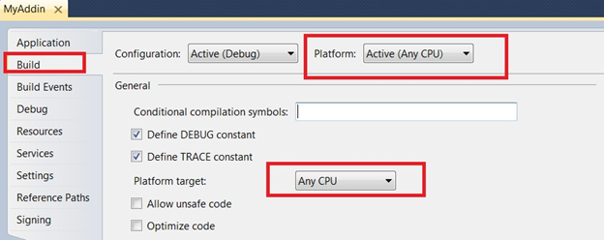

1. Default namespace (check green comments below):

using System;

using System.Collections.Generic;

using System.Linq;

using System.Text;

using RobotOM;

namespace MyAddin

{

[System.Runtime.InteropServices.ComVisibleAttribute(true)]

public class Class1 : IRobotAddIn

{

private IRobotApplication iapp = null;

public bool Connect(RobotApplication robot_app, int add_in_id, bool first_time)

{

iapp = robot_app;

return true;

}

public bool Disconnect()

{

iapp = null;

return true;

}

public void DoCommand(int cmd_id)

{

System.Windows.Forms.MessageBox.Show("Command " + cmd_id.ToString() + " executed.");

// or execute any of your command for eg new Form1().Show();

}

public double GetExpectedVersion()

{

return 10;

}

public int InstallCommands(RobotCmdList cmd_list)

{

cmd_list.New(1, "My Command 1"); // Text in Robot menu

return cmd_list.Count;

}

}

}

1. Create GUID from Tools menu \ GUID

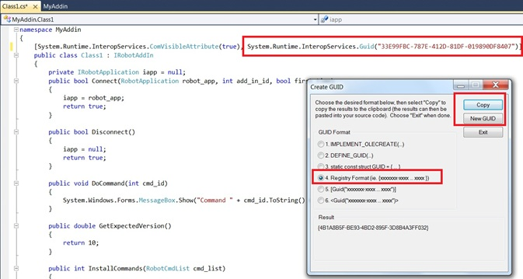

1. After writing \ adding your own code Build Project (F6)
2. Then File menu \ Open \ File -> open created dll file (in our example …\MyAddin\bin\Debug\MyAddin.dll)
3. Add created tlb library to dll (right hand mouse click menu), Resource type should be named as TYPELIB:

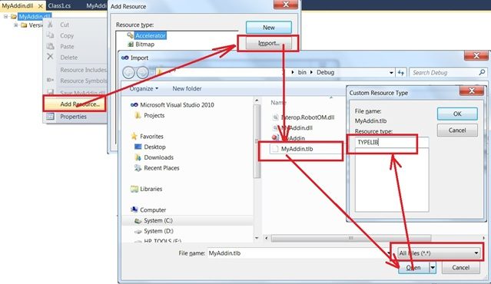

1. Change TYPELIB number onto 1 using Properties (right hand mouse click menu)

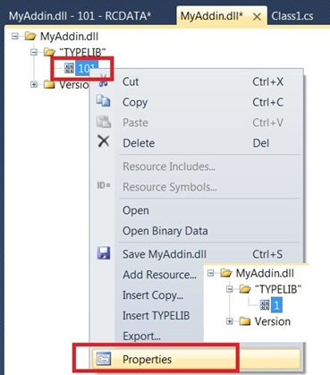

1. Close Visual Studio and save changes to dll file
2. Take \ copy created dll file to any computer you want to use, after locating it in target folder please register it this way:

Open Command Prompt window as Admin

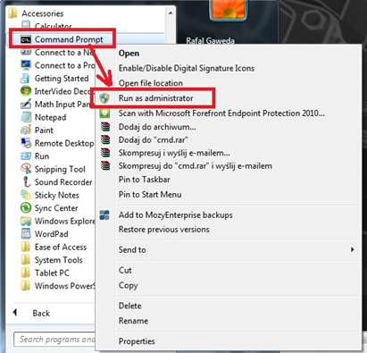

Go to the folder where the file is located

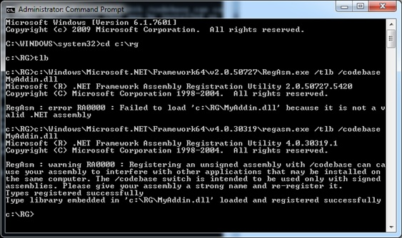

And register it by commands:

c:\Windows\Microsoft.NET\Framework64\v4.0.30319\regasm.exe /tlb /codebase MyAddin.dll

or

c:\Windows\Microsoft.NET\Framework64\v2.0.50727\RegAsm.exe /tlb /codebase MyAddin.dll

or use tlb.bat file attached (modify if needed)

1. Then start robot, select any structure type, then from Add-ins menu use Add-ins Manager
2. Using “…” button show path to this dll file, then press Add button

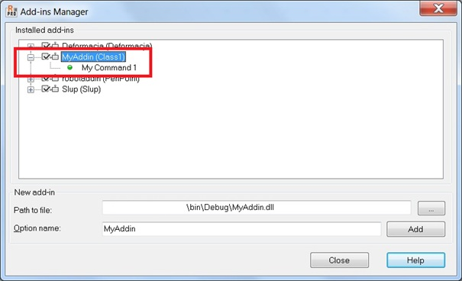

1. After closing manager this option should be available in robot menu:

