Brennan Huber, Matthew Marshall
HW6

Query 1:
SELECT last_name, first_name, email
FROM customer
ORDER BY last_name;
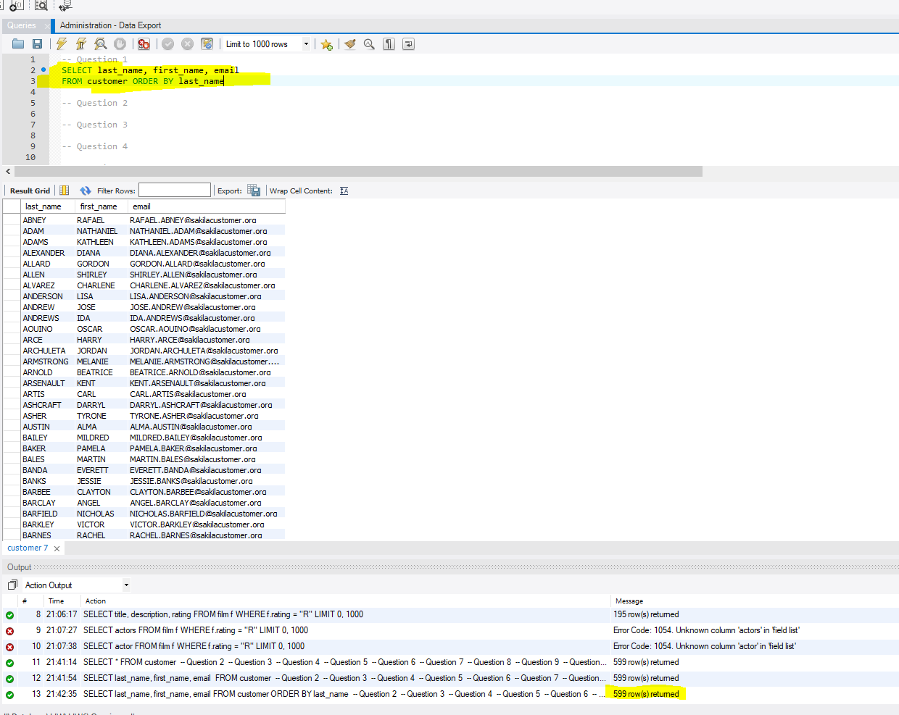
Query 2:
SELECT last_name, first_name, email
FROM customer
WHERE active=0
ORDER BY last_name;
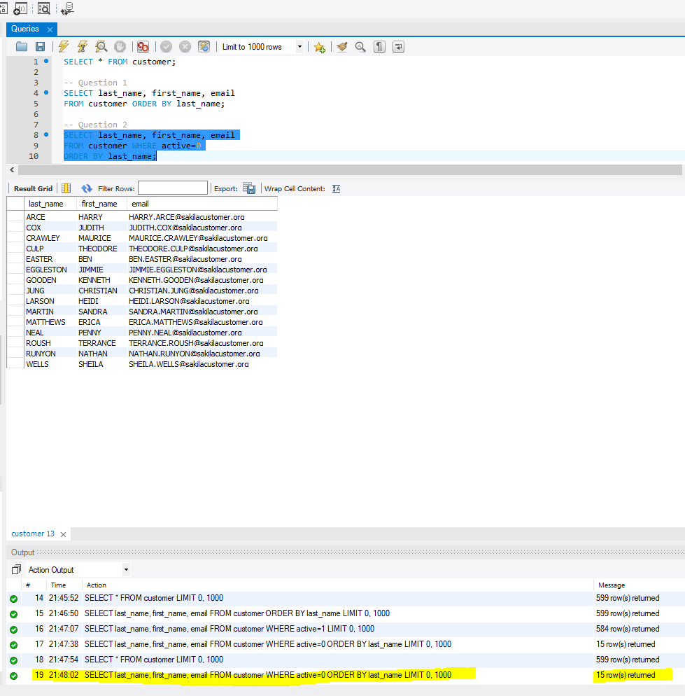
Query 3:
SELECT c.last_name, c.first_name, a.address, a.district, a.phone
FROM customer c, address a
WHERE c.address_id=a.address_id;
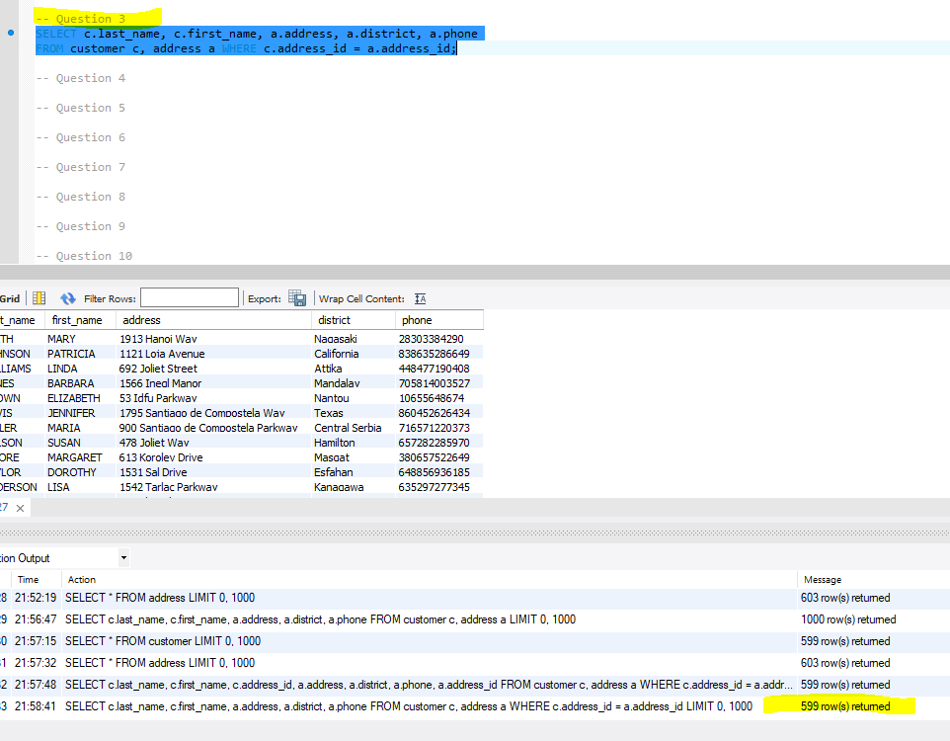
Query 4:
SELECT c.last_name, c.first_name, a.address, a.district, a.phone, ci.city, co.country, a.postal_code
FROM customer c, address a, city ci, country co
WHERE c.active=0
AND c.address_id=a.address_id
AND a.city_id=ci.city_id
AND ci.country_id=co.country_id;
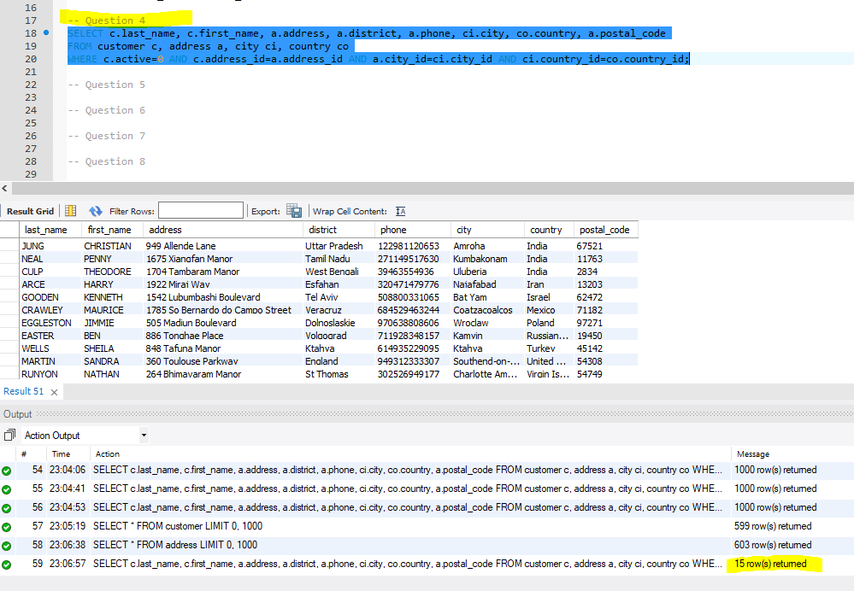
Query 5:
INSERT INTO film (film_id, title, description, release_year, language_id, original_language_id, rental_duration, rental_rate, length, replacement_cost, rating, special_features)
VALUES(1001, '1st Grade FBI Agent', 'An undercover FBI agent must pretend to be a 1st grade teacher to catch the bad guy', 2014, 2, null, 5, 4.99, 123, 20.99, 'PG-13', 'Trailers');

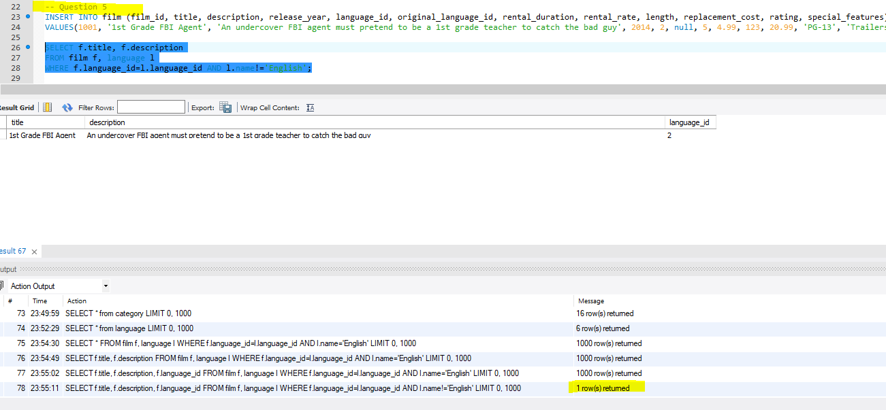
SELECT f.title, f.description
FROM film f, language l
WHERE f.language_id=l.language_id AND l.name!='English';

Query 6:
SELECT f.title, f.rental_rate, l.name
FROM film f, film_category fc, category c, language l
WHERE f.film_id=fc.film_id
AND fc.category_id=c.category_id
AND c.name='Sci-Fi';
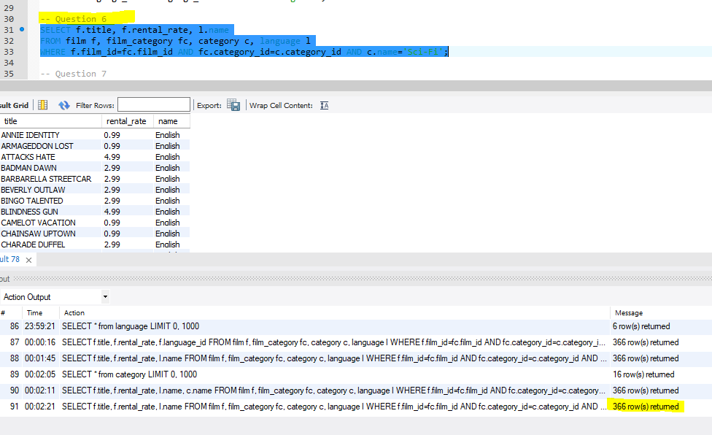

Query 7:
SELECT COUNT(DISTINCT f.title) AS count
FROM film f, category c, film_category fc
WHERE f.film_id=fc.film_id AND fc.category_id=c.category_id AND c.name='Action';

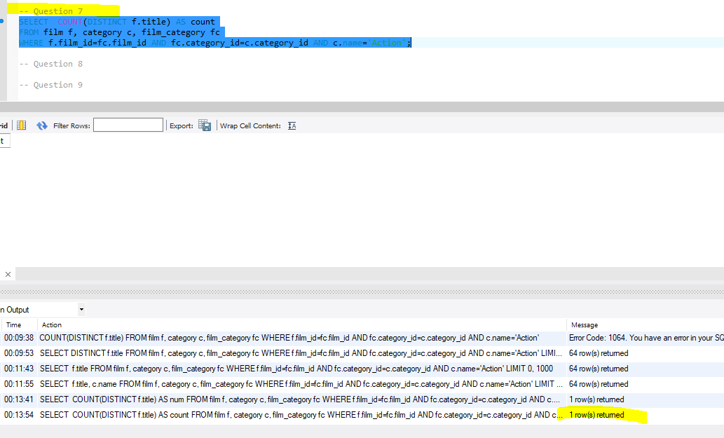

Query 8:
SELECT COUNT(f.title) AS count
FROM film f, category c, film_category fc
WHERE f.film_id=fc.film_id AND fc.category_id=c.category_id AND c.name='Action';
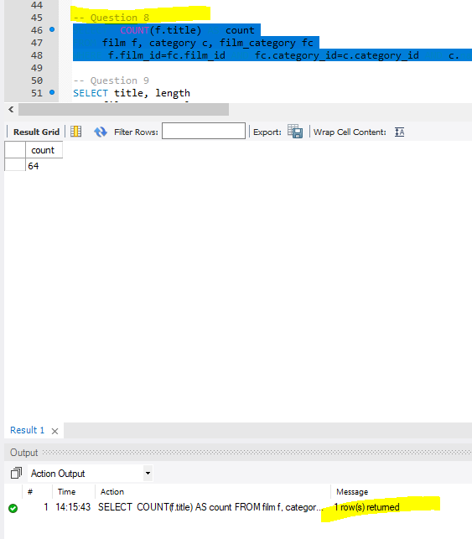
Query 9:
SELECT title, length
FROM film WHERE replacement_cost BETWEEN 15 AND 23;
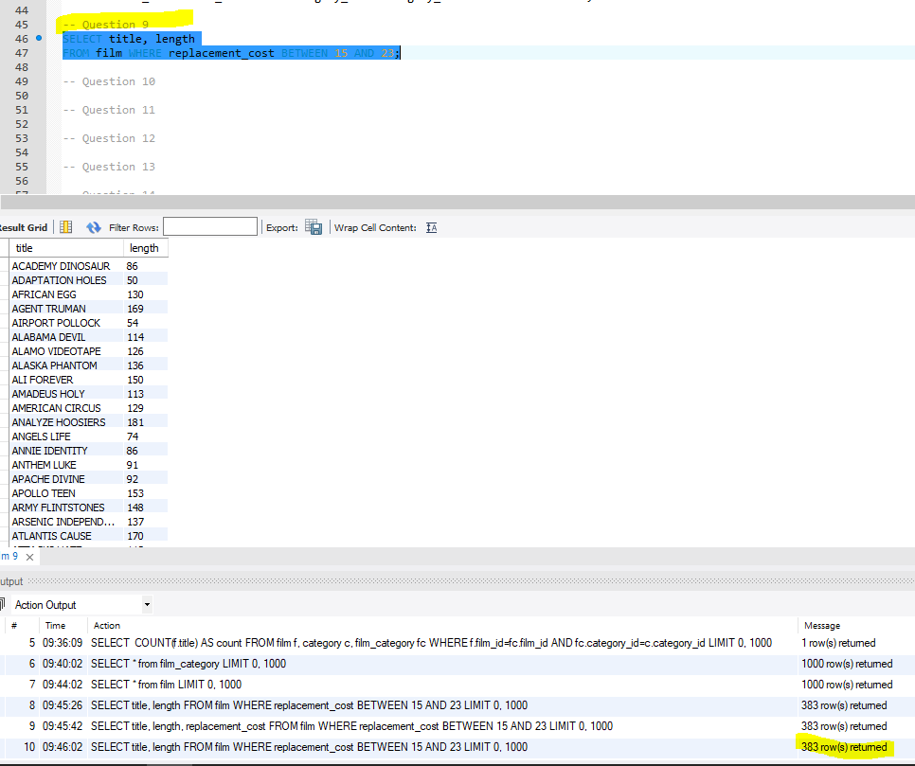
Query 10:
SELECT f.title
FROM film f, category c, film_category fc
WHERE f.film_id=fc.film_id AND fc.category_id=c.category_id AND c.name='Action' AND (f.rating='PG-13' OR f.rating='R' OR f.rating='NC-17');
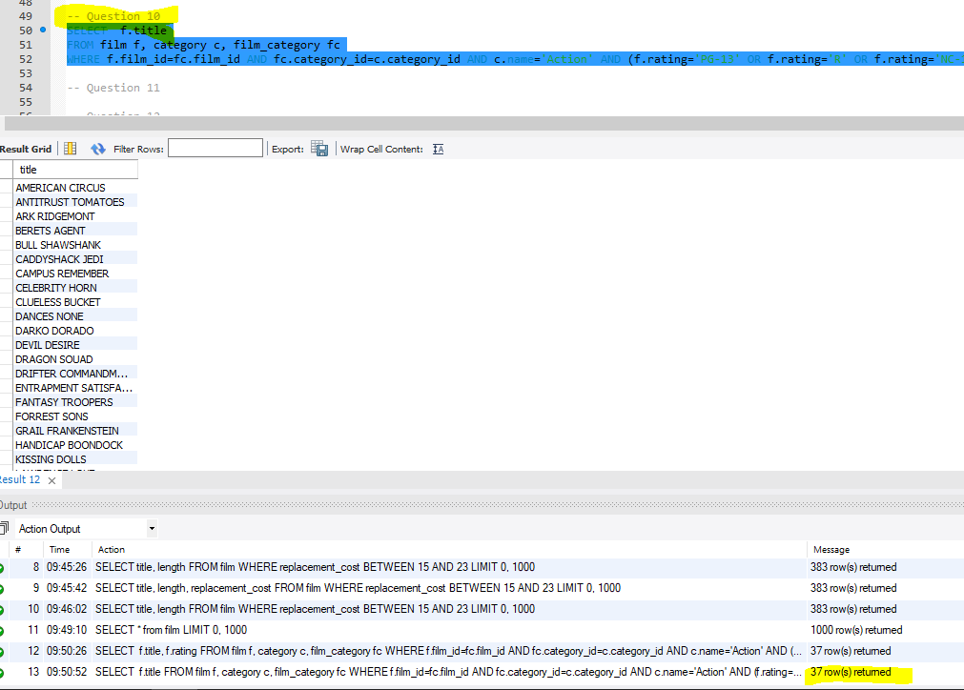
Query 11:
SELECT AVG(f.length) as Average
FROM film f, category c, film_category fc
WHERE f.film_id=fc.film_id AND fc.category_id=c.category_id AND c.name='Children';
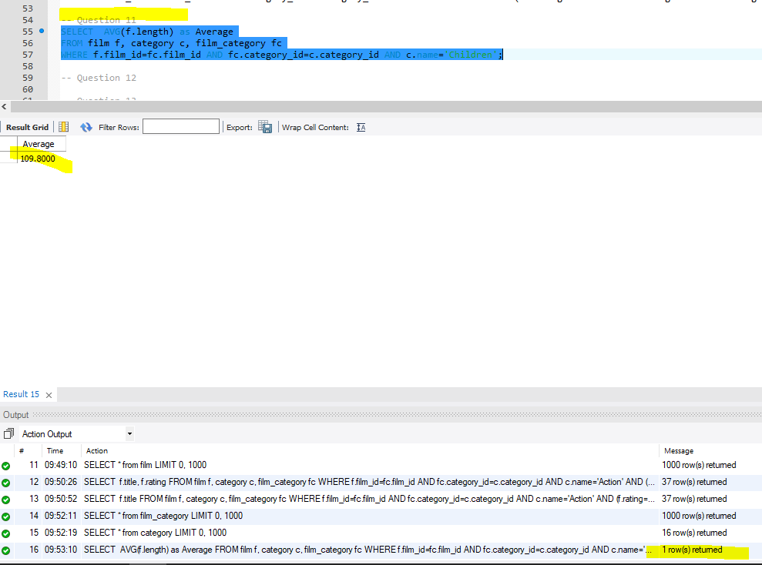
Query 12:
SELECT a.last_name, a.first_name, f.title
FROM actor a, film f, film_category fc, category c, film_actor fa
WHERE f.film_id=fc.film_id AND fc.category_id=c.category_id AND f.film_id=fa.film_id AND fa.actor_id=a.actor_id AND (c.name='Family' OR c.name='Foreign' OR c.name='Horror')
ORDER BY a.last_name;
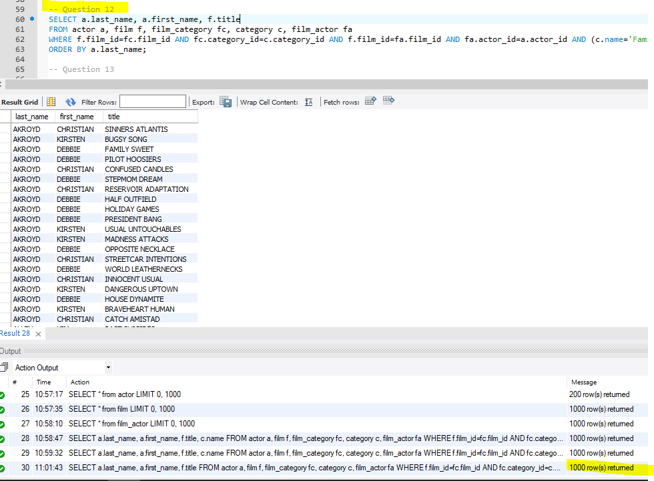
Query 13:
SELECT a.last_name, a.first_name, f.title, c.name as Category
FROM actor a, film f, film_category fc, category c, film_actor fa
WHERE f.film_id=fc.film_id AND fc.category_id=c.category_id AND f.film_id=fa.film_id AND fa.actor_id=a.actor_id AND (c.name='Family' OR c.name='Horror')
ORDER BY a.last_name;
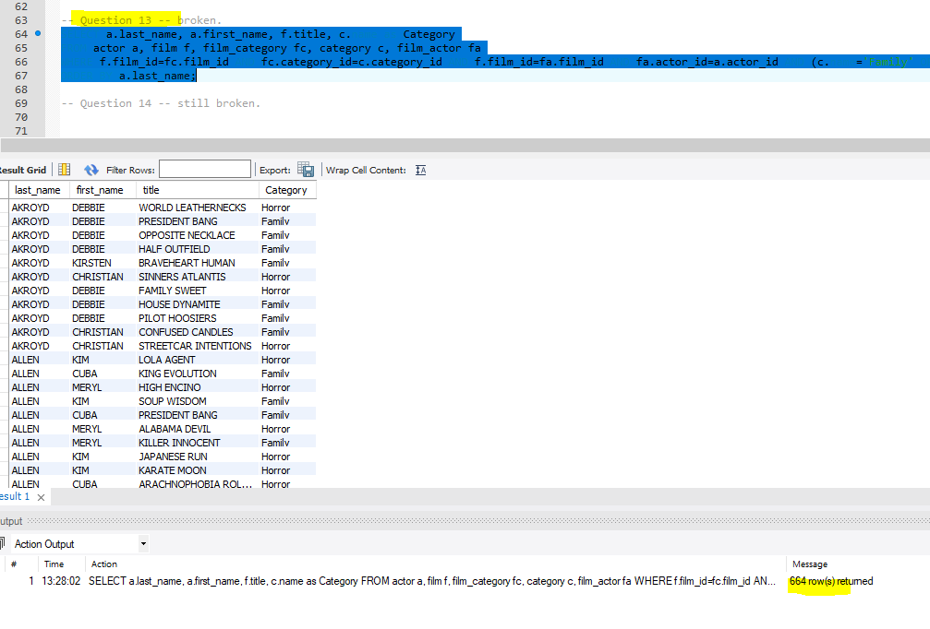
Query 14:
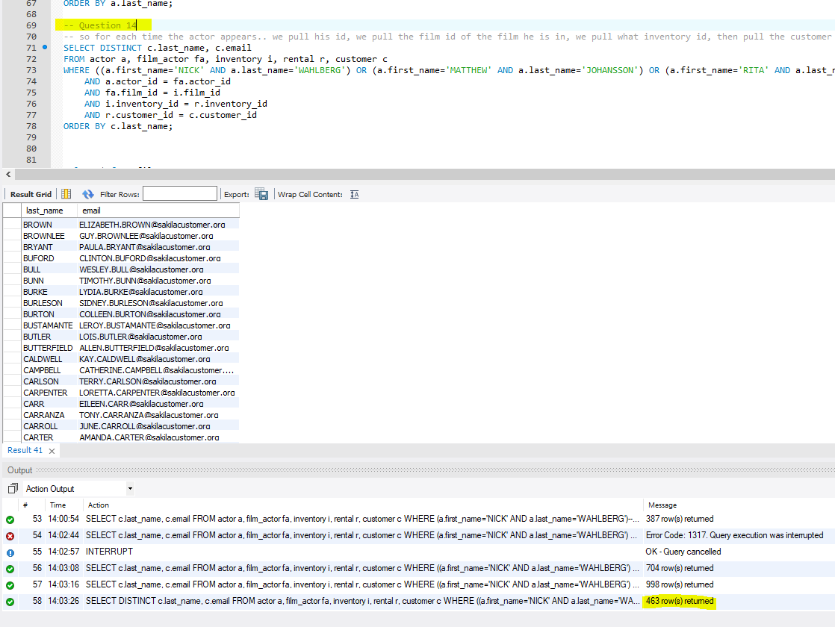
SELECT DISTINCT c.last_name, c.email
FROM actor a, film_actor fa, inventory i, rental r, customer c
WHERE ((a.first_name='NICK' AND a.last_name='WAHLBERG') OR (a.first_name='MATTHEW' AND a.last_name='JOHANSSON') OR (a.first_name='RITA' AND a.last_name='REYNOLDS'))
AND a.actor_id = fa.actor_id
AND fa.film_id = i.film_id
AND i.inventory_id = r.inventory_id
AND r.customer_id = c.customer_id
ORDER BY c.last_name;

