Spam

Thadryan Sweeney

November 7, 2017

# read and inspect the raw data  
sms_raw <- read.csv('C:/Users/Thadryan.Hank-PC/Documents/R/da5030.spammsgdataset.csv', stringsAsFactors = TRUE)  
str(sms_raw)

## 'data.frame': 5574 obs. of 2 variables:  
## $ type: Factor w/ 2 levels "ham","spam": 1 1 2 1 1 2 1 1 2 2 ...  
## $ text: Factor w/ 5160 levels "'An Amazing Quote'' - \"Sometimes in life its difficult to decide whats wrong!! a lie that brings a smile or th"| __truncated__,..: 1180 3255 1082 4274 2904 1107 1015 458 4757 1314 ...

We'll make a table to get an idea of the data looks like in terms of our areas of interest, in this case, spam and ham. We see the the majority of the set is composed of what we're looking for, but the unwanted messages are common enough to be problematic.

# create a table based on type   
table(sms_raw$type)

##   
## ham spam   
## 4827 747

R has great library support in general, and text mining is no exception. We can import the tm library and use it to create a corpus of data

# this is a library for text mining  
library(tm)

## Loading required package: NLP

# we make a body of text to mine. The "V" stands for volatile, meaning it is not store permanantly on the hardrive.   
sms_corpus <- VCorpus(VectorSource(sms_raw$text))  
  
# display the traits  
print(sms_corpus)

## <<VCorpus>>  
## Metadata: corpus specific: 0, document level (indexed): 0  
## Content: documents: 5574

# inspec the first two   
inspect(sms_corpus[1:2])

## <<VCorpus>>  
## Metadata: corpus specific: 0, document level (indexed): 0  
## Content: documents: 2  
##   
## [[1]]  
## <<PlainTextDocument>>  
## Metadata: 7  
## Content: chars: 111  
##   
## [[2]]  
## <<PlainTextDocument>>  
## Metadata: 7  
## Content: chars: 29

# view the content of a message  
as.character(sms_corpus[[1]])

## [1] "Go until jurong point, crazy.. Available only in bugis n great world la e buffet... Cine there got amore wat..."

# view more than one   
lapply(sms_corpus[1:2], as.character)

## $`1`  
## [1] "Go until jurong point, crazy.. Available only in bugis n great world la e buffet... Cine there got amore wat..."  
##   
## $`2`  
## [1] "Ok lar... Joking wif u oni..."

# start cleaning text  
sms_corpus_clean <- tm_map(sms_corpus, content_transformer(tolower))  
   
as.character(sms_corpus[[1]])

## [1] "Go until jurong point, crazy.. Available only in bugis n great world la e buffet... Cine there got amore wat..."

as.character(sms_corpus_clean[[1]])

## [1] "go until jurong point, crazy.. available only in bugis n great world la e buffet... cine there got amore wat..."

# update the data with removal of numbers, stopwords (to, but, and), and punctuation   
sms_corpus_clean <- tm_map(sms_corpus_clean, removeNumbers)  
sms_corpus_clean <- tm_map(sms_corpus_clean, removeWords, stopwords())  
sms_corpus_clean <- tm_map(sms_corpus_clean, removePunctuation)

Next we will convert works into thier roots, for example "writing" becomes "write". This keeps the themes legitimate without cluttering the dataset with redundancy and making it difficult to count.

# this library will allow use to convert forms of the words to roots  
library(SnowballC)

Numerous steps still need to take place before the dataset is ready to use, however. We'll need to remove whitespace and create a matrix. There is also a function that could speed up this process for next time now that we understand it.

sms_corpus_clean <- tm_map(sms_corpus_clean, stemDocument)  
  
# remove extra whitespace   
sms_corpus_clean <- tm_map(sms_corpus_clean, stripWhitespace)  
  
# create a document term matrix from the data  
sms_dtm <- DocumentTermMatrix(sms_corpus_clean)  
  
#demostrate function parameters that could speed up the whole process   
sms_dtm2 <- DocumentTermMatrix(sms_corpus, control = list(  
 tolower = TRUE,  
 removeNumbers = TRUE,  
 stopwords = TRUE,  
 removePunctuation = TRUE,  
 stemming = TRUE))  
sms_dtm

## <<DocumentTermMatrix (documents: 5574, terms: 6604)>>  
## Non-/sparse entries: 42631/36768065  
## Sparsity : 100%  
## Maximal term length: 40  
## Weighting : term frequency (tf)

sms_dtm2

## <<DocumentTermMatrix (documents: 5574, terms: 6998)>>  
## Non-/sparse entries: 43720/38963132  
## Sparsity : 100%  
## Maximal term length: 40  
## Weighting : term frequency (tf)

# Partition the data

Now we can create training and validation datasets, and create the labels for what we are trying to predict. We will also observe the proportions in the datasets, to ensure we haven't accidentally loaded the dice by putting a drastically different proportion in one than the other.

# break into testing and training set  
sms_dtm_train <- sms_dtm[1:4169, ]  
sms_dtm_test <- sms_dtm[4170:5559, ]  
  
  
# set labels while we are at it   
sms_train_labels <- sms_raw[1:4169, ]$type  
sms_test_labels <- sms_raw[4170:5559, ]$type  
  
# confirm we are on the right track   
prop.table(table(sms_train_labels))

## sms_train_labels  
## ham spam   
## 0.8647158 0.1352842

prop.table(table(sms_test_labels))

## sms_test_labels  
## ham spam   
## 0.8697842 0.1302158

# Visualize the data

Now that we have that taken care of, we can proceede though some analytical steps and then build our model. One thing we want to know about is word frequency. Wordclouds are a great way to get an idea of paterns intuitively.

# get the library   
library(wordcloud)

## Loading required package: RColorBrewer

#call the function   
wordcloud(sms_corpus_clean, min.freq = 50, random.order = FALSE)

## Warning in wordcloud(sms_corpus_clean, min.freq = 50, random.order =  
## FALSE): someon could not be fit on page. It will not be plotted.

## Warning in wordcloud(sms_corpus_clean, min.freq = 50, random.order =  
## FALSE): tonight could not be fit on page. It will not be plotted.

## Warning in wordcloud(sms_corpus_clean, min.freq = 50, random.order =  
## FALSE): went could not be fit on page. It will not be plotted.

## Warning in wordcloud(sms_corpus_clean, min.freq = 50, random.order =  
## FALSE): around could not be fit on page. It will not be plotted.

## Warning in wordcloud(sms_corpus_clean, min.freq = 50, random.order =  
## FALSE): collect could not be fit on page. It will not be plotted.

## Warning in wordcloud(sms_corpus_clean, min.freq = 50, random.order =  
## FALSE): soon could not be fit on page. It will not be plotted.

## Warning in wordcloud(sms_corpus_clean, min.freq = 50, random.order =  
## FALSE): gonna could not be fit on page. It will not be plotted.

## Warning in wordcloud(sms_corpus_clean, min.freq = 50, random.order =  
## FALSE): plan could not be fit on page. It will not be plotted.

## Warning in wordcloud(sms_corpus_clean, min.freq = 50, random.order =  
## FALSE): alway could not be fit on page. It will not be plotted.

## Warning in wordcloud(sms_corpus_clean, min.freq = 50, random.order =  
## FALSE): live could not be fit on page. It will not be plotted.

## Warning in wordcloud(sms_corpus_clean, min.freq = 50, random.order =  
## FALSE): name could not be fit on page. It will not be plotted.

## Warning in wordcloud(sms_corpus_clean, min.freq = 50, random.order =  
## FALSE): nice could not be fit on page. It will not be plotted.

## Warning in wordcloud(sms_corpus_clean, min.freq = 50, random.order =  
## FALSE): wan could not be fit on page. It will not be plotted.

## Warning in wordcloud(sms_corpus_clean, min.freq = 50, random.order =  
## FALSE): word could not be fit on page. It will not be plotted.

## Warning in wordcloud(sms_corpus_clean, min.freq = 50, random.order =  
## FALSE): minut could not be fit on page. It will not be plotted.

## Warning in wordcloud(sms_corpus_clean, min.freq = 50, random.order =  
## FALSE): check could not be fit on page. It will not be plotted.

## Warning in wordcloud(sms_corpus_clean, min.freq = 50, random.order =  
## FALSE): special could not be fit on page. It will not be plotted.

## Warning in wordcloud(sms_corpus_clean, min.freq = 50, random.order =  
## FALSE): box could not be fit on page. It will not be plotted.

## Warning in wordcloud(sms_corpus_clean, min.freq = 50, random.order =  
## FALSE): shop could not be fit on page. It will not be plotted.

## Warning in wordcloud(sms_corpus_clean, min.freq = 50, random.order =  
## FALSE): mean could not be fit on page. It will not be plotted.

## Warning in wordcloud(sms_corpus_clean, min.freq = 50, random.order =  
## FALSE): month could not be fit on page. It will not be plotted.

## Warning in wordcloud(sms_corpus_clean, min.freq = 50, random.order =  
## FALSE): guarante could not be fit on page. It will not be plotted.

## Warning in wordcloud(sms_corpus_clean, min.freq = 50, random.order =  
## FALSE): peopl could not be fit on page. It will not be plotted.

## Warning in wordcloud(sms_corpus_clean, min.freq = 50, random.order =  
## FALSE): reach could not be fit on page. It will not be plotted.

## Warning in wordcloud(sms_corpus_clean, min.freq = 50, random.order =  
## FALSE): girl could not be fit on page. It will not be plotted.

## Warning in wordcloud(sms_corpus_clean, min.freq = 50, random.order =  
## FALSE): happen could not be fit on page. It will not be plotted.

## Warning in wordcloud(sms_corpus_clean, min.freq = 50, random.order =  
## FALSE): offer could not be fit on page. It will not be plotted.

## Warning in wordcloud(sms_corpus_clean, min.freq = 50, random.order =  
## FALSE): yet could not be fit on page. It will not be plotted.

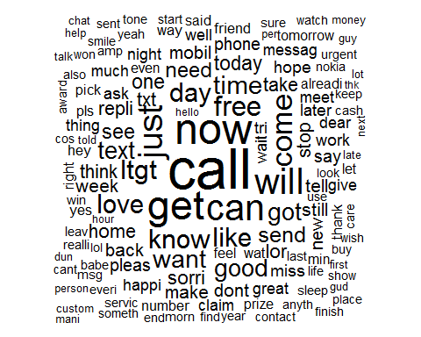

Let's compare that to the junk folder. If we're on the right track, there should be a difference, which we will later quantify and use for our classifier.

# call the subsets  
spam <- subset(sms_raw, type == "spam")  
ham <- subset(sms_raw, type == "ham")  
  
# pass to the wordcloud function   
wordcloud(spam$text, max.words = 40, scale = c(3, 0.5))

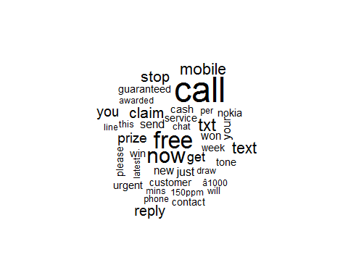

wordcloud(ham$text, max.words = 40, scale = c(3, 0.5))

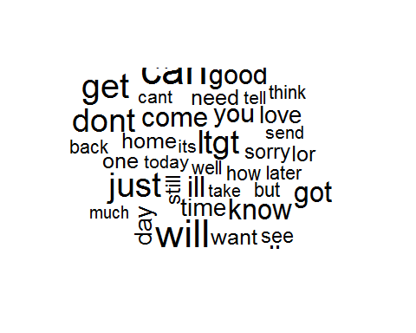

Now let's get more quantitative about the frequency, finding some areas the keep popping up.

# call the frequency counter with argument for number of occurences  
sms_freq_words <- findFreqTerms(sms_dtm_train, 5)  
str(sms_freq_words)

## chr [1:1158] "â<U+0080><U+0093>" "abiola" "abl" "abt" "accept" "access" "account" ...

# see if there is a difference in the sets  
sms_dtm_freq_train <- sms_dtm_train[ , sms_freq_words]  
sms_dtm_freq_test <- sms_dtm_test[ , sms_freq_words]

We will now make a function to convert to yes/no values for a more reader friendly output.

# define function   
convert_counts <- function(x)  
{  
 x <- ifelse(x > 0, "yes", "no")  
}  
  
# apply the function by rows to the datasets  
sms_train <- apply(sms_dtm_freq_train, MARGIN = 2, convert_counts)  
sms_test <- apply(sms_dtm_freq_test, MARGIN = 2, convert_counts)

Next we will get a few more libraries. These will be used for the actual classification and to see how our model preforms.

# get required materials  
library("e1071")  
library("gmodels")  
  
# call the naive bayes function  
sms_classifier <- naiveBayes(sms_train, sms_train_labels)  
  
# use it to make a predition  
sms_test_pred <- predict(sms_classifier, sms_test)  
  
# inspect the results   
CrossTable(sms_test_pred, sms_test_labels, prop.chisq = FALSE, prop.t = FALSE, dnn = c('predicted', 'actual'))

##   
##   
## Cell Contents  
## |-------------------------|  
## | N |  
## | N / Row Total |  
## | N / Col Total |  
## |-------------------------|  
##   
##   
## Total Observations in Table: 1390   
##   
##   
## | actual   
## predicted | ham | spam | Row Total |   
## -------------|-----------|-----------|-----------|  
## ham | 1200 | 20 | 1220 |   
## | 0.984 | 0.016 | 0.878 |   
## | 0.993 | 0.110 | |   
## -------------|-----------|-----------|-----------|  
## spam | 9 | 161 | 170 |   
## | 0.053 | 0.947 | 0.122 |   
## | 0.007 | 0.890 | |   
## -------------|-----------|-----------|-----------|  
## Column Total | 1209 | 181 | 1390 |   
## | 0.870 | 0.130 | |   
## -------------|-----------|-----------|-----------|  
##   
##

Ont thing we haven't talked about so far in this context is the Laplace approximator. Naive Bayes classifiers work by multiplying probabiliteis derived from imperical values. This means that if we're looking at a term that didn't occur, we end up multiplying by zero and nullifying our results. To avoid having the function need to work around this, we can simply replace the value with a 1, which will likely cause very little, if any, perceptible disturbance in the functions.

# add laplace argument, replacing zeros with ones   
sms_classifier2 <- naiveBayes(sms_train, sms_train_labels, laplace = 1)  
  
# make new predictor   
sms_test_pred2 <- predict(sms_classifier2, sms_test)  
  
# visualize the results   
CrossTable(sms_test_pred2, sms_test_labels, prop.chisq = FALSE, prop.t = FALSE, dnn = c('predicted', 'actual'))

##   
##   
## Cell Contents  
## |-------------------------|  
## | N |  
## | N / Row Total |  
## | N / Col Total |  
## |-------------------------|  
##   
##   
## Total Observations in Table: 1390   
##   
##   
## | actual   
## predicted | ham | spam | Row Total |   
## -------------|-----------|-----------|-----------|  
## ham | 1202 | 28 | 1230 |   
## | 0.977 | 0.023 | 0.885 |   
## | 0.994 | 0.155 | |   
## -------------|-----------|-----------|-----------|  
## spam | 7 | 153 | 160 |   
## | 0.044 | 0.956 | 0.115 |   
## | 0.006 | 0.845 | |   
## -------------|-----------|-----------|-----------|  
## Column Total | 1209 | 181 | 1390 |   
## | 0.870 | 0.130 | |   
## -------------|-----------|-----------|-----------|  
##   
##