The system currently consists of two parts
- A PC application
- A console application standing in for the sub software for testing
The PC application consists of two screens and main screen and settings screen.
The Settings Screen
The settings screen allows the following to be configured and saved:
- Target IP address
- Target port: console currently hard coded to 9000
- Text to send on UPp button press
- Text to send on Down button press
- Text to send on Left button press
- Text to send on Right button press
Settings are saved in a file on the PC
The Main Screen
The main screen enables the following actions:
- Connect to sub software (console)
- Disconnect from sub software (console)
- Send Up command to sub software
- Send Down command to sub software
- Send Left command to sub software
- Send Right command to sub software
- Send Cutter on command to sub software
- Send Cutter off command to sub software
- Send cutter speed commands to sub software (slider bar 0 - 100)
- View the cutter current send from the sub software (console just returns slider settings)
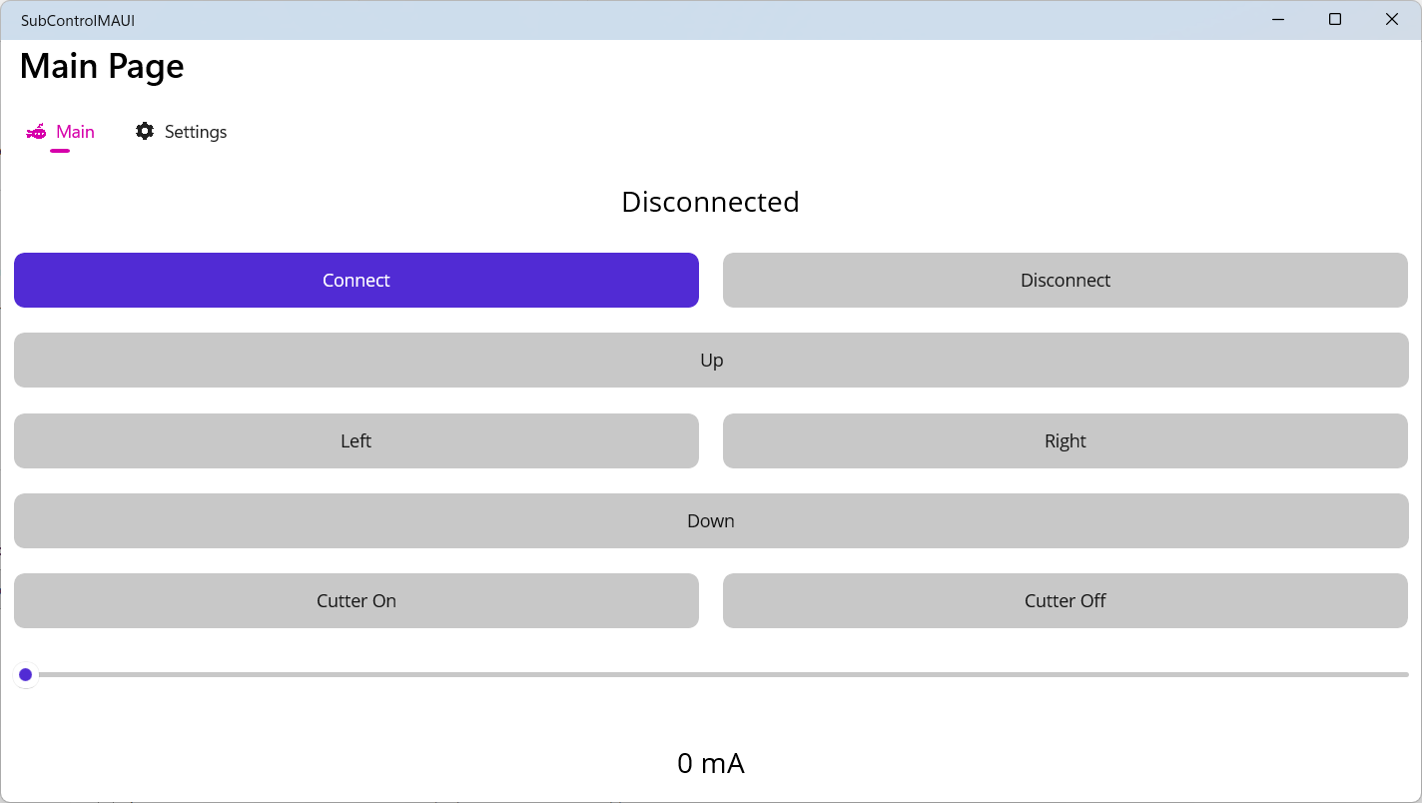

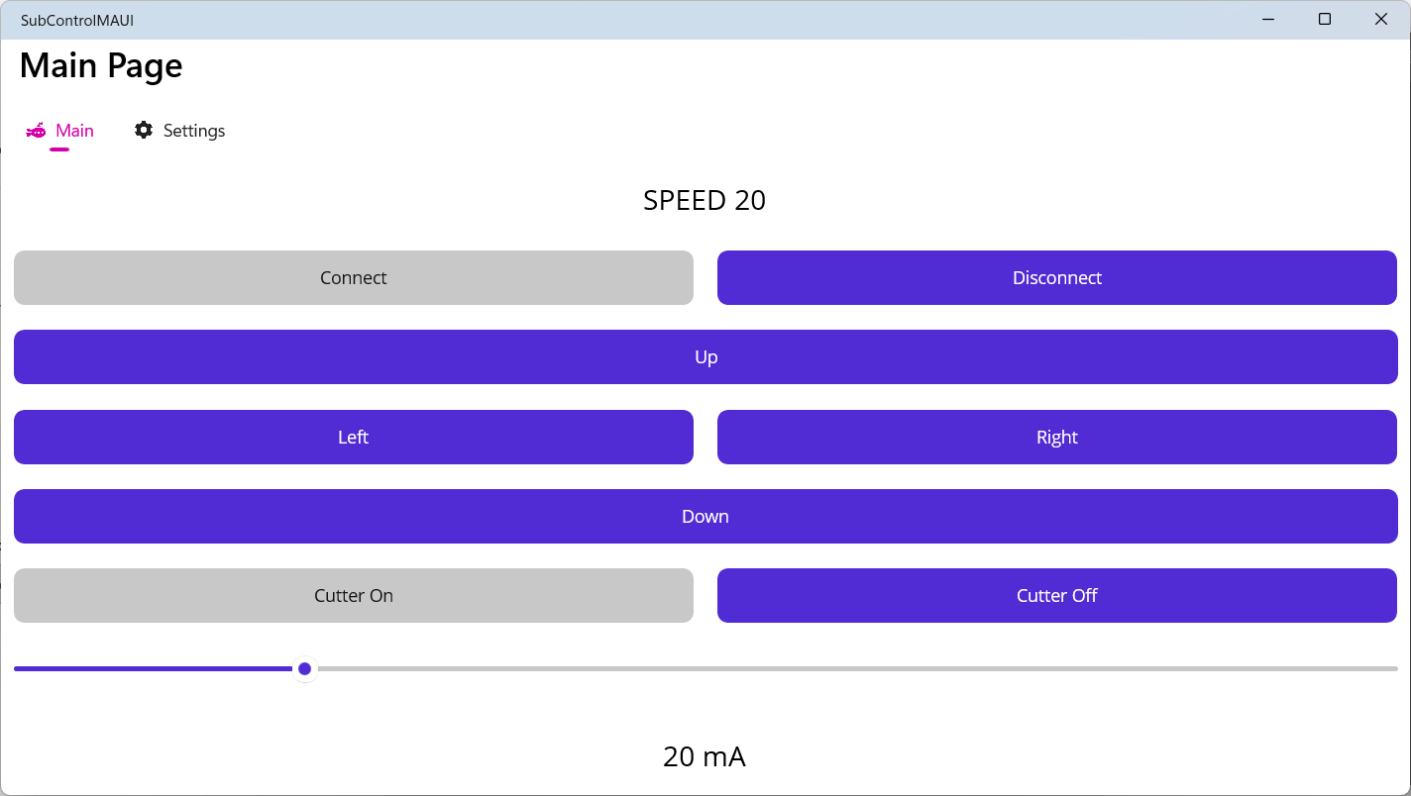

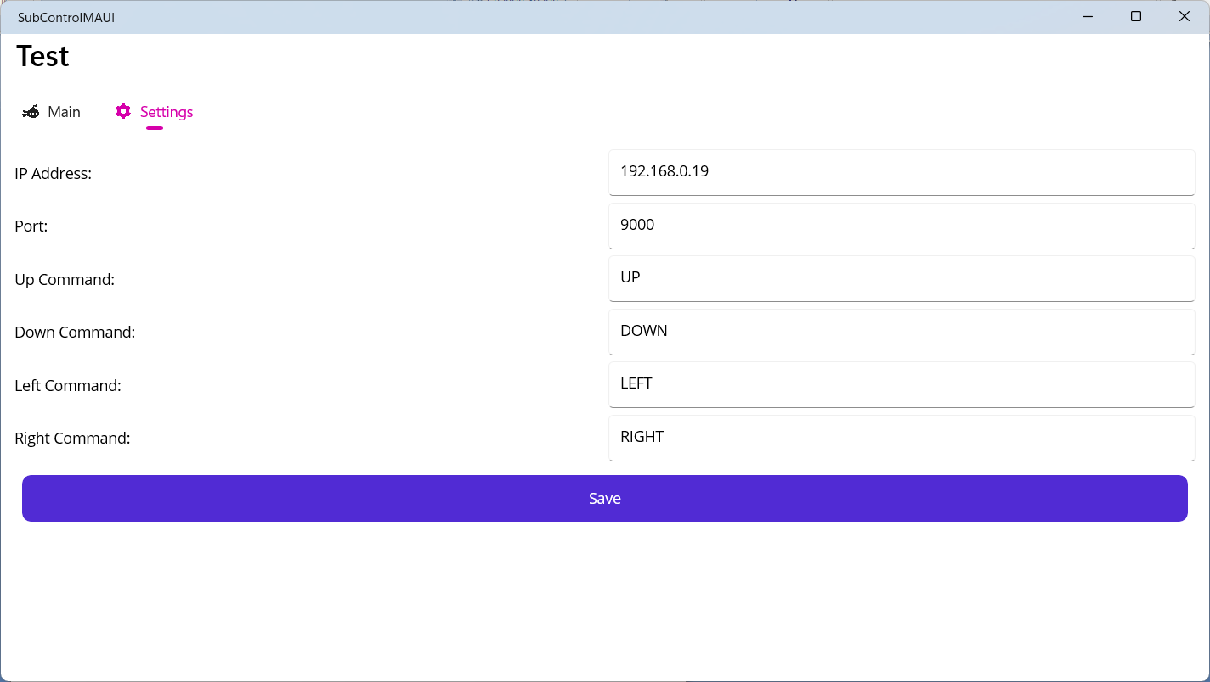

The console is currently just for test purposed but could become the basis for a Raspberry Pi application, the console receives incoming connections on port 9000, acknowledges received messages and prints received messages to the console.

