MAVUNO HOME & CARE
Revenue Decline Diagnostic
Why group revenue fell 10.7% — and who owns each cause

Comparison period | Q3 2026 vs Q3 2025
Prepared | 2026-10-05
Prepared by | Senior Data Analyst
Classification | Internal — Commercial leadership
Reproduce with | python3 src/run_pipeline.py

The question this answers
Whose plan gets rewritten next quarter — retention, pricing, or merchandising?

Group net revenue fell KSh 5.21M (10.7%). We did not lose customers — active customers rose +5.5%. We lost trips (-11.4% orders per customer) and basket (-4.5% average order value), and 71% of the damage sits in two of six stores.

Contents
1. Executive summary
2. The decision this supports
3. What the data is, and what it is not
4. Descriptive — what happened
5. Diagnostic, part 1 — the mechanism
6. Diagnostic, part 2 — the structure, and who owns what
7. The intersection — which store x product x segment
8. Segments and retention
9. The supply event, with dates
10. Pricing, mix and margin
11. Facts, hypotheses, and the edge of what we know
12. Predictive — the run-rate if nothing changes
13. Prescriptive — what to do
14. How we will know whether it worked
Appendix A — method, provenance and reproducibility
Appendix B — index of charts
Appendix C — the evidential 5-Whys

SECTION 1

Executive summary
NET REVENUE  KSh 43.65M  -10.7% from KSh 48.86M in Q3 2025 | GROSS MARGIN  18.57%  -1.38pp gross profit KSh 8.04M | ORDERS PER CUSTOMER  4.82  -11.4% the engine of the decline
AVERAGE ORDER VALUE  KSh 1,619  -4.5% 3.40 lines per order | ACTIVE CUSTOMERS  5,555  +5.5% acquisition is NOT the problem | REVENUE WITH NO CUSTOMER ID  0.76%  KSh 0.70M the declared coverage limit

Group net revenue fell KSh 5.21M (10.7%). We did not lose customers — active customers rose +5.5%. We lost trips (-11.4% orders per customer) and basket (-4.5% average order value), and 71% of the damage sits in two of six stores.
Gross profit fell 16.9% against a 10.7% revenue fall, because gross margin compressed 1.38pp to 18.57%. Revenue is not profit: every recommendation below is therefore priced in gross profit, not revenue.

The four findings, ranked by how much of the decline they own
# | Owner | The problem | Cost | Share
1 | Supply Chain & Merchandising | Two hero Personal Care SKUs out of stock for six weeks at Mombasa Nyali; the damage spread to whole baskets | KSh -2.16M | 41%
2 | Retail Operations (Thika Road) | Thika Road footfall cut for the full quarter — visits per customer well below every other store | KSh -1.49M | 29%
3 | CRM / Loyalty & Assortment | Residual: fewer trips per customer and slimmer baskets right across the chain | KSh -0.97M | 19%
4 | Pricing & Category Management | Beverage promotional depth deepened sharply outside the two affected stores | KSh -0.55M | 11%

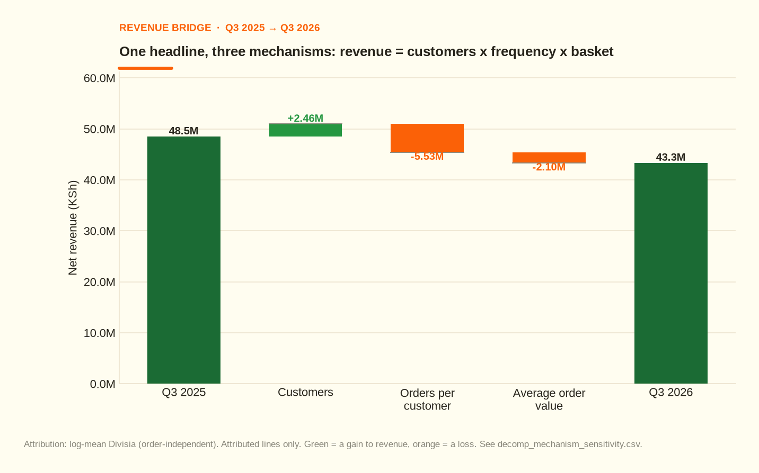
The 10.7% fall is one customer gain against two larger losses — it is not one event.
Figure 1 — the revenue bridge: one gain, two larger losses.
SECTION 2

The decision this supports
The question
Whose plan gets rewritten next quarter — retention, pricing, or merchandising?

An analysis is only worth reading to the extent it changes who does what on Monday. This one converts a single headline — revenue fell — into four named owners with a quantified problem, an expected recovery and a review date. If it does not change someone's plan next quarter, it has failed.

What this report is, and what a dashboard is
 | This report | The dashboard that follows it
Job | explain a change and support a decision | monitor the KPIs the analysis identified
Question | “why, and what should we do?” | “are we OK?”
Cadence | one-off, on demand | monthly, always-on
Output | findings + recommendations, with owners | tiles, trends, exceptions

The dashboard ships after the thinking and monitors what this report concluded. Its build specification, including the DAX measures and the targets below, is docs/07_dashboard_spec.md.
SECTION 3

What the data is, and what it is not
Line-item grain: one row = one line item on one customer receipt — 195,224 lines across 55,431 invoices in the two quarters, plus a separate branch x SKU x day shelf-availability table that makes the supply event provable rather than plausible.

Declared limits — limits on the conclusions, not footnotes
- 0.76% of revenue carries no customer identifier (KSh 0.70M of anonymous walk-ins). Every segment-level conclusion therefore reconciles to 99.24% of revenue, not 100%. The reconciliation is shown as its own line rather than hidden in an 'Other' bucket.
- The dataset is simulated from a documented mechanism (docs/00_ground_truth.md). That is deliberate: it lets the diagnosis be graded. See outputs/validation_report.md — 14/14 checks pass against the sealed answer key.
- No procurement, lead-time or supplier-performance data exists in this extract. The fifth why therefore stops at a data-capture recommendation instead of a guess.
- The annualised figure is a stated run-rate (KSh -20.83M, the quarter's change x 4), not a forecast. It assumes the Mombasa Nyali incident does not repeat and ignores Q4 seasonality.

Method in one line: decompose by mechanism first (customers x frequency x basket), then by structure (store, category, segment, channel), then intersect the three, then ask why five times with a number attached to every answer. The attribution is log-mean Divisia, audited so the driver partition covers the decline exactly.
SECTION 4

Descriptive — what happened
Metric | Q3 2025 | Q3 2026 | Change
Net revenue | KSh 48.86M | KSh 43.65M | -10.7%
Gross profit | KSh 9.68M | KSh 8.04M | -16.9%
Gross margin | 19.95% | 18.57% | -1.38pp
Active customers | 5,265 | 5,555 | +5.5%
Orders | 28,618 | 26,764 | -6.5%
Orders per customer | 5.44 | 4.82 | -11.4%
Average order value | KSh 1,694 | KSh 1,619 | -4.5%
Lines per order | 3.59 | 3.40 | -5.2%
List price per unit | KSh 312 | KSh 326 | +4.3%
Discount depth (% of gross) | 4.80% | 7.82% | +3.02pp

Every figure in this table is reproduced from outputs/kpis.json, which the pipeline regenerates. Nothing here is typed by hand.
One customer gain against two larger losses. This is not one event.
Figure 1 — the revenue bridge.
SECTION 5

Diagnostic, part 1 — the mechanism
Revenue = Customers x Frequency x Average order value.
Driver | Effect on revenue | YoY move
Customers | KSh +2.46M | +5.5%
Orders per customer | KSh -5.53M | -11.4%
Average order value | KSh -2.10M | -4.5%
Total | KSh -5.21M | -10.7%

Attribution is log-mean Divisia, so the ranking does not depend on the order in which the three factors are multiplied. The frequency effect is the largest under every ordering — that is the robust part of the result.
Sequential-order sensitivity band: customers KSh 2.26M to KSh 2.67M; frequency KSh -5.81M to KSh -5.26M; aov KSh -2.17M to KSh -2.03M.
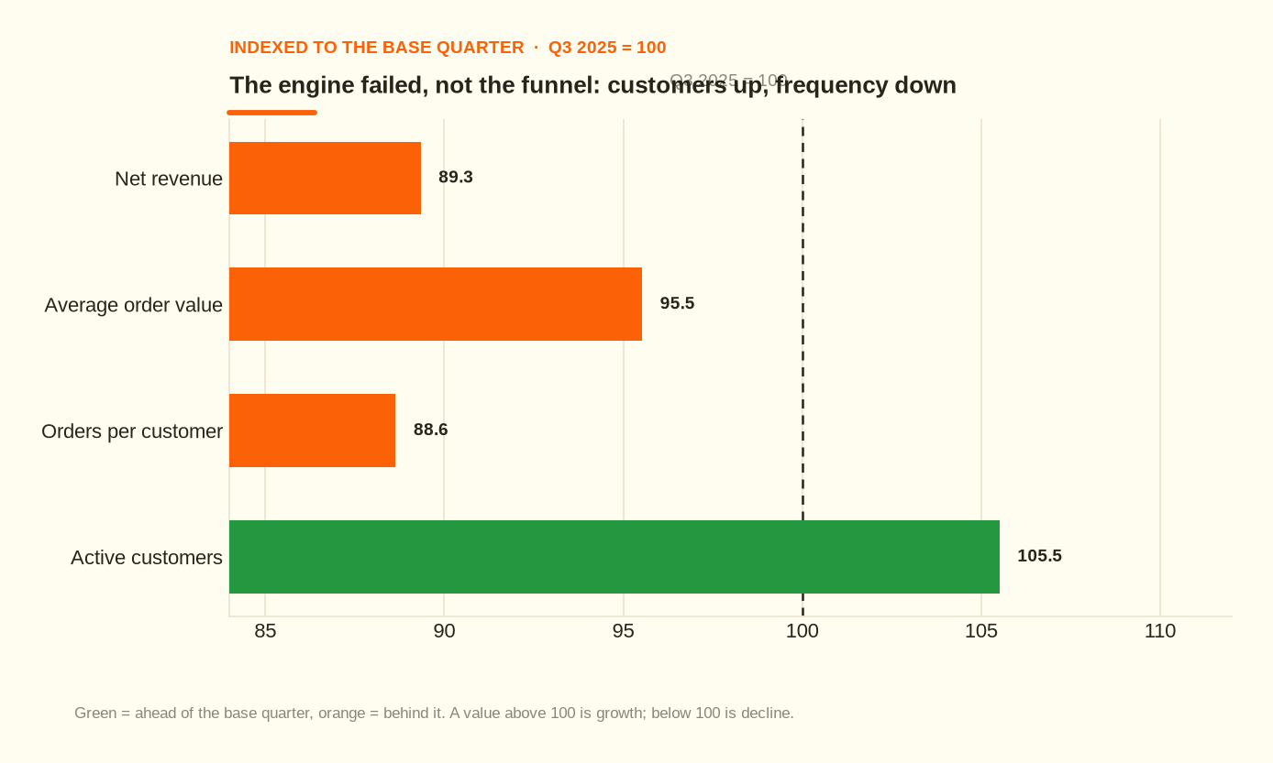
Customers grew. Orders per customer and basket value did not. Any report that stops at “fewer customers” is wrong.
Figure 2 — the same three drivers indexed to the base quarter.

SECTION 6

Diagnostic, part 2 — the structure, and who owns what

By store
Rank | Slice | Revenue change | YoY | Share of group decline
1 | Mombasa Nyali | KSh -2.18M | -27.0% | 41.9%
2 | Thika Road | KSh -1.50M | -18.7% | 28.9%
3 | Kisumu Lakefront | KSh -0.69M | -11.5% | 13.2%
4 | Town Centre | KSh -0.39M | -3.4% | 7.4%
5 | Westlands | KSh -0.26M | -2.8% | 5.0%
6 | Nakuru CBD | KSh -0.19M | -3.0% | 3.6%

By category
Rank | Slice | Revenue change | YoY | Share of group decline
1 | Groceries | KSh -1.60M | -13.1% | 30.7%
2 | Beverages | KSh -1.08M | -20.3% | 20.7%
3 | Household & Cleaning | KSh -0.82M | -11.3% | 15.7%
4 | Personal Care | KSh -0.65M | -7.9% | 12.4%
5 | Baby & Kids | KSh -0.46M | -6.7% | 8.8%
6 | Dairy & Eggs | KSh -0.37M | -8.0% | 7.0%
7 | Fresh Produce | KSh -0.15M | -4.7% | 2.9%
8 | Bakery | KSh -0.09M | -6.9% | 1.7%
9 | Unclassified | KSh -0.00M | -27.9% | 0.0%

By customer segment
Rank | Slice | Revenue change | YoY | Share of group decline
1 | Loyal | KSh -3.03M | -15.2% | 58.2%
2 | Regular | KSh -2.52M | -14.0% | 48.4%
3 | At-Risk | KSh -0.85M | -14.2% | 16.3%
4 | Hibernating | KSh -0.04M | -2.9% | 0.8%
5 | New | KSh +1.28M | +40.7% | -24.5%

By channel
Rank | Slice | Revenue change | YoY | Share of group decline
1 | In-store | KSh -4.54M | -10.8% | 87.1%
2 | Online | KSh -0.67M | -9.9% | 12.9%

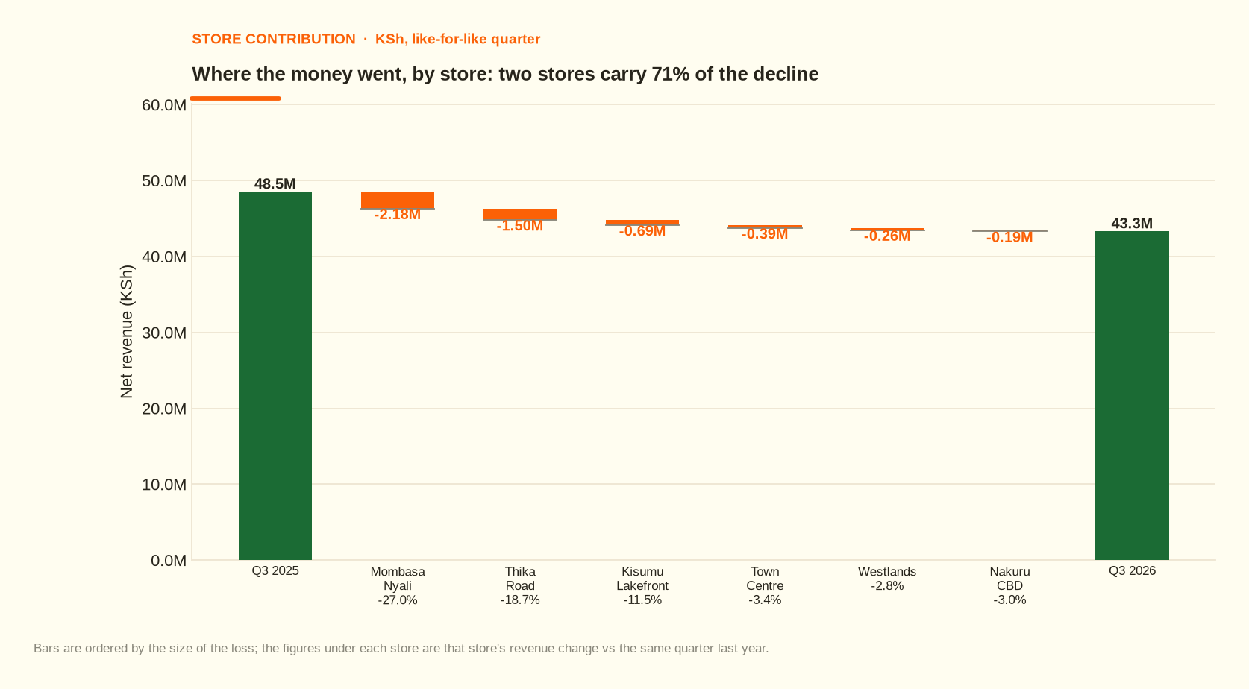
Two of six stores carry 71% of the decline.
Figure 3 — where the money went, by store.
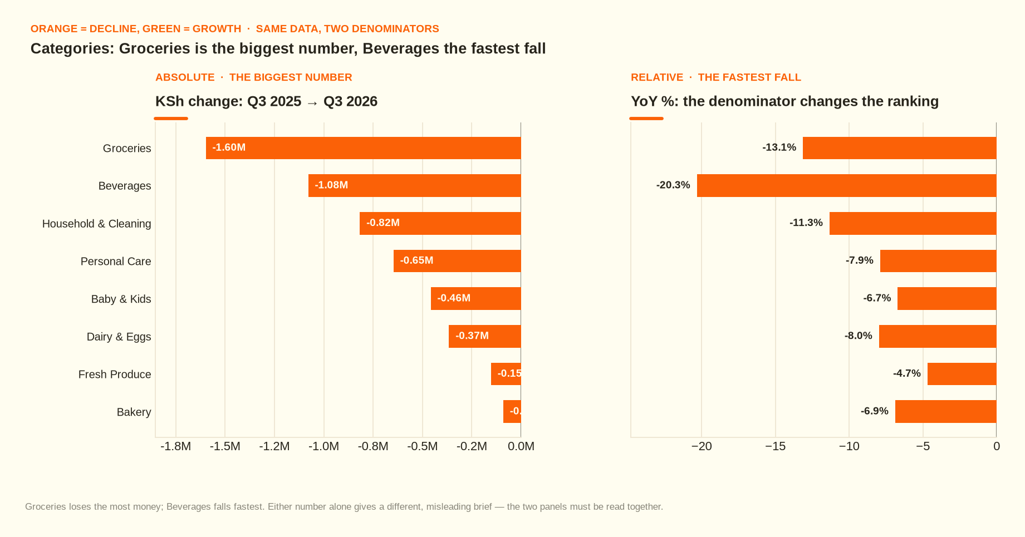
Groceries is the biggest absolute loss, Beverages the fastest fall. Either alone is a misleading brief.
Figure 4 — categories, in both KSh and %.

SECTION 7

The intersection — which store x product x segment
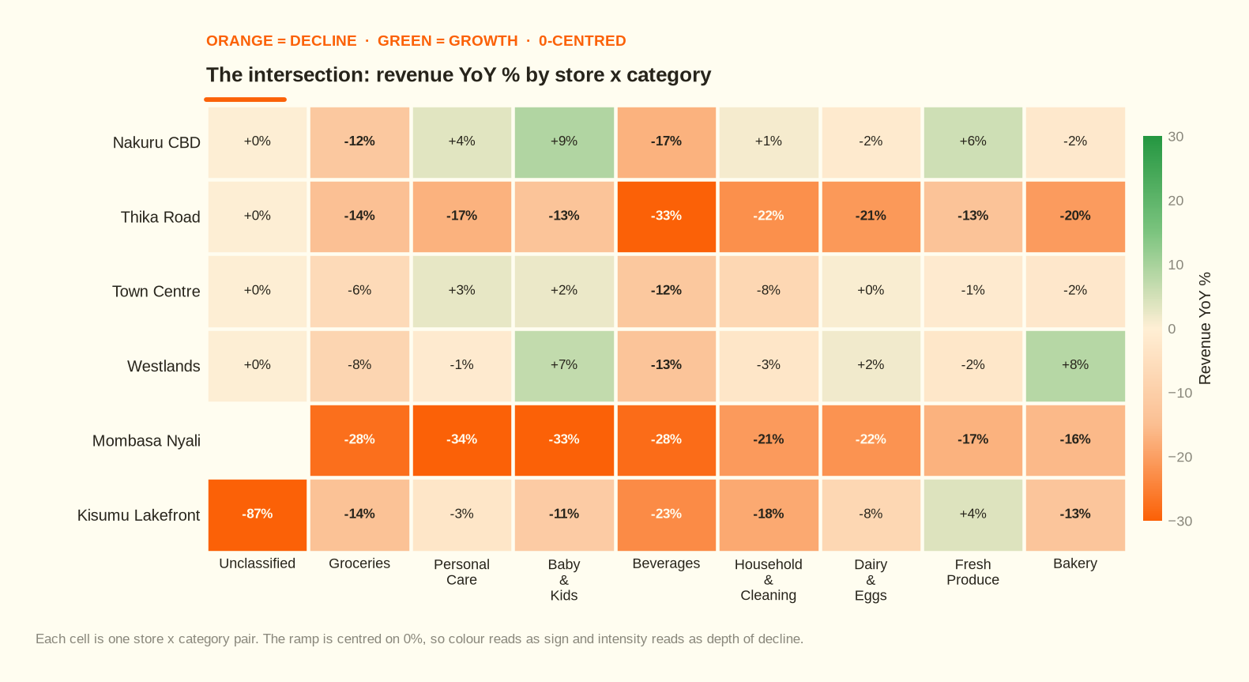
The decline is concentrated, not diffuse — which is why the fix can be targeted too.
Figure 5 — revenue YoY % by store x category.
The worst 8 cells (store x category x segment) account for 23.5% of the total decline.
# | Cell | Revenue change | YoY | % of group decline
1 | Mombasa Nyali | Groceries | Regular | KSh -0.28M | -33.6% | 5.4%
2 | Mombasa Nyali | Groceries | Loyal | KSh -0.23M | -29.6% | 4.4%
3 | Mombasa Nyali | Personal Care | Regular | KSh -0.22M | -41.1% | 4.2%
4 | Mombasa Nyali | Baby & Kids | Loyal | KSh -0.21M | -42.0% | 4.0%
5 | Mombasa Nyali | Personal Care | Loyal | KSh -0.19M | -35.9% | 3.6%
6 | Mombasa Nyali | Baby & Kids | Regular | KSh -0.17M | -34.8% | 3.3%
7 | Thika Road | Personal Care | Loyal | KSh -0.17M | -30.9% | 3.3%
8 | Mombasa Nyali | Household & Cleaning | Regular | KSh -0.17M | -37.0% | 3.2%

The counter-intuitive result
The single largest cell is Mombasa Nyali | Groceries | Regular — not the category that was out of stock. At Mombasa Nyali, every category fell together because the stock failure removed the reason for the trip and the whole basket shrank with it. Measuring only the affected category would have understated this event by roughly 4.8x.
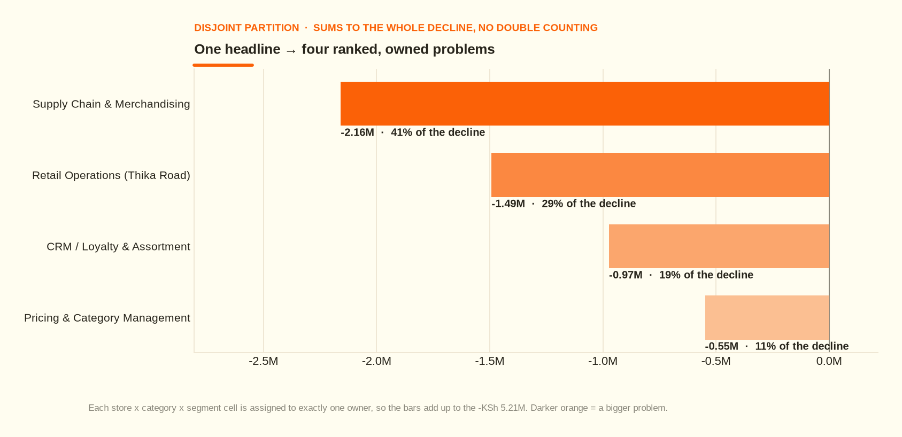
Each cell is assigned to exactly one owner, so there is no double counting.
Figure 6 — four ranked, owned problems (disjoint; sums to the whole decline).

SECTION 8

Segments and retention
Cohort metric | Value
Q3 2025 customers | 5,265
Returned in Q3 2026 | 4,410 (83.8%)
Lapsed | 855
New customers acquired | 1,145

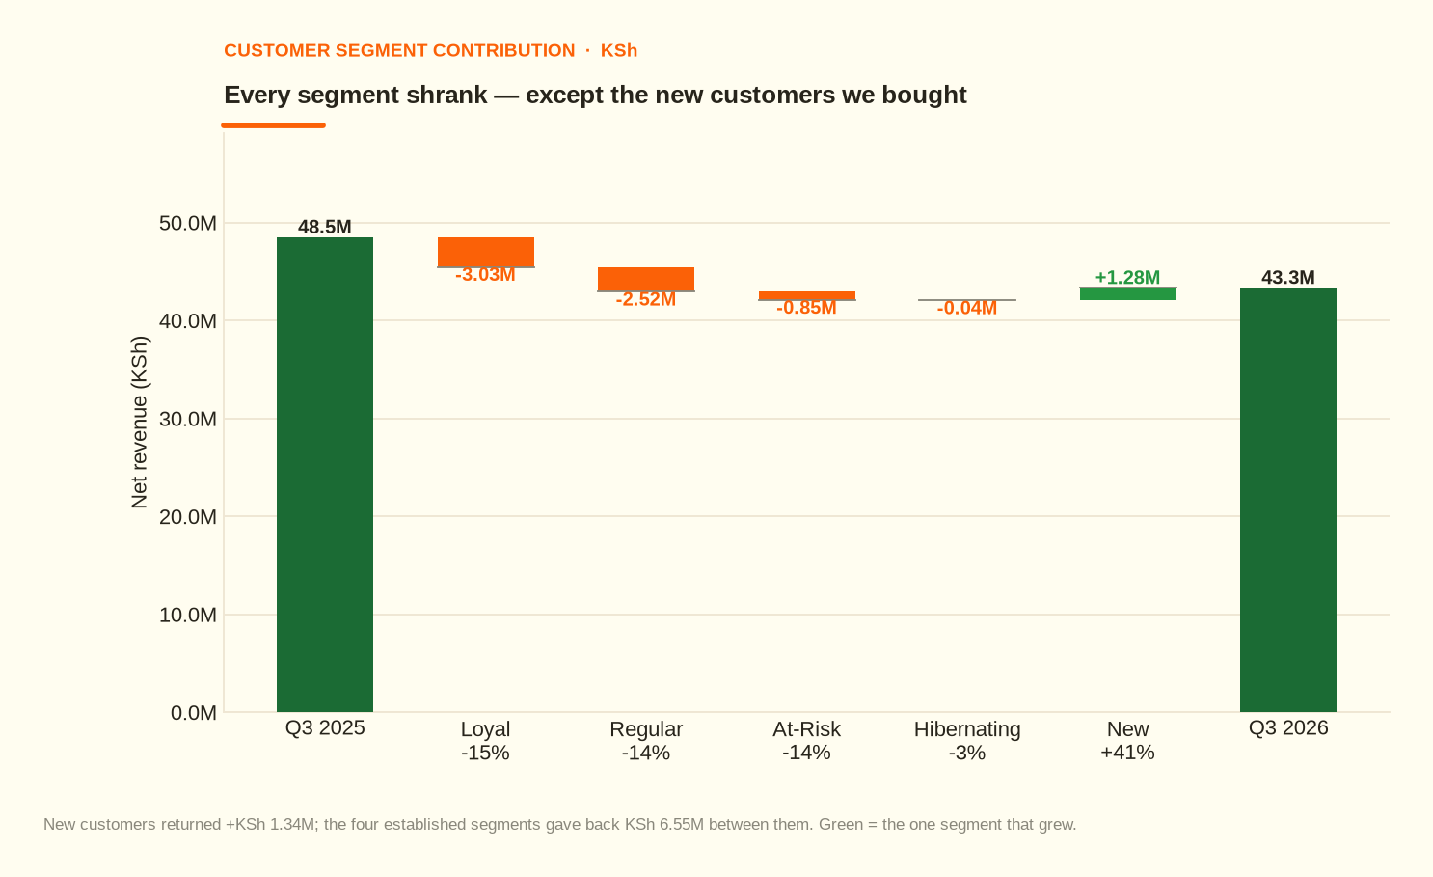
Buying growth is not a strategy while the existing base contracts.
Figure 7 — every established segment shrank except the customers we bought.
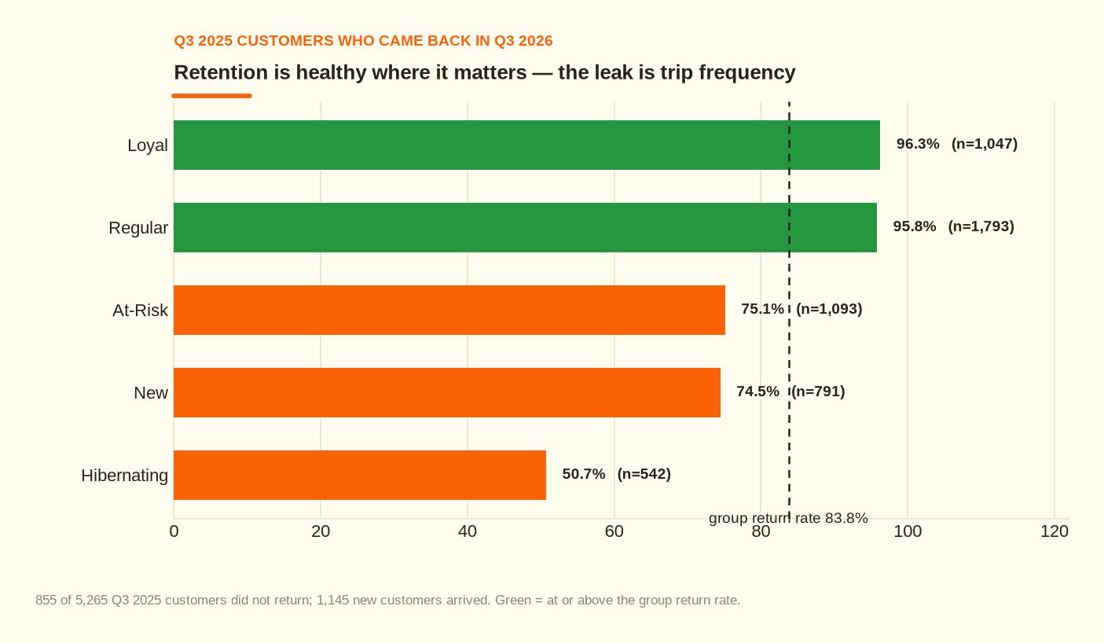
Retention is healthy where it matters. The leak is trip frequency, not churn.
Figure 8 — return rate by base-quarter segment.
SECTION 9

The supply event, with dates
 | Value
Store | Mombasa Nyali
Hero SKUs | Bath Soap 800g
Shelf availability in the incident window | 9.5%
Days out of stock | 76
Total cost attributed | KSh 2.16M
Of which the affected category | KSh 0.45M
Of which basket spillover (other categories) | KSh 1.71M

Why this is evidence, not a story
The shelf-availability table records, per branch, per SKU, per day, whether the item was on the shelf. That is what turns “probably a supply problem” into a dated, store-specific, owned finding.
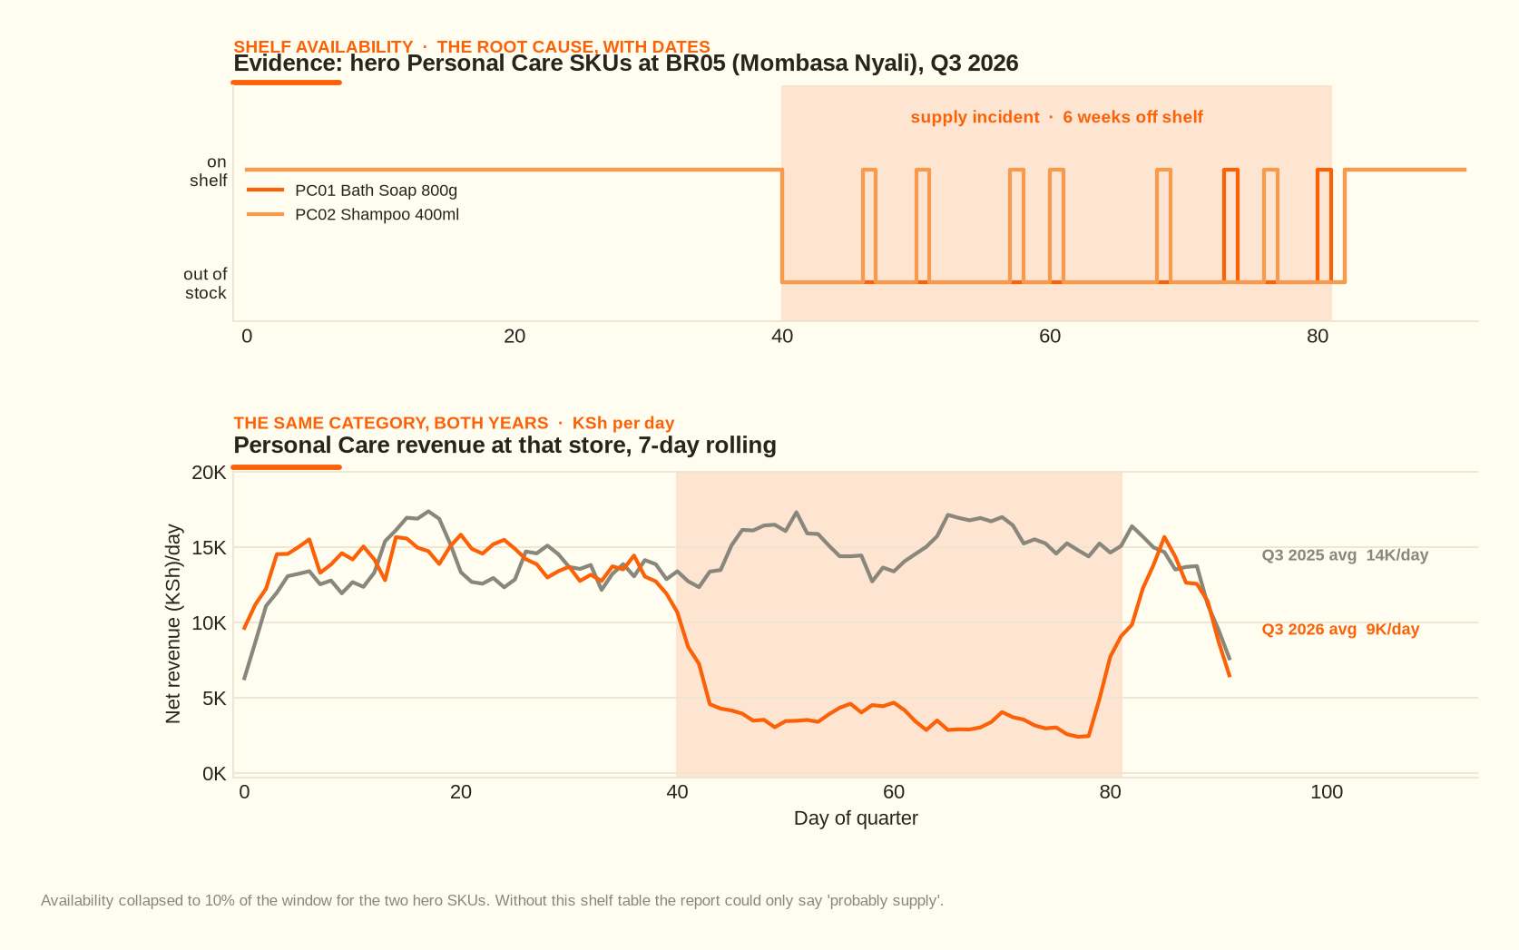
The incident has a start date, an end date, a store and a measurable cost.
Figure 9 — shelf availability and the revenue trace that followed it.
SECTION 10

Pricing, mix and margin
 | Q3 2025 | Q3 2026 | Change
Discount depth (% of gross) | 4.80% | 7.82% | +3.02pp
Gross margin | 19.95% | 18.57% | -1.38pp
Gross profit | KSh 9.68M | KSh 8.04M | -16.9%

Roughly KSh 1.43M of extra discount was given away this quarter, concentrated in Beverages (+13.05pp). Gross profit fell faster than revenue, so margin — not just revenue — is the thing at risk.
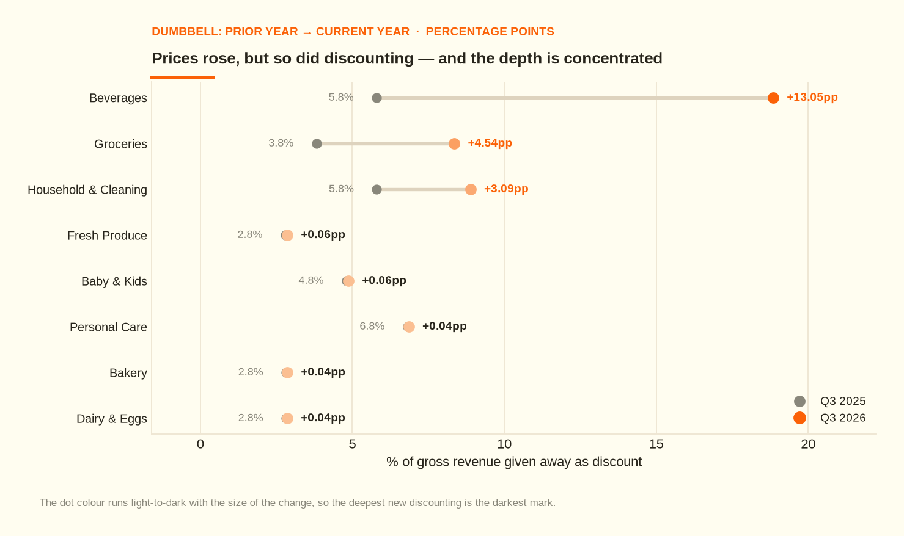
Prices rose, but so did discounting. The depth is concentrated.
Figure 10 — discount depth, prior year vs current year, by category.
SECTION 11

Facts, hypotheses, and the edge of what we know
A senior analysis is judged as much by what it refuses to claim as by what it concludes. Every statement below is tagged.
Statement | Tier | Note
Revenue fell 10.7%; gross profit fell 16.9% | Fact | measured from the cleaned star schema
Two stores explain 71% of the decline | Fact | measured; contribution shares sum to the group change
Hero SKUs were 9.5% available for 76 days at Mombasa Nyali | Fact | from the branch x SKU x day availability table
Active customers rose +5.5% while frequency fell -11.4% | Fact | the mechanism identity, order-independent attribution
The stock-out *caused* the basket erosion at that store | Hypothesis | the two co-move exactly in time; no causal test was run
Single-sourcing or no safety stock caused the stock-out | Hypothesis | no procurement, supplier or lead-time data in this extract
Thika Road's decline is due to the road-works | Hypothesis | the frequency-only signature is consistent with an access problem; no other local factor is recorded
Kisumu Lakefront's -11.5% | Unexplained | flagged, deliberately not back-filled with a story
855 Q3 2025 customers did not return | Fact | but 83.8% did — churn is not the problem
SECTION 12

Predictive — the run-rate if nothing changes
A run-rate, not a forecast
If this quarter's frequency and basket levels persist, the annualised revenue impact is roughly KSh -20.83M (KSh 5.21M x 4). This assumes the Mombasa Nyali incident does not repeat — it should be fixed — and it ignores Q4 seasonality, which is typically stronger. Treat it as the size of the hole, not the shape of the year.

The honest reading: the quarter's damage is stable and repeatable in nature, so the cost of inaction is not zero. It is the run-rate above, minus whatever the actions in Section 13 recover.
SECTION 13

Prescriptive — what to do
Every action carries the four things an action needs to be real: an owner, an expected impact, an evidence link and a review date. Impacts are deliberately conservative and priced in gross profit — they assume partial capture.
# | Action | Owner | Why (evidence) | Expected impact | Review
1 | Rebuild safety stock on the two hero Personal Care SKUs and qualify a second supplier | Supply Chain | Availability was 9.5% for 76 days; the store lost KSh 2.18M | KSh 1.51M – KSh 2.16M | 2026-11-04 (+30d)
2 | Rebuild the Mombasa basket: substitutes on shelf, Personal Care adjacent to Groceries, a substitution script for staff | Merchandising | AOV fell -22.6% while the category alone explains only KSh 0.45M of the KSh 2.16M damage | KSh 0.18M | 2026-11-19 (+45d)
3 | Thika Road access recovery: landlord and county engagement, extended hours, local marketing to restore trips | Retail Operations | Frequency fell -23.7% while basket value held at -0.3% — a pure traffic problem worth KSh 1.49M | KSh 0.89M | 2026-12-04 (+60d)
4 | Cap beverage promotional depth back toward 4.8% of gross and require an approval gate above it | Pricing & Category Management | Beverage discount depth rose +13.05pp; category revenue fell -20.3% | KSh 0.27M | 2026-10-26 (+21d)
5 | Convert the frequency leak: targeted win-back for the 855 lapsed customers and a second-purchase nudge for the 1,145 new ones | CRM / Loyalty | -11.4% trips per customer across all four established segments; residual pool worth KSh 0.97M | KSh 0.49M | 2027-01-03 (+90d)
6 | Capture a customer identifier on every transaction; start logging supplier promised-vs-actual lead times | Data / POS & Supply Chain | 0.76% of revenue is currently unattributable and the root cause of the stock-out is unanswerable | No direct revenue; removes both blind spots | 2027-01-03 (next quarter)

Sequencing and dependencies
- Days 0-30: actions 1 and 4. Both are cheap and reversible, and both stop active bleeding. Action 4 is a policy change; action 1 is a purchase order.
- Days 30-60: actions 2 and 3. These need time to show up in traffic data.
- Days 60-90: action 5, which depends on knowing the base is stable first.
- Continuous: action 6. It is the only item that makes the *next* diagnosis cheaper — and this entire report exists because two data gaps had to be worked around.
SECTION 14

How we will know whether it worked
Track the same five numbers this analysis used, on the same grain, every month. An analysis that never checks its own predictions never improves.
Metric | Baseline | Target by Q1 FY2027 | Watched by
Orders per customer | 5.44 | back above 5.44 | CRM
Hero SKU shelf availability (Mombasa) | 9.5% | >99% | Supply Chain
Thika Road visits per customer | -23.7% YoY | >0% YoY | Retail Ops
Beverage discount depth | 7.82% of gross | <= 4.80% | Pricing
Gross margin | 18.57% | back above 19.95% | Finance
APPENDIX A

Method, provenance and reproducibility
The whole project is a pipeline, not a set of notebooks. Each step consumes the previous step's outputs, so the analysis is reproducible rather than narrated.
Step | What it does
generate_data | simulate the star schema, with planted data-quality defects
clean_data | audit and repair, and write the data-quality report
run_sql | build the SQLite warehouse and run every sql/*.sql
decompose | mechanism, structure and the disjoint driver partition
five_whys | the evidential why-chain, generated from tables
write_report | the findings report and the recommendations register
make_figures | the ten decision charts, in the dashboard's visual language
write_reports | this report, the brief, the deck and the PDF
validate_against_truth | grade the diagnosis against the sealed answer key

Reproduce everything with: python3 src/run_pipeline.py (dataset seed 20260914). Note on the interpreter: the vendored numpy is built for CPython 3.12, so run the pipeline with a 3.12 interpreter that can see pylibs/ — for example make PY=/usr/bin/python3.12.
The dataset is simulated from a documented mechanism (docs/00_ground_truth.md). That is deliberate: it allows the diagnosis to be graded. outputs/validation_report.md records 14/14 falsifiable checks passing.
APPENDIX B

Index of charts
Figure | Section | The sentence it proves
One headline, three mechanisms | Mechanism | The 10.7% fall is one customer gain against two larger losses — it is not one event.
Customers up, frequency down | Mechanism | Acquisition is working; repeat behaviour is not. Different problem, different owner.
Where the money went, by store | Structure | Two stores carry 71% of the decline.
The intersection: store x category | Intersection | The decline is concentrated, not diffuse — so the fix can be too.
Categories: KSh and % side by side | Structure | Groceries is the biggest absolute loss, Beverages the fastest fall. Either alone misleads.
Every segment shrank except the customers we bought | Segments | Buying growth is not a strategy while the existing base contracts.
Who came back | Segments | 83.8% returned — the leak is trips, not churn.
The supply failure, with dates | Evidence | 9.5% availability for 76 days at Mombasa Nyali.
Prices rose, discounting rose faster | Pricing | KSh 1.43M of extra discount in one quarter.
Four ranked, owned problems | Actions | Disjoint and audited: the bars sum to the whole decline with no double counting.
APPENDIX C

The evidential 5-Whys
Every “why” is answered with a number and a source, and the chain stops where the data stops rather than speculating.
Why 1 — Why did group revenue fall?
Net revenue fell KSh 5.17M (10.66%), from KSh 48.49M to KSh 43.32M. Volumes, not customers: active customers ROSE +5.51% while orders fell 6.48%.
Source: mechanism_by_period.csv · No — this is the question, not an answer
Why 2 — Customers grew but orders fell. Why?
Orders per customer fell -11.36% (5.44 -> 4.82 trips), and average order value fell -4.48% (KSh 1,694 -> KSh 1,619). Log-mean attribution puts KSh 2.46M of growth on new customers, KSh 5.53M against frequency and KSh 2.10M against basket value.
Source: mechanism_by_period.csv, decomp_mechanism_waterfall.csv · Partly — it names the mechanism (repeat visits, not acquisition)
Why 3 — Where is the frequency and basket loss concentrated?
Two of six stores explain 71.3% of the entire group decline: Mombasa Nyali (KSh -2.18M, -27.0%) and Thika Road (KSh -1.50M, -18.7%). Frequency fell -11.7% at Mombasa and -23.7% at Thika Road, versus -11.4% for the group.
Source: structure_by_branch.csv, structure_branch_mechanism.csv · Yes for the stores — but not yet for the cause
Why 4 — Why did Mombasa Nyali lose so much more than the rest of the chain?
Its two hero Personal Care SKUs were off the shelf for six weeks: 76 out-of-stock days out of 84 observations (9.5% shelf availability, first gap 2026-08-10). Personal Care revenue at that store fell -34.2% — but Mombasa's average order value also fell -22.6% (KSh 1,724 -> KSh 1,334) against a group AOV change of -4.5%. The missing items cost the whole basket, not just the category.
Source: fact_stockouts, stockout_incident_vs_rest.csv, structure_category_mechanism.csv · Yes — this is a supply-chain event with a date and a store
Why 5 — Why were the SKUs unavailable for six weeks?
The data shows WHAT happened (a 40-day gap on the worst single SKU, longest consecutive outage 33 days) but cannot show WHY. Replenishment, supplier and lead-time data are not in this dataset. Candidate causes — single-sourced supply, no safety stock, a mis-set reorder point — are HYPOTHESES and must be labelled as such until procurement data is pulled.
Source: fact_stockouts (WHY is absent by design) · Stop here: the actionable unit is 'restore stock and dual-source', not 'explain the universe'

