Introduction

The Simple Banking System is a Java-based desktop application designed to simulate the fundamental operations of a real-world banking environment in a simplified manner.
It enables users to perform essential transactions such as depositing and withdrawing money, and to view a detailed transaction history. The system also provides real-time balance updates and ensures that all transactions are securely stored in a database for future reference.
This project aims to bridge the gap between theoretical knowledge of programming concepts and their real-world applications. Through this project, we explore how Java Swing can be used to create user-friendly interfaces and how database systems can be integrated seamlessly to store and manage data efficiently.
In today’s world, banking systems are heavily computerized and automated. Understanding the working mechanism of such systems helps students grasp the importance of data persistence, user interaction, validation, and error handling in software development.
The project demonstrates how an application can provide ease of use, security, and accuracy — three key aspects of financial software.
Furthermore, the project emphasizes object-oriented programming principles such as encapsulation, abstraction, and modularity. The use of event-driven programming through ActionListeners provides hands-on experience in handling GUI events in Java.
Overall, this project not only improves technical programming skills but also helps in understanding the software development life cycle in a miniature yet practical form.

Objectives

The objectives of the project are as follows:
- To design and develop a simple, interactive banking system using Java Swing.
- To perform basic banking operations like deposit, withdrawal, and balance inquiry.
- To ensure data persistence by connecting the application with a database.
- To implement error checking and input validation to prevent incorrect data entry.
- To display transaction history in a clear and organized format.
- To gain practical knowledge in GUI design, event handling, and database connectivity.
- To understand the structure of modular programs and apply object-oriented concepts.

Requirement Specification

Hardware Requirements
- Processor: Intel Core i3 or higher
- RAM: Minimum 4 GB
- Hard Disk: 500 MB free space
- Display: 1024 × 768 resolution or higher
- Input Devices: Keyboard and Mouse
Software Requirements
- Operating System: Windows 10 / 11
- Programming Language: Java (JDK 8 or higher)
- IDE: IntelliJ IDEA / Eclipse / NetBeans
- Database: SQLite or MySQL
- Additional Libraries: JDBC for database connectivity

Design Document

Class Diagram
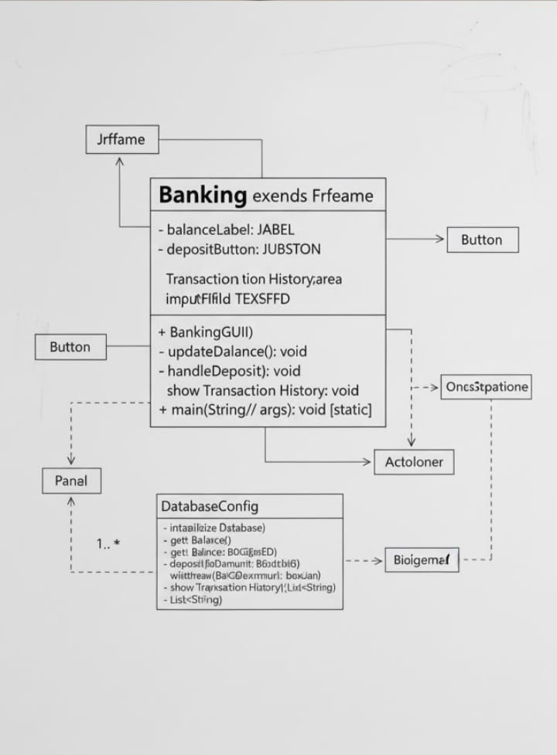
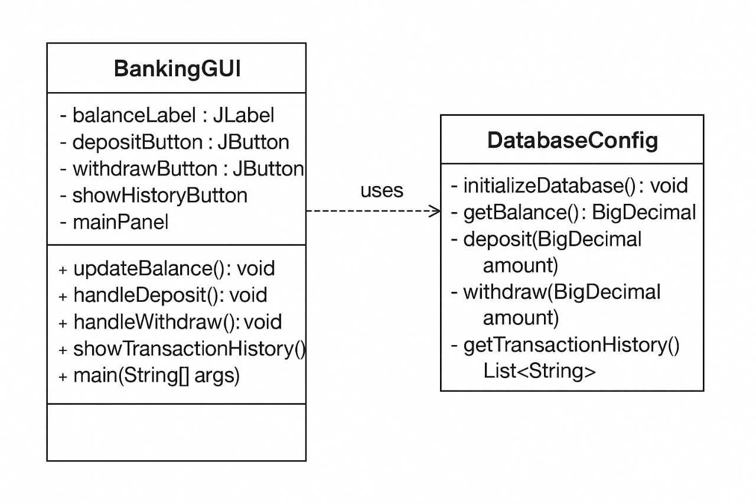

Database Design
Tables:
1. balance
Column Name | Data Type | Description
id | INTEGER | Unique ID for account balance record
amount | DECIMAL(10,2) | Current available balance

2. transactions
Column Name | Data Type | Description
id | INTEGER (Primary Key) | Unique transaction ID
type | TEXT | Type of transaction (“Deposit” / “Withdraw”)
amount | DECIMAL(10,2) | Amount of transaction
Date_time | TEXT | Date and time of transaction

Source Code

User Interface

import javax.swing.*;
import java.awt.*;
import java.awt.event.*;
import java.math.BigDecimal;
import java.util.List;

public class BankingGUI extends JFrame {
private JLabel balanceLabel;
private JButton depositButton;
private JButton withdrawButton;
private JButton showHistoryButton;
private JPanel mainPanel;

public BankingGUI() {
// Initialize database on startup
DatabaseConfig.initializeDatabase();

// Set up the frame
setTitle("Simple Banking System");
setSize(500, 300);
setDefaultCloseOperation(JFrame.EXIT_ON_CLOSE);
setLocationRelativeTo(null);

// Create main panel with BorderLayout
mainPanel = new JPanel(new BorderLayout(10, 10));
mainPanel.setBorder(BorderFactory.createEmptyBorder(20, 20, 20, 20));

// Create top panel for balance display
JPanel topPanel = new JPanel();
topPanel.setBackground(new Color(70, 130, 180));
topPanel.setPreferredSize(new Dimension(0, 80));

balanceLabel = new JLabel();
balanceLabel.setFont(new Font("Arial", Font.BOLD, 24));
balanceLabel.setForeground(Color.WHITE);
updateBalance(); // Load initial balance
topPanel.add(balanceLabel);

// Create center panel for buttons
JPanel buttonPanel = new JPanel(new GridLayout(1, 3, 15, 0));

// Deposit button
depositButton = new JButton("Deposit");
depositButton.setFont(new Font("Arial", Font.BOLD, 16));
depositButton.setBackground(new Color(60, 179, 113));
depositButton.setForeground(Color.WHITE);
depositButton.setFocusPainted(false);
depositButton.addActionListener(new ActionListener() {
@Override
public void actionPerformed(ActionEvent e) {
handleDeposit();
}
});

// Withdraw button
withdrawButton = new JButton("Withdraw");
withdrawButton.setFont(new Font("Arial", Font.BOLD, 16));
withdrawButton.setBackground(new Color(220, 20, 60));
withdrawButton.setForeground(Color.WHITE);
withdrawButton.setFocusPainted(false);
withdrawButton.addActionListener(new ActionListener() {
@Override
public void actionPerformed(ActionEvent e) {
handleWithdraw();
}
});

// Show History button
showHistoryButton = new JButton("Show History");
showHistoryButton.setFont(new Font("Arial", Font.BOLD, 16));
showHistoryButton.setBackground(new Color(255, 165, 0));
showHistoryButton.setForeground(Color.WHITE);
showHistoryButton.setFocusPainted(false);
showHistoryButton.addActionListener(new ActionListener() {
@Override
public void actionPerformed(ActionEvent e) {
showTransactionHistory();
}
});

// Add buttons to panel
buttonPanel.add(depositButton);
buttonPanel.add(withdrawButton);
buttonPanel.add(showHistoryButton);

// Add components to main panel
mainPanel.add(topPanel, BorderLayout.NORTH);
mainPanel.add(buttonPanel, BorderLayout.CENTER);

// Add main panel to frame
add(mainPanel);
}

// Update balance display
private void updateBalance() {
BigDecimal balance = DatabaseConfig.getBalance();
balanceLabel.setText(String.format("Current Balance: ₹%.2f", balance));
}

// Handle deposit operation
private void handleDeposit() {
String input = JOptionPane.showInputDialog(
this,
"Enter amount to deposit:",
"Deposit",
JOptionPane.QUESTION_MESSAGE
);

// Check if user cancelled
if (input == null || input.trim().isEmpty()) {
return;
}

try {
BigDecimal amount = new BigDecimal(input);

// Validate amount
if (amount.compareTo(BigDecimal.ZERO) <= 0) {
JOptionPane.showMessageDialog(
this,
"Please enter a positive amount!",
"Invalid Amount",
JOptionPane.ERROR_MESSAGE
);
return;
}

// Perform deposit
if (DatabaseConfig.deposit(amount)) {
updateBalance(); // Update balance in real-time
JOptionPane.showMessageDialog(
this,
String.format("Successfully deposited ₹%.2f", amount),
"Success",
JOptionPane.INFORMATION_MESSAGE
);
} else {
JOptionPane.showMessageDialog(
this,
"Deposit failed. Please try again.",
"Error",
JOptionPane.ERROR_MESSAGE
);
}
} catch (NumberFormatException e) {
JOptionPane.showMessageDialog(
this,
"Please enter a valid number!",
"Invalid Input",
JOptionPane.ERROR_MESSAGE
);
}
}

// Handle withdraw operation
private void handleWithdraw() {
String input = JOptionPane.showInputDialog(
this,
"Enter amount to withdraw:",
"Withdraw",
JOptionPane.QUESTION_MESSAGE
);

// Check if user cancelled
if (input == null || input.trim().isEmpty()) {
return;
}

try {
BigDecimal amount = new BigDecimal(input);

// Validate amount
if (amount.compareTo(BigDecimal.ZERO) <= 0) {
JOptionPane.showMessageDialog(
this,
"Please enter a positive amount!",
"Invalid Amount",
JOptionPane.ERROR_MESSAGE
);
return;
}

// Check sufficient balance
BigDecimal currentBalance = DatabaseConfig.getBalance();
if (currentBalance.compareTo(amount) < 0) {
JOptionPane.showMessageDialog(
this,
String.format("Insufficient balance! Current balance: ₹%.2f", currentBalance),
"Insufficient Funds",
JOptionPane.WARNING_MESSAGE
);
return;
}

// Perform withdrawal
if (DatabaseConfig.withdraw(amount)) {
updateBalance(); // Update balance in real-time
JOptionPane.showMessageDialog(
this,
String.format("Successfully withdrawn ₹%.2f", amount),
"Success",
JOptionPane.INFORMATION_MESSAGE
);
} else {
JOptionPane.showMessageDialog(
this,
"Withdrawal failed. Please try again.",
"Error",
JOptionPane.ERROR_MESSAGE
);
}
} catch (NumberFormatException e) {
JOptionPane.showMessageDialog(
this,
"Please enter a valid number!",
"Invalid Input",
JOptionPane.ERROR_MESSAGE
);
}
}

// Show transaction history
private void showTransactionHistory() {
List<String> history = DatabaseConfig.getTransactionHistory();

if (history.isEmpty()) {
JOptionPane.showMessageDialog(
this,
"No transactions found.",
"Transaction History",
JOptionPane.INFORMATION_MESSAGE
);
return;
}

// Create a text area to display history
JTextArea textArea = new JTextArea(20, 50);
textArea.setEditable(false);
textArea.setFont(new Font("Monospaced", Font.PLAIN, 12));

StringBuilder sb = new StringBuilder();
sb.append("TRANSACTION TYPE | AMOUNT | DATE & TIME\n");
sb.append("=".repeat(70)).append("\n");

for (String transaction : history) {
sb.append(transaction).append("\n");
}

textArea.setText(sb.toString());

JScrollPane scrollPane = new JScrollPane(textArea);
JOptionPane.showMessageDialog(
this,
scrollPane,
"Transaction History",
JOptionPane.PLAIN_MESSAGE
);
}

// Main method to run the application
public static void main(String[] args) {
// Use Swing's event dispatch thread for GUI operations
SwingUtilities.invokeLater(new Runnable() {
@Override
public void run() {
try {
UIManager.setLookAndFeel(UIManager.getSystemLookAndFeelClassName());
} catch (Exception e) {
e.printStackTrace();
}

BankingGUI gui = new BankingGUI();
gui.setVisible(true);
}
});
}
}

Backend

import java.math.BigDecimal;
import java.sql.*;
import java.util.ArrayList;
import java.util.List;

public class DatabaseConfig {
private static final String URL = "jdbc:postgresql://localhost:5432/banking_db";
private static final String USER = "postgres";
private static final String PASSWORD = "tiger"; // Change this

// Get database connection
public static Connection getConnection() throws SQLException {
try {
Class.forName("org.postgresql.Driver");
} catch (ClassNotFoundException e) {
System.err.println("PostgreSQL JDBC Driver not found.");
e.printStackTrace();
}
return DriverManager.getConnection(URL, USER, PASSWORD);
}

// Initialize database tables (run once)
public static void initializeDatabase() {
String createAccountTable = "CREATE TABLE IF NOT EXISTS account (" +
"id SERIAL PRIMARY KEY, " +
"balance NUMERIC(10,2) DEFAULT 0)";

String createTransactionsTable = "CREATE TABLE IF NOT EXISTS transactions (" +
"id SERIAL PRIMARY KEY, " +
"trans_type VARCHAR(10), " +
"amount NUMERIC(10,2), " +
"trans_time TIMESTAMP DEFAULT CURRENT_TIMESTAMP)";

String insertInitialAccount = "INSERT INTO account (balance) " +
"SELECT 0 WHERE NOT EXISTS (SELECT 1 FROM account WHERE id = 1)";

try (Connection conn = getConnection();
Statement stmt = conn.createStatement()) {

stmt.execute(createAccountTable);
stmt.execute(createTransactionsTable);
stmt.execute(insertInitialAccount);
System.out.println("Database initialized successfully!");

} catch (SQLException e) {
System.err.println("Error initializing database: " + e.getMessage());
}
}

// Get current balance
public static BigDecimal getBalance() {
String query = "SELECT balance FROM account WHERE id = 1";

try (Connection conn = getConnection();
Statement stmt = conn.createStatement();
ResultSet rs = stmt.executeQuery(query)) {

if (rs.next()) {
return rs.getBigDecimal("balance");
}
} catch (SQLException e) {
System.err.println("Error fetching balance: " + e.getMessage());
}
return BigDecimal.ZERO;
}

// Deposit money
public static boolean deposit(BigDecimal amount) {
if (amount.compareTo(BigDecimal.ZERO) <= 0) {
return false;
}

Connection conn = null;
try {
conn = getConnection();
conn.setAutoCommit(false); // Start transaction

String updateBalance = "UPDATE account SET balance = balance + ? WHERE id = 1";
String insertTransaction = "INSERT INTO transactions (trans_type, amount) VALUES (?, ?)";

try (PreparedStatement pstmt1 = conn.prepareStatement(updateBalance);
PreparedStatement pstmt2 = conn.prepareStatement(insertTransaction)) {

// Update balance
pstmt1.setBigDecimal(1, amount);
pstmt1.executeUpdate();

// Insert transaction record
pstmt2.setString(1, "DEPOSIT");
pstmt2.setBigDecimal(2, amount);
pstmt2.executeUpdate();

conn.commit(); // Commit transaction
return true;
}
} catch (SQLException e) {
if (conn != null) {
try {
conn.rollback(); // Rollback on error
} catch (SQLException ex) {
System.err.println("Rollback failed: " + ex.getMessage());
}
}
System.err.println("Deposit failed: " + e.getMessage());
return false;
} finally {
if (conn != null) {
try {
conn.setAutoCommit(true);
conn.close();
} catch (SQLException e) {
System.err.println("Error closing connection: " + e.getMessage());
}
}
}
}

// Withdraw money
public static boolean withdraw(BigDecimal amount) {
if (amount.compareTo(BigDecimal.ZERO) <= 0) {
return false;
}

BigDecimal currentBalance = getBalance();
if (currentBalance.compareTo(amount) < 0) {
return false; // Insufficient balance
}

Connection conn = null;
try {
conn = getConnection();
conn.setAutoCommit(false); // Start transaction

String updateBalance = "UPDATE account SET balance = balance - ? WHERE id = 1";
String insertTransaction = "INSERT INTO transactions (trans_type, amount) VALUES (?, ?)";

try (PreparedStatement pstmt1 = conn.prepareStatement(updateBalance);
PreparedStatement pstmt2 = conn.prepareStatement(insertTransaction)) {

// Update balance
pstmt1.setBigDecimal(1, amount);
pstmt1.executeUpdate();

// Insert transaction record
pstmt2.setString(1, "WITHDRAW");
pstmt2.setBigDecimal(2, amount);
pstmt2.executeUpdate();

conn.commit(); // Commit transaction
return true;
}
} catch (SQLException e) {
if (conn != null) {
try {
conn.rollback(); // Rollback on error
} catch (SQLException ex) {
System.err.println("Rollback failed: " + ex.getMessage());
}
}
System.err.println("Withdrawal failed: " + e.getMessage());
return false;
} finally {
if (conn != null) {
try {
conn.setAutoCommit(true);
conn.close();
} catch (SQLException e) {
System.err.println("Error closing connection: " + e.getMessage());
}
}
}
}

// Get transaction history
public static List<String> getTransactionHistory() {
List<String> history = new ArrayList<>();
String query = "SELECT trans_type, amount, trans_time FROM transactions ORDER BY trans_time DESC";

try (Connection conn = getConnection();
Statement stmt = conn.createStatement();
ResultSet rs = stmt.executeQuery(query)) {

while (rs.next()) {
String type = rs.getString("trans_type");
BigDecimal amount = rs.getBigDecimal("amount");
Timestamp time = rs.getTimestamp("trans_time");

String record = String.format("%s | ₹%.2f | %s", type, amount, time);
history.add(record);
}
} catch (SQLException e) {
System.err.println("Error fetching transaction history: " + e.getMessage());
}
return history;
}
}

User Manual

Steps to Run the Application
- Open the project folder in your preferred Java IDE.
- Ensure that the DatabaseConfig file initializes the database before running the GUI.
- Compile and run BankingGUI.java.
- The main window will appear showing the current balance.
- Use the Deposit button to add money. Enter a valid numeric amount when prompted.
- Use the Withdraw button to withdraw money. The system will check for sufficient balance.
- Use the Show History button to view all your transactions in a scrollable text area.
- Close the application — all data will remain stored in the database for the next session.
Key Features
- Real-time balance update after each transaction.
- Input validation for positive numbers and sufficient balance checks.
- Readable transaction history with timestamps.
- Clean and responsive user interface.

Test Cases

Test Case ID | Description | Input | Expected Output | Result
TC001 | Deposit a valid amount | ₹1000 | Balance increases by ₹1000 | Pass
TC002 | Deposit invalid amount | -₹500 | Error: “Please enter a positive amount” | Pass
TC003 | Withdraw valid amount | ₹500 | Balance decreases by ₹500 | Pass
TC004 | Withdraw more than balance | ₹5000 (when balance < ₹5000) | Warning: “Insufficient balance” | Pass
TC005 | View transaction history | Click “Show History” | All past transactions displayed | Pass
TC006 | Cancel input dialog | Click cancel | No change to balance | Pass

Conclusion

The Simple Banking System project successfully fulfills the requirements of a basic banking application using Java.
It provides a complete implementation of deposit, withdraw, and transaction history features, combined with an intuitive and responsive graphical user interface.
The project demonstrates how simple yet powerful applications can be built using Java Swing and JDBC for database operations.
Through this project, valuable insights were gained into various software development concepts, including:
- Graphical User Interface design using Swing components.
- Event-driven programming through ActionListeners.
- Database integration and real-time data updates.
- Importance of input validation, error handling, and user feedback.
Additionally, the project emphasizes modularity and maintainability, as functions such as deposit, withdrawal, and history are implemented in well-defined methods.
The system is reliable, efficient, and scalable for future improvements such as adding login authentication, multiple accounts, or online transaction features.
Overall, this project strengthened the understanding of Java programming, object-oriented principles, and real-world software design, marking a significant step in practical software development learning.

