Digital Forensic Investigation Report
Case Lab_01 — Ch01InChap01.dd
Prepared by David | ICDFA E-CAMPUS | 30 August 2026
This report documents the acquisition handling, hashing, chain-of-custody, and file-system analysis performed against the raw forensic disk image Ch01InChap01.dd using The Sleuth Kit (TSK) and Autopsy on a Kali Linux workstation. The objective was to identify and recover deleted files from a FAT12 file system and verify recovered data through independent extraction methods and hash comparison.

1. Workspace Initialization and Evidence Preservation
- Directory Setup: The working environment was established by creating structured directories for evidence, exports, and documentation using mkdir -p Lab_01/Evidence Lab_01/Export Lab_01/Documentation.
- Evidence Protection: The target image Ch01InChap01.dd was moved into Lab_01/Evidence and locked to read-only with chmod 444 to prevent any accidental modification during analysis.
- Visual Documentation: Terminal logs (below) capture workspace creation, file relocation, and permission locking.
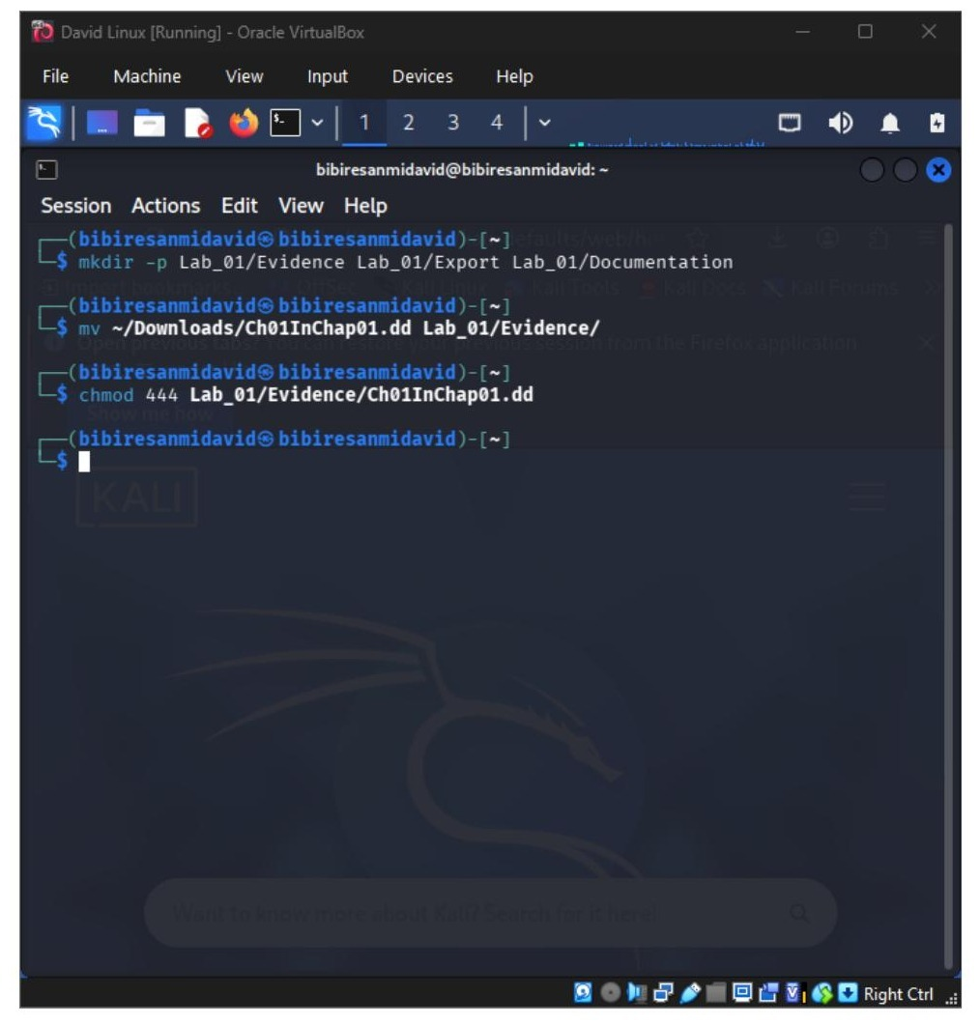
Figure 1. Directory setup, evidence relocation, and read-only permission lock.

2. Evidence Hashing and Chain of Custody
Cryptographic baselines were generated for the evidence file before any diagnostic tool was run against it, establishing an unbroken integrity record.
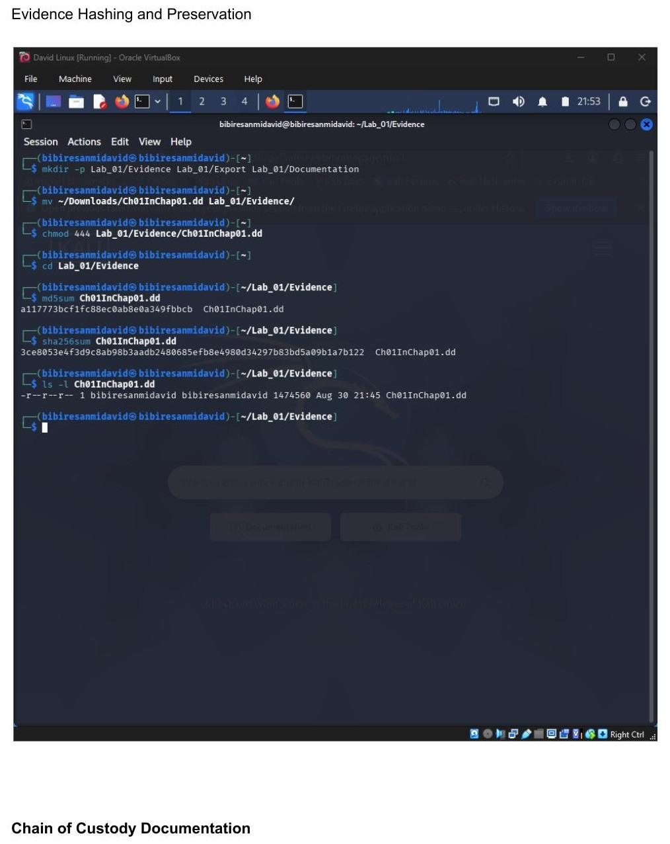
Figure 2. MD5 and SHA-256 hash generation and file listing (evidence hashing and preservation).

Chain of Custody Worksheet
Item Description | Ch01InChap01.dd (Raw forensic disk image)
Source / Acquisition | ICDFA E-CAMPUS
Storage Location | ~/Lab_01/Evidence
File Size | 1,474,560 bytes
Sector Size | 512 bytes
MD5 Hash | a117773bcf1fc88ec0ab8e0a349fbbcb
SHA-256 Hash | 3ce8053e4f3d9c8ab98b3aadb2480685efb8e4980d34297b83bd5a09b1a7b122
Permissions Applied | chmod 444 (read-only, all users)
Date/Time Secured | 30/08/2026, 21:57

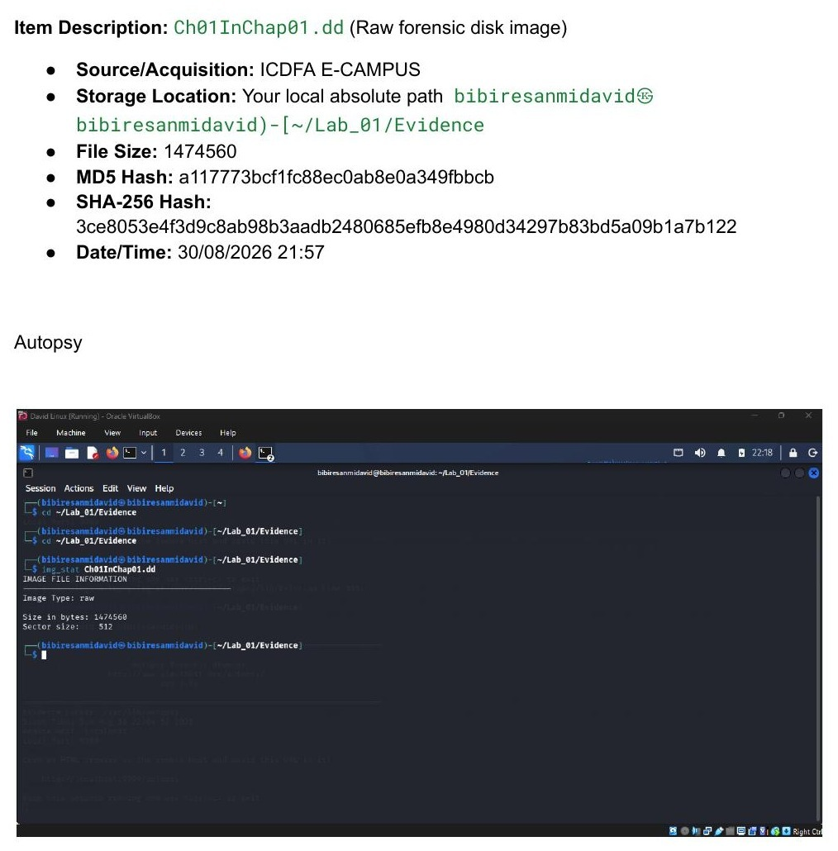
Figure 3. Chain-of-custody item description and initial img_stat output in Autopsy.

3. File System and Metadata Analysis (The Sleuth Kit)

3.1 Image Statistics (img_stat)
Confirmed the raw image corresponds to a standard 1.44 MB floppy-disk medium with 512-byte sectors (1,474,560 bytes total).

3.2 Partition Layout (mmls / fsstat)
mmls returned no partition table, consistent with raw floppy disk media. fsstat identified the underlying structure as a FAT12 file system, with the FAT and root directory areas mapped to sectors 1–18 and 19–32 respectively.
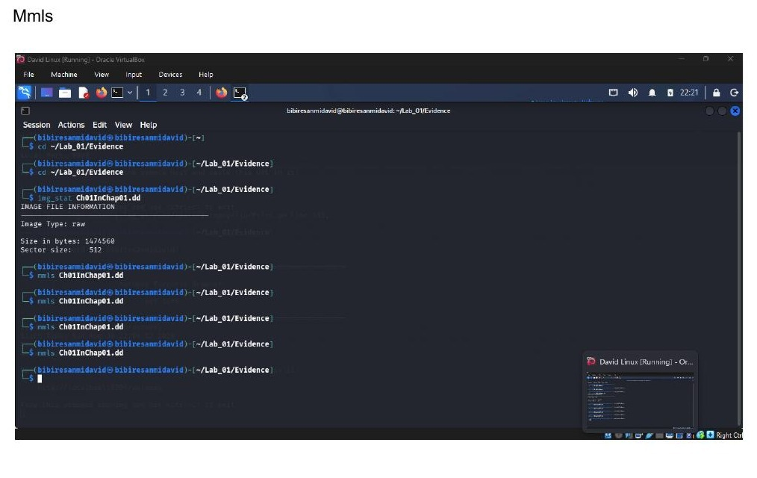
Figure 4a. mmls output — no partition table present.
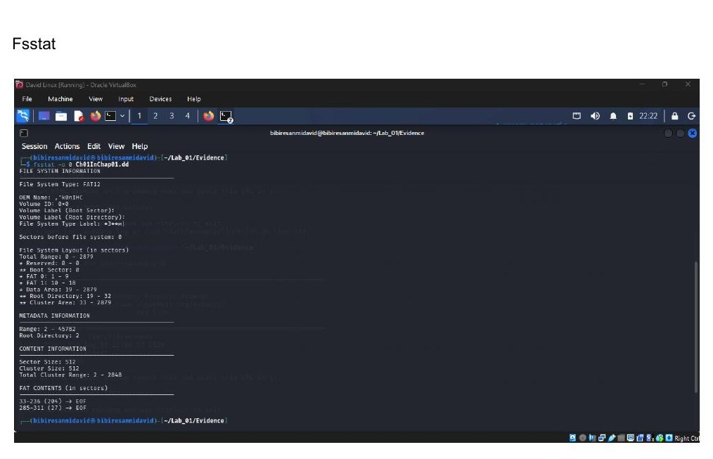
Figure 4b. fsstat output — FAT12 file system layout and metadata ranges.

3.3 File Listings (fls)
Recursive deleted-file analysis surfaced deleted artifacts still resident on the volume, including Billing Letter.doc, confirmation.txt, letter1.txt, and INCOME.XLS.

3.4 Metadata Examination (istat)
Querying metadata address 13 for INCOME.XLS returned an allocated file size of 13,824 bytes with active file attributes, and data blocks spanning sectors 285–311 (27 contiguous sectors).
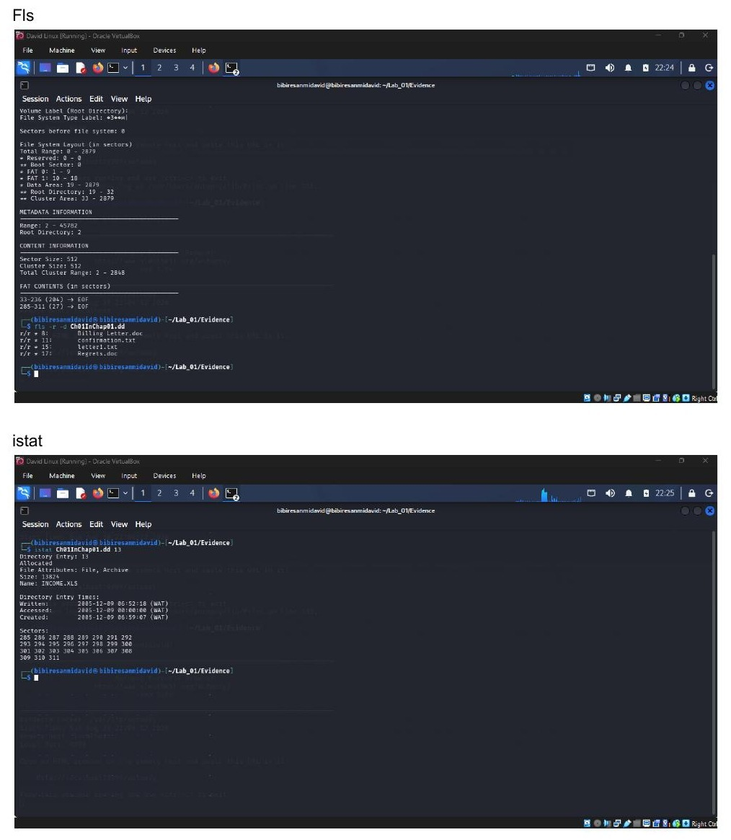
Figure 5. fls deleted-file listing and istat metadata for INCOME.XLS (address 13).

4. Evidence Extraction and Verification

4.1 Automated Recovery (tsk_recover)
Automated file carving was run against the image to export all recoverable content into an isolated tsk_output directory (2 files recovered).
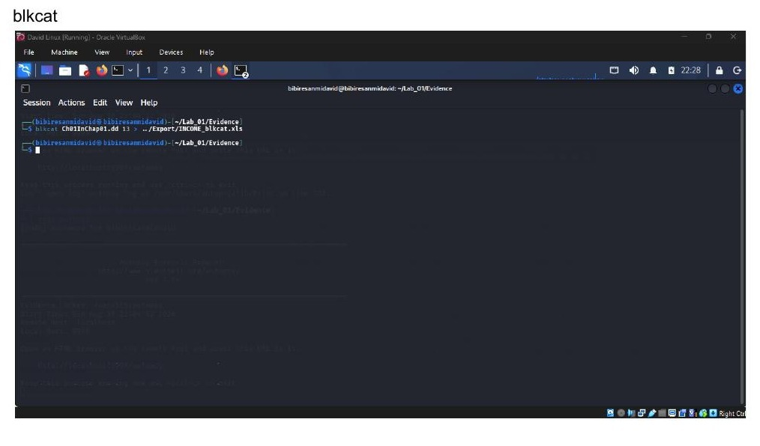
Figure 6a. blkcat initial extraction attempt.
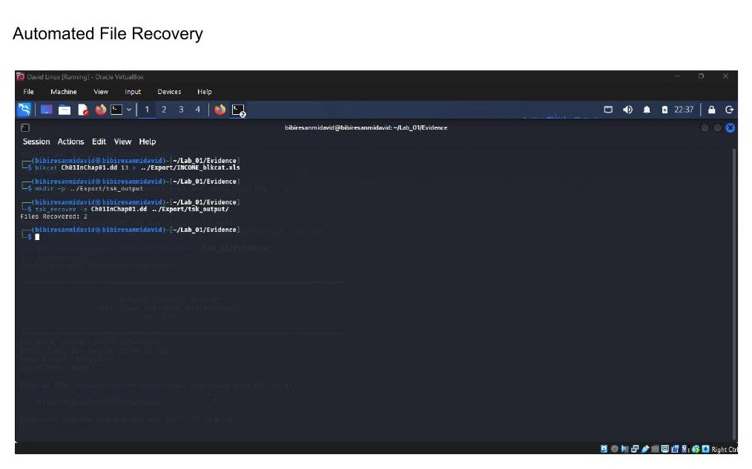
Figure 6b. tsk_recover automated file recovery into tsk_output/.

4.2 Manual Sector-Level Recovery (blkcat)
The exact data blocks were also extracted manually using the sector range identified by istat:
blkcat Ch01InChap01.dd 285 27 > ../Export/INCOME_blkcat_fixed.xls
Note: an initial blkcat attempt using an assumed sector number failed with an “Invalid block address” error. The correct starting sector (285) and length (27 sectors) were derived directly from the istat output for metadata address 13 rather than estimated, and the extraction was re-run successfully with that corrected sector range.
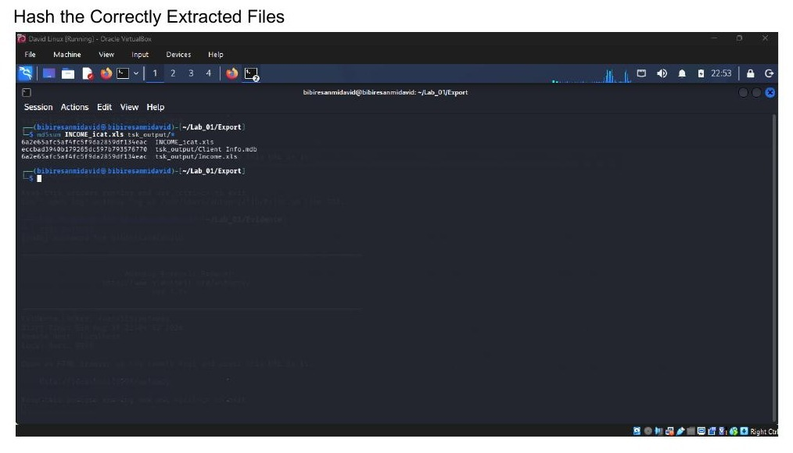
Figure 7a. Hashing the correctly extracted files (icat and tsk_recover outputs).
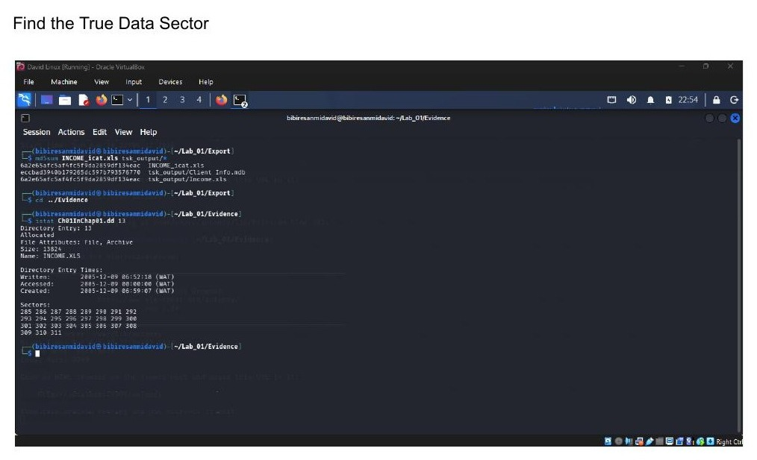
Figure 7b. Locating the true data sector via istat before re-extraction.
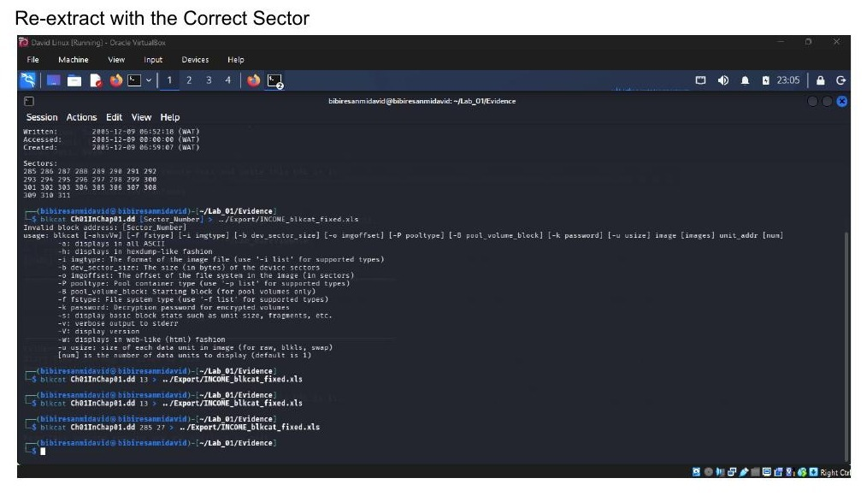
Figure 8a. Re-extracting with the corrected sector address (285, 27).
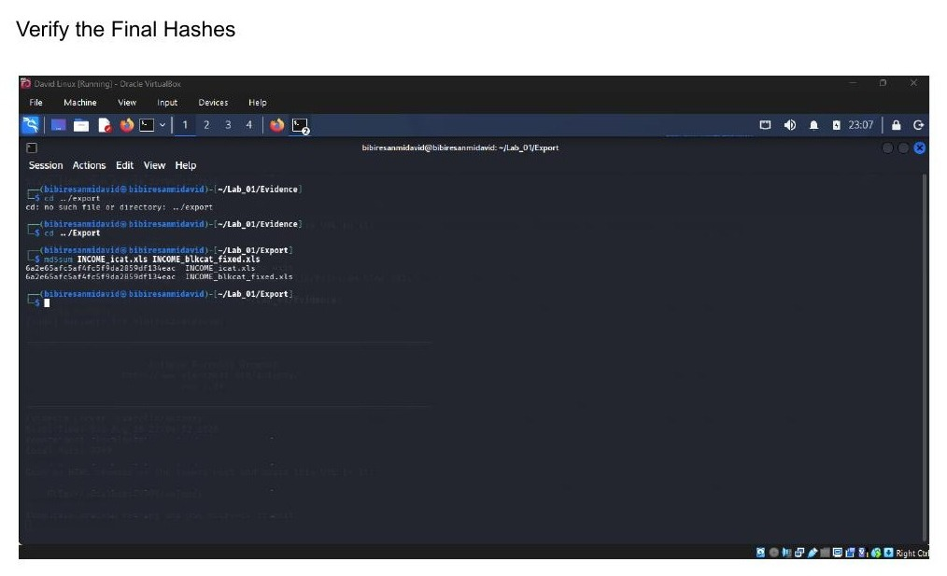
Figure 8b. Verifying the final md5sum hashes across all three extraction methods.

4.3 Hash Verification (md5sum)
The recovered copies produced by all three independent methods — icat, tsk_recover, and blkcat — were compared and found to be cryptographically identical:

File | MD5 Hash
INCOME_icat.xls (icat, metadata addr 13) | 6a2e65afc5af4fc5f9da2859df134eac
tsk_output/Income.xls (tsk_recover) | 6a2e65afc5af4fc5f9da2859df134eac
INCOME_blkcat_fixed.xls (blkcat, sectors 285+27) | 6a2e65afc5af4fc5f9da2859df134eac

This match across three independently executed extraction methods confirms that the recovered INCOME.XLS content is complete and unaltered.

4.4 Functional Integrity Check (file / LibreOffice)
The recovered spreadsheet was validated with the file command and opened in LibreOffice to confirm structural integrity. It was identified as a genuine Microsoft Excel Composite Document File V2 document (Windows, code page 1252), authored by “Amelia Phillips,” last saved by “Amelia Phillips,” created 23 Nov 2002 and last saved 09 Dec 2005 — consistent, well-formed header metadata with no signs of corruption.
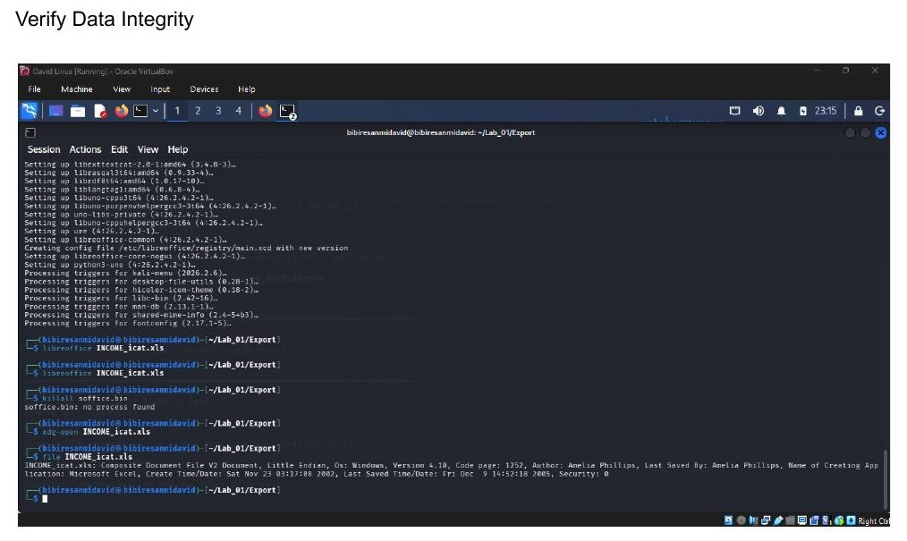
Figure 9. file command output and successful LibreOffice rendering of the recovered INCOME.xls.

5. Conclusion
The evidence file Ch01InChap01.dd was preserved, hashed, and documented in accordance with standard chain-of-custody practice prior to any analysis. File-system examination with The Sleuth Kit identified a FAT12 volume containing several deleted files, and INCOME.XLS was successfully recovered using three independent methods (icat, tsk_recover, and manual blkcat sector extraction). All three recoveries produced matching MD5 hashes, and the recovered file passed a functional integrity check, confirming a forensically sound and reproducible recovery.

