# Informasjon om opphavsrett i skjermen "Vis innførsel"

F. eks.: http://brage-utvikle.bibsys.no/xmlui/handle/11250.1/38773009

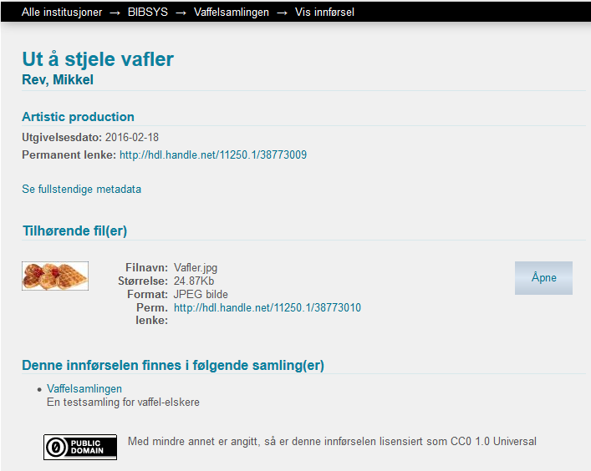

### Nye fortekster:

**modules > xmlui > src > main > webapp > i18n > messages_no.xml**

Ny linje: <message key=*"xmlui.dri2xhtml.METS-1.0.item-copyright"*>Opphavsrett</message>

**modules > xmlui > src > main > webapp > i18n > messages.xml**

Ny linje: <message key=*"xmlui.dri2xhtml.METS-1.0.item-copyright"*>Copyright</message>

### Fortekster + data:

**modules > src > main > webapp > themes > common > aspect > artifactbrowser > item-view.xsl**

Ny kode:

<!— copyright row -->

**<xsl:when test**=*"$clause = 11 and (dim:field[@element='rights'][@qualifier='holder'])"***>**

<div class="simple-item-view-other">

<span class="bold"><i18n:text>xmlui.dri2xhtml.METS-1.0.item-copyright</i18n:text>:</span>

<span>

**<xsl:for-each select**=*"dim:field[@element='rights' and @qualifier='holder']"***>**

**<xsl:value-of select**=*"./node()"***/>**

**<xsl:if test**=*"count(following-sibling::dim:field[@element='rights' and @qualifier='holder']) != 0"***>**

<br/>

**</xsl:if>**

**</xsl:for-each>**

</span>

</div>

**<xsl:call-template name**=*"itemSummaryView-DIM-fields"***>**

**<xsl:with-param name**=*"clause"* **select**=*"($clause + 1)"***/>**

**<xsl:with-param name**=*"phase"* **select**=*"$otherPhase"***/>**

**</xsl:call-template>**

**</xsl:when>**