**LAMP Data Examples**

The following are examples of what we learn from the data collected from the LAMP app. Data collected is not identifiable or used to track you. It is shared with no one outside the study. But you can always access, see, and keep any data you collect. Comparing your different data types may help answer questions like how does taking more steps impact my mood or how is my anxiety different when I am alone or with friends.

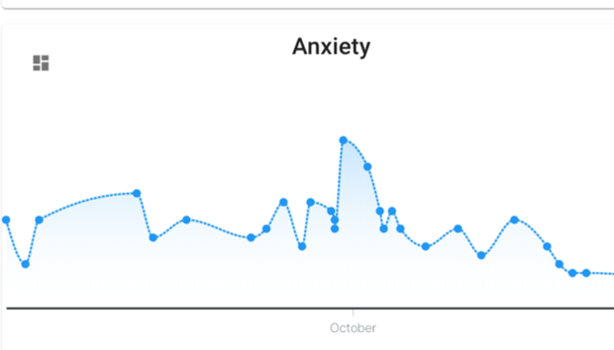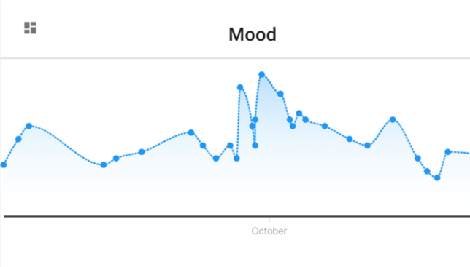



**SURVEYS**

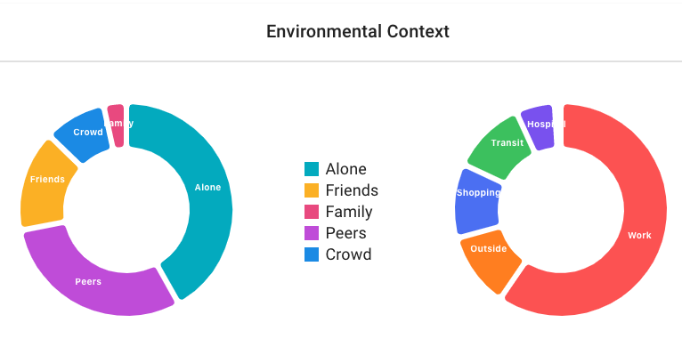****



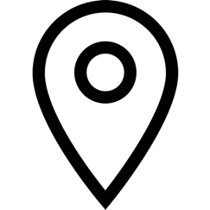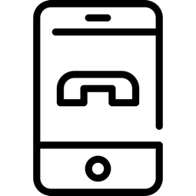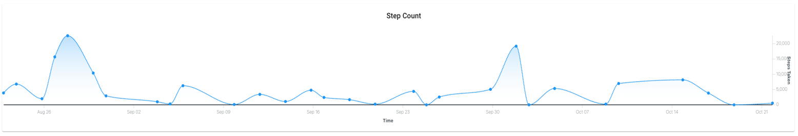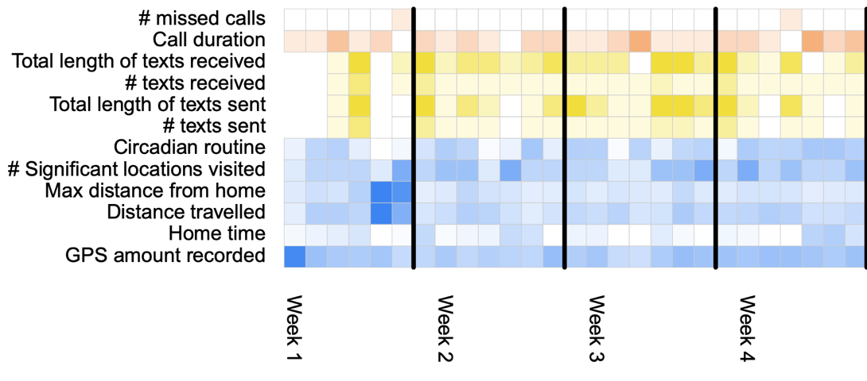

**ENVIRONMENT**

**GPS & CALL/TEXT LOGS**

**STEPS**

**STEPS**