**Annotation Guidelines for Main Clinical Entities and Modifiers**

Version Number: 1.1

**By**

Yujia Zhou

Kalpana Raja

September 21, 2022

**Table of contents**

|  |  |
| --- | --- |
| **Topic** | **Page** |
| 1 Introduction | 1 |
| 2 Main entities | 3 |
| 2.1 General guidelines | 3 |
| 2.2 Specific guidelines | 6 |
| 2.2.1 Problem | 6 |
| 2.2.2 Treatment | 8 |
| 2.2.3 Drug | 9 |
| 2.2.4 Test | 10 |
| 2.3 Miscellaneous examples and annotation guidelines | 12 |
| 3 Modifiers and Relations | 13 |
| 3.1 General guidelines for entity - modifier relation | 13 |
| 3.2 Specific guidelines for each entity - modifier relation | 17 |
| 3.2.1 Problem - Modifier relation | 17 |
| 3.2.2 Treatment - Modifier relation | 22 |
| 3.2.3 Drug - Modifier relation | 24 |
| 3.2.4 Test - Modifier relation | 28 |

**1 Introduction**

This annotation guideline describes the annotation of main clinical entities, the related modifiers and the relation between them.

The main clinical entities to be annotated are problem, treatment, drug, and test (see Table 1 for details).

The modifiers to be annotated are specific to the clinical entities. For example, the modifiers such as severity and bodyloc (body location) are specific to the problem, a clinical entity. In the current study, eight modifiers should be annotated for the problem entity (see Table 2 for details), two modifiers should be annotated for the treatment entity (see Table 3 for details), eight modifiers should be annotated for the drug entity (see Table 4 for details), and four modifiers should be annotated for the test entity (see Table 5 for details).

The modifiers are always related to a clinical entity. The relation between a modifier and a clinical entity should also be annotated.

**Table 1. Main entities**

|  |  |
| --- | --- |
| Entity Name | Definition |
| Problem | The abnormal condition that happens physically or mentally to a patient |
| Treatment | The procedures, interventions, and substances given to a patient for treating a problem |
| Drug | Generic or brand name of a single medication or a collective name of a group of medication |
| Test | A medical procedure performed (i) to detect or diagnose a problem, (ii) to monitor diseases, disease processes, and susceptibility, or (iii) to determine a course of treatment |

**Table 2. Modifiers for problem**

|  |  |
| --- | --- |
| Modifier Name | Definition |
| Severity | The degree of intensity of a clinical condition |
| Condition | A phrase that indicates the problems existing in a certain situation |
| Uncertain | A measure of doubt related to problem |
| Subject | The person who experiences the problem |
| Bodyloc | The location on the body where the observation is present |
| Course | The development or alteration of a problem |
| Temporal | Calendar date, time, or duration related to a problem |
| Negation | The phrase that indicates the absence of an entity |

**Table 3. Modifiers for treatment**

|  |  |
| --- | --- |
| Modifier Name | Definition |
| Temporal | Calendar date, time, or duration related to a treatment |
| Negation | The phrase that indicates the absence of an entity |

**Table 4. Modifiers for drug**

|  |  |
| --- | --- |
| Modifier Name | Definition |
| Strength | The amount of active ingredient in a given dosage form  Example: Acetaminophen 500 mg tablet  Here, 500 mg is the strength. |
| Dosage | The amount of active ingredient from the number of drugs prescribed.  Example: Acetaminophen 500 mg tablet twice a day  Here, 1000 mg (500 * 2 mg) prescribed per day is the dosage. |
| Duration | The time period a patient should take a drug  Example: Acetaminophen 500 mg tablet twice a day for 4 days  Here, 4 days is the duration |
| Form | The form in which a pharmaceutical drug product is marketed for use  Example: Acetaminophen 500 mg tablet twice a day for 4 days  Here, tablet is the form |
| Frequency | The number of regular recurrences of taking a drug in a given time  Example: Acetaminophen 500 mg tablet twice a day for 4 days  Here, twice a day is the frequency |
| Route | In pharmacology and toxicology, route (or route of administration) is the way by which a drug, fluid, poison, or other substance is taken into the body.  Example: Acetaminophen 500 mg tablet orally  Here, orally is the route |
| Temporal | Calendar date, or time related to a drug |
| Negation | The phrase that indicates the absence of an entity |

**Table 5. Modifiers for Test**

|  |  |
| --- | --- |
| Modifier Name | Definition |
| Labvalue | A numeric value or a normal description of the result of a lab test |
| Reference_range | The range or interval of values that are deemed as normal for a test in a healthy person |
| Temporal | Calendar date, time, or duration related to a test |
| Negation | The phrase that indicates the absence of an entity |

**2 Main entities**

An entity is a word or a series of words (phrase) that refers to a biomedical name (ex. Cancer, Lidocaine, TAU protein). The main entities to be considered in the current work are problem, treatment, drug, and test. Please refer to Table 1 for more details.

**2.1 General guidelines**

The guidelines for annotating the four main entities is given below.

The instances marked in **BLUE** are the correctly annotated entities. The instances marked in **RED** are the terms that should not be annotated as entities.

**2.1.1** Only the complete noun phrases (NPs) and adjective phrases (APs) should be marked.

* The man was obese.
* She developed diabetes.
* Patient underwent catheterization. Catheterization report showed …

NOTE: The terms that fit into the concept’s semantic rules, but used as modifiers in a noun phrase should not be marked.

* Patient arrived in the surgery suite. Surgery was performed.

NOTE: The terms that fit into the concept’s semantic rules, but used as modifiers in a noun phrase should not be marked.

**2.1.2** All the modifiers that appear with the entities within the same phrase should be included.

* bilateral DVT
* some recurrent angina
* high grade LAD lesion
* chronic hepatitis
* cataract surgery
* diabetes medication
* head CT
* no fever
* possible tamponade

**2.1.3** Multiple prepositional phrases (PP) with a PP connecting the multiple organs or body parts should be included.

* pain in chest ­- indicates body part and can be rearranged to chest pain
* changes in mental status ­- can be rearranged to mental status changes
* defect in lobe of liver ­- includes multiple PP (i.e. in, of) and it can be rearranged to liver lobe defect
* removal of mass ­- two separate entities can be annotated as one entity if they are connected by a PP and the connection becomes a new concept (more detailed explanation in section 2.3.1)

**2.1.4** Articles and possessives should be included

* his cancer
* her medications
* the surgery
* an appendectomy
* the patient’s tumor

Exclusion:

* The articles/possessives and entities connected by a temporal word should not be included in the annotation.

Example: a recent weight loss.

Here, the phrase “weight loss” is annotated as a problem, and the word “recent” is annotated as a “temporal” modifier for the problem. The article word, “a”, is ignored.

**2.1.5** The conjunctions (see below) should be included if they occur within the modifiers, or if they are connected by a common set of modifiers. If a portion(s) of the list is independent, it should not be included. The entities that are mentioned in more than one way in a noun phrase (such as the definition of an acronym or where a generic and a brand name of a drug are used together) should be annotated together.

* metastases in the liver and pancreas
* behavioral/mental changes
* diarrhea, nausea, and vomiting ­- three separate concepts diarrhea, nausea, and vomiting
* Zocor (Simvastatin) 20 mg p.o. once daily.
* DM (diabetes mellitus)

**2.1.6** The entities related to the patient or someone else should be included in the annotation. The section headers that are not specific to a person should not be annotated.

* HISTORY OF PRESENT ILLNESS:
* The patient’s illness continued to worsen.
* DISCHARGE MEDICATIONS:
* The patient should remain on his home medications.
* Body location treated as section header case see in section 2.3.3

**2.2 Specific guidelines**

Here, we provide specific guidelines for each of the main entities (i.e., problem, treatment, drug, and test).

**2.2.1 Problem**

**Definition:** The phrases containing the observations made by the patient or clinician about the patient’s body or mind as abnormal or caused by a disease is considered as a “Problem”. These are loosely based on the UMLS semantic types: pathologic functions, disease or syndrome, mental or behavioral dysfunction, cell or molecular dysfunction, congenital abnormality, acquired abnormality, injury or poisoning, anatomic abnormality, neoplastic process, virus/bacterium, and sign or symptom. However, these are not limited to the UMLS concepts.

For annotation, it is not mandatory to check UMLS Metathesaurus for every entity.

What terms or phrases should be annotated?

* Medical problems are abnormal observations in a patient and these problems can be treated.
* The problems should be in complete noun phrases (NPs) or adjective phrases (APs).
* The problems should belong to one of the UMLS semantic types mentioned above. These problems are not restricted to the UMLS concepts.

All these conditions must be satisfied.

Examples of problems that **should be annotated**:

1. The phrases that include disease, syndrome, sign, or symptom

* the wound was noted to be clean with mild serous drainage
* an echocardiogram revealed a pericardial effusion and possible tamponade clinically .
* the drop in hematocrit was secondary to ...
* the patient has had increasing dyspnea on exertion
* he underwent a resection of a skull base chordoma

1. The phrases that include the Mental or behavioral status observations

* His mental status changes remained stable
* the patient developed a sudden change in her mental status
* she did well except for some episodes of confusion
* the patient seemed subdued
* the patient was unresponsive

1. The phrases that include a virus or bacterium

* Blood cultures were positive for S. Veridans
* procured sample to rule out MRSA

1. The phrases that include an Injury

* patient arrived with a broken arm
* examined the deep gash in her head

1. The phrases that include an Abnormality

* The defects were found
* chest x­ray revealed an abnormality

1. The phrases that include a test result that explicitly states that the result is abnormal

* low blood pressure
* moderately decreased ejection fraction

Examples of problems that should **not be annotated**:

1. Statements about normal states of health

* she had been comfortable on the Morphine drip
* wound was clean
* He was dynamically stable on his Dobutamine

1. Verbs that describe the outcome of an event

* the patient defervesced
* the tumor was growing
* the patient’s respiratory status continued to decline
* the patient’s LDH climbed

1. Alcohol, elicit drug, and tobacco use

* 2 packs cigarettes per day
* moderate alcohol use
* he uses recreational drugs

**2.2.2 Treatment**

**Definition:** The phrases that describe the procedures, interventions, and substances given to a patient for treating a medical problem are considered as “Treatment”. They are loosely based on the UMLS semantic types: therapeutic or preventive procedure, medical device, steroid, pharmacologic substance, biomedical or dental material, and drug delivery device. Other treatment-related entities that are not in UMLS are also included. The treatments that a patient had in the past, will have or may have in the future, or the treatments that explicitly mention that the patient will not have are all marked as treatments.

What terms or phrases should be annotated?

* In general, the annotated concepts are the ones that can treat a problem.
* They should sensibly answer the question “what fixed the medical problem?”
* They should be complete noun phrases (NPs) or adjective phrases (APs)
* They should belong to one of the UMLS semantic types mentioned above, but not necessarily be the UMLS concepts.

All these conditions must be satisfied.

Examples of treatments that **should be annotated**:

1. Biological substances

* creatinine improved with hydration and packed red blood cells
* the patient remained on IV hydration therapy
* lipids
* he did not require a transfusion

1. Drug/treatment delivery devices

* ICD shocks
* he was responsive to having an NG feeding tube placed with Jevity feeds started
* the patient uses her respirator at night.
* the patient remained hemodynamically stable on the ventilator

1. Procedures and devices or hardware involved in those procedures

* the patient had a bronchoalveolar lavage performed
* After tube removal, she was started on...
* Significant for radiation therapy after his surgery
* the staples were removed
* status post myocardial infarction with stent placement
* Total abdominal hysterectomy, bilateral salpingooophorectomy, bilateral lymph node dissection, omentectomy, lysis of adhesions, removal of mass from the surface of the transverse colon
* after months of physical therapy, the patient gained strength
* the patient required a cane

1. General terms referring to the patient’s treatments

* the patient’s asthma medication
* this drug seemed to reduce ...
* her treatment

Examples of treatments that should **not be annotated**:

1. Verbs that indicate the application of a treatment

* Her dressing was changed
* ...had PPM and AICD placed
* Tube was removed
* The patient was intubated at that time
* he had the right knee aspirated
* The sheaths were removed and heparin was restarted

1. Locations and persons providing treatment

* need consult with rheumatology
* patient discharged to physical therapy
* patient admitted to ICU

**2.2.3 Drug**

**Definition:** This includes the medication names, brand names, and generic names for single medications, and the collective names for groups of medications. The amount, dose, frequency, form, route, and strength are not included as a part of the medication entity. The classes of drugs should also be included.

What terms or phrases should be annotated?

* In general, the annotated entity should be a specific drug name or a class of drugs that can treat a problem.
* The annotated entity should be a complete NPs or APs.
* The annotated entity should belong to one of the semantic types mentioned above, but not necessarily an UMLS concept.

All these conditions must be satisfied.

Examples of drugs that **should be annotated**:

* Lasix 20 mg b.i.d. by mouth
* 800 mg ibuprofen
* She was started on IV Ciprofloxacin
* regular sliding scale insulin
* Vitamin K therapy -> therapy only contains drugs annotated as drug (see section 2.3.2)
* low­dose ASA, statin
* Patient was placed on a morphine drip

**2.2.4** **Test**

**Definition:** The phrases that describe the procedures, panels, and measures given to a patient, body fluid, or a sample in order to discover, or rule out more information on the medical problem are considered as the “Test”. They are loosely based on the UMLS semantic types: laboratory procedure, and diagnostic procedure, but also include instances that are not covered by UMLS.

What terms or phrases should be annotated?

* In general, the annotated entities help to determine whether the patient has a problem. The tests are analogous to treatments, but instead of fixing a problem, they are used to find more information about the problem. The tests should sensibly answer the question, “What was done to find out if there was a medical problem?”
* They should be complete NPs or APs.
* They should belong to one of the UMLS semantic types mentioned above, but not necessarily be the UMLS concepts.

All these conditions must be satisfied.

Examples of tests that **should be annotated**:

1. Procedures performed on the patient

* An abdominal ultrasound was performed showing no stones.
* Chest x­ray revealed clear lungs
* Cardiac catheterization revealed coronary artery lesions
* An echocardiogram revealed an ejection fraction of 25%
* A lung biopsy was performed, revealing chorio carcinoma pathologically
* EKG revealed normal sinus rhythm with no ST changes.
* A mediastinoscopy was also performed at that time.

1. Panels and tests run on patient body fluids

* His urinalysis showed 10­20 granular casts
* CBC was unremarkable.
* Metabolic 20 panel was unremarkable.
* Blood cultures were positive for S. Veridans
* WBC: 12.8
* CRE: 1.2

1. Physiologic measures and vital signs

* Blood pressure 120/80
* Pulse 40

1. Examinations and evaluations of the patient

* Cardiac exam revealed an irregular rate
* Rectal exam was heme negative
* rash apparent upon evaluation
* workup for liver cancer

Examples of tests that should **not** **be annotated**:

1. The verbs that indicate the application of a treatment

* The patient was evaluated for repair of false femoral aneurysm
* A lung biopsy was performed, revealing choriocarcinoma pathologically
* EKG revealed normal sinus rhythm with no ST changes.
* A mediastinoscopy was also performed at that time.

1. Test values and measurements

* Blood pressure 120/80
* Pulse: 40
* HCT: 30.1

1. Mentions of tests that are stated as problems (these are marked as problems)

* The patient has high blood pressure
* elevated enzymes were noted

**2.3 Miscellaneous entity examples and their annotation details**

Certain entities can’t be categorized under general guidelines or specific guidelines. We provide such entity examples below and explain their annotations.

**2.3.1**

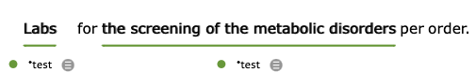

Here, the phrase is combined by NP, “the metabolic disorders” and the gerund, “the screening of” which can be two separate concepts “problem” and “test”. NP and gerund together represent a new concept, a screening test, which is specific to cervical cancer. The new concept is annotated as “test”.

**2.3.2**

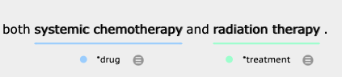

Here, the word “chemotherapy” is annotated as drug and the word “therapy” is annotated as treatment. Though chemotherapy contains the word “therapy”, it uses drugs for treating a disease (ex. cancer). Therefore, it is annotated as “drug”.

**2.3.3**

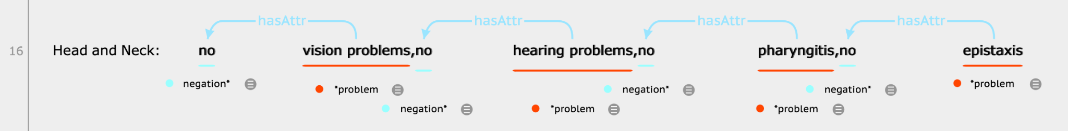

If the body location is at the beginning of a sentence and it is followed by the mentions of several problems, then treat the body location as a section header.

**3. Modifiers and Relations**

A modifier is a term that modifies the meaning of an entity in a systematic way. In other words, a modifier maps the meaning associated with an entity to a new meaning, without altering the basic meaning.

The modifiers are the spans of text that complement the entity mentioned in the previous sections. Some modifiers are annotated by selecting the spans of text, and others are annotated as indicators. Modifiers can either be direct modifiers or non-direct modifiers based on how they are related to the entity.

A modifier is always related to an entity.

**3.1 General guidelines for entity - modifier relation**

**3.1.1** For each relation between an ENTITY and a MODIFIER, the MODIFIER further explains the ENTITY. For the relations mentioned across multiple sentences, the sentences before and/or after the target sentence are considered for annotating the relations.

**a)**

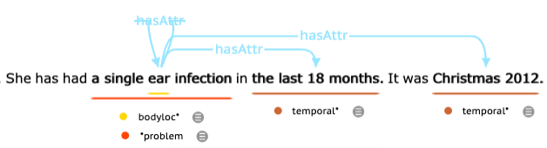

In this example, bodyloc “ear”, the span of the word is within the span of the problem “a single ear infection”. This is the example of rule 5.3 (see below).

There are two temporal concepts in the above example, “the last 18 months” and “Christmas 2012”. The First temporal concept “the last 18 months” is in the same sentence as the problem “a single ear infection”. The PP word “in” connects the temporal and the problem in the same sentence. The second temporal concept, “Christmas 2012” is in the next sentence. This temporal concept is an extension of the first temporal concept and gives additional detail on a specific date. Therefore, the problem and the second temporal concept should be annotated as a relation.

**b)**

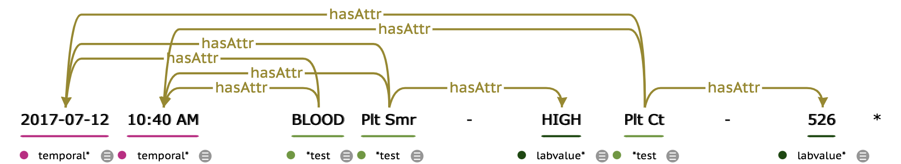

Here, all the test entities “BLOOD”, “Plt Smr”, “Plt Ct” are in relation with the time, “2017-07-12” and “10:40 AM”. Therefore, all the test entities should be annotated with two temporals as shown above. The lab values, “HIGH” and “526” should only be connected with the test mentioned just before them because these lab values are specific to a test.

**c)**

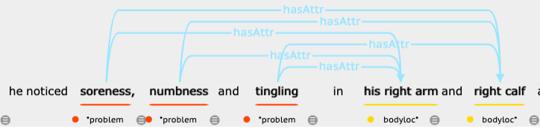

In this example, we see three problems, “soreness”, “numbness” and “tingling”, and two modifiers, “right arm”, and “right calf”. In such sentences, all three problems should be annotated with both modifiers.

**3.1.2** Except for some types of temporal (ex. Date/Time), all other modifiers should only be annotated when the entity exists.

**a)**



Though “Carnial nerves” and “The Pupils” are both bodyloc in this example sentence, we don’t need to annotate them because the problem is not mentioned.

**b)**

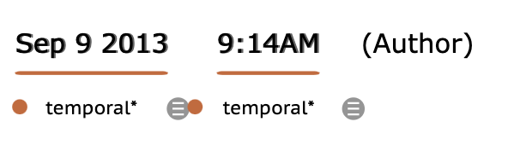

Here, even though there is no main entity, we still annotate the temporal.

**c)**



Here, the temporal word “recently” is for the treatment (i.e. the word “treated” in the sentence), not for the problem, “systemic lupus erythematosus”. Such temporals should not be annotated.

**3.1.3** Except for bodyloc, course, and severity, all other modifiers cannot overlap with the entity.

**a)**

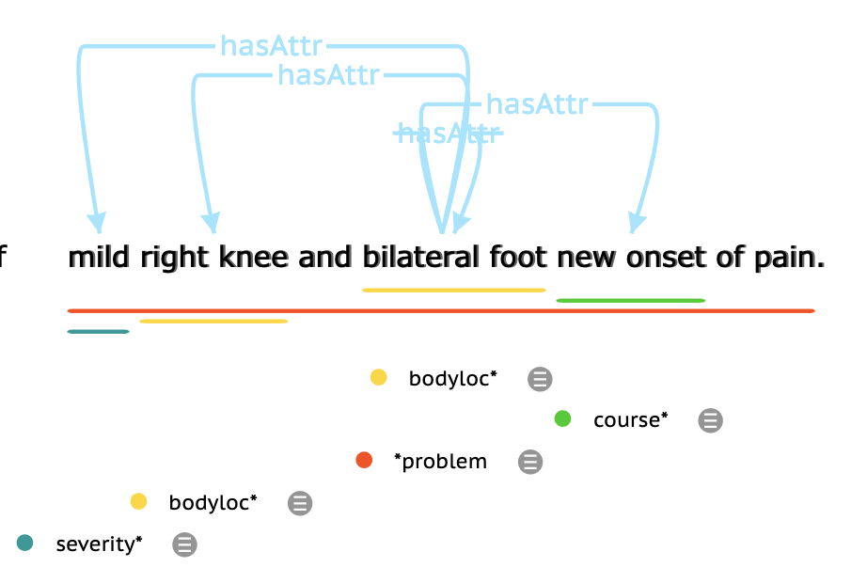

In this sentence, the severity, bodyloc, and course are within the problem span.

**b)**

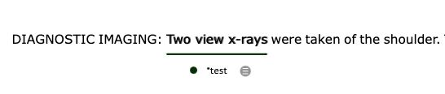

In this sentence, even though “the shoulder” is a body part, there is no problem entity. Therefore, “the shoulder” should not be annotated as bodyloc.

**c)**

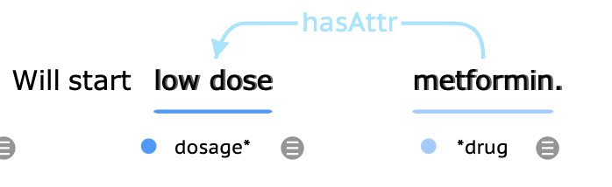

In this case, although “low dose metformin” is an NP, the phrase “low dose” is a modifier (i.e. dosage) for the entity, “metformin”. Therefore, we annotate the phrase as a modifier. The entity “metformin” span starts after the modifier span because the modifier cannot be overlapped with the entity.

**3.1.4**

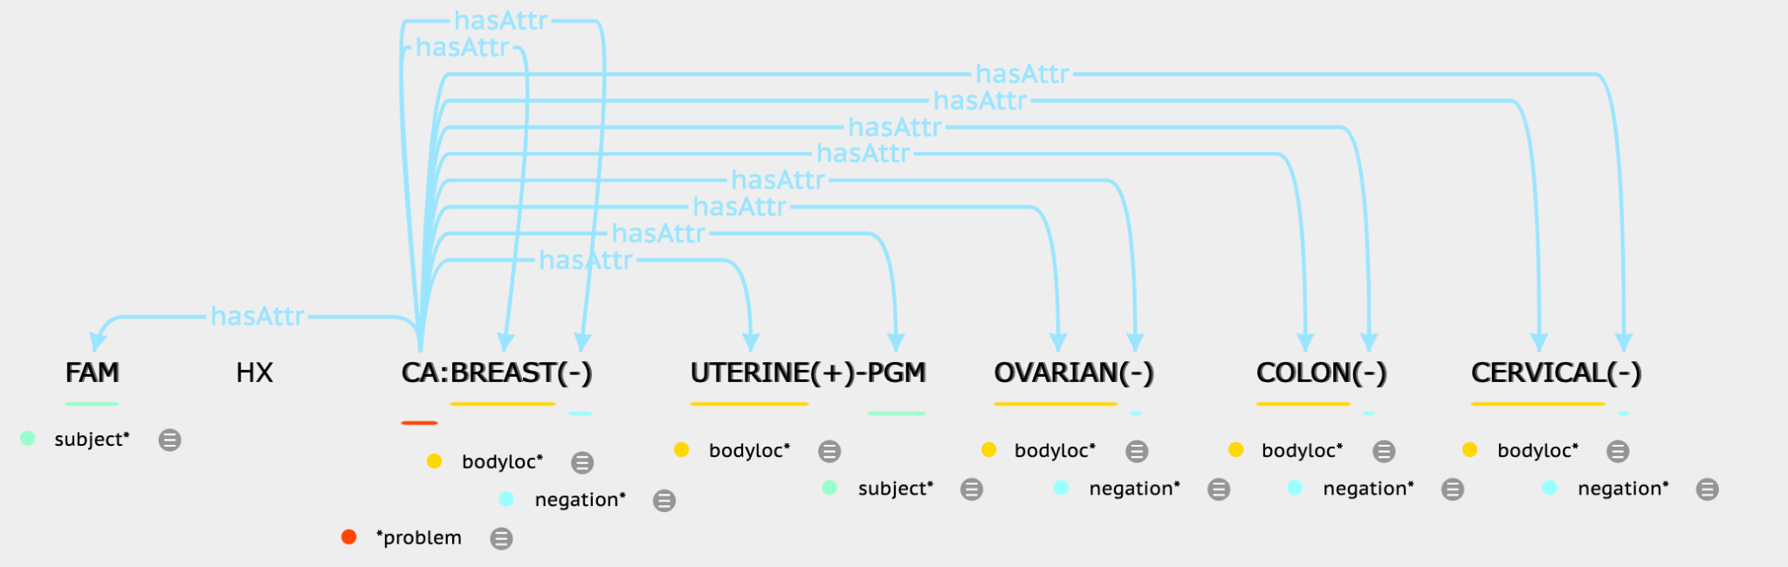

In this sentence, each bodyloc (ex. “BREAST”, “UTERINE”) should be annotated and further connected with the problem, “CA”. The bodyloc is suffixed with a hyphen, “-” or a plus sign, “+” within braces. The hyphen, “-” denotes that the problem does not occur in a specific bodyloc. This should be annotated as negation. The plus sign, “+” denotes the occurrence of a problem in a specific bodyloc.

**3.2. Specific guidelines for each entity - modifier relation**

Certain modifiers are specific to the entity. We provide the annotation guidelines for such modifiers in the following subsections. There are eight modifiers for the problem entity, two modifiers for the treatment entity, eight modifiers for the drug entity, and four modifiers for the test entity.

**3.2.1 Problem - Modifier relation**

1. **Bodyloc**

**Definition:** This modifier refers to a relation between a problem and a well-defined anatomical site (i.e., body location, body part, or laterality). The modifier, “bodyloc” (or body location), refers to the location on the body where the observation is present. Often, bodyloc is a SNOMED-CT concept belonging to any of the following semantic types (this follows the Bodenreider and McCray Anatomy group):

* Anatomical structure
* Body location or region
* Body part, organ or organ component
* Body space or junction
* Body substance
* Cell
* Cell component
* Embryonic structure
* Fully formed anatomical structure
* Tissue

For annotation, it is not mandatory to check the body location in SNOMED CT. For annotation, the body location is not limited to SNOMED CT concepts.

Examples:

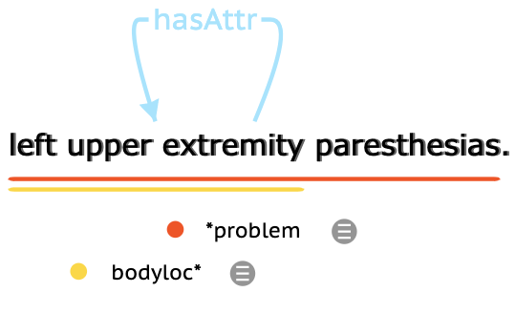

The span of bodyloc can be outside or inside the span of the problem.

Examples:

* For an inside example, please see the example below. “Left upper extremity paresthesias” is annotated as a problem and “left upper extremity” is annotated as a bodyloc. The span of “left upper extremity” is within the span of “left upper extremity paresthesias”.



* For an outside example, please see the example below. The bodylocs “the hip joints” and “the left knee joint” are not within the span of “Symptoms”.

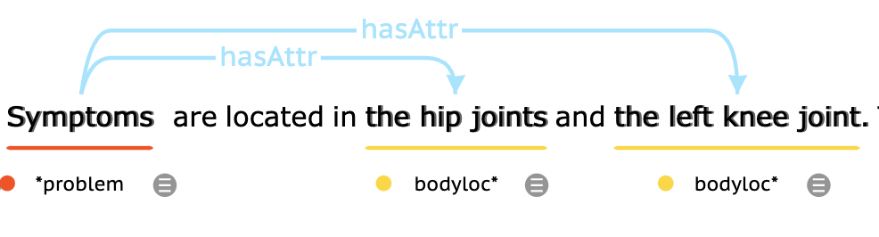

Exclusion:

* The body systems such as “neurological” should not be annotated as bodyloc.

**b) Condition**

**Definition:** The condition modifier refers to a problem that cannot exist under certain circumstances. Condition is the conditional use of a disorder (ex. “if pain is reported, then…”). By default a disorder has no Conditional modifier associated with it. The interpretation is that it is not conditional.

Example:

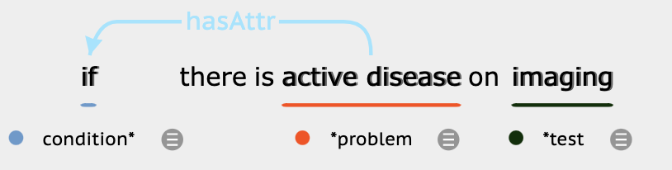

**c) Course**

**Definition:** This modifier refers to the development or alteration of a problem. Course is an indication of progress or decline of a condition. By default, a disorder has no mention of course. This is interpreted as an unmarked Course. A span of text for the Course modifier can be mapped to the following: unmarked, changed, increased, decreased, improved, worsend, and resolved.

Examples:

* The cough worsened over the next two days.
* Screen mammogram showed increasing calcifications in right breast.

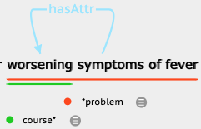

A Course modifier can also be negated.

Example:

* He had a skin tumor with no known recurrence.

The span of the course can be outside, inside, or overlapping the span of the problem.

**d)** **Severity**

**Definition:** The Severity modifier refers to the degree of intensity of a clinical condition.

A span of text can be mapped to four types of Severity: unmarked, slight, moderate, and severe.

Examples:

* He noted a slight bleeding.
* Patient presents with mild sleep apnea.

The span of severity can be outside, inside, or overlapping with the span of the clinical condition.

Examples:

* The patient presented with severe pre-eclempsia.

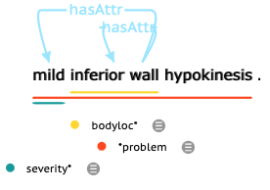

The severity should be explicit. If inference is required to determine the severity of a disorder, then the severity modifier should NOT be annotated.

Example:

* The patient presented with tiny gallstones.

Here, the problem, “gallstones” has no severity modifier. The word “tiny” is a qualitative modifier, and mapping it to a severity would require medical inference.

**e)** **Subject**

**Definition:** This modifier refers to the person entity who is experiencing the disorder. By default, the Subject modifier is the patient, about whom the note is written. We don’t annotate the default subject and only annotate others mentioned in the clinical text. There are four possible values for the Subject: Family_Member, Donor_Family_Member, Donor_Other, and Other.

Example:

* The patient’s son has schizophrenia.

**f) Uncertain**

**Definition:** This modifier refers to the uncertainty associated with the mention of a disorder. It only refers to the explicit mentions of uncertainty, and does not involve any pragmatics-level of reasoning.

The modifier, Uncertain, is a measure of doubt in a statement. By default, a problem entity has no uncertainty associated with it. Because this modifier is an indicator of uncertainty, there is no normalization associated with it. When the modifier is not annotated, it signifies the absence of uncertainty related to the disorder. when there is an annotated span of text, it signifies that there is an explicit mention of uncertainty related to the disorder.

Example:

* There has been possible pain.

**g)** **Temporal**

* **Date:**

**Definition:** It can be the calendar dates (such as {January 4}) and other verbal expressions which can be mapped to calendar dates either concretely (such as {Last week}, {This month}, {next Friday}, or {this time}), or in a more fuzzy sense ({lately}, {the past}).

Examples:

* His anterior chest rash has not reoccurred since the PCN VK was discontinued 24-hours ago.
* I stated that if there is no other evidence of any disease recurrence, in approximately one-month’s time we would proceed with approximately six-months worth of adjuvant therapy.
* She has experienced heavy bleeding in the past.
* She complains that she’s felt tired lately.
* He wasn’t sure he wanted surgery at that point
* Recently, she has had several episodes of syncope.

Exclusion:

A phase that only implies the orders of events, not a specific time or period should not be annotated.

Examples:

‘after’, ‘before’, ‘followed by’, ‘subsequently’, ‘Initially’, “post-surgery”, “before admission”

* **Time**

**Definition:** It refers to a specific time within a day (ex. {3:00PM} or {23:45}). It can also be relative.

Example:

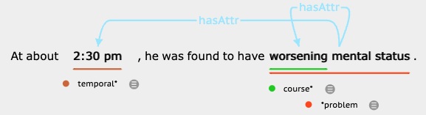

* **Duration**

**Definition:** It is a single temporal expression that reflects a span of time (ex. "for {24 hours}" or "All of February"), rather than a specific time.

Example:

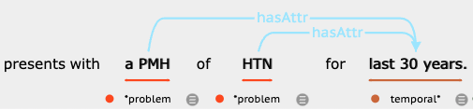

Examples:

* The patient continuously experienced nausea for nearly two weeks.
* Since August, she has not had any episodes.
* In the last week, his pain has significantly worsened.

**h)** **Negation**:

**Definition:** This modifier refers to a problem that was negated. Negation is used to indicate that problems did not occur or do not exist.

Examples:

* The patient has not noticed any numbness.
* No further episodes of CP.

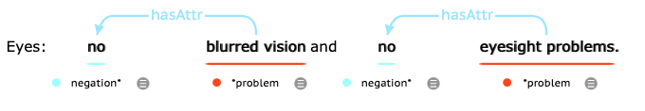

Exclusion:

* If a negation word is a part of the problem, it should not be annotated.

Example:

* “no breath”

Here, “no breath” is a problem. The negation word, “no” is a part of the problem and it should not be annotated as a negation keyword.

**3.2.2 Treatment - Modifier relation**

**a)** **Temporal**

* **Date:**

**Definition:** It can be the calendar dates (such as {January 4}) and other verbal expressions which can be mapped to calendar dates either concretely (such as {Last week}, {This month}, {next Friday}, or {this time}), or in a more fuzzy sense ({lately}, {the past}).

Example:

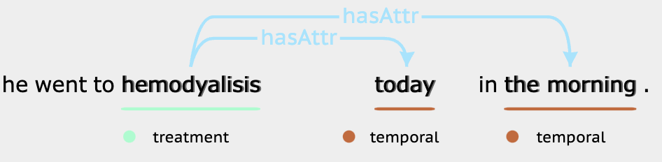

Exclusion:

A phase that only implies the orders of events, not a specific time or period should not be annotated.

Example:

‘after’, ‘before’, ‘followed by’, ‘subsequently’, ‘Initially’, “post-surgery”, “before admission”

* **Time:**

**Definition:** It refers to a specific time within a day (ex. {3:00PM} or {23:45}). It can also be relative.

Examples:

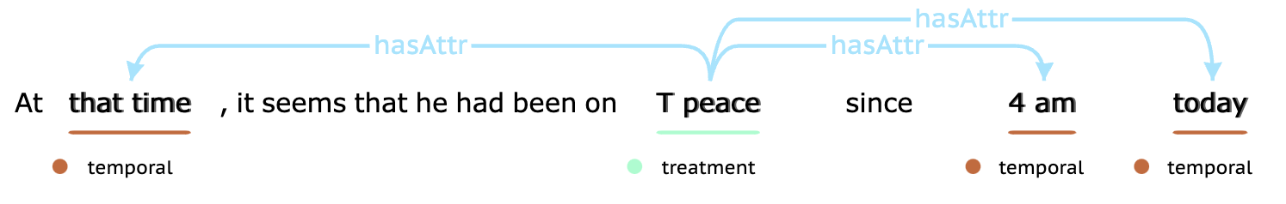

* **Duration:**

**Definition:** It is a single temporal expression that reflects a span of time (ex. "for {24 hours}" or "All of February"), rather than a specific time.

Example:

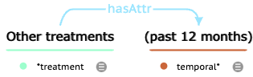

**b)** **Negation**

**Definition:** This modifier refers to a treatment that was negated. Negation is used to indicate that a treatment did not occur or does not exist.

Example:

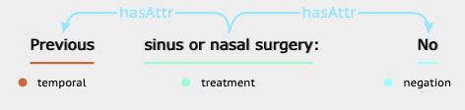

In this case, the word “No” after the colon means that the patient didn’t have any “sinus or nasal surgery”, so “No” is annotated as negation and has a relation with the treatment.

**3.2.3 Drug - Modifier relation**

**a) Strength**

**Definition:** Strength is the amount of active ingredient in a given dosage form.

Examples:

* Patient prescribed 1 x 20 mg Prednisone tablet daily for 5 days.
* Patient prescribed 1-2 325 mg / 10 mg Norco pills every 4-6 hours as needed for pain.
* Patient has been switched to lisinopril 10mg 1 tablet PO QD.
* Patient received 100 Units/kg IV heparin sodium injection for treatment of deep vein thrombosis.

**b) Dosage**

**Definition:** Dosage is the amount of active ingredient from the number of drugs prescribed.

Examples:

* Patient prescribed 1 x 20mg Prednisone tablet daily for 5 days.
* Patient prescribed 1-2 325 mg / 10 mg Norco pills every 4-6 hours as needed for pain.
* Patient has been switched to lisinopril tablet 10mg 1 tablet PO QD.
* 2ml PO bid 2
* Sliding scale
* Bolus
* Taper (as in steroid taper)

**c) Duration**

**Definition:** The duration of durg refers to how long (e.g., days, weeks, months, years) a patient should be treated with manual methods for any given problem.

Examples:

* Patient prescribed 1 x 20mg Prednisone tablet daily for 5 days.

**d) Frequency**

**Definition:** The number of regular recurrences taking a drug in a given time.

Examples:

* The patient was prescribed 1 x 20mg Prednisone tablet daily for 5 days.
* Patient prescribed 1-2 325 mg / 10 mg Norco pills every 4-6 hours.
* Patient has been switched to lisinopril tablet 10mg 1 tablet PO QD.
* tylenol Q8H PRN4
* B.I.D

**e) Form**

**Definition:** The administration form of the completed pharmaceutical product (e.g., tablet, capsule, suspension)

Examples:

* The patient prescribed 1 x 20mg Prednisone tablet daily for 5 days.
* Patient prescribed 1-2 325 mg / 10 mg Norco pills every 4-6 hours as needed for pain.
* Patient has been switched to lisinopril 10mg 1 tablet PO QD. Patient received 100 Units/kg IV heparin sodium injection for treatment of deep vein thrombosis.

**f) Route**

**Definition:** The route of drug administration is the path by which a drug is taken into the body

Examples:

* Patient has been switched to lisinopril 10mg 1 tablet PO QD.
* Patient received 100 Units/kg IV heparin sodium injection for treatment of deep vein thrombosis.
* Gtt
* Drip
* Inhalation
* Topical

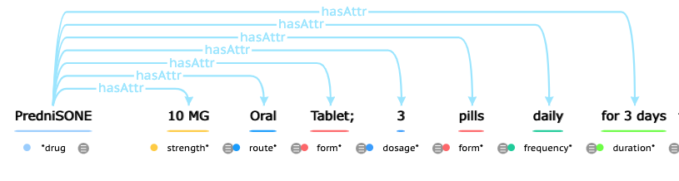

Here is the example for drug modifiers (strength, dosage, frequency, form, duration, route)

**g)** **Temporal**

* **Date:**

**Definition:** It can be the calendar dates (such as {January 4}) and other verbal expressions which can be mapped to calendar dates either concretely (such as {Last week}, {This month}, {next Friday}, or {this time}), or in a more fuzzy sense ({lately}, {the past}).

Examples:

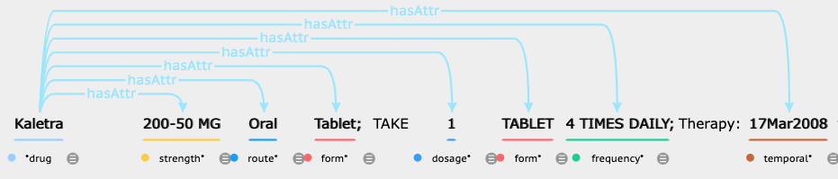

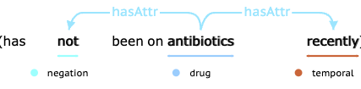

Exclusion:

A phase that only implies the orders of events, not a specific time or period should not be annotated.

Examples:

‘after’, ‘before’, ‘followed by’, ‘subsequently’, ‘Initially’, “post-surgery”, “before admission”

* **Time:**

**Definition:** It refers to a specific time within a day (ex. {3:00PM} or {23:45}). It can also be relative.

Examples:

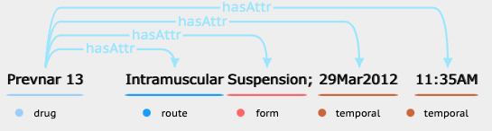

In this sentence, vaccine “Prevnar 13” is annotated as drug, and “11:35AM” is a time temporal.

* Exclusion: duration for the drug will annotate as “duration” rather than “temporal” for drug

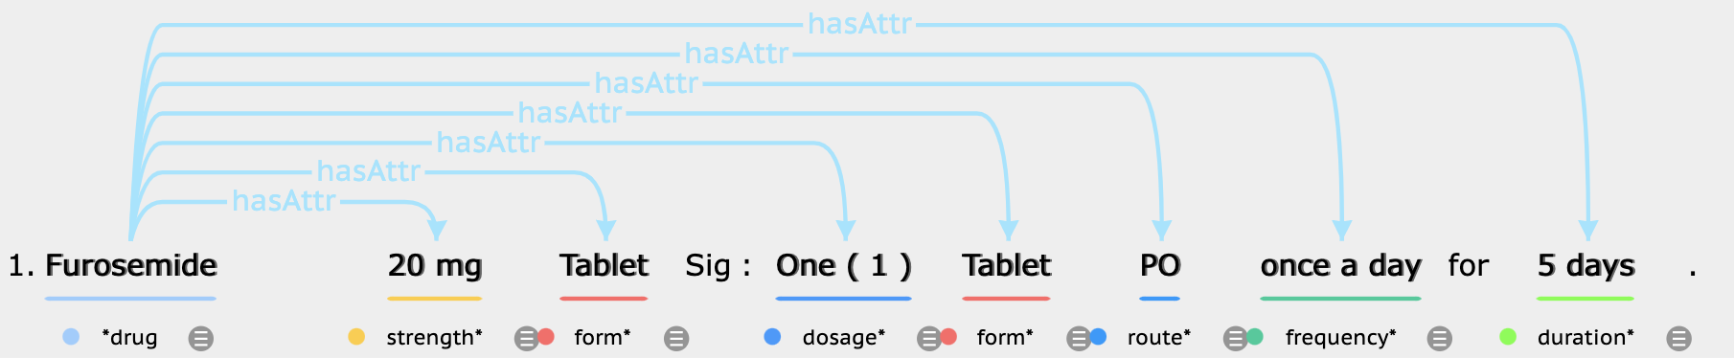

In this sentence, 5 days is a duration modifier to drug “Furosemide”

**h)** **Negation**

**Definition:** This modifier refers to a drug that was negated. Negation is used to indicate that a drug did not occur or does not exist.

Example:

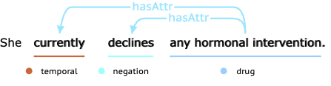

In this sentence, “declines” is a verb. It indicates that the patient is not taking “any hormonal intervention”. Therefore, it should be annotated as the negation.

Exception:

For words like “stopped”, and “discontinues”, we don’t consider those as negation.

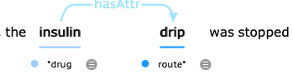

**3.2.4 Test - Modifier relation**

1. **Labvalue**

**Definition:** Labvalue is a number or normal result description for a lab test.

Examples:

* Weight: 125 lb
* Normal rate and rhythm

1. **Reference_range**

**Definition:** Reference_range is the range or interval of values that are deemed as normal for a physiological measurement in a healthy person.

Example**:**

* CHOLESTEROL, TOTAL: 131 mg/dl Reference Range 125-200

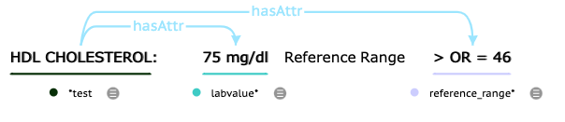

Here is the example for test modifiers (labvalue and reference_range).

**c)** **Temporal**

* **Date:**

**Definition:** It can be the calendar dates (such as {January 4}) and other verbal expressions which can be mapped to calendar dates either concretely (such as {Last week}, {This month}, {next Friday}, or {this time}), or in a more fuzzy sense ({lately}, {the past}).

Examples:

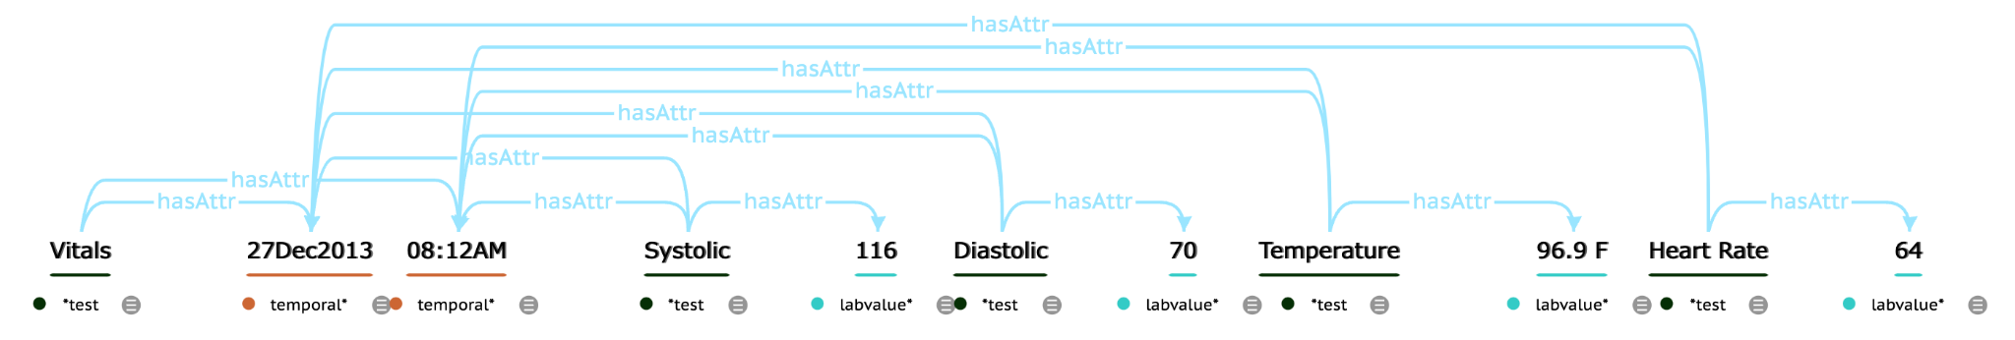

Here, “27Dec2013” is a calendar date.

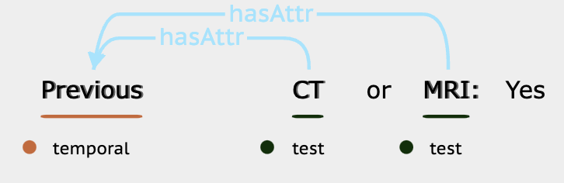

In this sentence, the temporal word “Previous” is a fuzzy sense of the date.

Exclusion:

A phase that only implies the orders of events, not a specific time or period should not be annotated.

Example:

‘after’, ‘before’, ‘followed by’, ‘subsequently’, ‘Initially’, “post-surgery”, “before admission”

* **Time:**

**Definition:** It refers to a specific time within a day (ex. {3:00PM} or {23:45}). It can also be relative.

Example:



* **Duration:**

**Definition:** It is a single temporal expression that reflects a span of time (ex. "for {24 hours}" or "All of February"), rather than a specific time.

**d)** **Negation**

**Definition:** This modifier refers to a test that was negated. Negation is used to indicate that a test did not occur or does not exist.

Example:

