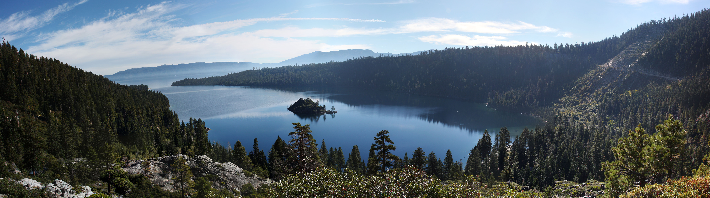

**Tutorial: Analysis and visualization of 3D data in Python**

**14th International Symposium on Visual Computing**

Lake Tahoe, Nevada, USA

October 7-9, 2019

http://[www.isvc.net](http://www.isvc.net)

**Tutorial abstract**

* This hands-on tutorial teaches how to analyze three dimensional stacked / volumetric images at scale in Python, primarily using scikit-image and scikit-learn.  The material is formatted as a sequence of interactive Jupyter notebooks designed to investigate aspects of analysis such as counting, object relationships, and shape measurements. Real-world examples are given from various domains such as material science and biomedicine, and all data and code are made available freely. For each section above, we show how to implement the solution, and then provide several hands-on exercises to that attendees can become more intimately familiar with the techniques shown by applying it to the provided datasets.

**Tutorial description**

* Objectives: a) a brief overview of scikit-image and related packages in the scientific Python ecosystem; b) exploration and visualization of large 3D images, including filters and segmentation; c) inspection, counting, and measuring attributes of objects; routines that extract shape, color and texture features; how to use topological description to calculate equidistant boundaries; d) data reduction algorithms using priors from image acquisition instruments and/or sample architecture; e) parallel data processing pipelines for accelerating image analysis.
* Intended audience and any background requirements: researchers with basic to intermediate knowledge of Python and machine learning. Check
* Duration: half-day
* Schedule: we expect 5 sessions of 50 minutes each, which includes hands-on exercises.
  + 12:30pm: fundamentals; scikit image;
  + 1:30pm: intro to datasets; 2D and 3D visualization tools;
  + 2:30pm: filters and segmentation;
  + 3:30pm: feature extraction and I/O;
  + 4:30pm: data reduction and parallel pipelines;
* Instructions:
  + Requirements:
  + Additional reading material: book Elegant SciPy by by [Juan Nunez-Iglesias](http://www.oreilly.com/pub/au/6371), [Stéfan van der Walt](http://www.oreilly.com/pub/au/6372), [Harriet Dashnow](http://www.oreilly.com/pub/au/6373).

**Organizers**

* **Daniela Ushizima,** Berkeley Institute for Data Science, UC Berkeley, USA, dani.lbnl@berkeley.edu
* **Alexandre de Siqueira,** Berkeley Institute for Data Science, UC Berkeley, USA, alex.desiqueira@berkeley.edu
* **Stéfan van der Walt,** Berkeley Institute for Data Science, UC Berkeley, USA, stefanv@berkeley.edu

**Dani Ushizima,** Ph.D. is a staff scientist at Berkeley Lab and a data scientist at University of California Berkeley. With 20 years of R&D in computer vision, she has focused on algorithms for images across domains at the Berkeley Institute for Data Science (BIDS), while materials sciences and energy are themes in her work as the Department of Energy early career researcher.

**Alex de Siqueira**, Ph.D. is a postdoctoral researcher at BIDS, University of California, Berkeley, working on open source algorithms for processing computed tomography (CT) 3D images. A core developer of scikit-image, he is an open source and free software developer contributing to several projects and events in Latin America and Europe.

**Stéfan van der Walt**, Ph.D. is a researcher at BIDS, University of California, Berkeley. Stéfan has been developing scientific open source software for more than a decade, focusing mainly on Python packages such as NumPy & SciPy. He is the founder of scikit-image and co-author of Elegant SciPy.

**Date**

* Sunday, October 6, 2019 (tentatively)

