**Pump API**

This is a minimal REST API specification and implementation for controlling a dosing pump.

**What is a REST API?**

An API (Application Programming Interface) is a software computer interface that can accept requests and provide responses to these requests, REST is a way of communication in which computers interchange data using APIs.

Usually, REST APIs match HTTP commands (GET) and paths (/pump), also called URIs (Uniform resource identifiers), to program routines inside the server. Responses and requests can contain data in their body which can be stored in JSON format, a type of human readable data interchange format.

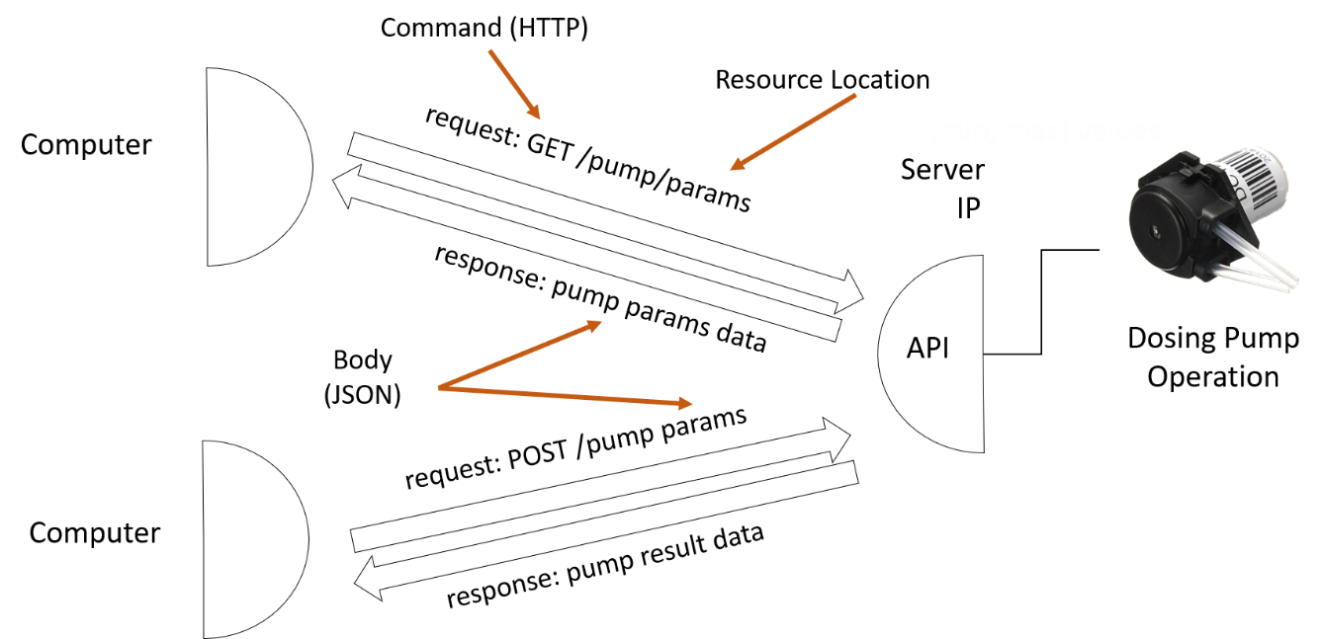

**Specification**

The minimal pump API can receive 3 types of requests, with no parameters, all of them use the GET HTTP command so they can be sent from a web browser (Example: typing 190.157.46.49:81/pump prompts the browser to send a GET /pump request to the server):

* GET /pump: Returns the pump data as a JSON document. Example response body: {“id”:1, “port”:2, “status”: 0}
* GET /pump/on: Turns the pump on and returns the pump data as a JSON document. Example response body: {“id”:1, “port”:2, “status”: 0}
* GET /pump/off: Turns the pump off and returns the pump data as a JSON document. Example response body: {“id”:1, “port”:2, “status”: 1}

A more detailed specification using the OpenAPI specification, can be found in /ESP8266/ESPMinPumpEx/minpumpapi.yaml

The specification file can also be rendered in an interactive form using the Swagger [editor](https://editor.swagger.io/) (go to file -> import yaml file)

An example of an API that would run more advanced operations, for example pump-water operations could look like this:

* GET /pump_water/params: return pump information and available parameter values. Example response:

{"id": 0, "type": "pump_water", "pumping_time": [0, 50], "pumping_speed": [0,255], "input_substances": ["Water"], "measure": [{"type": "temp", "measure_time": ["at_start", "at_end"]}]}

* POST /pump_water: receives a request with the desired parameters, runs the operation and returns the measured data. Example request body:

{ "id": 1, "type": "pump_water", "pumping_time": 20, "pumping_speed": 100, "input_substances": ["Water"], "measure": [ {"type": "temp", "measure_time": "at_end" }] }

Example response body

{"id": 1, "meta_data": { "id": 1, "type": "pump_water", "pumping_time": 20, "pumping_speed": 100, "input_substances": [ "Water" ], "measure": [ { "type": "temp", "measure_time": "at_end" } ] }, "data": [ {"type": "temp", "measured_data": 21.5 } ]}

A more detailed specification can be seen in /Operations/pump_water/pump_waterapi.yaml

**Implementation**

**Computer**

The API can be implemented using different computer systems from the API specification. The example in this repository has been implemented using an ESP8266 NodeMCU V3 Wifi [board](http://prometec.org/communications/nodemcu/arduino-ide/).

**Source Code**

The software implementation (/ESP8266/ESPMinPumpEx/) is built in the Arduino language and makes use of the ESP8266WebServer and ArduinoJson libraries. Most languages have similar tools and frameworks for handling requests and providing responses (i.e. FastAPI), and for handling JSON documents. There are two important parts in the code:

* Routing: This part is in charge of matching the incoming request command (i.e GET) and path (i.e. /pump), with the corresponding program routine or action (get_pump function).

void config_rest_server_routing() { //Routing function: Set actions for incoming commands and locations

http_rest_server.on("/", HTTP_GET, []() {

http_rest_server.send(200, "text/html",

"Welcome to Minimal REST Server Example");//Welcome page

});

http_rest_server.on("/pump", HTTP_GET, get_pump); //Return pump info

http_rest_server.on("/pump/on", HTTP_GET, get_pump_on); //Turn pump on and return status

http_rest_server.on("/pump/off", HTTP_GET, get_pump_off);//Turn pump off and return status

}

* Action: The program routine that is executed when handling a request, it is in charge of interpreting the incoming body of the request, building the JSON response (serialization) and sending it through the server.

void get_pump_on(){//GET /pump/on action

pump_resource.status = LOW; //Change resource status

digitalWrite(pump_resource.port, pump_resource.status);//Change external pin status

DynamicJsonDocument doc(capacity);

doc["id"] = pump_resource.id;

doc["port"] = pump_resource.port;

doc["status"] = pump_resource.status;

String buf;

serializeJson(doc, buf);

http_rest_server.send(200, F("application/json"), buf);

}

The JSON document is populated using information from a struct "database".

struct Pump { //Resource "database"

byte id;

byte port;

byte status;

} pump_resource;

The web server is initialized by the setup function, which also attempts to connect to the wifi network. The main program loop waits for and handles incoming requests.

void setup() {

Serial.begin(115200);

init_pump_resource();

if (init_wifi() == WL_CONNECTED) { //Connect to Wifi

Serial.print("Connected to ");

Serial.print(wifi_ssid);

Serial.print("--- IP: ");

Serial.println(WiFi.localIP());

}

else {

Serial.print("Error connecting to: ");

Serial.println(wifi_ssid);

}

config_rest_server_routing(); //Configure routing

http_rest_server.begin();//Start web server

Serial.println("HTTP REST Server Started");

}

void loop() {

http_rest_server.handleClient();//Handle incoming requests

}

**Hardware**

The following hardware is connected to the ESP8266 device:

* L298N motor driver [board](https://howtomechatronics.com/tutorials/arduino/arduino-dc-motor-control-tutorial-l298n-pwm-h-bridge/)
* 12V, 3W peristaltic dosing [pump](https://www.adafruit.com/product/1150)
* 12V and 5V power source

**Connections**

* Pin D4 (GPIO 2) of the ESP8266 is connected to ENA in the L298N board.
* In1 and In2 in the L298N board are connected to 5V and Gnd respectively.
* Ground pins on the ESP8266 and the L298N board are connected together and to the main power source ground.
* The pump terminals are connected to OUT1 and OUT2 on the L298N board.