# Versioning

### How to schedule a page to be published with different content throughout a period of time

1. We create an item with different versions and different content in all of them: 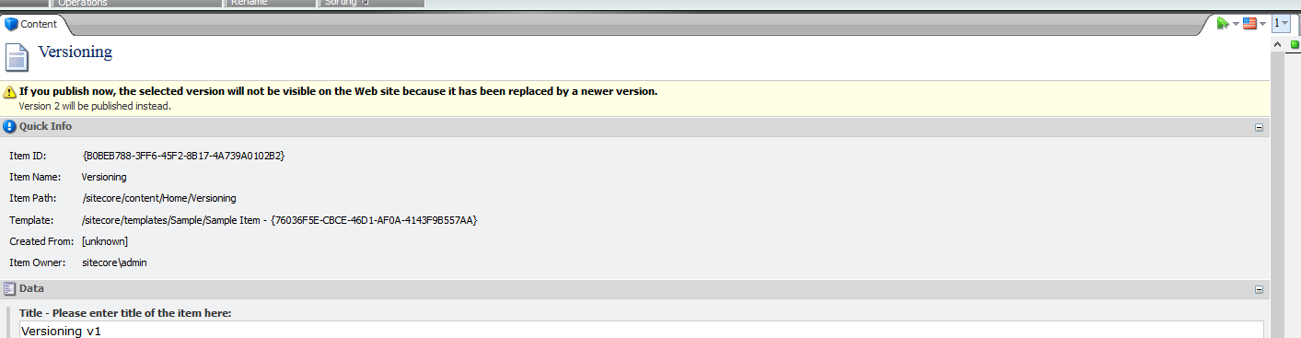

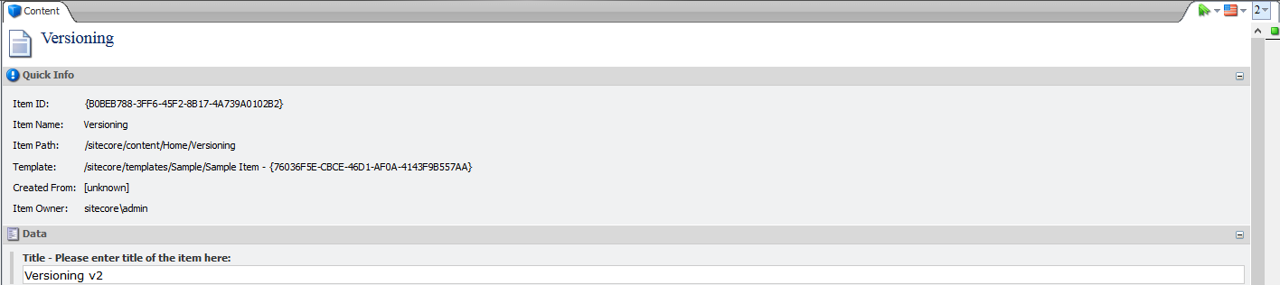 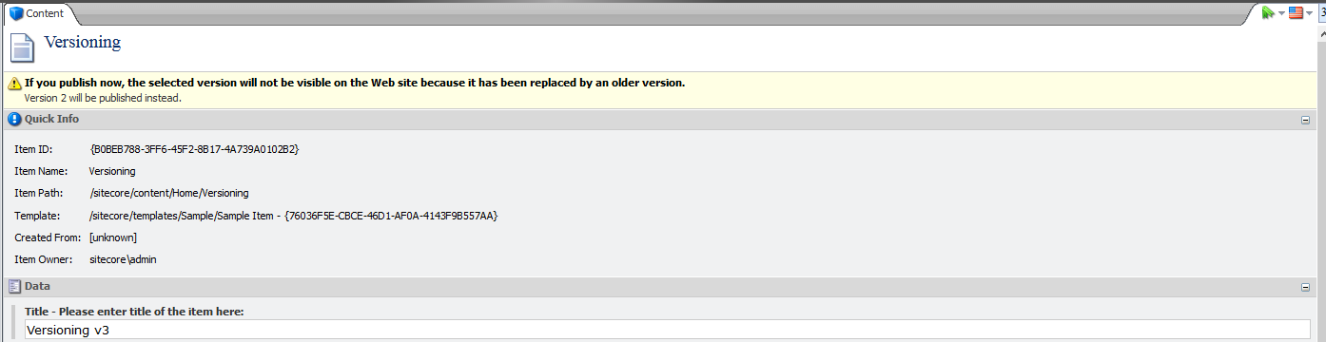

1. We want Version 1 to be on the website in the period April 1st – April 7th, Version 2 to be what visitors see from April 8th to April 15th and then Version 3 to be the one that would be visible on the website until we specifically want to change it. We will use Sitecore Scheduling and Custom Scheduled Publishing to achieve all of that with one single setup.
2. Go to the Publish ribbon and choose Change in the Restrictions section. 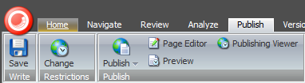
3. You will see all versions of the item listed in the Publish Settings window. Most of the fields will be empty.

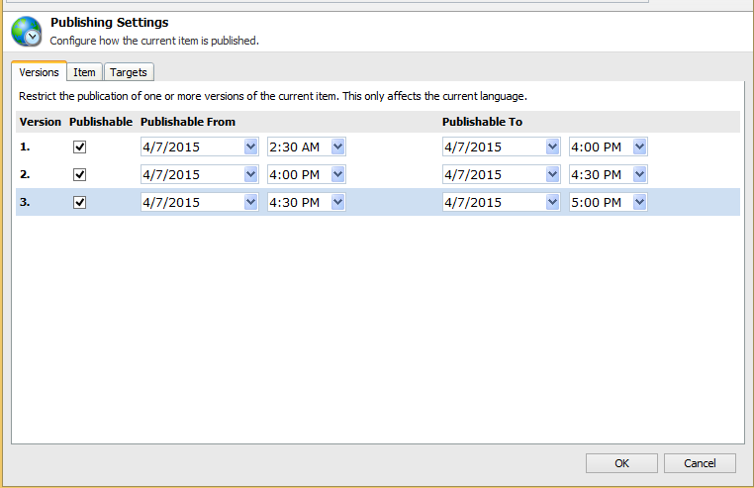

1. For Version 1, choose from April 1st some time in the morning to April 7th, for Version 2 choose from April 8th to April 15th, and for Version 3 choose from April 16th and no end date. Click OK.
2. Then go to the Schedule Publishing and schedule the item to be published in the hour after the “Publishable From” values you set for the different versions. Refer to the Scheduled Publishing documentation.

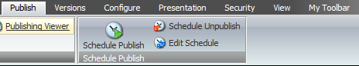

1. Whenever you visit the item in Sitecore, you will see a yellow strip notification of which version is currently the active one (the one that is set in the Publish Restrictions).