Run SearchEngine.py:

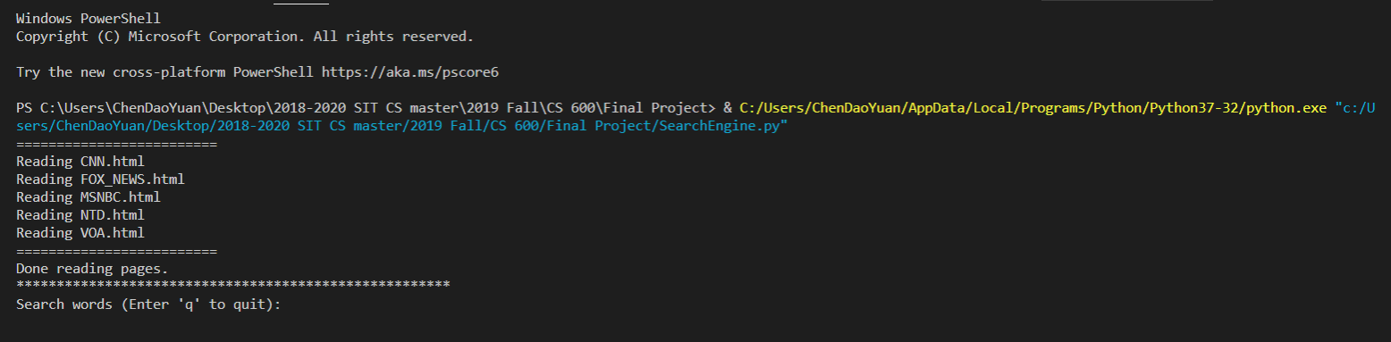

Press “Enter” without input:

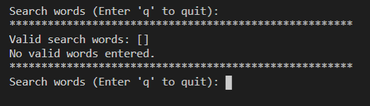

Enter a word:

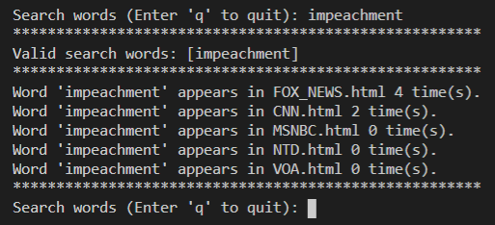

Enter a sentence:

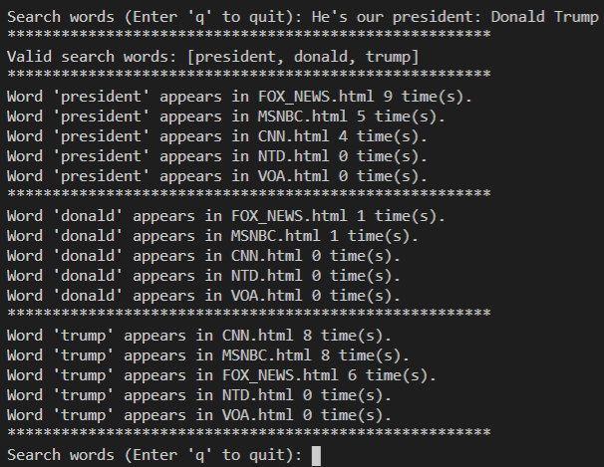

Enter a stop word:

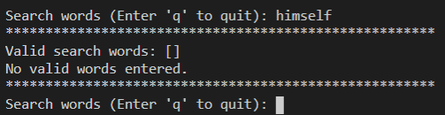

Enter punctuation and number:

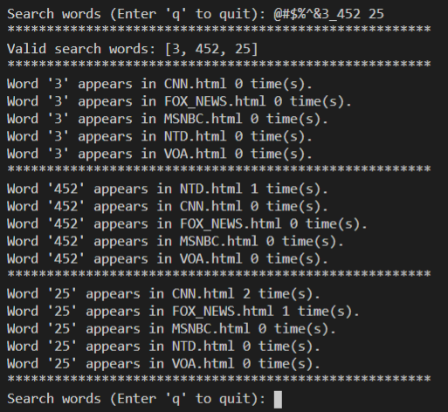

Enter ‘q’ to terminate the program:

