Dong Yoo

CSC 3320 HW 3

Part 1:

1. First command: **grep**

This command filters out every line in a file that doesn’t contain the specified line



1. Second command: **egrep**

This command is functionally similar to grep, but it allows the use of extended regex



1. Third command: **fgrep**

This command is functionally similar to grep, but does not accept regex



1. Fourth command: **uniq**

This command displays the input file with all adjacent repeated lines removed

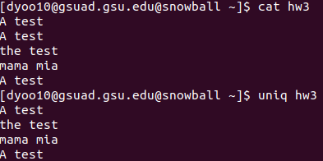

1. Fifth command: **sort**

This command sorts a file based on a specific field

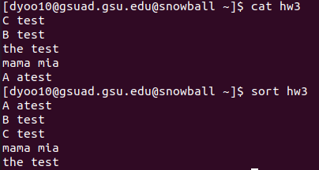

1. Sixth command: **cmp**

This command compares two files to find: if they differ, if one is a prefix of the other, or they are the exact same

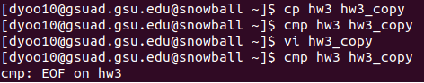

1. Seventh command: **diff**

**Diff** first compares two files then lists edits that would convert the first file to the second



1. Eighth command: **find**

**Find** can locate a file or a group of files with certain conditions, then modify/erase them

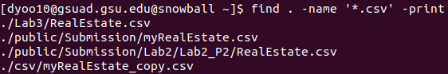

1. Ninth command: **cpio**

This creates cpio-format files that can be used to back up small subdirectories

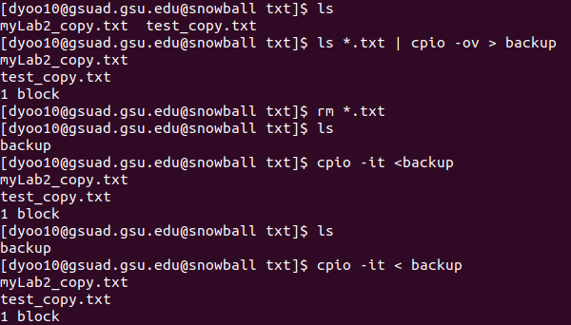

1. Tenth command: **tar**

**Tar** creates a special tar file that can combine multiple files into a singular archive file

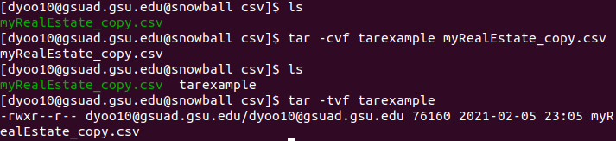

1. Eleventh command: **dump**

The **dump** command is used to copy files from a location to dumpFile, which is a backup storage for all the files involved

1. Twelfth command: **restore**

The restore command can be used to restore a set of files using a previously created dump file

1. Thirteenth command: **crontab**

**Crontab** allows the user to schedule specific commands that will be executed periodically, with the format minute – hour – day – month – weekday (asterisk for full match)

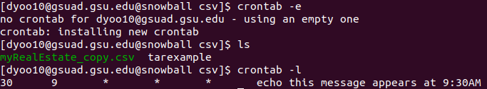

1. Fourteenth command: **at**

**At** is similar to **crontab**, but rather than periodically, at only executes its command once



1. Fifteenth command: **awk**

The **awk** command searches for every line that matches the parameters in a file, then performs an action on all those lines

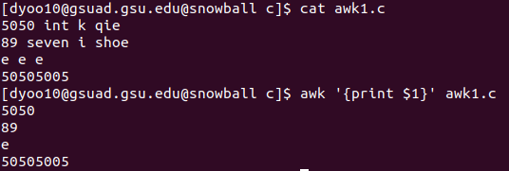

1. Sixteenth command: **ln**

This utility forms links between files. A hard link is when two files are identical, whereas a symbolic link functions the same way as a shortcut

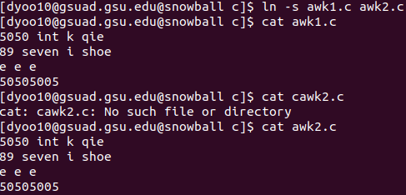

1. Seventeenth command: **whoami**

**Whoami** functions as “who am I”, which will echo the user’s name



1. Eighteenth command: **su**

**Su** will allow the user to become a “substitute user”, allowing one to access the files of another user. However, this requires the super-user’s password

1. Nineteenth command: **biff**

**Biff** allows the user to enable/disable mail notifications



1. Twentieth command: **compress/uncompress**

**Compress** allows the user to format a file to be packed more efficiently, to reduce disk space. However, to regain access to the file, it must be uncompressed.

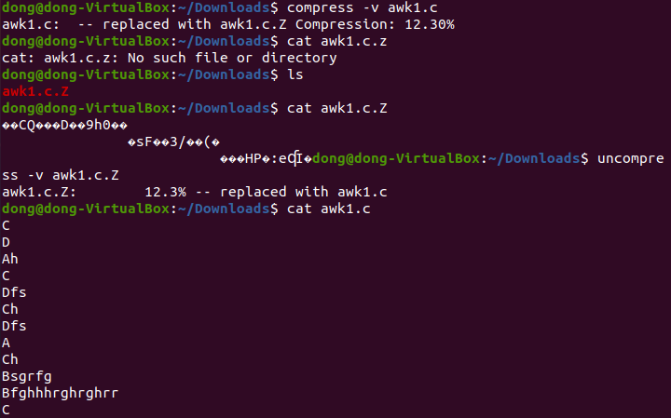

1. Twenty first command: **gzip/gunzip**

These commands are the same as **compress/uncompres**s but use a different algorithm

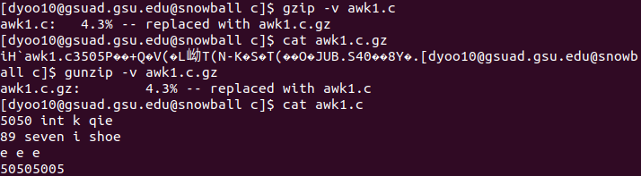

1. Twenty second command: **crypt**

**Crypt** makes a key-encoded version of a txt file that can only be retrieved by using the same crypt that was used to encode it

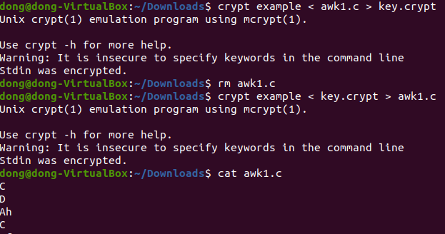

1. Twenty third command: **sed**

**Sed** allows the user to insert, delete, substitute, or find text in a file

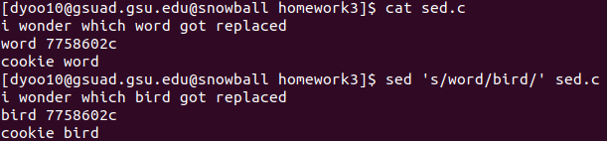

1. Twenty fourth command: **tr**

**Tr** is a more basic text editor than **sed** or **awk**, it can change the case of letters, delete specific characters or perform basic replacements

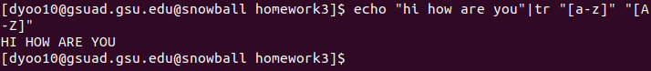

1. Twenty fifth command: **ul**

Allows underlined characters to be displayed correctly, useful with commands like **man**

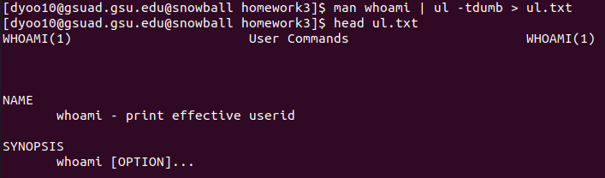

1. Twenty sixth command: **od**

Writes the input file as a representation of octal bytes

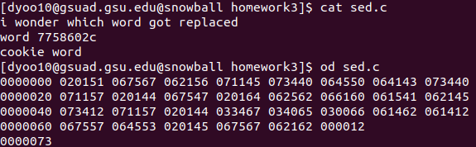

1. Twenty seventh command: **mount/umount**

**Mount** allows the device file to be put into the root hierarchy, while **unmount** unmounts a previously mounted system

1. Twenty eighth command: **tty**

Displays the name of terminal



1. Twenty ninth command: **nroff/troff/style/spell**

These utilities were created to format text in a certain way

1. Thirtieth command: **time**

**Time** allows the user to see how long it took to run a program/command

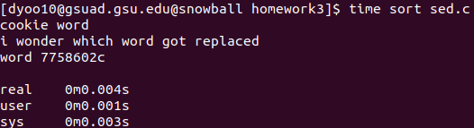

Part 2:

1. First command: **chsh**

Changes the shell that the user is using

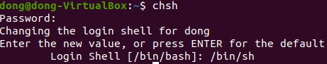

1. Second command: **echo**

Displays the arguments to standard output



1. Third command: **ps**

Allows the user to monitor the status of processes

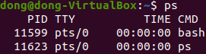

1. Fourth command: **sleep**

Similar to **at** but it puts the terminal to sleep until the execution

1. Fifth command: **nohup**

Allows a program(s) to run even after the login shell is exited



1. Sixth command: **kill**

Allows the user to terminate a process before it finishes

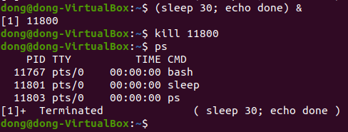

1. Seventh command: **wait**

Waits for child processes to terminate before continuing the command

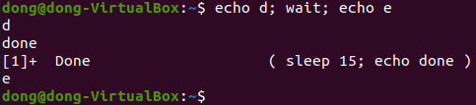

1. Eighth command: **eval**

**Eval** can take some argument and execute it as a command (for example, if x= echo big, eval x would echo big)

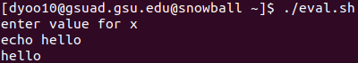

1. Ninth command: **exec**

Causes the shell that performed the exec command to cease to exist, or terminate the login

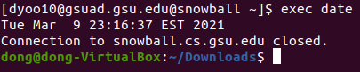

1. Tenth command: **shift**

**Shift** shifts all arguments that were entered by one less

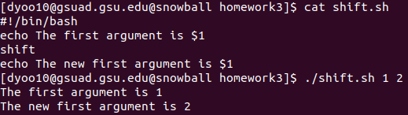

1. Eleventh command: **umask**

**Umask** is a four digit octal number that controls default file permissions for new files

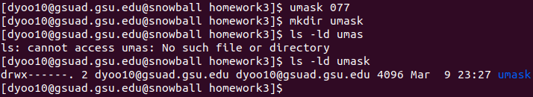

Part 3:

1. First command: **read**

Takes user input and stores it into a variable

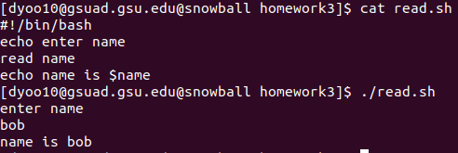

1. Second command: **export**

**Export** can list all exported name, remove names from export list, or export names as functions

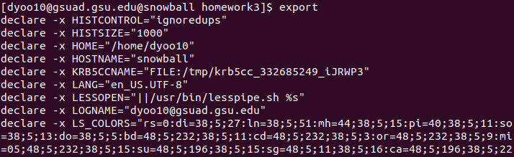

1. Third command: **env**

**Env** can print a list of environment variables, or run commands/programs in an altered environment

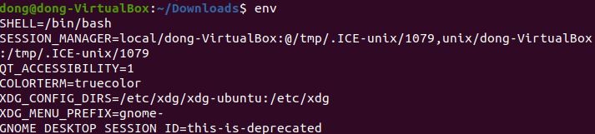

1. Fourth command: **readonly**

**Readonly** protects variables against modification

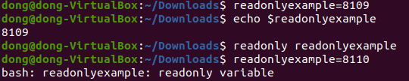

1. Fifth command: **expr**

**Expr** evaluates the expression then sends the result to the output

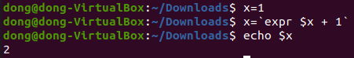

1. Sixth command: **test**

Tests if an expression is true or not



1. Seventh command: **case**

Based on the value of a variable, **case** can branch towards multiple ways depending on its value

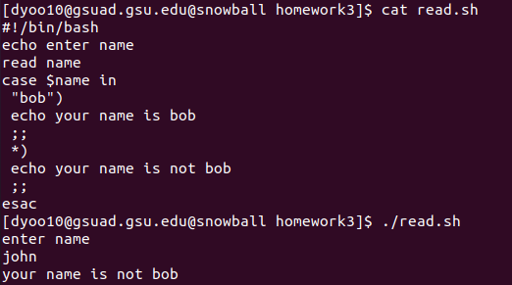

1. Eighth command: **for**

**For** command runs a list of commands on each given input

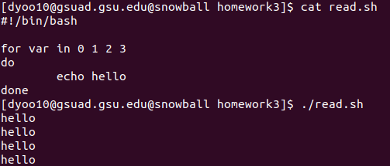

1. Ninth command: **if**

Runs commands based on the condition given to the **if** statement

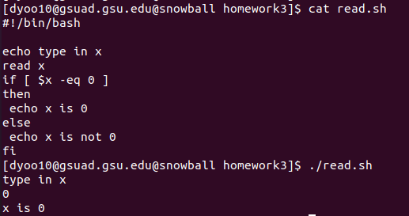

1. Tenth command: **trap**

**Trap** executes a command whenever a certain signal is received

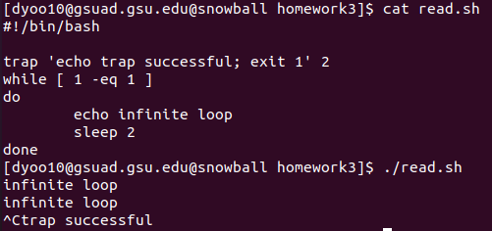

1. Eleventh command: **until**

**Until** command executes a set of commands until the condition given succeeds

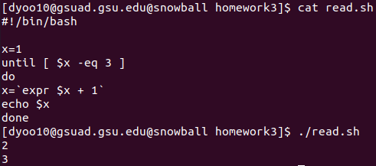

1. Twelfth command: **while**

Similar to **until**, but **while** will execute commands until the initial condition fails

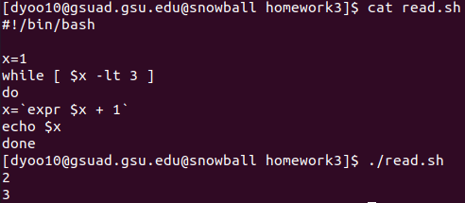

1. Thirteenth command: **set**

Allows one to control shell options, like changing the values of arguments

