Dong Yoo

CSC 3320

Lab 11

Part 1:

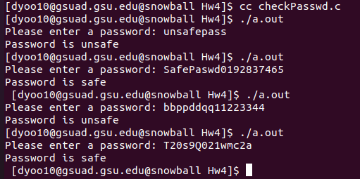

Part 2:

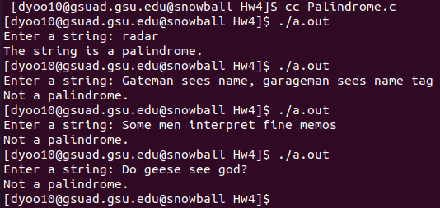

Part 3:

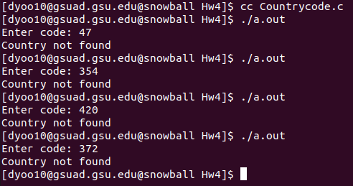

(My countries were different than these ones that were selected)