Lab 2

CSC 3320

1/22/2021 Fri 4:00PM lab

Dong Yoo

1. The working directory is /home/dyoo10
2. The difference is that now it shows “csc3320” in the working directory
3. The directory is now /home/dyoo10/csc3320
4. To make a “lab2” folder I typed mkdir lab2
5. I typed cd lab2
6. The > sign creates a file, and we need to press ctrl-d to exit the text file so that we can do other commands
7. And h)

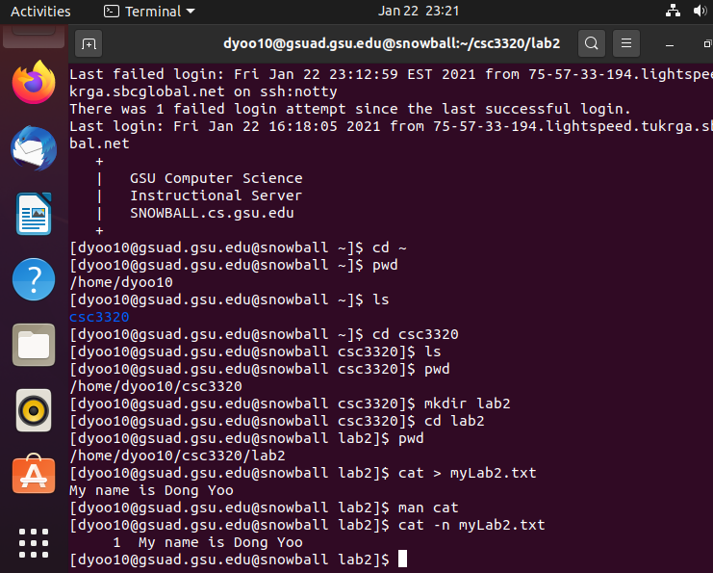

\*\* for step 13 it said to use cd <Answer from step(2)> but step 2 wasn’t the right direction so I used 1 instead