Lab 4 CSC 3320

Dong Yoo

1. $ grep ‘Towns|Union’ mountainList.txt
2. $ grep ‘Rabun’ mountainList.txt |wc -l
3. $ grep -c ‘Rabun’ mountainList.txt
4. A)

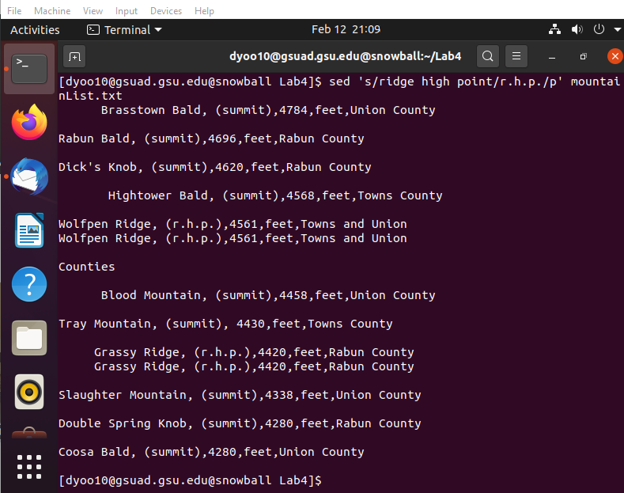

b)

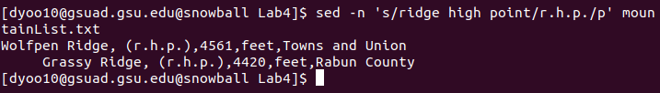

c) The -n command only prints the lines affected by sed

d) The sed command in b) will only print the two lines in which ridge high point was replaced

1. $ sed -e ‘s/[ \t]//’ mountainList.txt
2. $ sed -e ‘s/[ \t]//’ mountainList.txt|tee newList.txt
3. $ sed -n ‘/^\s/p’ mountainList.txt
4. $ sed ‘/Union County/d’ mountainList.txt
5. $ awk -F’,’ ‘{print $1”,”$5}’ mountainList.txt
6. $ sed ‘1 i Table: Eleven highest mountains in Georgia’ mountainList.txt
7. $ sort mountainList.txt
8. $ sort -t’,’ -k 3n mountainList.txt

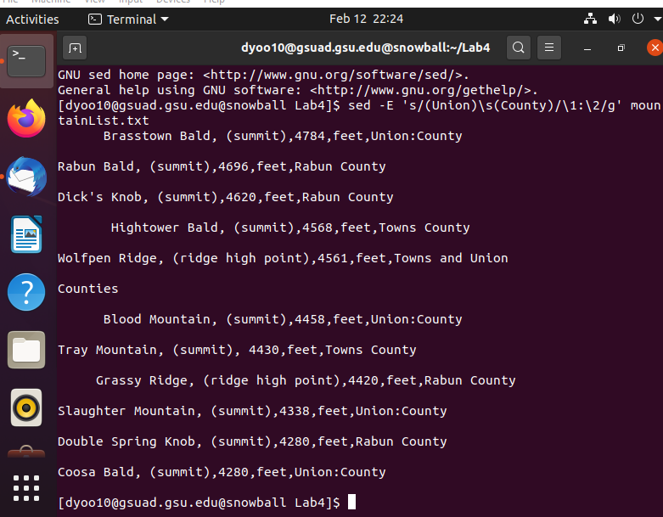

1. $ sed ‘s/,\(.\*,\)\{0,1}/, /’ mountainList.txt