Lab5 In-Lab assignment

Dong Yoo

CSC 3320

1. -bash: simple.sh: command not found
2. -bash: ./simple/sh: No such file or directory

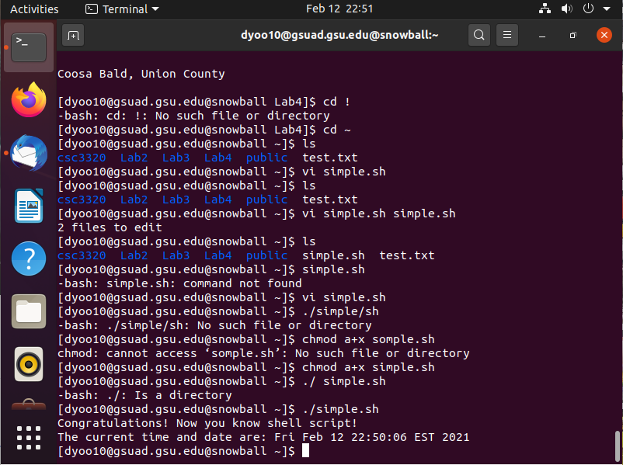

1. No new line between that line and the date
2. Yes, it is a comment
3. It is not a comment, it is used to give the program a BASH shell
4. There are 6
5. The command we just entered added the home directory to the list of PATHs, so it searches this directory when using the command
6. Yes
7. Yes, because the PATH change we did in the earlier command wasn’t permanent