Dong Yoo

CSC 3320

Lab Assignment 7

1)

#include <stdio.h>

Void printNum(char \*x)

{

Char new[12];

New[0] = x[1];

New[1]=x[2];

New[2]=x[3];

New[3]=’-‘;

New[4]=x[5];

New[5]=x[6];

New[6]=x[7];

New[7]=’-‘;

New[8]=x[9];

New[9]=x[10];

New[10]=x[11];

New[11]=x[12];

Printf(“You entered: %s\n”, new);

}

Int main(void)

{

Char num[13];

Printf(“Enter phone number [(999)999-9999]: “);

Scanf(“%s”, num);

printNum(num);

return 0;

}

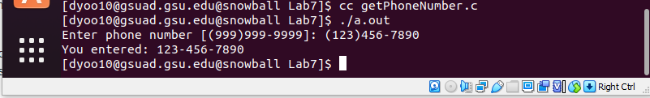

2)

#include <stdio.h>

Int main(void)

{

Float price;

Int num, qty;

Char dat[10];

Printf(“Enter item number:”);

Scanf(“%d”, &num);

Printf(“Enter unit price:”);

Scanf(“%f”, &price);

Printf(“Enter quantity:”);

Scanf(“%d”, &qty);

Printf(“Enter purchase date (mm/dd/yyyy) :”);

Scanf(“%s”, &dat);

Printf(“Item\tUnit\tPrice\tQTY\tPurchase Date\tTotalAmount\n”);

Printf(“%d\t$\t%.2f\t%d\t%s\t$%.2f\n”, num, price, qty, dat, price\*qty);

Return 0;

}

