Dong Yoo

Sys Level Programming CSC 3320

Lab 9

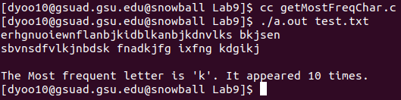

1. a)

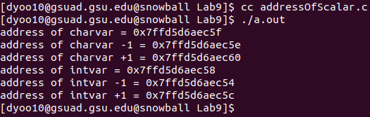

b)

#include<stdio.h>

int main()

{

char charvar='\0';

printf("address of charvar = %p\n",(void\*)(&charvar));

printf("address of charvar -1 = %p\n",(void\*)(&charvar-1));

printf("address of charvar +1 = %p\n",(void\*)(&charvar+1));

int intvar=1;

printf("address of intvar = %p\n",(void\*)(&intvar));

printf("address of intvar -1 = %p\n",(void\*)(&intvar-1));

printf("address of intvar +1 = %p\n",(void\*)(&intvar+1));

}

c)

Intvar variables takes 4 bytes of memory as opposed to charvar taking 1 byte of memory

1. a)

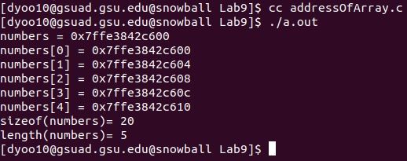

b)

Yes

c)

printf(“length(numbers)= %lu\n”, sizeof(numbers)/sizeof(numbers[0]));