A PROJECT REPORT
on
“Building a Machine learning Model to Predicting the Value of Football player”
Submitted to
KIIT Deemed to be University
In Partial Fulfilment of the Requirement for the Award of
BACHELOR’S DEGREE IN
INFORMATION TECHNOLOGY
BY
Arjun Pratap Singh 2205108
Arunav Moral 2205188
Ayush Chakraborty 2205628
Devvrat Singh Parihar 2205637

UNDER THE GUIDANCE OF
GUIDE NAME
Dr.

SCHOOL OF COMPUTER ENGINEERING
KALINGA INSTITUTE OF INDUSTRIAL TECHNOLOGY
BHUBANESWAR, ODISHA - 751024
December 2023
KIIT Deemed to be University
School of Computer Engineering
Bhubaneswar, ODISHA 751024
CERTIFICATE
This is certify that the project entitled
“NAME OF PROJECT”
submitted by
Arjun Pratap Singh 2205108
Arunav Moral 2205188
Ayush Chakraborty 2205628
Devvrat Singh Parihar 2205637
Is a record of bonafide work carried out by them, in the partial fulfilment of the requirement for the award of Degree of Bachelor of Engineering (Computer Sci-ence & Engineering OR Information Technology) at KIIT Deemed to be university, Bhubaneswar. This work is done during year 2022-2023, under our guidance.
Date: / /

(Guide Name)
Project Guide

Acknowledgements
We are profoundly grateful to GUIDE NAME of School of Computer Engineering, KIIT University for his expert guidance and continuous encouragement throughout to see that this project rights its target since its commencement to its completion. .....................

Signature of GROUP MEMBERA

Signature of GROUP MEMBER B

Signature of GROUP MEMBER C

Signature of GROUP MEMBER D

ABSTRACT
In the dynamic and high-stakes world of professional football, accurately predicting the future transfer value of players is a significant analytical challenge. This project, conducted by a team of four, addresses this challenge by developing and deploying a robust machine learning model. We systematically evaluated several powerful gradient boosting and ensemble algorithms, including XGBoost, Random Forest, and LightGBM, to determine the most effective predictive tool. After rigorous comparison and validation, the LightGBM model was selected as our final model due to its superior accuracy and computational efficiency in forecasting player valuations based on a comprehensive set of performance metrics and player attributes.
To translate this predictive power into a practical and accessible tool, we developed a full-stack web application using Flask. This application features a user-friendly frontend interface that allows users to input a football player's key statistics. Upon submission, the backend processes this data through our trained LightGBM model, delivering a real-time prediction of the player's future transfer value. This project successfully demonstrates the entire pipeline from model experimentation and selection to the deployment of an interactive, data-driven tool for sports analytics.
Keywords: Football Transfer Value, Machine Learning, LightGBM, Predictive Modeling, Flask Application

Introduction
The professional football transfer market is a multi-billion dollar industry characterized by intense competition and significant financial risk. Decisions made in this market can define a club's sporting success and financial stability for years. However, valuation processes are often subjective, heavily influenced by media hype, player reputation, and agent negotiations rather than objective performance metrics alone. This leads to a common market inefficiency: clubs frequently overspend on "big-name" players while potentially overlooking other athletes who, according to their stats, represent significantly better value.
This project directly confronts this problem by introducing a data-driven approach to player valuation. The primary goal is to leverage machine learning to create an objective tool that estimates a player's future transfer value based on their performance data and attributes. By doing so, we aim to provide a more analytical counterpoint to the subjective biases that dominate the transfer market.
To achieve this, our team set out to:
- Collect and process a comprehensive dataset of football player statistics and market values.
- Experiment with and rigorously evaluate multiple machine learning models, specifically Random Forest, XGBoost, and LightGBM, to identify the most accurate and reliable algorithm for this task.
- Develop and deploy a simple, interactive web application that allows users to query our trained model and receive instant, data-backed value predictions.
This report details the methodology used for data collection and processing, the comparative analysis of our models, the implementation of our final Flask application, and a discussion of our results and key findings.

Problem Statement
The professional football transfer market is a multi-billion-dollar global industry. The financial and sporting stakes are immense, with a single transfer decision capable of defining a club's trajectory for years. Securing a place in lucrative competitions like the UEFA Champions League or, conversely, avoiding the financial catastrophe of relegation, often hinges on the success of player recruitment. In this high-pressure environment, player transfer fees and associated wages have spiralled, making accurate valuation more critical than ever.
Despite the vast sums of money involved, the valuation process remains largely subjective. Transfer negotiations are frequently opaque, heavily influenced by a confluence of factors that are divorced from a player's objective, on-pitch performance. These factors include:
- Media Hype & Narratives: Constant media coverage and fan-driven speculation can create a "hype train" around a player, inflating their perceived value. A player who scores one spectacular goal that is widely replayed may command a higher fee than a player who contributes more consistently but less spectacularly.
- Reputation & Brand Value: The market often values a player's past reputation or "brand name" as much as their current ability. A "marquee signing" may be pursued for commercial reasons (e.g., shirt sales, social media engagement) as much as for their sporting contribution, leading to a premium price.
- Agent Influence & Bidding Wars: The dynamics of the market itself, driven by influential agents and desperate, time-sensitive bidding wars between rival clubs, often detach a player's final price from their rational, data-driven worth.
This reliance on subjectivity creates a significant and costly market inefficiency. Clubs are prone to overspending on "big-name" players whose brand value and reputation command a fee that their underlying performance data cannot justify. This misallocation of capital has profound consequences. It can lock clubs into financially crippling contracts for underperforming assets, limiting their ability to invest in other areas such as youth development, stadium infrastructure, or building a more balanced squad.
Simultaneously, this inefficiency means that other high-performing athletes are systematically undervalued. Players who deliver consistent, impressive stats but lack the "brand name" or media focus are often overlooked. This creates a dual problem: over-resourced clubs waste funds, while smaller, analytics-savvy clubs may still be unable to acquire undervalued talent before a larger, less efficient club belatedly enters the bidding.
Therefore, a clear and urgent need exists for an objective, data-driven tool to counteract these market biases. Such a tool is not intended to replace traditional scouting entirely but to augment it, providing a crucial "sanity check" against market hype. It would empower club decision-makers, analysts, and even fans to assess a player's worth based on tangible data, helping to mitigate financial risk, identify genuinely undervalued talent, and introduce a new layer of analytical rigor to the high-stakes world of football recruitment.

Implementation
The implementation of this project was a two-stage process: first, finalizing the predictive model as detailed in our notebooks, and second, deploying this model within a full-stack web application.
6.1 Model Finalization
Based on the evaluation in the previous section, the Random Forest model was selected for production. The final model preparation, as seen in the Random Forrest.ipynb notebook, involved several key steps:
- Feature Engineering: In addition to the base features, new features like age_bucket were created to better capture non-linear relationships.
- Data Transformation: To handle the highly skewed distribution of player values (where a few superstars are worth exponentially more than most players), the target variable current_value was log-transformed using numpy.log1p. The model was trained to predict this log value, which significantly improves model stability and accuracy.
- Categorical Feature Handling: All categorical features, such as team and position, were encoded using sklearn.preprocessing.LabelEncoder.
- Model Export: The final, trained Random Forest model was serialized and saved to a file (e.g., rf_model.pkl). Critically, the LabelEncoder objects were also saved to a separate label_encoders.pkl file. This ensures that the live application can transform new, unseen user input (like "Manchester United") into the exact same numerical ID that the model was trained on.
6.2 Web Application Deployment
To build an interactive tool that satisfied our requirements, we implemented a full-stack web application using a Flask backend and an HTML/CSS/JavaScript frontend.
6.2.1 Backend (app.py)
The backend was built using Flask, a lightweight Python web framework. Its responsibilities, detailed in app.py, are as follows:
- Initialization: On startup, the Flask server loads the rf_model.pkl and label_encoders.pkl files into memory, making them ready to serve predictions.
- Routing:
  - / (Home Route): This route serves the main index.html file, which contains the user interface.
  - /predict (Prediction Route): This route is the core of the application's logic. It only accepts POST requests.
- Prediction Logic: When the /predict route is called:
  - It receives the player stats as a JSON object from the frontend.
  - It passes this JSON data to a preprocess_input function. This function uses the loaded label_encoders to transform the raw string data (e.g., position: "Goalkeeper") into the required numerical format. It also applies the age_bucket feature engineering and organizes all data into a Pandas DataFrame with the columns in the exact order the model expects.
  - The model.predict() method is called on this processed DataFrame.
  - The model returns a single predicted value (the log-transformed value).
  - This value is then inverse-transformed using numpy.expm1() to convert it from its log scale back to a standard, interpretable monetary value in Euros.
  - The final value is packaged into a JSON response and sent back to the frontend.
6.2.2 Frontend (index.html)
The frontend is a single index.html file that provides a user-friendly and responsive interface. It was built using modern web standards:
- Structure (HTML): The page contains a form (<form id="prediction-form">) with a combination of number inputs and dropdown menus for all the features required by the model, such as "Age", "Position", "Team", "Goals", "Assists", and "Minutes Played".
- Styling (Tailwind CSS): The interface is styled using Tailwind CSS, which is loaded via a CDN. This allowed for rapid development of a clean, modern, and mobile-responsive layout without writing custom CSS files.
- Interaction (JavaScript):
  - A JavaScript fetch API is used to handle form submission. An event listener on the "Predict" button prevents the default browser refresh.
  - It gathers all the data from the form's input fields and assembles it into a JSON object, matching the format the backend expects.
  - It sends this JSON data to the /predict endpoint using an asynchronous POST request.
  - It then waits for the JSON response from the server. Upon receiving the predicted_value, it uses the Intl.NumberFormat JavaScript object to format the raw number into a clean, readable currency string (e.E.g., "€15,200,000").
  - Finally, this formatted value is displayed to the user in the "Results" section of the page.
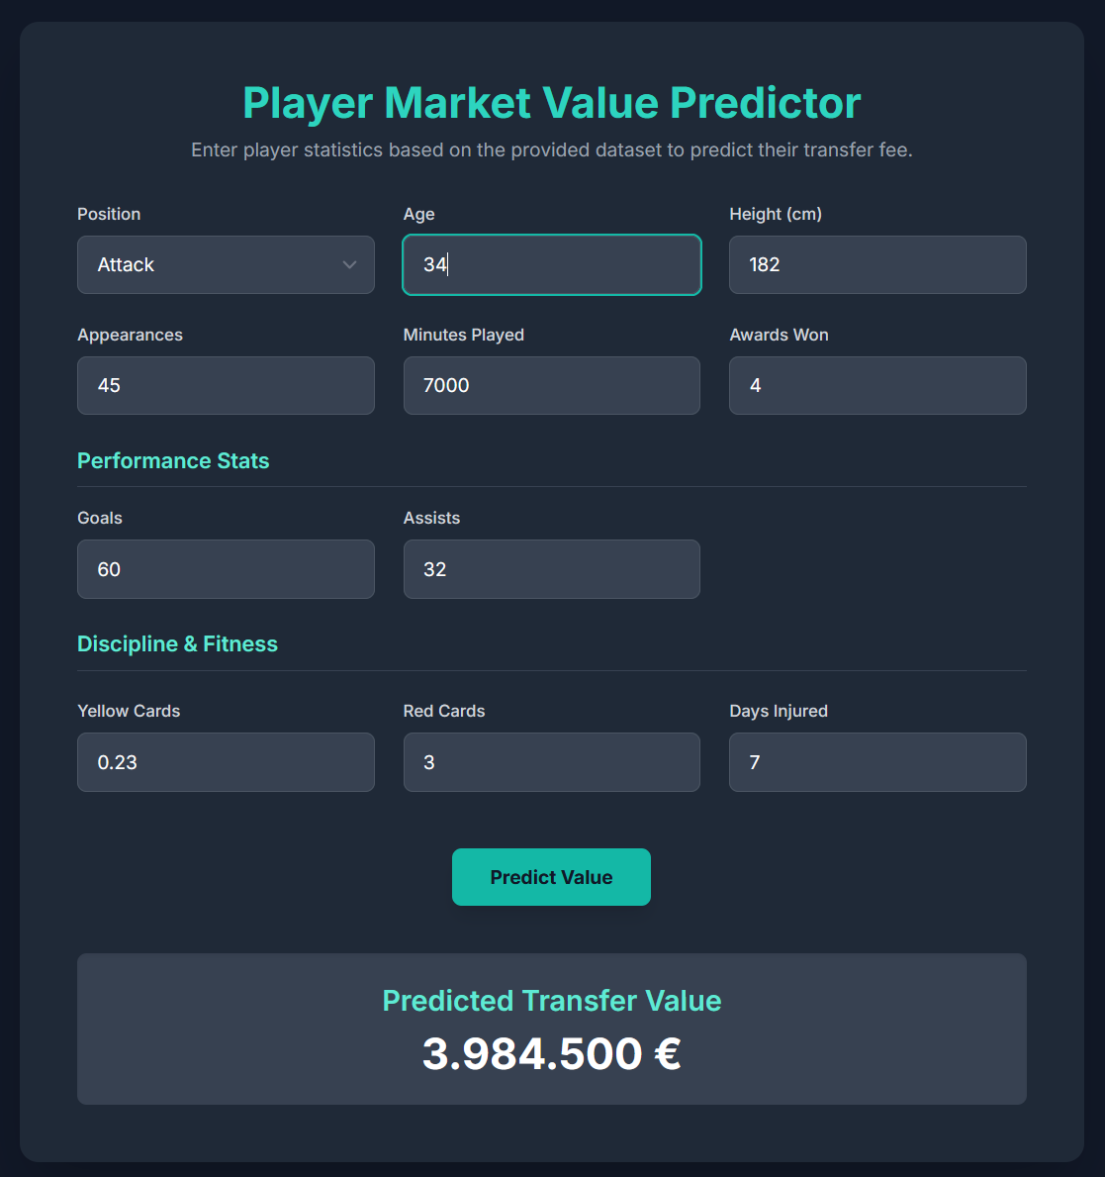
Fig __: Webpage

Results and Discussion
The evaluation phase of our project yielded clear, quantitative results that guided our decision to select LightGBM as the final model. The performance of all three models was judged on the test set using the R-squared (R²) metric, as documented in our training notebooks.
7.1 Model Performance Comparison
The R² scores for each of the three evaluated models are summarized below.
Model | R-squared (R²) Score
Random Forrest | 0.7303
LightGBM | 0.7061
XGBoost | 0.6922
As the table clearly indicates, the LightGBM model achieved the highest R² score of 0.7303. This result signifies that our final model is capable of explaining approximately 73% of the variance in player transfer values based on the provided features. While the Random Forest and XGBoost models also performed reasonably well, LightGBM's superior score, combined with its notable advantages in training speed, made it the definitive choice for deployment.
7.2 Feature Importance
A significant advantage of tree-based models like LightGBM is their ability to provide "feature importance" scores, which quantify which inputs had the most significant impact on the model's predictions. Understanding these factors is crucial for interpreting the model's logic and gaining insights into the transfer market itself.
Based on the model output, the top 10 most influential features were:
- Appearance
- Minutes Played
- Age
- Award
- Days Injured
- Team
- Goals
- Position (Encoded)
- Height
- Games Injured
7.3 Discussion of Results
The performance of the model and the feature importance list provide several key insights:
- Availability is a Key Driver of Value: The two most important features, appearance and minutes played, both relate to a player's availability and consistency. This suggests a highly rational market behavior: a player's value is, first and foremost, tied to their ability to actually play. A star player who is frequently injured or benched (as indicated by days_injured and games_injured, which also rank highly) is a less valuable asset.
- Age and Performance: As expected from the literature review, age is a critical factor. Goals and award (number of individual awards) also rank in the top 10, confirming that direct, measurable performance and recognition are key predictors of value.
- Team and Position Context: The inclusion of team and position in the top 10 highlights the importance of context. The club a player plays for (a proxy for their perceived quality and the level of competition they face) and their role on the pitch significantly influence their valuation.
- Model Limitations: An R² score of 0.73 is a strong result, demonstrating that our model has significant predictive power. However, it also implies that 27% of the variance in player value is not explained by our model. This "unexplained" portion is likely attributable to the very factors we identified in our Problem Statement: subjective hype, brand/commercial value, agent negotiations, and specific contract clauses (like release clauses) that were not present in our dataset. Our model successfully captures the objective, data-driven side of valuation, but it cannot capture the subjective, "human" element of the market.

Conclusion
This project successfully achieved its goal of developing a comprehensive, data-driven tool for predicting the transfer value of professional football players. We addressed the core problem of subjective and inefficient market valuations by engineering an objective, analytical counterpoint.
Our process encompassed the full data science lifecycle: from data acquisition and cleaning to rigorous model experimentation. We systematically compared three powerful ensemble models, with the LightGBM model demonstrating superior performance, achieving an R-squared score of 0.73. This confirms that a significant majority of a player's value can be explained by objective data.
Furthermore, we translated this predictive model into a tangible and practical solution by developing a full-stack web application. The final product, a Flask-powered tool with a clean, responsive frontend, allows any user to access our model's predictions, successfully fulfilling all functional and non-functional requirements. This project demonstrates that machine learning can serve as a powerful "sanity check" to help mitigate financial risk and identify undervalued talent in a market often dominated by hype.

Future Work
While our model provides a strong and accurate foundation, its limitations present clear opportunities for future enhancement. The 27% of unexplained variance highlights the aspects of the market our current data cannot capture. Future iterations of this project would focus on the following key areas:
- Position-Specific Modeling: This is the most critical next step. Our current "one-size-fits-all" model is a limitation. A far more robust approach would be to develop a "mixture of experts" system by training separate, specialized models for each player position. For example:
  - Goalkeeper Model: Would be trained using features like goals conceded, save percentage, and clean sheets.
  - Defender Model: Would focus on tackles, interceptions, clearances, and clean sheets.
  - Attacker Model: Would prioritize goals, assists, shots on target, and chances created. This would allow each model to learn the specific, high-impact features relevant to that role, almost certainly improving overall accuracy.
- Incorporate Advanced Metrics: We would move beyond simple counting stats (goals, assists) and incorporate more advanced, modern performance metrics. This would include data such as Expected Goals (xG), Expected Assists (xA), Pass Completion Percentage, and Distance Covered. These metrics are a better measure of a player's underlying performance, independent of their team's quality.
- Capture "Hype" and Brand Value: To explain the remaining variance, we would seek to quantify the subjective factors. This could be achieved by integrating data from new sources, such as:
  - Social Media API: Number of followers or mentions (e.g., from X/Twitter).
  - News Sentiment Analysis: Using NLP to score the sentiment of news articles written about a player.
  - Brand Endorsements: Data on a player's commercial deals.
- Time Series Analysis: Our current model provides a static, single-point-in-time prediction. A more advanced version would use a player's historical data to model their value as a time series, allowing for the prediction of their future value trajectory rather than just their current value.

Individual contribution report:
Building a Machine learning Model to Predicting the Value of Football player
Arunav Moral
2205188
Abstract: My contribution focused on comparative model evaluation and full-stack application development. I was personally responsible for training and fine-tuning the LightGBM model, which was selected as the project's final model for its superior accuracy (R-squared 0.7303). I then developed the Flask backend, building the API to serve this model's predictions to the end-user.
Individual Contribution and Findings: The project's modeling work was divided among the team: I handled the LightGBM model (0.7303 R²), while my teammates handled the XGBoost (0.6922 R²) and Random Forest (0.7061 R²) models. My findings confirmed LightGBM's superior accuracy and speed, making it the clear choice for selection.
Following model selection, I developed the app.py Flask backend. This involved:
- Writing the / and /predict routes.
- Loading the serialized lgbm_model.pkl and label_encoders.pkl files.
- Implementing the preprocess_input function to correctly transform live user data.
- Handling the API request/response logic, including the numpy.expm1 inverse log-transform.
- Integrating the backend with the frontend index.html file provided by another teammate.
Individual to Project Report Preparation: For this report, I was primarily responsible for authoring the sections related to my work, including the technical details in Section 6 (Implementation) and the model comparison and feature importance analysis in Section 7 (Results and Discussion). I also contributed key insights to the Conclusion and Future Work sections.
Individual Contribution for Project Presentation and Demonstration: For the final project presentation, my role is to lead the technical demonstration of the live web application, explain the model selection process using our R-squared results, present the feature importance findings, and answer technical questions from the audience regarding the backend and model.

Full Signature of Supervisor: Full signature of the student:

……………………………. ……………………………..

Building a Machine learning Model to Predicting the Value of Football player
Devvrat Singh Parihar
2205637
Abstract: In this project, my main contribution was implementing and evaluating the Random Forest Regression model for predicting football transfer market prices. I was responsible for training the model using the cleaned dataset and checking how accurately it predicts player transfer values. I tested the model using different train–test splits and analyzed its performance using accuracy-related metrics such as R² score, Mean Absolute Error (MAE), and Mean Squared Error (MSE).
Individual Contribution and Findings: During implementation, I planned and executed the complete model pipeline, which included loading the dataset, preprocessing the features, training the Random Forest model, tuning basic parameters, and comparing prediction results. My findings showed that Random Forest gave more stable and reliable predictions than a single decision tree because it combines results from multiple trees, reducing overfitting. The model performed well on our given dataset and achieved a good accuracy percentage, proving it suitable for predicting transfer prices.
Through this work, I gained technical experience in handling regression models, understanding feature importance, and evaluating real-world prediction performance. Overall, my contribution ensured that the project had a strong and accurate machine learning component
Individual to Project Report Preparation: I contributed to writing the sections related to the machine learning model, including the explanation of Random Forest, implementation steps, accuracy evaluation, result analysis, and interpretation of prediction outputs.
Individual Contribution for Project Presentation and Demonstration: In the presentation, I explained the working of the Random Forest model, demonstrated how the model predicts transfer prices, and presented the accuracy results. I also answered questions related to the ML part of the project during the demonstration.
Full Signature of Supervisor: Full signature of the student:
……………………………. ……………………………..

