**DSD Final Checkpoint Scores**

**1. Baseline**

(1) Area: (um2)

截圖: Total cell area = 245036.661605

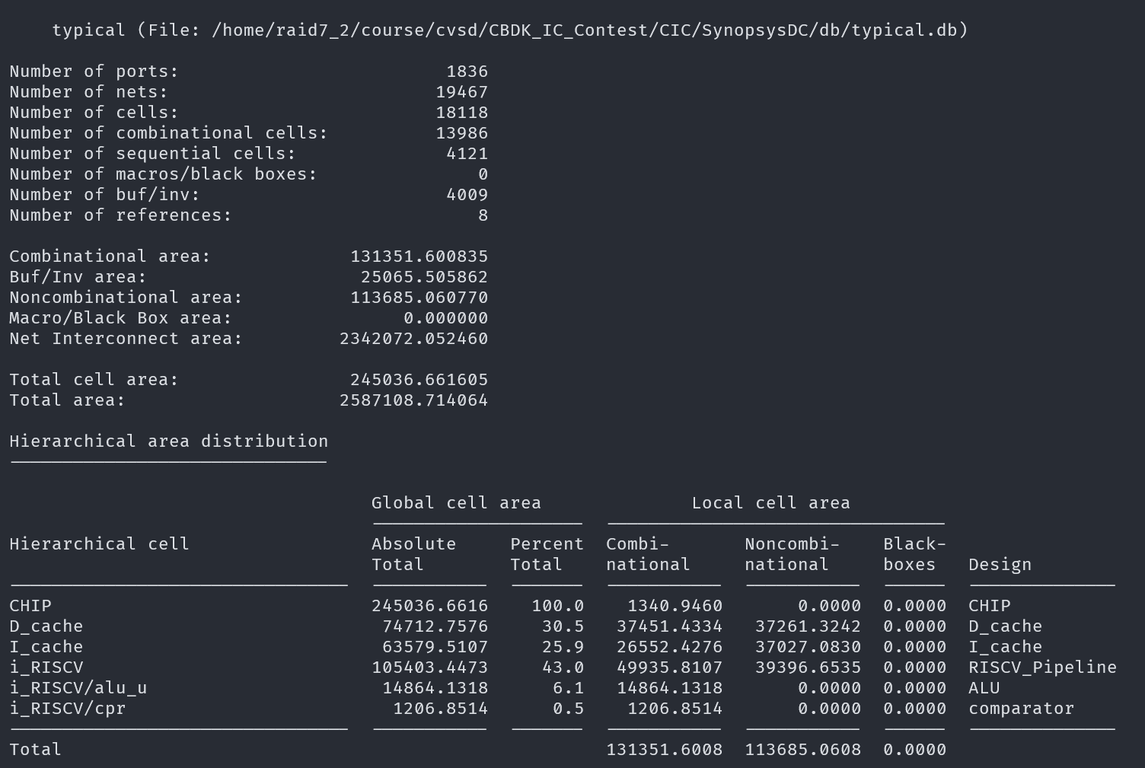

(2) Total Simulation Time of given noHazard testbench: (ns)

截圖: 1088.490 ns

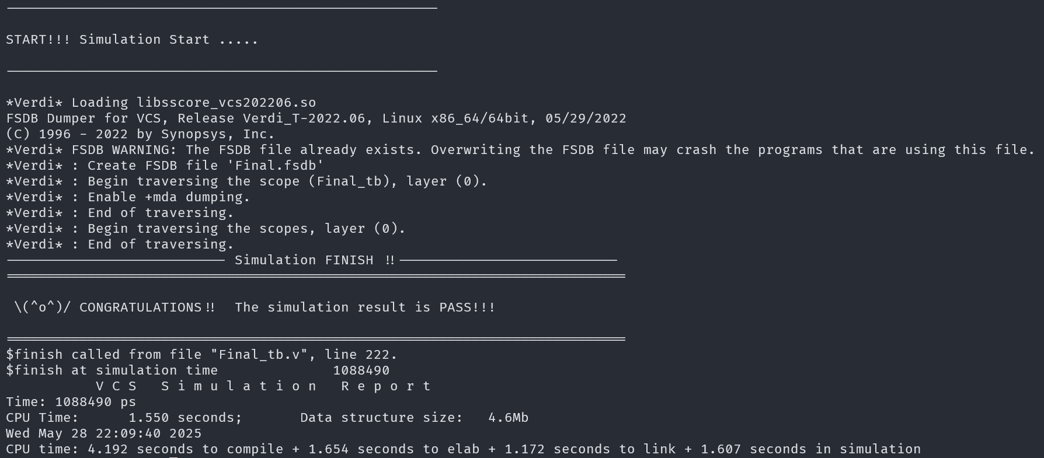

(3) Total Simulation Time of given hasHazard testbench: (ns)

截圖: 9187.490 ns

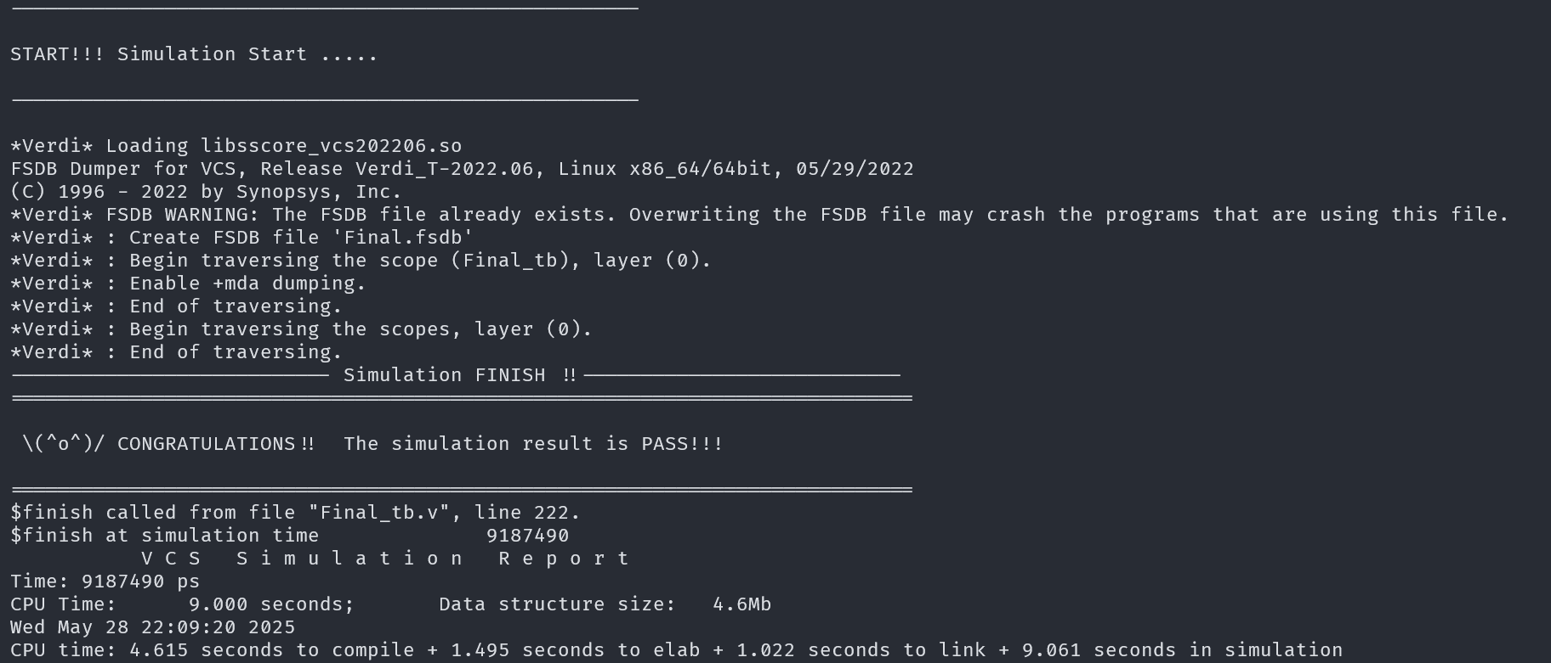

(4) Clock cycle for post-syn simulation (cycle in testbench, not cycle in sdc): (ns)

3.49 ns

