**信號與系統 Signals and Systems**

**Mat-Lab HW3**

鄭宇彥

B12901035

電機系大一

陳宏銘教授班

**Part I**

(a)

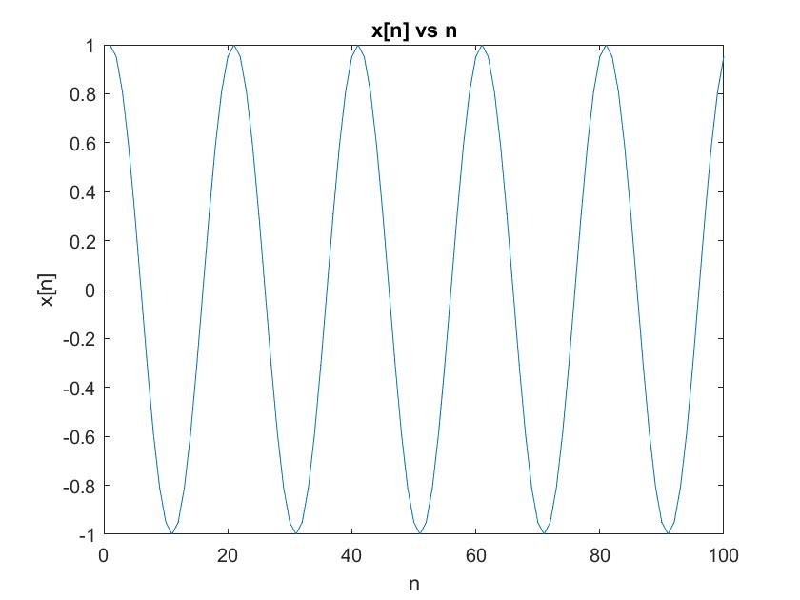

(b)(c)(d) plots

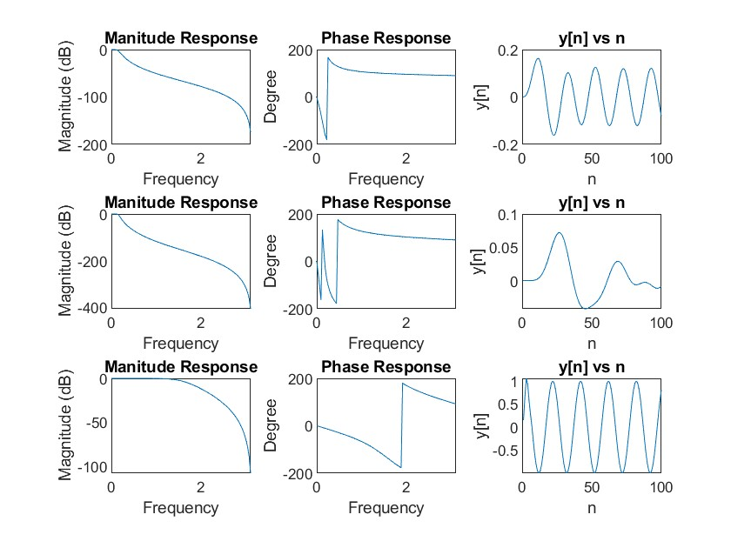

(d)

(c)

(b)

Transfer functions:

(b) L = 3/fc = 0.05

|  |  |  |  |  |
| --- | --- | --- | --- | --- |
| k | 1 | 2 | 3 | 4 |
| ak | 1.0000 | -2.6862 | 2.4197 | -0.7302 |
| bk | 4.1655e-04 | 0.0012 | 0.0012 | 4.1655e-04 |

H(ejw) =

(c) L = 7/fc = 0.05

|  |  |  |  |  |  |  |  |  |
| --- | --- | --- | --- | --- | --- | --- | --- | --- |
| k | 1 | 2 | 3 | 4 | 5 | 6 | 7 | 8 |
| ak | 1.0000 | -6.2942 | 17.0111 | -25.5884 | 23.1343 | -12.5702 | 3.8005 | -0.4932 |
| bk | 1.3134e-08 | 9.1939e-08 | 2.7582e-07 | 4.5969e-07 | 4.5969e-07 | 2.7582e-07 | 9.1939e-08 | 1.3134e-08 |

H(ejw) =

(d) L = 3/fc = 0.5

|  |  |  |  |  |
| --- | --- | --- | --- | --- |
| k | 1 | 2 | 3 | 4 |
| ak | 1.0000 | -4.9960e-16 | 0.3333 | -1.8504e-17 |
| bk | 0.1667 | 0.5000 | 0.5000 | 0.1667 |

H(ejw) =

(e)

Increasing L:

A higher order of a Butterworth low-pass filter will lead to a sharper roll-off in the frequency domain, which means that for the transfer function, there will be steeper on the edge of cutoff frequency. In other words, the transition band becomes smaller, which makes the low pass filter more ideal. As we can see, if we compare the y[n] plots of (b) and (c), the higher frequency component is eliminated more cleanly, so the result of (c) seemingly lacks some high-frequency parts.

Increasing fc:

A larger cut-off frequency will make the pass-band of the low pass filter larger, which means that more high-frequency components won’t be filtered at all. Let’s compare the plots of (b) and (d). It seems that the response y[n] of (d) carries almost the same frequency as x[n], which implies that the passband of (d) becomes larger enough so that the function of x[n] on the frequency domain passes through the low pass filter successfully.

**Part II**

(a)(b)(c)

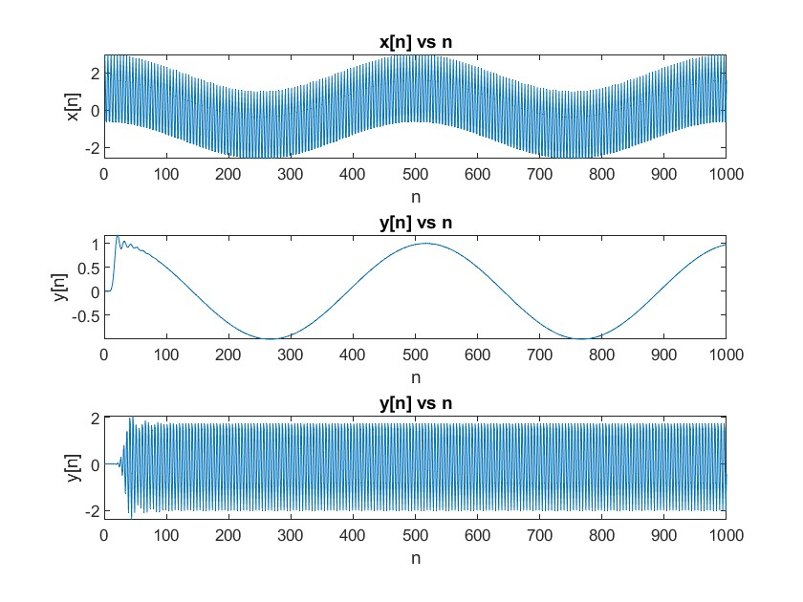

(b)

L = 16/ **Cutoff Frequency:** 0.40 (Where $π$ is normalized to 1)

|  |  |  |  |  |  |  |  |  |  |
| --- | --- | --- | --- | --- | --- | --- | --- | --- | --- |
| k | 1 | 2 | 3 | 4 | 5 | 6 | 7 | 8 | 9 |
| ak | 1.0000 | -9.5922 | 43.9955 | -127.7924 | 262.6519 | -404.4528 | 482.1181 | -453.3463 | 339.5554 |
| bk | 5.8242e-10 | 9.3187e-09 | 6.9890e-08 | 3.2616e-07 | 1.0600e-06 | 2.5440e-06 | 4.6640e-06 | 6.6629e-06 | 7.4957e-06 |
| k | 10 | 11 | 12 | 13 | 14 | 15 | 16 | 17 |  |
| ak | -203.1005 | 96.6268 | -36.1596 | 10.4286 | -2.2398 | 0.3377 | -0.03192 | 0.001424 |  |
| bk | 6.6629e-06 | 4.6640e-06 | 2.5440e-06 | 1.0600e-06 | 3.2616e-07 | 6.9890e-08 | 9.3187e-09 | 5.8242e-10 |  |

H(ejw) =

(c)

L = 16/**Bandpass Frequency**: [0.3, 0.5] (Where $π$ is normalized to 1)

|  |  |  |  |  |  |  |  |  |  |
| --- | --- | --- | --- | --- | --- | --- | --- | --- | --- |
| k | 1 | 2 | 3 | 4 | 5 | 6 | 7 | 8 | 9 |
| ak | 1.0000 | -8.315 | 42.0959 | -154.6111 | 455.8491 | -1126.2839 | 2406.6052 | -4530.1483 | 7622.3311 |
| bk | 5.8242e-10 | 0 | -9.3187e-09 | 0 | 6.9890e-08 | 0 | -3.2616e-07 | 0 | 1.0600e-06 |
| k | 10 | 11 | 12 | 13 | 14 | 15 | 16 | 17 | 18 |
| ak | -11575.6595 | 15992.3753 | -20211.0703 | 23471.3176 | -25125.2487 | 24853.0290 | -22750.2379 | 19291.2166 | -15155.4874 |
| bk | 0 | -2.5440e-06 | 0 | 4.6640e-06 | 0 | -6.6629e-06 | 0 | 7.4957e-06 | 0 |
| k | 19 | 20 | 21 | 22 | 23 | 24 | 25 | 26 | 27 |
| ak | 11027.9569 | -7424.2511 | 4616.9087 | -2645.2515 | 1391.8820 | -669.4899 | 292.7251 | -115.4187 | 40.6422 |
| bk | -6.6629e-06 | 0 | 4.6640e-06 | 0 | -2.5440e-06 | 0 | 1.0600e-06 | 0 | -3.2616e-07 |
| k | 28 | 29 | 30 | 31 | 32 | 33 |  |  |  |
| ak | -12.5952 | 3.3731 | -0.7563 | 0.1361 | -0.01778 | 0.001424 |  |  |  |
| bk | 0 | 6.9890e-08 | 0 | -9.3187e-09 | 0 | 5.8242e-10 |  |  |  |

H(ejw) =