**信號與系統 Signals and Systems**

**Mat-Lab HW4**

鄭宇彥

B12901035

電機系大一

陳宏銘教授班

**Questions**

(a)

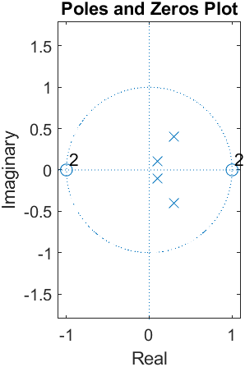

Zeros: -2, +2

Poles: 0.1+j, 0.1-j, 0.3+0.4j, 0.3-0.4j

The ROC of H(z): |z|>0.5 (causal and stable system)

(b)

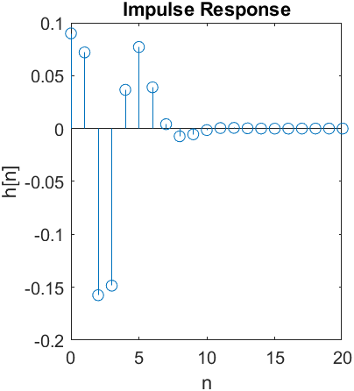

Meaning of r and p: After the partial fraction expansion, the coefficient vectors of the following terms:

$\frac{r\left(i\right)}{\left(1-p{\left(i\right)z}^{-1}\right)}$ $\underset{→}{Z^{-1}} r\left(i\right)⋅p{\left(i\right)}^{n}u[n]$

Meaning of k: the coefficients of the nonpositive power series of z

$k\left(1\right)+k\left(2\right)z^{-1}+k\left(3\right)z^{-2}+…$ $\underset{→}{Z^{-1}}k\left(i\right)δ\left[n+1-i\right]$

(c)

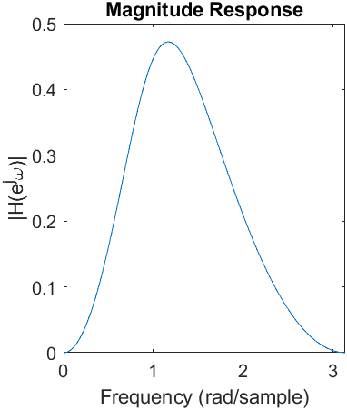 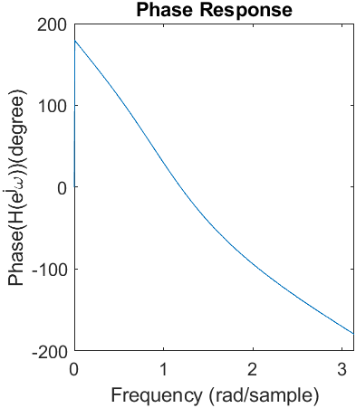

When $z=e^{iω}$, the magnitude and phase of transfer function H

(d)

sos matrix:

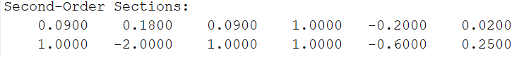

$$H\left(z\right)=H_{1}\left(z\right)H_{2}\left(z\right)$$

$$H_{1}\left(z\right)= \frac{0.09+0.18z^{-1}+0.09z^{-2}}{1-0.2z^{-1}+0.02z^{-2}}$$

$$H_{2}\left(z\right)= \frac{1-2z^{-1}+z^{-2}}{1-0.6z^{-1}+0.25z^{-2}}$$

(e)

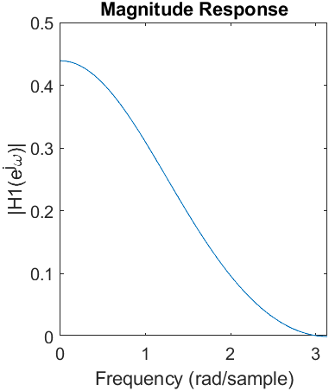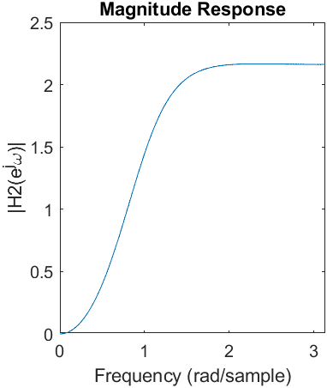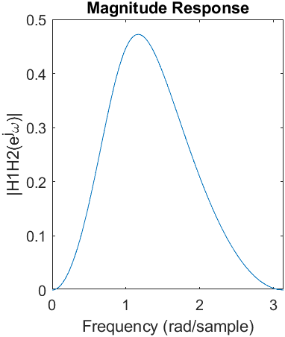

By observation, the magnitude of H1H2 is the same as that of H in (c)

###

Actually, there is slight difference, but by the verifying code, I determine that they are almost the same.

Code: (88-102) , take the acceptable error as 10^-15

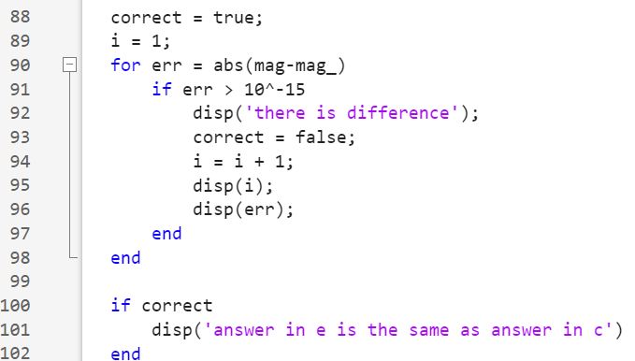

Result:



###

(f)

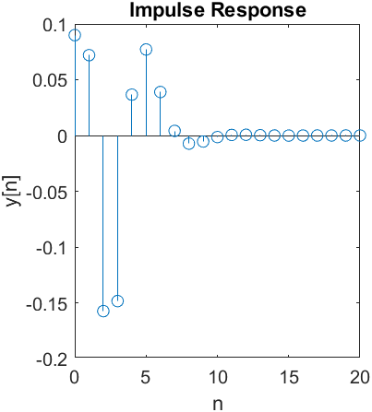

By observation, the impulse response y[n] is the same as h[n] in (b)

###

Actually, there is slight difference, but by the verifying code, I determine that they are almost the same.

Code: (114-128) , take the acceptable error as 10^-14

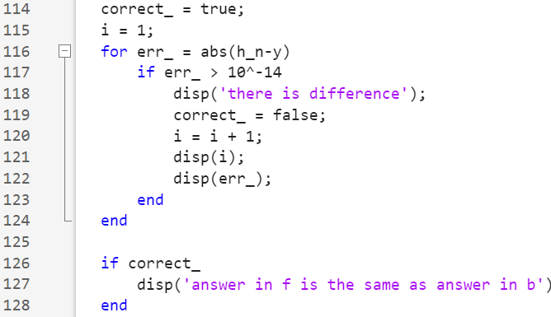

Result:

