Electroencephalography (EEG) Analysis
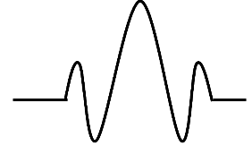
Using Wavelet Transforms
2025 Fall
TFW course term paper
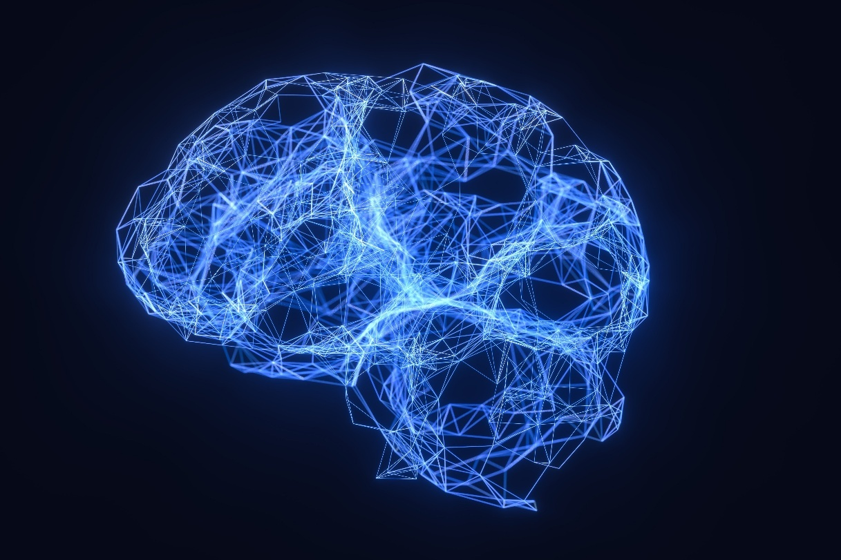

Author: Yu-Yan Zheng
No. B12901035
Advisor: Prof. Jian-Jiun Ding
Contents
1. Introduction 3
1.1 Motivation 3
1.2 Contribution of This Tutorial 3
2. Background of EEG Signals 4
2.1 Physiological Origin of Electroencephalography (EEG) 4
2.2 EEG Frequency Bands 6
2.3 EEG Acquisition and Hardware 8
2.4 EEG Artifacts and Noise 11
*2.5 Simple Case Study 12
*2.6 Volume Conduction 14
3. Mathematical Foundations of Wavelet Transforms 15
3.1 Time-Frequency Analysis Review 15
3.2 Continuous Wavelet Transform (CWT) 15
3.3 Discrete Wavelet Transform (DWT) 16
3.4 Common Wavelet Families 16
4. Wavelet-Based EEG Signal Processing 17
4.1 Detection 17
4.2 Denoising 19
4.3 Classification 22
4.4 Feature Extraction 24
5. Experimental Design and Dataset 27
5.1 Overview 27
5.2 Dataset 27
5.3 Experiment 1 – Denoising 29
5.4 Experiment 2 – Decomposition 30
5.5 Experiment 4 – Classification with Machine Learning 31
6. Experimental Results and Analysis 31
6.1 Case Study 31
6.2 Entropy / Energy Group Study 34
6.3 Machine Learning Result and Potential Improvements 36
7. EEG-Based Brain-Computer Interfaces (BCI) 37
7.1 Overview of Brain-Computer Interfaces 37
7.2 EEG Signal Characteristics and Challenges in BCI 38
8. Conclusion 41
9. References 42

Introduction

Motivation
During the summer, I interned at Academia Sinica. At the end of the program, I happened to attend a presentation by one of the research groups, which mentioned studies related to brain-computer interfaces. That was the first time I had heard about this technology. Its level of fascination immediately made me think of scenes in sci-fi movies, where one can put on a headset and, without any invasive devices, enter a virtual world and control a virtual-self using only one’s thoughts. It sounds far-fetched, but then I thought, haven’t all modern inventions once seemed like wild fantasies? Fifty years ago, no one could have imagined that people would be able to interact with screens just by touching them—but now almost everyone does. Therefore, it is not entirely impossible that head-mounted devices capable of controlling actions through brain signals could become a reality in the near future. For this reason, when I saw that the final project for this course included EEG as one of the topic options, I immediately chose it, seeing it as an opportunity to gain a deeper understanding of this field.

1.2 Contribution of This Tutorial
This tutorial is structured from basic to advanced, providing a comprehensive introduction to the generation of EEG signals, detection methods, common systems, classification approaches, and typical issues. It also recaps the wavelet transform taught in the course. The tutorial then explores multiple research papers to examine how wavelet transforms are applied to EEG signals for tasks such as denoising, seizure detection, feature extraction, and classification, often in combination with various popular machine learning techniques. The experimental section focuses on the HMS Harmful Brain Activity Classification dataset, implementing pipelines for denoising and various decompositions, analyzing band-specific energy and entropy, and applying simple machine learning models to attempt classification tasks. Finally, the tutorial introduces BCI-related tasks, also drawing on several research papers for discussion.

2. Background of EEG Signals

2.1 Physiological Origin of Electroencephalography (EEG)
The human brain contains more than 100 billion neurons. From the communication between them, the electrical activity is generated, resulting in the human EEG. Following will briefly introduce some involved physiological backgrounds.
Membrane Polarity:
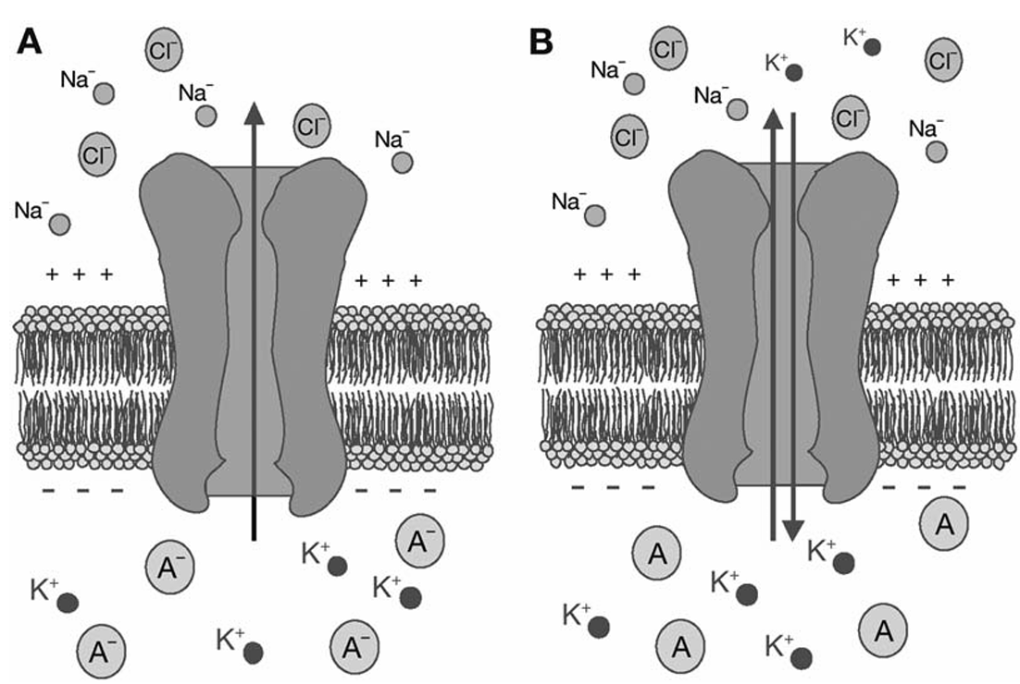
Fig 1: In neurons, K+ has higher concentration, when K+ outflows, the inside becomes more negative.
At some point, a steady state is constructed which contributes to membrane polarity
All neurons and glia have lipid bilayer membranes separating the internal cell activity from external environment. The movement of charged ions through ion channels results in voltage change across the membrane, which is determined by not only the ion concentration gradient but also the selective permeability of ion channels. Charged ions that dominate the voltage across membrane are Na⁺ and K⁺.
Action Potential:
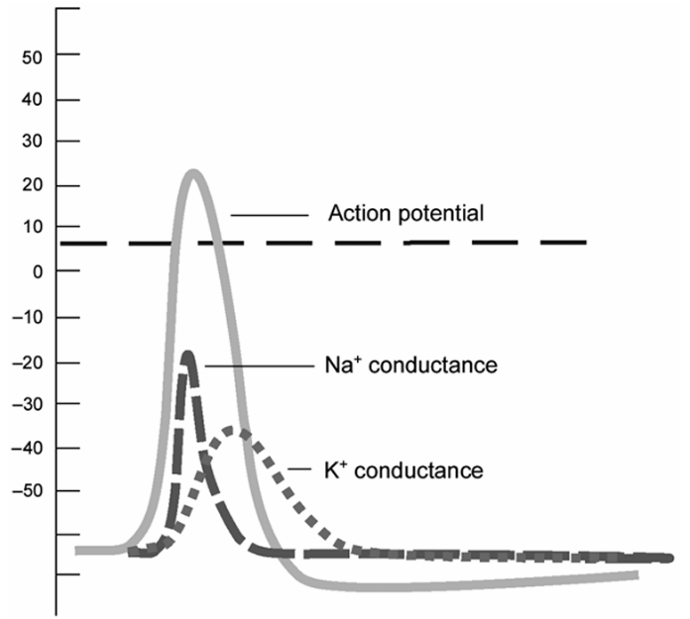
For a neuron to transmit information, the electrical current must be generated, termed as action potential. The current is carried by cations and anions. Through either neurotransmitter release at synapses or current through gap junctions, ligand-gated or voltage-gated ion channels open and elicit postsynaptic potentials. When the membrane potential reaches a threshold (-55 to 60mV), the voltage-gated Na+ channels open rapidly. The influx of Na⁺ makes the interior of the cell more positive will result in further acceleration of the depolarization, and then initiates the action potential, called EPSP.
Fig 2: This plot showcases the openings of channels
during the action potential
The Neural Source of EEG:
The EEG arises from synchronized synaptic activity in populations of cortical neurons (mostly pyramidal cells aligned cortical volumes). Deeper structures, such as the hippocampus, thalamus, or brainstem, do not contribute directly to the surface EEG. However, transmission of electrical impulses from distant sites has substantial effects on the surface EEG. Below shows the current flow in a cortical neuron:
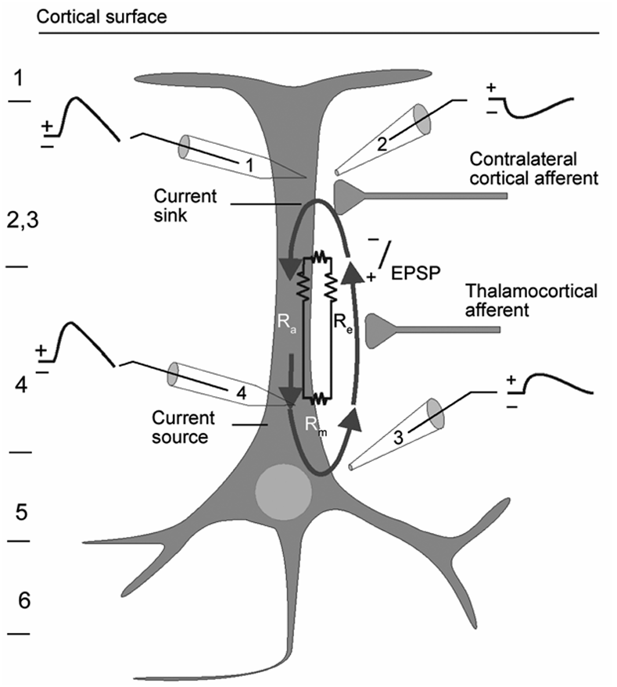
Fig 3: Current flow in a cortical neuron
As we can see, excitation of the postsynaptic neurons creates an extracellular voltage near the neural dendrites that is more negative than elsewhere along the neuron. This situation is referred to as a dipole: a region of positive charge separated from a region of negative charge by some distance. The region of positive charge is referred to as a current source, while the region of negative charge is referred to as a current sink.
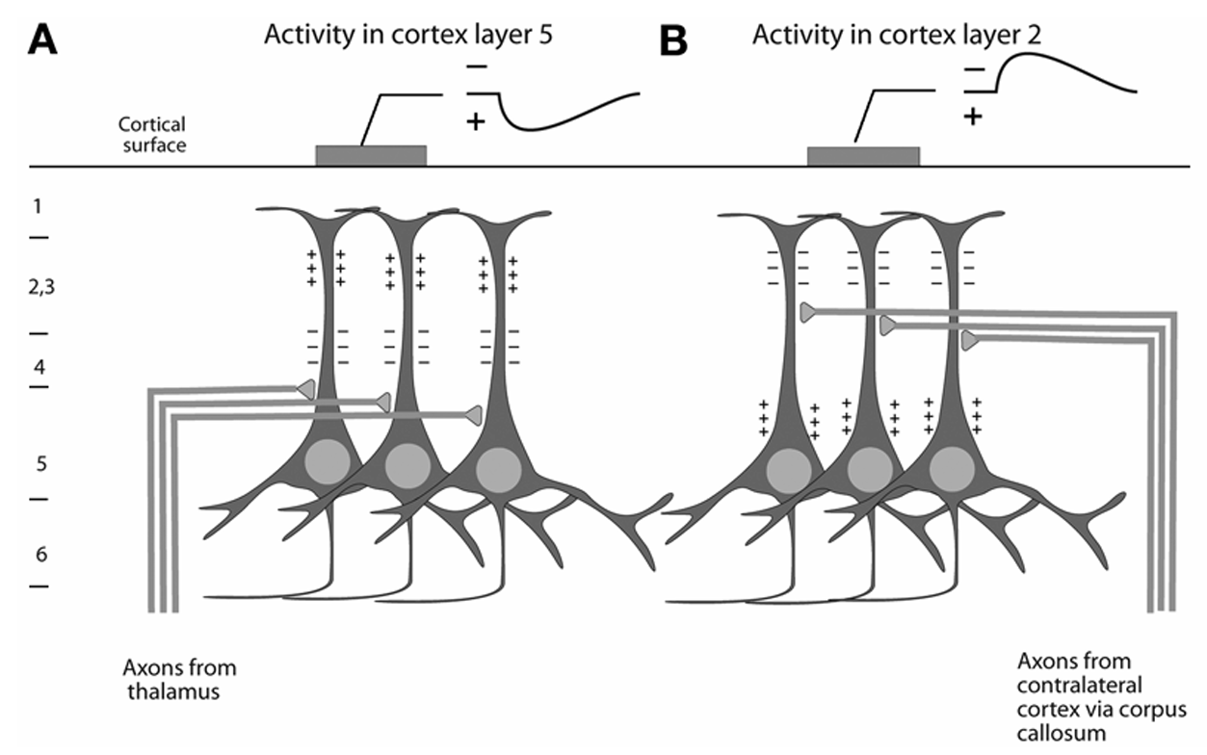
Fig 4: Polarity of the surface EEG depends on the location of synaptic activity within the cortex
Electrodes will detect the sum of positive and negative charges in their vicinity. Since a single neuron’s dipole is too small to be detected, the result is the sum of individual dipoles from multiple neurons in a region. Therefore, the parallel arrangement is necessary to produce a measurable dipole because the same orientation of signals can form a larger one.
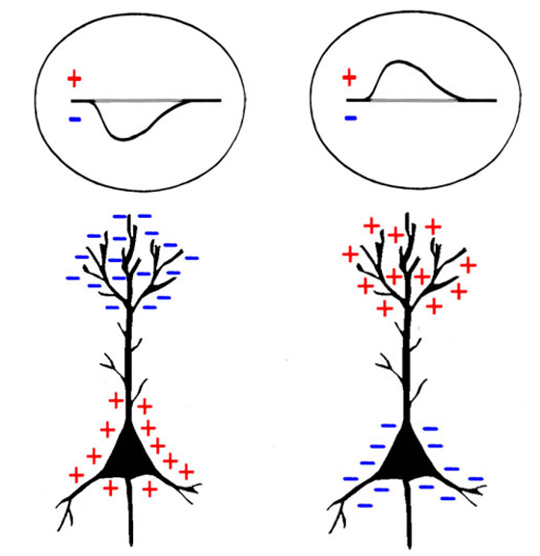
Fig 5: Measure EEG cannot determine if activity is excitatory or inhibitory.
Neuron on the left can either receive IPSP near the soma or EPSP at dendrite
Neuron on the right can either receive EPSP near the soma or IPSP at dendrite
From our discussion above, when EPSP happens there will be current sink at dendrites, then we may predict that there will be negative deflection at scalp electrode.
However, if an EPSP arrives at a synapse that is closer to the cell body (soma) rather than in the dendritic arbor, then the positivity will be closer to the scalp, and a scalp electrode will measure a positive deflection in voltage. Similarly, an inhibitory postsynaptic potential (IPSP), which would hyperpolarize the synaptic region, that is closer to the dendrite than the cell body will produce a positive voltage, while an IPSP closer to the cell body will produce a negative voltage.
Thus, EPSPs and IPSPs can produce either a positive or negative deflection in the EEG signal, depending on whether the positivity is closer to the scalp than the negativity or vice versa.

2.2 EEG Frequency Bands
EEG waveforms are generally classified according to their frequency, amplitude, shape, and position of the electrodes on the scalp. A common classification based on signal frequency bands is alpha, beta, theta, delta, and gamma. Brain wave frequency differs corresponds to different behavior and mental states of the brain.
- Delta $0.1\sim 4Hz$
Delta wave is highest in amplitude and slowest in wave. It represents the gray matter of the brain. This wave activity is found in all stages of sleep especially in stageIII and stageIV. It’s abnormal for awake adults, but is dominant rhythms in infants and induces growth hormone.
- Theta $4\sim 8Hz$
This relies on subconscious activity. It’s observed in deep relaxation and meditation. There is research showing that human can get extrasensory skills through meditation by reaching theta activity level. It’s still abnormal to observe on awake adults, but is normal for children under 13 years.
- Alpha $8\sim 13Hz$
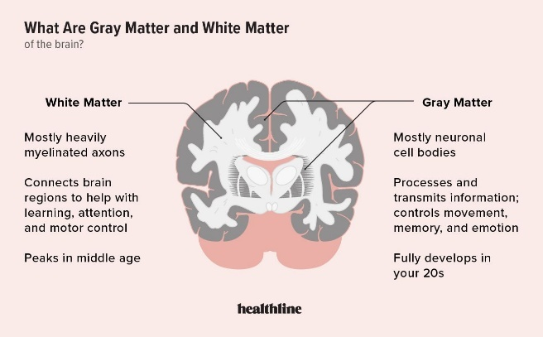
Alpha waves are seen in all age groups, commonly found in adults who is awake but with relaxed with closed eyes. It occurs on both side of head but slightly higher on non-dominant side, while recorded from the occipital and parietal regions of the brain. It represents white matter of the brain, acting as a bridge between conscious and subconscious mind.
Fig 6: White and gray matters of brain
from https://www.healthline.com/health/gray-matter-vs-white-matter

- Beta $13\sim 30Hz$
Beta waves are concerned with behavior and waves. It involves the sense of what we see, touch, hear, smell, and taste. It’s usually recorded from both sides of frontal and parietal lobes. These waves occur in conscious state.
- Gamma $30\sim 100Hz$
Gamma waves are related to perception and consciousness. These waves occur during hyper alertness and integration of sensory inputs. Occurrence of Gamma waves indicates our brains are properly combining senses and memory together for an ultimate experience.

There is also another categorization method based on morphological structure:
(Morphology refers to waveform/rhythm/shape)
- Mu 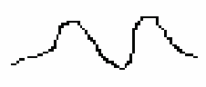:
Wave structure shows consecutive ‘V’ representation in rhythmic form. Occur in 8-13 Hz.
- K-Complex 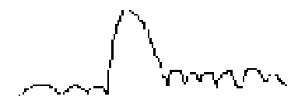:
Often occur in a run of theta waves with high amplitude followed by arousal response. Also occur especially in stage II sleep. They are large amplitude delta frequency waves with sharp apex.
- V 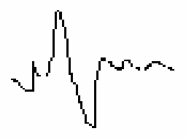:
Mostly occurs during sleep, presenting during semi arousals, and easily to be recognized.
- Lambda 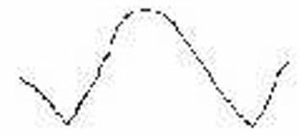:
triangular in shape and occurs when the eyes stare at blank surface. Occur when visual exploration (reading/watching), or stare at blank surface.
- Spike:
Large amplitude slow wave with 3 Hz usually in delta wave. This signal may occur synchronously in generalized epilepsies of focally in parietal. It occurs more usually with brain injury.
- Sleep Spindles ($σ$):
It’s also called sigma activity ranging up to 11-15Hz within upper level of alpha / lower level of beta. Spindles are group of waves that occur during sleep stages but particularly in stage II. This signal is mostly recorded near parasagittal regions.
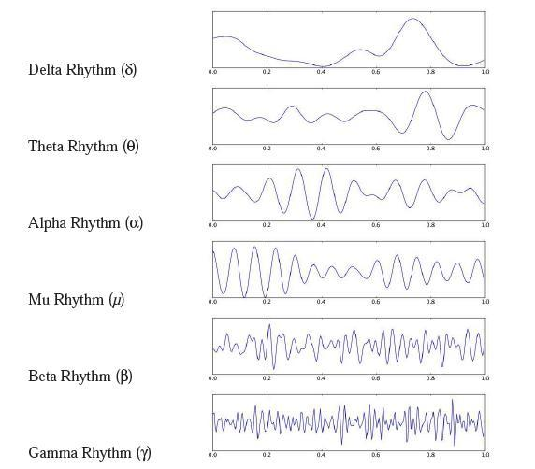
Fig 7: This image shows 5 categories of EEG signal based on frequency + Mu rhythm
from https://www.researchgate.net/figure/Different-frequency-bands-in-the-EEG-signal-wwwwikipediaorg_fig12_318262717

2.3 EEG Acquisition and Hardware
- Brain Structure
Brain is divided into two hemispheres. Each hemisphere is further divided into 4 lobes such as Frontal, Temporal, Parietal, and Occipital lobes:
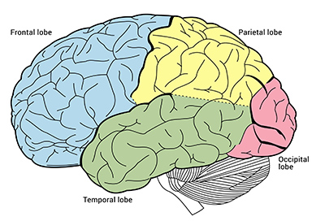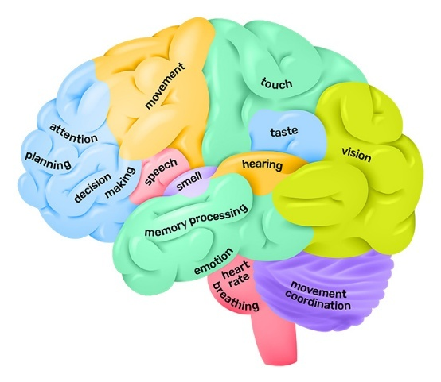
Fig 8: Brain structure overview, from wiki
- Cranial Nerve
Specific action/activity/states are controlled by particular parts of brain. Functional behavior of brain and their associated location are helpful to determine electrode positions for EEG recordings.
- EEG Device
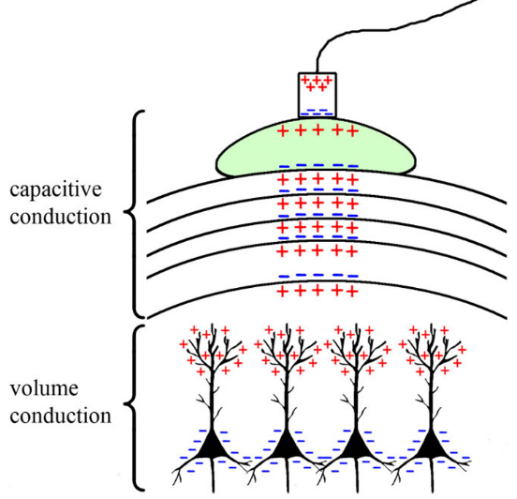
We use a special device called Electroencephalogram (EEG) comprised of electrodes, conductive gel, amplifiers, and Analog to Digital converter. In order to be measured with an electrode outside the head, the electrical signal created by neural should travel from the brain, through dura layers, skull layers, the scalp and finally to the electrode. Between volumes of conduction, a form of capacitance is responsible for signal’s propagation.
Fig 9: The image indicates propagation path

- EEG Atlas versus lobes of human brain
In the recording of the EEG, electrodes are typically placed on the scalp using specific patterns. In standardized methods, contacts are named by their locations and numbered with odd number over the left hemisphere, even numbers over the right, and z referring to the midline. The particular sequence in which the EEG data is displayed is called the Montage. Montages can be bipolar / referential. Bipolar montages involve a comparison of voltages recorded from (usually adjacent) active electrodes in chain-like fashion. e.g. Front-to-back or side-to-side. On the other hand, referential montages show a comparison of each active electrode to an ideally inactive electrode. Commonly chosen reference electrode is the ear, the mastoid, the vertex, or an average of lots of active leads called as average reference.
Bipolar montage is about serial comparisons along an electrode chain. It has the property phase reversal: At a time instance, the voltage of each electrode along the chain is first ascending then descending. Since bipolar montage is about comparison, then there will be a cut-point between positive and negative values, which can help to indicate the voltage peak position:
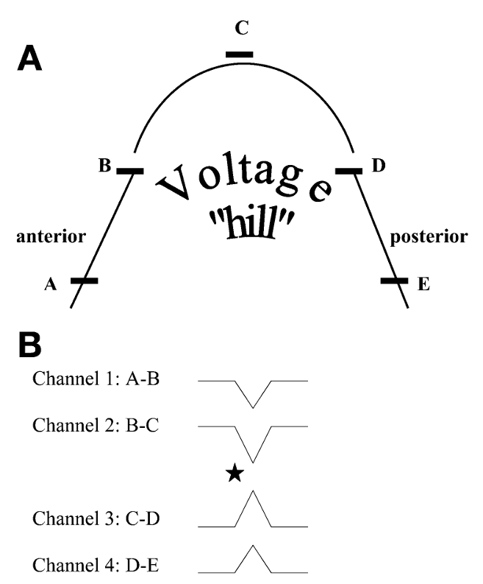
Fig 10: This indicates the phase reversal occurring in bipolar montage. As we can see, the black star position
marks the phase reversal, while it’s also the position for the voltage peak. (Or we should say the most negative electrode)
Convention: negativity at the “active” lead is defined as upward deflection in the display.
Below shows 2 international standards for electrode placement in EEG analysis:
10-20 System | 10-10 System
 | 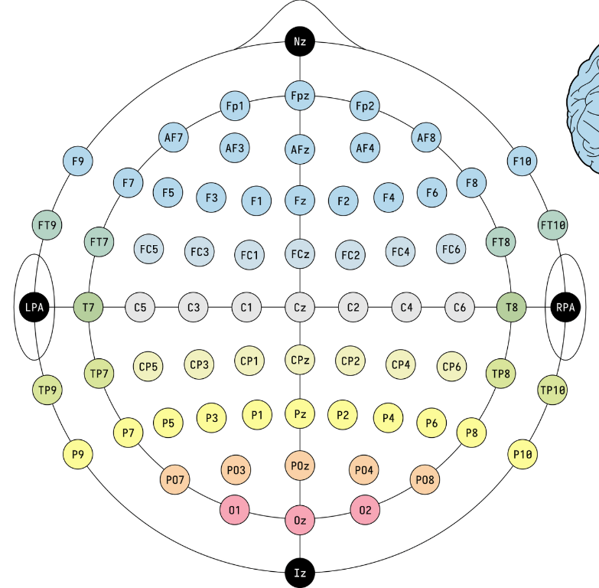
Distances between adjacent electrodes, which are either 10% or 20% of the total distance (front-back or right-left) of the skull. | Distances between adjacent electrodes, which are all 10% of the total distance (front-back or right-left) of the skull.

2.4 EEG Artifacts and Noise
An EEG recording system will however, measure electrical activity that arises from the brain as well as from other sources. Higher signal-to-noise ratio (SNR) reflects a better-quality signal that is contaminated by less noise, which is the fundamental requirements for success EEG analysis. “Noise” can also be EEG signals of certain frequencies that will intercept with our target event-related potentials (ERP).
- External Noise
Power supply is always the loudest source of noise, which is several orders of magnitude larger than the microvolt sources measured at the scalp. Electric field strength decreases exponentially w.r.t the distance from source to receiver, the field produced by wire, in walls, ceiling, lights will influence the measured results.
Remedies: Passive shielding like Faraday cage / Active electrode systems place amplifier as close to the electrode as possible to maximize SNR
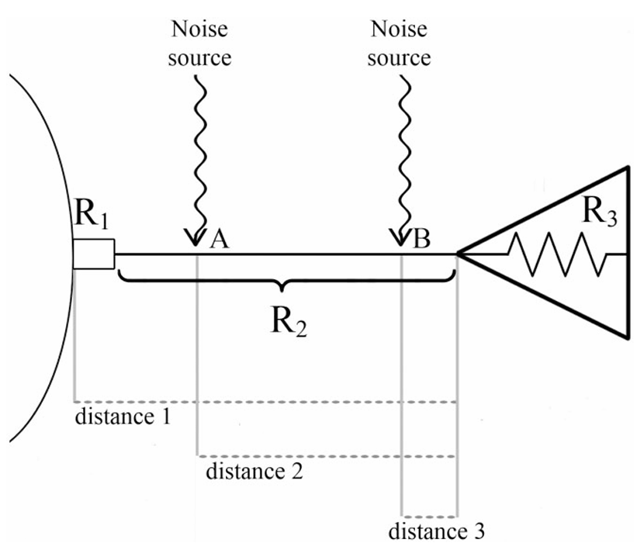
Fig 11: This image shows how noise may enter EEG system.
An amplifier with high enough input impedance can maximize SNR
- Internal Noise
This sources of noise comes from participants themselves. Its influence can be predictable (e.g. the 1Hz oscillation from breathing) or less predictably (from muscle tension or blinking), but all of them is unavoidable => must be dealt with proper filtering and artifact detection in post processing of signal.
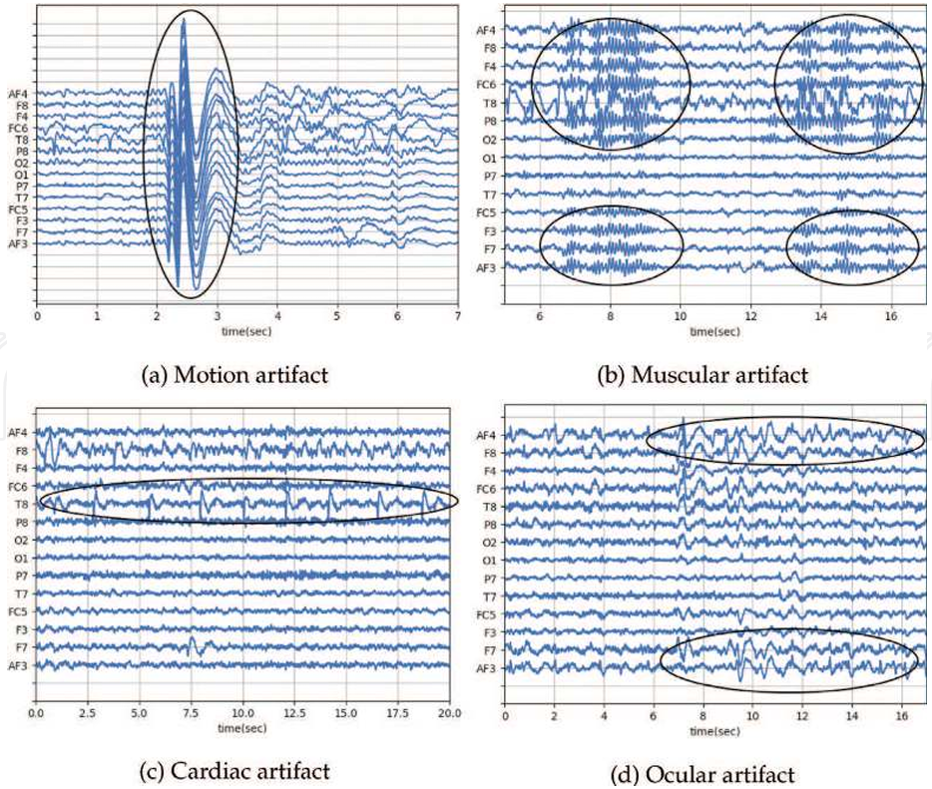
Fig 12: The image showcases 4 common internal noise that causes artifacts on EEG signals

*2.5 Simple Case Study
Some simple cases are listed below:
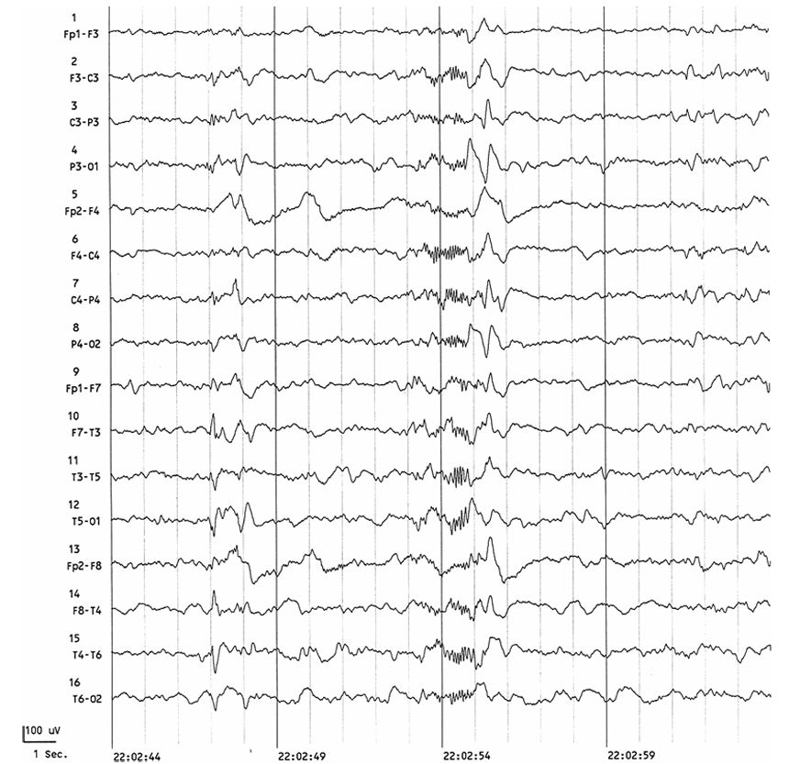
Fig 13: Approximately half way, it shows frontal-centrally fast bursts of spindle activity.
Followed by centrally dominant high-voltage slow sharp wave. Also referred to as K complex. -> hallmarks of Stage II sleep
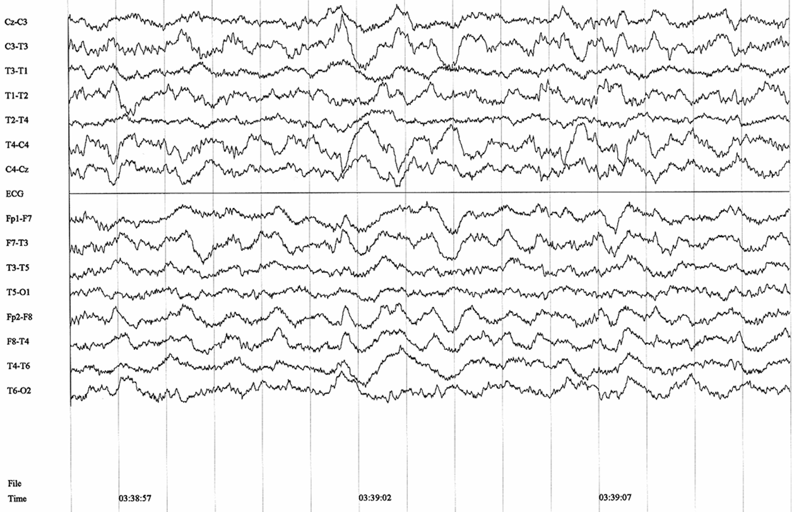
Fig 14: When the background consists of >= 50% delta activity -> Stage IV sleep
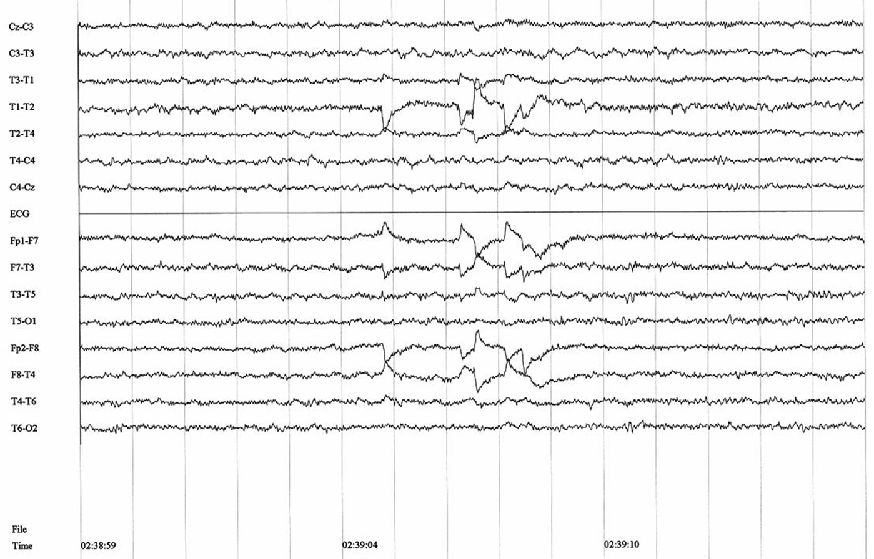
Fig 15: Background is stage IV sleep with low-voltage fast rhythm like wakeful state, but there are also rapid eye movements with frequency of approximate 1 Hz. These eye movements are seen over temporal leads. They are out of phase from side to side.

*2.6 Volume Conduction
The electrical signal transmission from neural activity to electrode is far more complicated. Volume conduction describes the effects of recording electrical potentials at a distance from the source.
Working model of volume conduction: a waveform moving down a nerve sitting in a medium
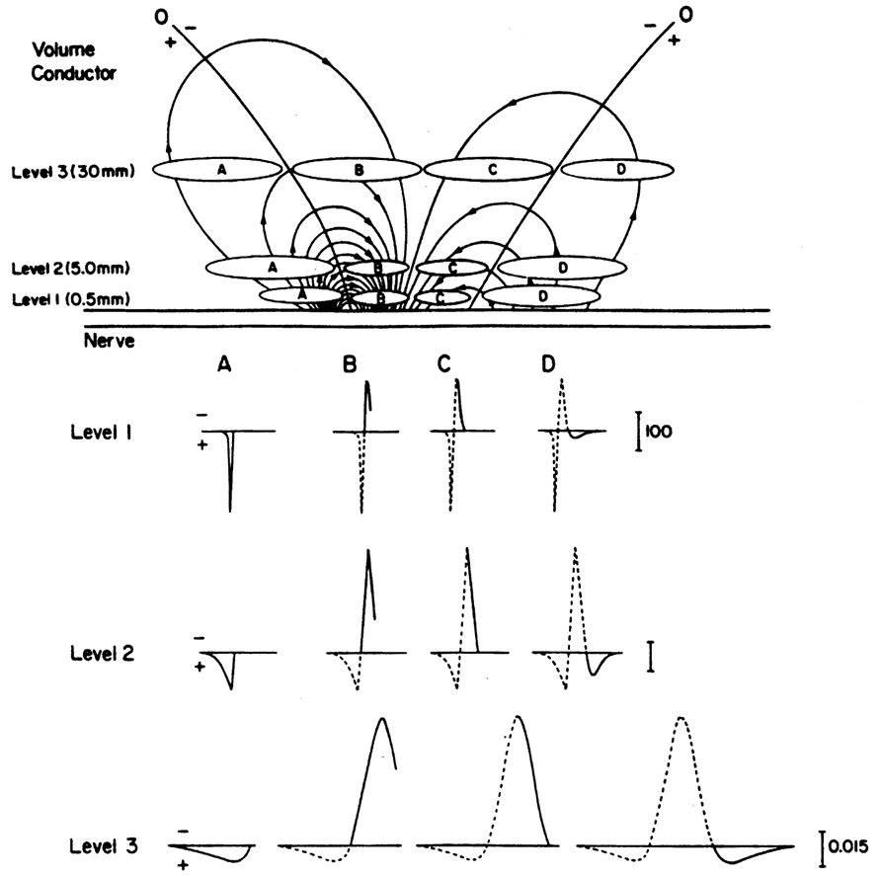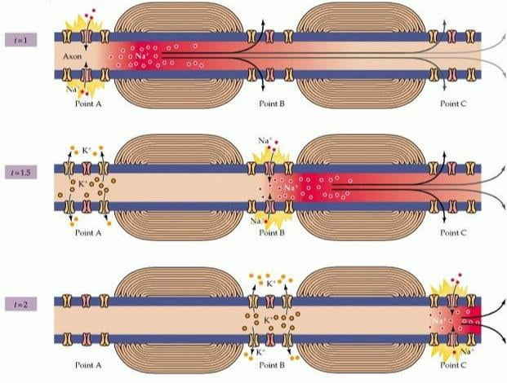
current sink
Fig 16: Volume conduction of an active nerve axon
The above figure shows the depolarization of an axon moving from left to right and the information will be observed depending on the exact location of recording electrodes. It’s simpler to imagine the depolarization frozen in time and electrode slowly moving from place A to D. Level 1, 2, and 3 represents the different distance between electrode and the nerve. For example, focusing on a single level, in A the lines of current fanning out beyond the electrode (travelling in opposite the electrode movement) causing a downward (positive) deflection.

Mathematical Foundations of Wavelet Transforms

Time-Frequency Analysis Review
Time–frequency analysis provides a framework for characterizing signals whose spectral content evolves over time, which is particularly important for non-stationary biomedical signals such as electroencephalography (EEG). Unlike classical Fourier analysis, which assumes signal stationarity (most of the real-life signals are non-stationary) and yields only global frequency information, time–frequency representations enable the simultaneous examination of temporal and spectral dynamics (to localize the events of interest). Common approaches include the short-time Fourier transform (STFT), which applies a fixed-length window to obtain localized frequency estimates, and the Wigner distribution, which offers high time–frequency resolution but suffers from cross-term interference when analyzing multicomponent signals. While these methods have been widely applied, their inherent trade-offs between time and frequency resolution rooting from uncertainty principle, as well as susceptibility to artifacts, limit their effectiveness for complex neural signals. To address these limitations, multiresolution techniques such as the wavelet transform have been introduced, allowing adaptive time–frequency resolution that is better suited for capturing transient, scale-dependent neural oscillations. As a result, wavelet-based analysis has become a prominent tool in modern EEG research and forms the basis of the methods discussed in the following sections.

Continuous Wavelet Transform (CWT)
$$X_{W}\left(a,b\right)=\frac{1}{\sqrt{b}}\int_{-∞}^{∞}{x\left(t\right)ψ(\frac{t-a}{b})dt}$$
where $x\left(t\right):input$, $ψ\left(t\right):mother wavelet$, $a∈(-∞,∞):location$, $b∈(-∞,∞):scaling$
As we can see, CWT can be regarded as inner product between input and a kernel (derived by mother wavelet) with alternating width and position. $a,b$symbols time and frequency⁻¹ respectively.
When$b$increases, the kernel width increases as well, causing less time resolution. On the other hand, according to uncertainty principle, the frequency resolution will increase at the same time.
Special case for CWT: with discrete coefficients:
$$X_{w}\left(n,m\right)=2^{m/2}\int_{-∞}^{∞}{x\left(t\right)ψ(2^{m}t-n)dt}; n,m∈Z, n,m∈(-∞,∞)$$
In fact, $a=n2^{-m}$, $b=2^{-m}$ -> Easier implementation with digital convolution and fast algorithm

Discrete Wavelet Transform (DWT)
Evolve from CWT with discrete coefficients with lots of simplifications on math. It discards the analysis on scaling functions or mother wavelets (since what matters is recursive relationships in CWT w/ discrete coefficients). The system for DWT is straightforward: input signal passes through low pass filter (scaling function) and high pass filter (wavelet function) and then do down-sampling. The hierarchical structure allows for customized decomposition or some serial connected systems.
$$\left\{\begin{aligned}x_{1,L}\left[n\right]=downsample(x\left[n\right]*g\left[n\right],Q=2) \\ x_{1,H}\left[n\right]=downsample(x\left[n\right]*h\left[n\right], Q=2)\end{aligned}\right.$$
$x\left[n\right]:input discrete signal$ $x_{1,L}, x_{1,H}:output discrete signals$
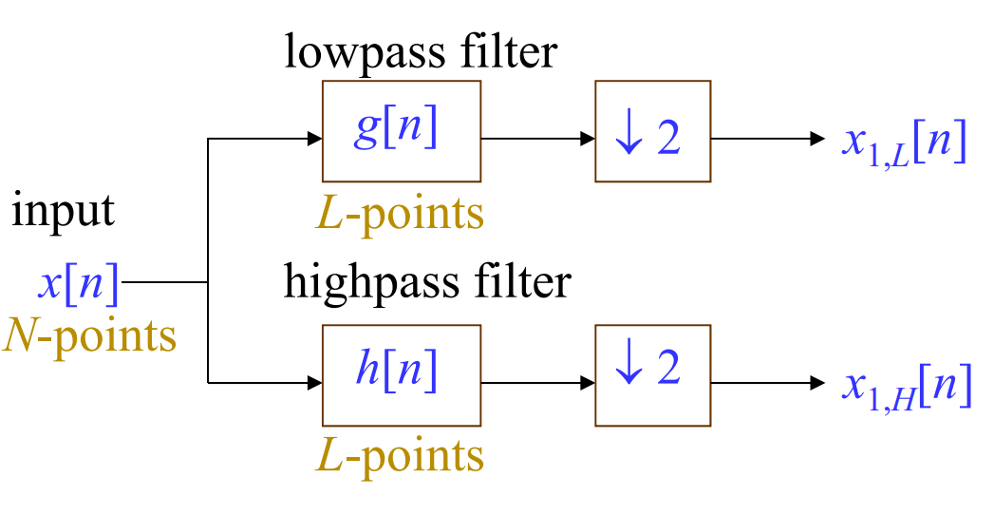
Fig 17: From course material p.460

Common Wavelet Families

Continuous Wavelets
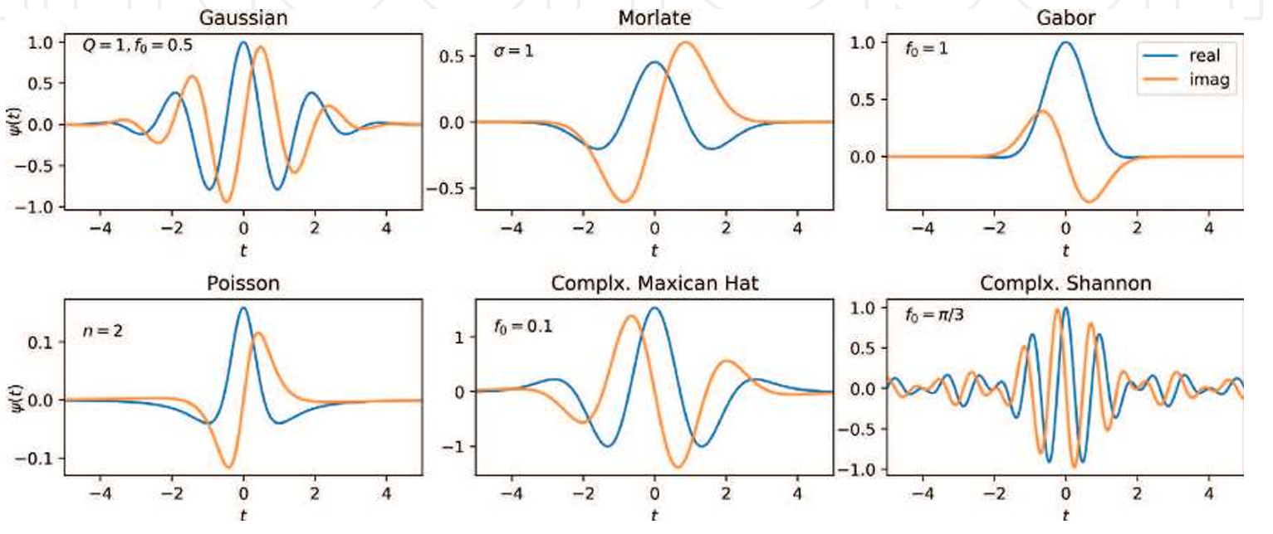
Fig 18: Different continuous wavelets
*There will be imaginary part extension for wavelet function to take “phase” into consideration.
- Gaussian wavelet: $ψ\left(t\right)=e^{-a{\left(t-t_{0}\right)}^{2}}⋅e^{-2πjf_{0}(t-t_{0})}$, where $a={\left(\frac{f_{0}}{Q}\right)}^{2}$
- Gabor wavelet: $ψ\left(t\right)=e^{-{\left(t-t_{0}\right)}^{2}/a^{2}}⋅e^{-jf_{0}(t-t_{0})}$
- Morlet wavelet: $ψ\left(t\right)={\left(1+e^{-σ^{2}}-2e^{-\frac{3σ^{2}}{4}}\right)}^{-0.5}π^{-0.25}e^{-0.5t^{2}}(e^{jσt}-e^{-0.5σ^{2}})$
- Poisson wavelet: $ψ\left(t\right)=\frac{1}{2π}{\left(1-jt\right)}^{-(n+1)}$
- Complex Mexican hat wavelet: $ψ\left(ω\right)=2\sqrt{\frac{2}{3}}π^{-\frac{1}{4}}{\left(ω-ω_{0}\right)}^{2}e^{-\frac{1}{2}{\left(ω-ω_{0}\right)}^{2}} for ω≥0$
- Complex Shannon wavelet: $ψ\left(t\right)=Sinc\left(\frac{t}{2}\right)⋅e^{-2jπf_{0}t}$

3.4.2 Discrete Wavelets
- Daubechies
- Coiflets
- Symlets
- Discrete Meyer
- Biorthogonal

Wavelet-Based EEG Signal Processing
There are lots of applications of wavelet transform on EEG signal. I divide related tasks into 4 categories, and each category will be introduced by several paper survey. Machine learning integrated methods🤖are also included since ML is an unavoidable trend and also an effective problem-solving technique.

Detection
“This section focuses on seizure detection and prediction from EEG analysis.”
    - Statistical Analysis of EEG Signals in Wavelet Domain for Efficient Seizure Prediction
Epilepsy impacts patients’ life badly. This paper aims to study the statistical characteristics of different EEG signals in the wavelet domain to divide signal batches to 3 different states: inter-ictal (normal), pre-ictal (pre-state), and ictal (seizure state) to predict seizure correctly.
Wavelet-Domain Seizure Detection
A sort of anomaly detection in EEG signals. Wavelet transform decomposes the EEG signal into sub-bands. From these sub-bands, different features such as coherence, entropy, energy, amplitude, and coefficient of variation can be extracted and used for state classification.
Wavelet-Domain Seizure Prediction
(Discrete) Wavelet packet decomposition, both the detail and approximation coefficients are decomposed
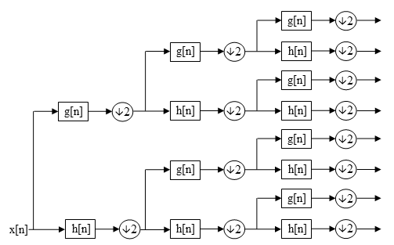
Fig 19: The image shows WPD over 3 levels, from wiki
In general, EEG signals containing seizures are built up of constantly changing bursting levels, which enables discrimination between wavelet sub-bands. The residual sub-band wavelet entropy (RSWE) can be used to estimate the entropy of bursts from the sub-bands.
WPD: $x\left(t\right)→\left\{W_{j}\left(k\right)\right\}, j=1, 2, .. J$, where $W_{j}(k)$: k-th sub-band wavelet coefficients
Wavelet Entropy (WE): $H=-\sum_{j=1}^{J}{p_{j}log⁡(p_{j})}$, where $p_{j}≔\frac{\sum_{k}{{\left|W_{j}\left(k\right)\right|}^{2}}}{\sum_{j}{\sum_{k}{{\left|W_{j}\left(k\right)\right|}^{2}}}}=\frac{E_{j}}{∑E_{j}}$
RSWE: $RSWE=\sum_{j∈R}{-p_{j}log⁡(p_{j})}$, where$R$indicates the specified sub bands set (middle to high frequencies), exclude low frequency bands.
Entropy high -> separate, evenly distributed -> stable -> Iner-ictal
Entropy low -> showing obvious frequency structure, center at high frequency -> seizure -> Pre-ictal / Ictal
    - 🤖Enhanced Epileptic Seizure Detection through Wavelet-Based Analysis of EEG Signal Processing
This paper proposed a 4-stage pipeline: (1) Preprocessing (2) Decomposition (3) Feature extraction (4) Classification by SVM method to determine whether contain a seizure.
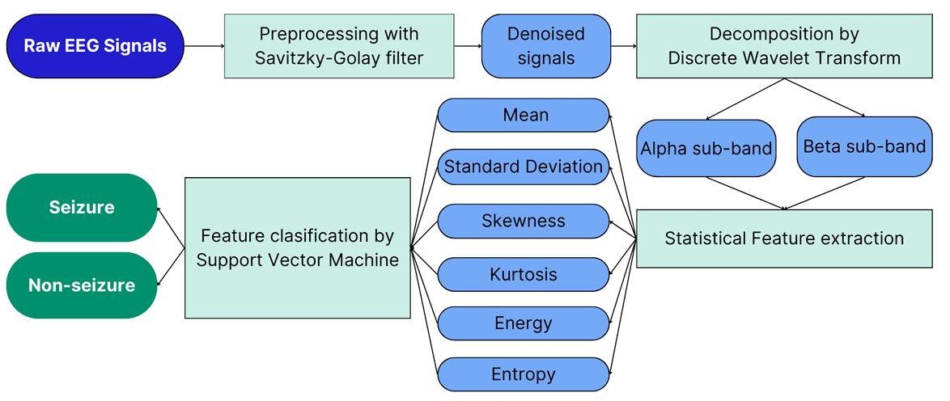
Fig 20: Methodology of epileptic seizure detection
- Savitzky-Golay filter: It can smooth the signal without significant alteration and enhancing the SNR while retaining high-frequency information:
$$p\left(n\right)=\sum_{k=0}^{N}{a_{k}n^{k}}, ϵ_{N}=\sum_{n=-M}^{M}{{\left(p\left(n\right)-x\left[n\right]\right)}^{2}}$$
Find coefficients $a_{k}$ by minimizing MSE error: $\frac{∂ϵ_{N}}{∂a_{i}}=0$
Performance of this filter depends largely on $M$ and $N$. With higher order in the polynomial will have a greater impact on the high-frequency response of the filter.
- Do DWT and separate the signal into 2 parts: low-frequency approximation coefficients$A_{i}$, the high-frequency detailed coefficient $D_{i}$.
- Feature Function: Calculate N samples and then store as vectors in a feature matrix to construct the training database for an ML model. The features such as mean, variance, skewness, kurtosis, entropy, and energy are calculated for labelled segments for either seizure or non-seizure.

Denoising
“Electroencephalogram (EEG) is a signal of an electrical nature reflecting the neuronal activities of the brain. It is used for the diagnosis of certain cerebral pathologies. However, it becomes more difficult to identify and analyze it when it is corrupted by artifacts of non-cerebral origin such as eye movements, cardiac activities ..., therefore, it is essential to remove these parasitic signals.”
    - Removing Artifacts from EEG Signal Using Wavelet Transform and Conventional Filters
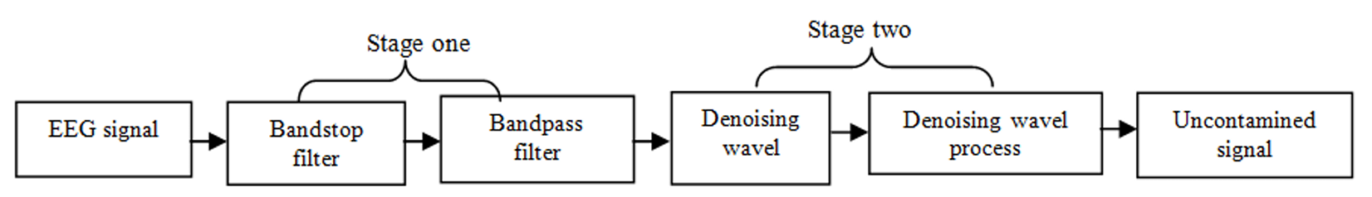
The proposed method contains 2 stages:
The first stage devoted to remove the effect of AC line and unwanted frequencies, preparing EEG signal and pinpointing useful frequencies.
The second stage used to remove different kind of noise via the use of process based on wavelet transform.
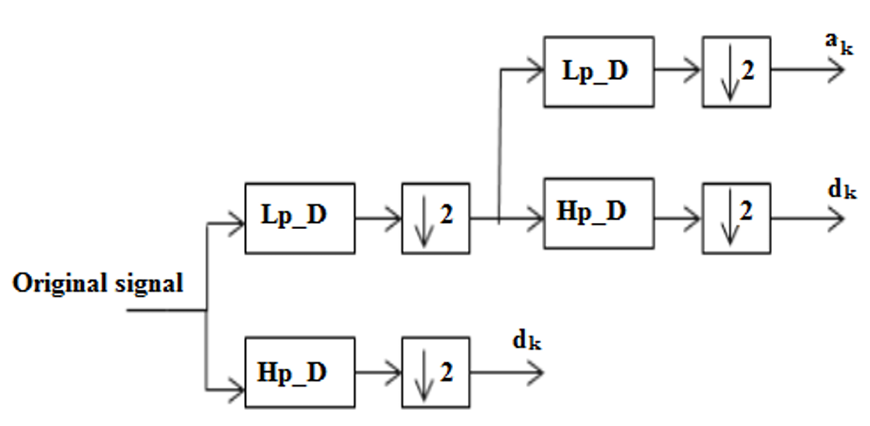
Fig 21: Example of 2 level decomposition of original signal
To remove artifacts, technique of wavelet-denoising (DWT) is introduced:
Step1: Decompose EEG signal via a set of low pass and high pass filters: low pass filter can obtain approximation coefficients, while high pass filter can extract coefficients of detail.
Step2: Find the threshold values of two types of coefficients obtained from step 1. Noise suppression process is done by resetting all coefficients having magnitude below the threshold level.
Step3: Reconstruction of new coefficients using inverse wavelet transform.
Experiments: Use Symlet5, decomposed into 7 levels.
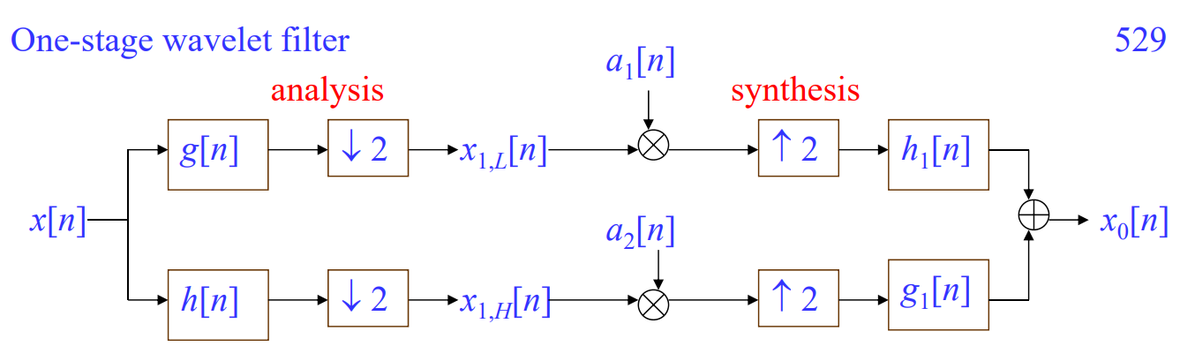
Fig 22: The main idea corresponds to course material p.529: wavelet filter

    - WAVELET TRANSFORMS FOR EEG SIGNAL DENOISING AND DECOMPOSITION
Methods for eliminating noise through selective frequency filtering are afflicted with a notable deprivation of EEG information. Therefore, even if the noise is decreased, the signal's uniqueness should be preserved.
Proposed method:
Phase-1: Using different mother wavelet functions, include Haar, Symlet2, and Coiflet2 to do DWT, WPT, and SWT to denoise EEG signal.
Stationary Wavelet Transform (SWT):
Unlike traditional DWT, SWT ignores the down-sampling steps, which can retain the time invariance property. The filter each stage, in turn, should be up sampled from the previous level to replace the down-sampling block:
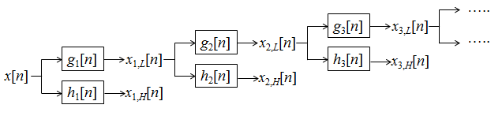
Where $h_{j}\left[n\right]=Zh_{j-1}\left[n\right]=Z^{2}h_{j-2}\left[n\right]=…$ same for$g_{j}$, where operation$Z$is defined below:
$$Upsampling with factor 2: {\left(Z_{x}\right)}_{k}=x_{k/2} for k=2, 4, …;{\left(Z_{x}\right)}_{k}=0 for k=1, 3, …$$
Phase-2: Evaluate the results of phase-1 with 3 metrics: SNR, MSE, and PSNR.
$$PSNR=20\log{MAX(x)/\sqrt{MSE}}$$
Phase-3: Denoised EEG signal has been decomposed according to 4 methods
Phase-4: Compare the results of phase-3 with 3 metrics: energy, correlation, and distance between power spectral density
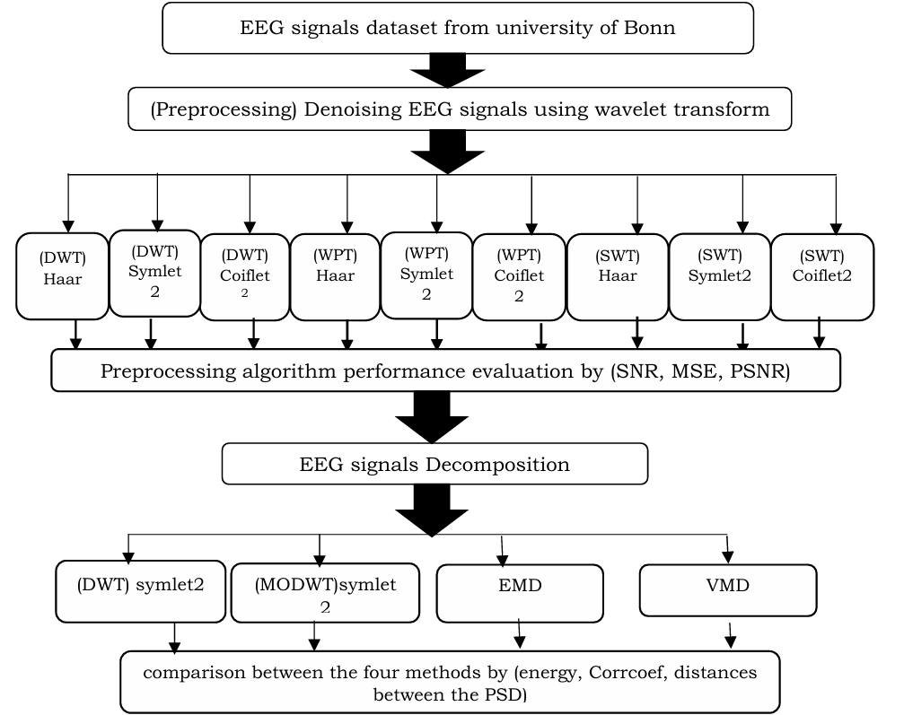
Fig 23: Overview of the proposed systematic evaluation approach for denoising / decomposition on wavelet-based methods

    - A Survey on Denoising Techniques of Electroencephalogram Signals Using Wavelet Transform
This paper proposed a hybrid method to handle EEG artifacts:
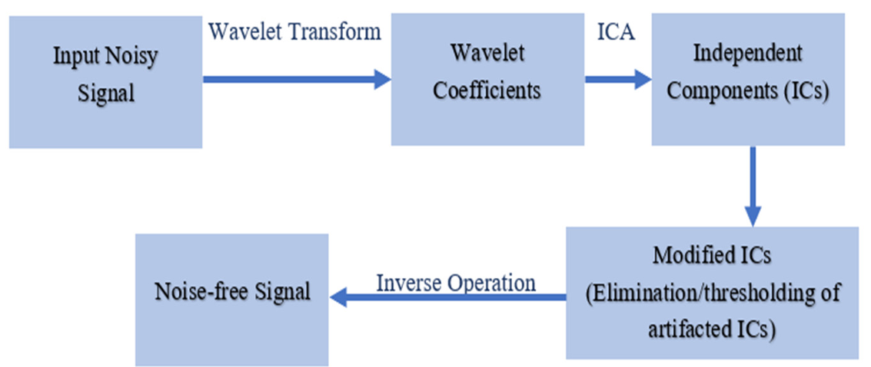
Fig 24: Wavelet-ICA-based method flowchart
Independent Component Analysis (ICA): A mathematical model that decomposes multivariate signals into their sub-components. In the wavelet-ICA-based method, the input EEG are first decomposed into wavelet coefficients. Next, all coefficients are used in ICA operation to separate various sources of EEG in the time-frequency domain. Then, the artifacted independent components (ICs) are directly eliminated. Finally, all ICs are used in inverse wavelet transform to obtain the noise-free EEG signals.
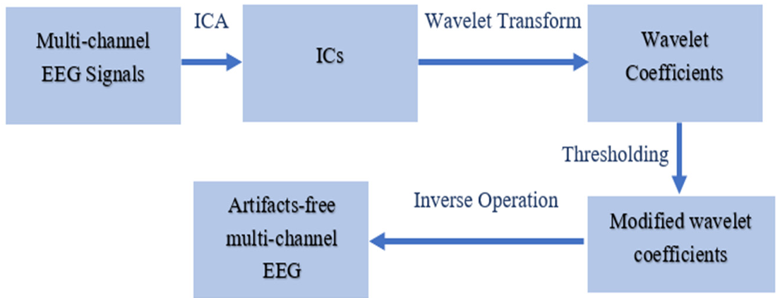
Fig 25: ICA-wavelet-based method flowchart
However, wavelet transform is limited to single-channel EEG signals (one electrode EEG signal each time). To overcome the issue for multi-channel EEG, the method ICA-wavelet-based method is introduced. Channels of EEG signals are first used in ICA to decompose into independent components. Then artifacted ICs are identified and decomposed into wavelet coefficients, and they are filtered with thresholding function. Finally, clean multi-channel EEG are achieved by performing inverse wavelet transform.

Classification
“Recent research regarding classification always uses ML-integrated method to enhance the performance. Wavelet transform still plays a vital role on preliminary feature extraction. Machine learning technique on the other hand, serves as a solver according to different downstream tasks.”
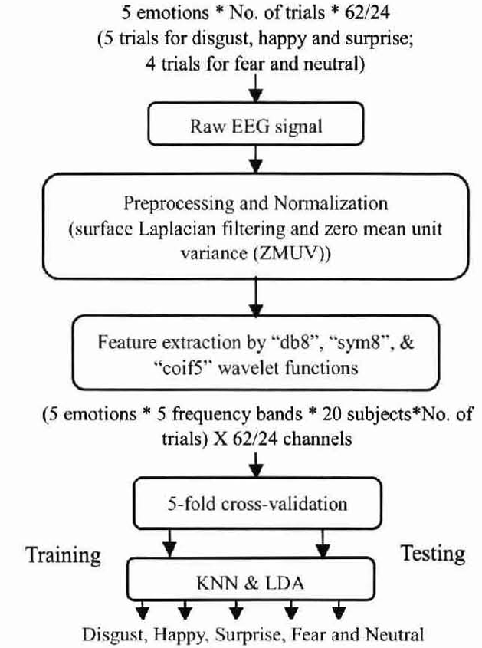
    - 🤖Combining Spatial Filtering and Wavelet Transform for Classifying Human Emotions Using EEG Signals
Fig 26: Systematic approach on emotion recognition using EEG signals
Emotion is one of the most important features. Without the ability of emotion processing, computers and robots cannot communicate with human in a natural way.
This work uses audio-visual stimuli to evoke participants’ five different emotions. A set of statistical features are then derived using DWT over five different frequency bands (delta, theta, alpha, beta and gamma) with 3 wavelet functions “db8”, “sym8”, and “coif5”. Then those statistical features are then classified through 2 classifiers KNN and LDA.
The EEG signal is obtained through 10-10 electrode placement system. The sampling frequency is 256 Hz, which can further match the frequency bands of DWT decomposition coefficients as follows:
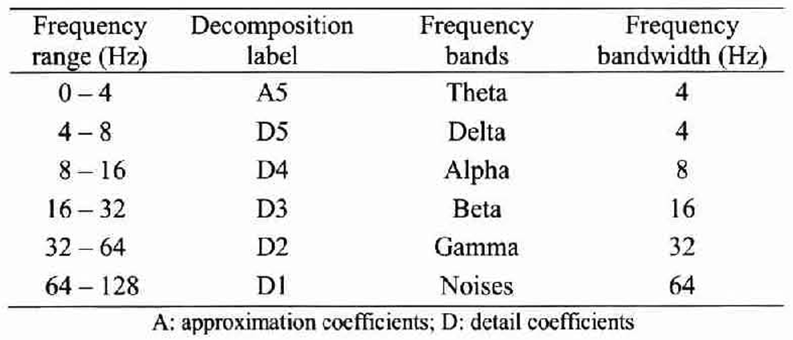
Fig 27: Decomposition of EEG signals into different frequency bands with SR=256Hz
The statistical features use for ML model contain standard deviation, variance, power, and entropy.
    - 🤖An Attention-Based Wavelet Convolution Neural Network for Epilepsy EEG Classification
Attention mechanism-based wavelet convolution network (AMWCNN) firstly uses multi-scale wavelet analysis to decompose the input EEGs to obtain components in different frequency bands. The decomposed multi-scale EEGs are then passed through CNN w/ attention mechanism for downstream tasks. This proposed pipeline can achieve quality classification effect on epilepsy EEG.
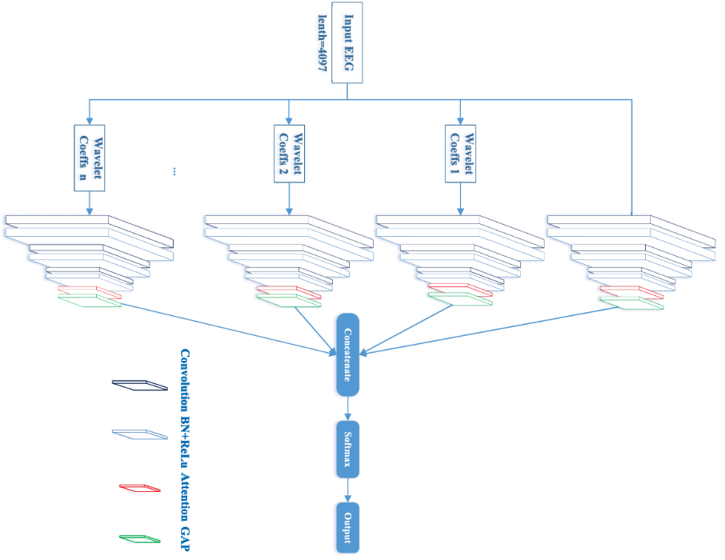
EEG signal is first decomposed through DWT and getting coefficients of different scales. Then feature extraction is carried out through attention-based CNN.
Fig 28: AMWCNN flowchart
Classification output is finally obtained through a soft-max layer.
Wavelet decomposition can be done channel-wise, and then directly serves as the input feature map of convolutional block without other processing.
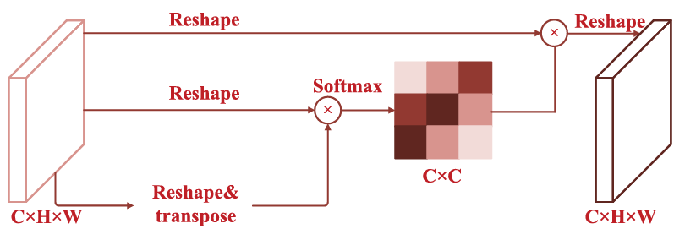
Fig 29: Attention mechanism network
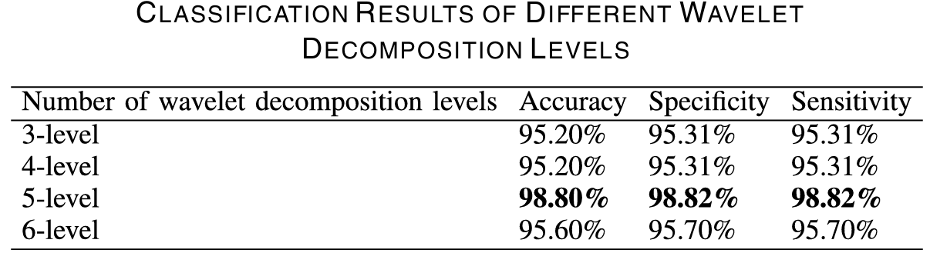
With different decomposition levels, the classification performance will change. The evaluation metrics are defined as follows:
$$Accuracy=\frac{TP+TN}{All}, Specificity=\frac{TN}{TN+FP}, Sensitivity=\frac{TP}{TP+FN}$$

Feature Extraction
“This section focuses on 2 interesting tasks: sleep clock period feature extraction and anesthesia stage feature extraction”
    - Feature Extraction of Human Sleep EEG Signals using Wavelet Transform and Fourier Transform
Spectral analysis of sleep EEG signal provides acute insight into the features of different stages of sleep which can be utilized to differentiate between normal and pathological conditions. This paper uses multi resolution DWT and FFT to do spectral analysis on sleep EEG.
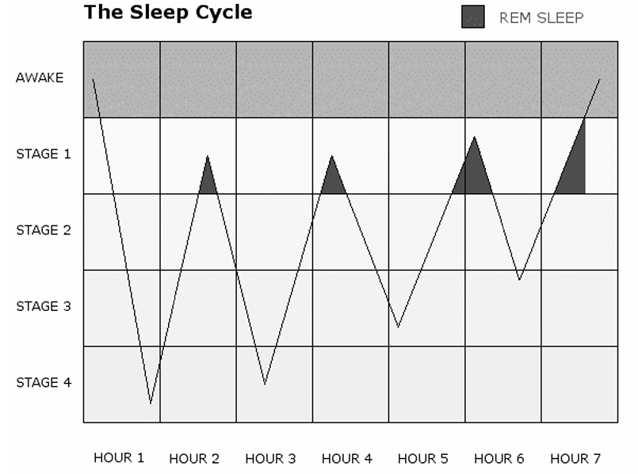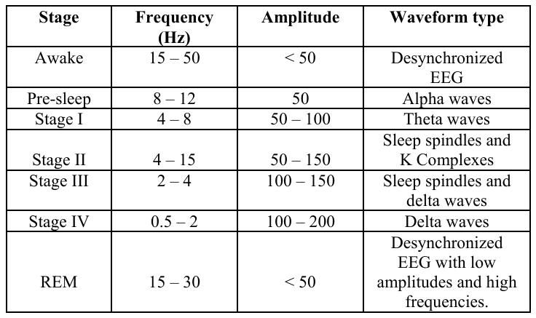
Fig 30: Left image is about sleep cycle illustration, starts with stage 1 and ends with REM sleep.
Right table illustrates summary of all sleep stages with different EEG signal characteristics
Decomposition of EEG data:
DWT is used to decompose the EEG waves into detailed coefficient (high pass filter output) and FFT is then applied on the coefficients of each of decomposition levels. The result of FFT operation will reveal the major frequency components at each decomposition level. Characteristics obtained from the analysis conforms the desired ones, below shows some analysis result:
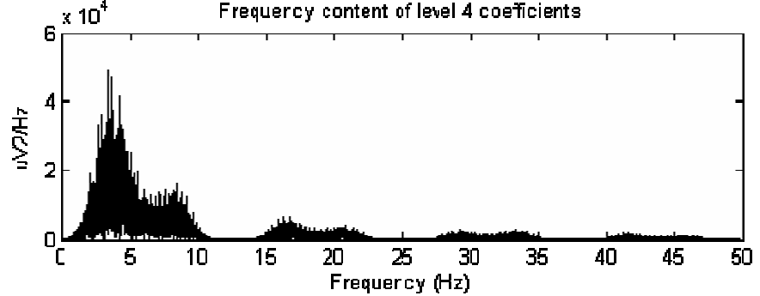
Fig 31: Frequency spectrum of level 4 decomposition coefficients within the time from 5 – 15 minutes from the start
From the FFT plot, it can be observed that the major frequency components are around 2.5~8Hz, which accounts for theta waves. The spectral components around 0~0.5Hz indicates the presence of slow rolling eye movements. Additionally, lack of alpha wave activity around 9~12Hz. All evidence is enough to characterize stage I sleep.
    - 🤖 Wavelet transform-based mode decomposition for EEG signals under general anesthesia
General anesthesia affects a patient’s central neural system by reducing consciousness, which can be demonstrated by their EEG patterns. This study aims to capture the frequency characteristics of EEGs to evaluate the depth of anesthesia. Three different decomposition methods – VMD, EWT, and WMD were applied to EEG dataset.
Empirical Wavelet Transform (EWT) method:
EWT method is to build adaptive wavelet filter to decompose a given signal into IMFs, operating in frequency domain. It becomes necessary to consider where the construction algorithm used for filter banks draws boundaries in frequency axis. If we assume the frequency domain $[0,π]$ is divided to$N$segments, then$N-1$boundaries needed to be extracted.
Naïve thought: local maxima in the spectrum are determined to locate boundaries for EWT. Each boundary is defined as average of consecutive maxima. Denote each segment as:
$$Λ_{n}=\left[Ω_{n-1}, Ω_{n}\right] s.t. \bigcup_{n=1}^{N}{Λ_{n}}=\left[0,π\right]$$
$$Transition phase T_{n}\left(τ_{n}=γω_{n}, 0<γ<1\right) of width 2τ_{n} is defined near center of each Λ_{n}$$
EWT algorithm steps:
- Apply FFT to signal$f\left(t\right)\left(t=\left\{t_{i}\right\}\right), i=1, 2, …, M$, where$M$is the number of sample points.
- Find the set of maxima$M={\left\{M_{i}\right\}}_{i=1, 2, …N}$ in the Fourier spectrum and estimate corresponding$ω={\left\{ω_{i}\right\}}_{i=1, 2, …N}$, where$N$denotes both the number of maxima and number of filter banks introduced from this point.
- Define the boundaries$Ω_{i}$of each segment as center points between 2 consecutive maxima:
$$Ω_{i}=\frac{{ω_{i}+ω}_{i+1}}{2}, Ω={\left\{Ω_{i}\right\}}_{i=1, 2, …N-1}$$
- Where the empirical scaling function and wavelets are defined as follows:
Mayer filter banks:
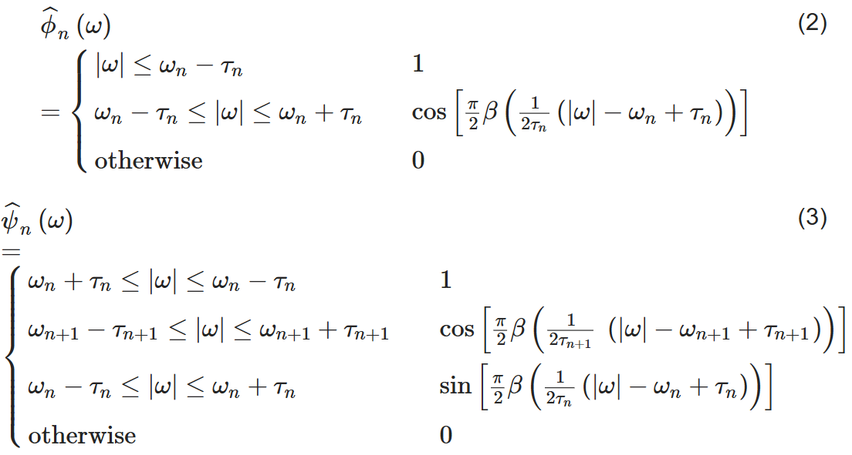
where $β\left(x\right)=\left\{\begin{aligned}x≤0:0 \\ x≥1:1 \\ x∈\left(0,1\right):\left(x\right)+β\left(1-x\right)=1\end{aligned}\right.$, and $β\left(x\right)=x^{4}(35-84x+70x^{2}+20x^{3})$
With the selection of $τ_{n}=γω_{n}, 0<γ<1$. The representation can be simplified as:
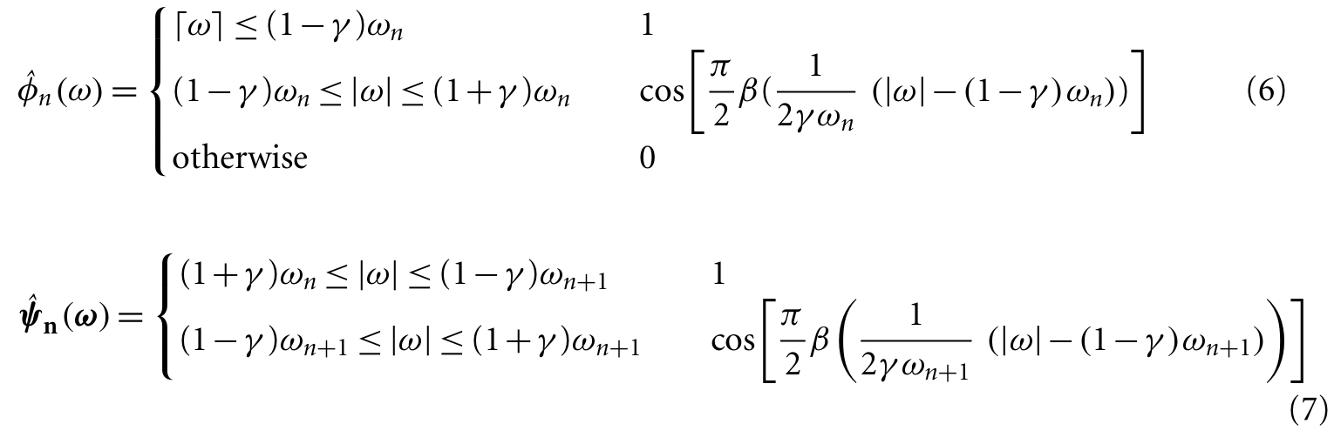
- Do wavelet transform:
The EWT $W_{f}^{ϵ}∈\left(n,t\right)$ of signal $f(t)$ is defined as inner product as follows:
$$W_{f}^{ϵ}\left(0,t\right)=〈f,ϕ_{1}〉=∫f\left(τ\right)\overline{ϕ_{1}\left(τ-t\right)}dτ$$
$$W_{f}^{ϵ}\left(n,t\right)=〈f,ϕ_{n}〉=∫f\left(τ\right)\overline{ψ_{n}\left(τ-t\right)}dτ:detailed coefficient of i-th filter bank at time t$$
The signal can be reconstructed by
$$f\left(t\right)=W_{f}^{ϵ}\left(0,t\right)*ϕ_{1}\left(t\right)+\sum_{n=1}^{N}{W_{f}^{ϵ}\left(n,t\right)*ψ_{n}\left(t\right)}=F^{-1}\{\hat{W_{f}^{ϵ}}\left(0,t\right)*\hat{ϕ_{1}}\left(t\right)+\sum_{n=1}^{N}{\hat{W_{f}^{ϵ}}\left(n,t\right)*\hat{ψ_{n}}\left(t\right)}\}$$
where hat = Fourier Transform
However, if the boundary frequencies are determined in advance and the transformation performed by the Meyer wavelet is used as a bandpass filter, the EEG can be then decomposed into multiple IMF modes that fall within the range of the target frequencies. It discards the empirical approach and decomposes the process into modes with specific target frequencies via the Meyer wavelet transform. (WMD method)
To gain further understandings of the frequency characteristics of each IMF, a Hilbert spectral analysis of the IMFs is performed to review their instantaneous frequency (IF) and amplitude (IA) difference on time domain.
For any IMF$f_{k}(t)$: Hilbert Transform is defined as ${\tilde{f}}_{k}\left(t\right)=f_{k}\left(t\right)*\frac{1}{πt}$, then IA is defined as:
$$IA≔\left|f_{k}\left(t\right)+j{\tilde{f}}_{k}\left(t\right)\right|, IF=ω_{k}\left(t\right)=\frac{dθ_{k}\left(t\right)}{dt}=\frac{d(\tan^{-1}{{\tilde{f}}_{k}(t)/f_{k}(t)})}{dt}$$
Finally, send to multiple linear regression models to predict anesthesia stages (BIS index).
The overall pipeline of proposed EWT and WMD is depicted as follows:
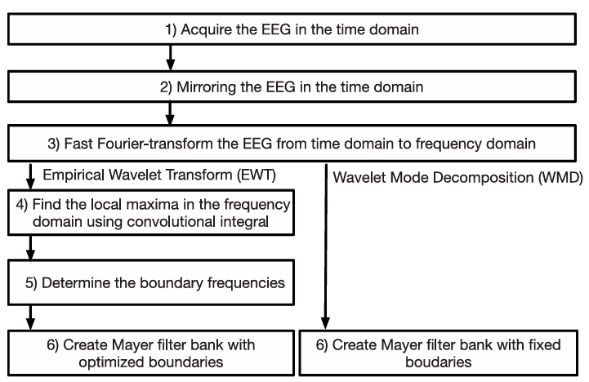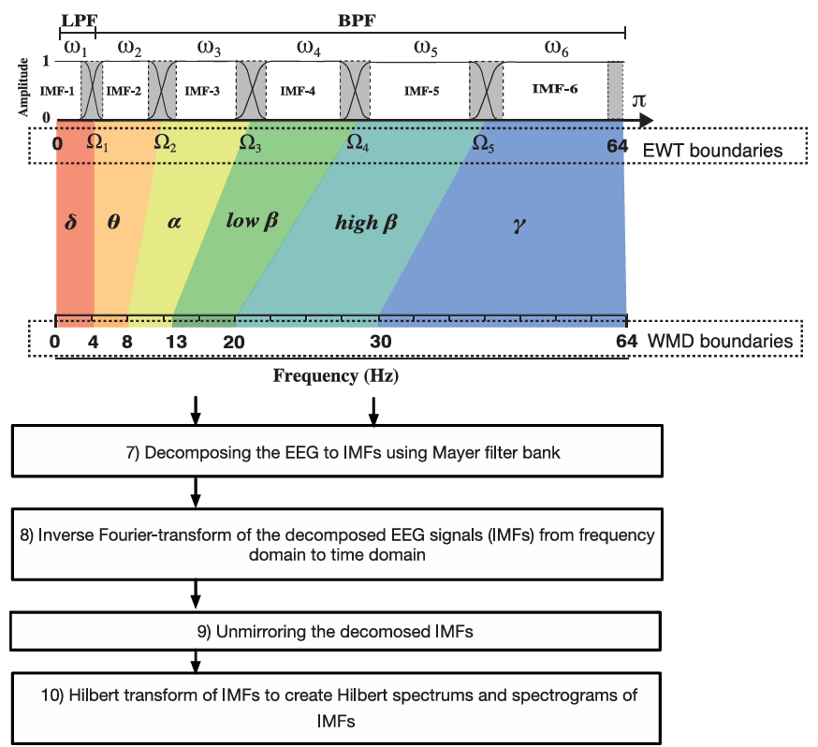
Fig 32: Algorithm flowchart for the EWT and WMD

Experimental Design and Dataset

Overview
The following sections provide a complete tutorial on using wavelet transform integrated with other techniques to do analysis and visualization on EEG dataset. The whole experiment design is based on some common techniques from section 4. Programming language used is Python.
Online code for experiment: https://www.kaggle.com/code/bigrem/waveletanalysisoneeg

Dataset
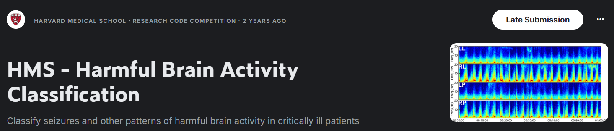
Fig 33: The screen shot from Kaggle website
Title: HMS – Harmful Brain Activity Classification
Source:
The dataset used in this study is sourced from the Kaggle competition “HMS – Harmful Brain Activity Classification”, provided by Massachusetts General Hospital (MGH) and Harvard Medical School (HMS). The competition aims to facilitate the development of automated methods for identifying and classifying harmful brain activity patterns in EEG signals. (Kaggle link)
Dataset Composition:
- EEG Signal Data
  - train_eegs/ — Parquet files containing training EEG recordings.
  - test_eegs/ — Parquet files containing test EEG recordings.
Each file represents a 50-second segment of multi-channel EEG data, typically sampled at 200 Hz. The electrode placement follows 10-20 system. Each parquet contains 20 columns, while 19 accounts for [Fp1, F3, C3, … O2] scalp part, and the last one is for electrocardiogram (ECG).
- Spectrogram Data
  - train_spectrograms/ and test_spectrograms/
Spectrograms convert time-domain EEG signals into the frequency domain (e.g., via Short-Time Fourier Transform), providing additional features for deep learning models.
- Metadata
  - train.csv includes detailed information for each training sample:
    - eeg_id: unique EEG recording identifier
    - eeg_label_offset_seconds: the real start time for each EEG signal (in parquet file)
    - Expert votes for each class (e.g., seizure_vote, lpd_vote)
Labels are determined by multiple expert reviewers, reflecting consensus and inter-rater agreement.

Experiment 1 – Denoising
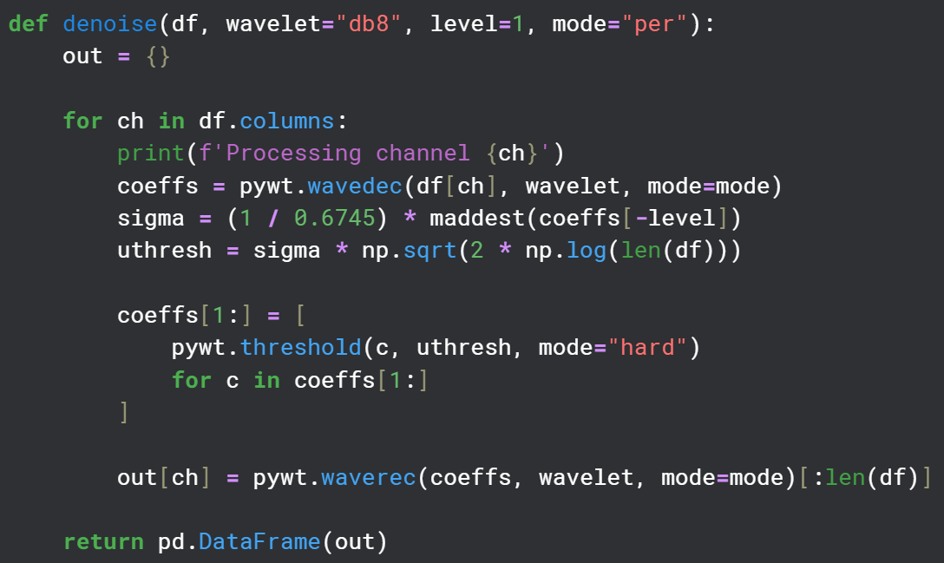
Fig 34: Code screenshot for denoising
EEG signal may have serious artifacts or noise. It turns out that denoising process will be necessary.
Denoising implementation (channel-wise) can be described by following steps:
- Conduct default level$×$stages of discrete wavelet transform, default wavelet is “db8”, which corresponds to 16-point Daubechies wavelet with vanishing moment = 8. Get coefficients coeffs, where coeffs[0] represents low frequency component, while coeffs[-1] is highest frequency component.
- Find the threshold through first finding mean absolute deviation (MAD) of coeffs[-1]:
$$MAD=\frac{1}{n}\sum_{i=1}^{n}{|x_{i}-\overline{x}|}, where \overline{x}=mean of x, n:data length$$
It’s to estimate the scale of Gaussian noise.
- Threshold value is then defined as $\frac{MAD\left(coeffs\left[-1\right]\right)}{0.6745}\sqrt{2\log{(n)}}$
This can be interpreted as: If high frequency coefficients magnitude < “max amplitude of estimated Gaussian noise”, then it’s viewed as noise and will be eliminated.
- Do filtering on high frequency components only, and keep the lowest frequency part.
- Do inverse DWT to recover the denoised signal.

Experiment 2 – Decomposition

WPD decomposition
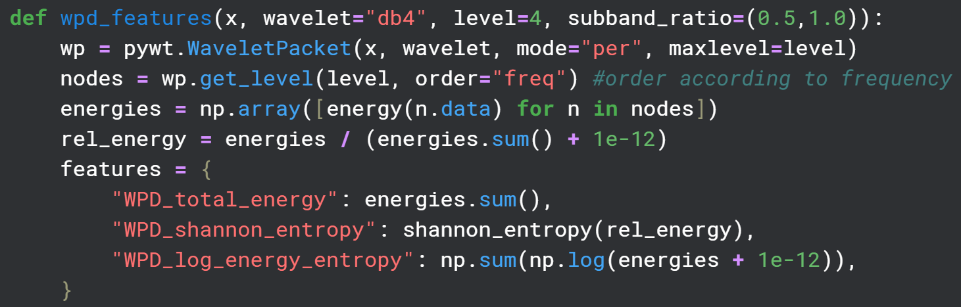
Fig 35: Code screen shot for WPD decomposition
The WPD implementation follows Fig 19, which is a tree-alike structure with$2^{level}$corresponding to$level$* different frequency sub-bands.
After obtaining these coefficients that belong to different frequency ranges, we can calculate their energy distribution, their total energy, and the entropy. Energy calculation:$\sum_{i}{x_{i}^{2}}$
For seizure detection we may take only middle to high frequency bands into consideration (sub band ratio) to calculate entropy relative within the subset of frequency.

5.4.2 DWT decomposition + FFT
DWT decomposition is equivalent to multi-level DWT. We can then do STFT or FFT on detailed coefficients from different levels for only visualization of energy distribution within each sub-band. We also should be careful about the real frequency range for each level since DWT includes down sampling process.
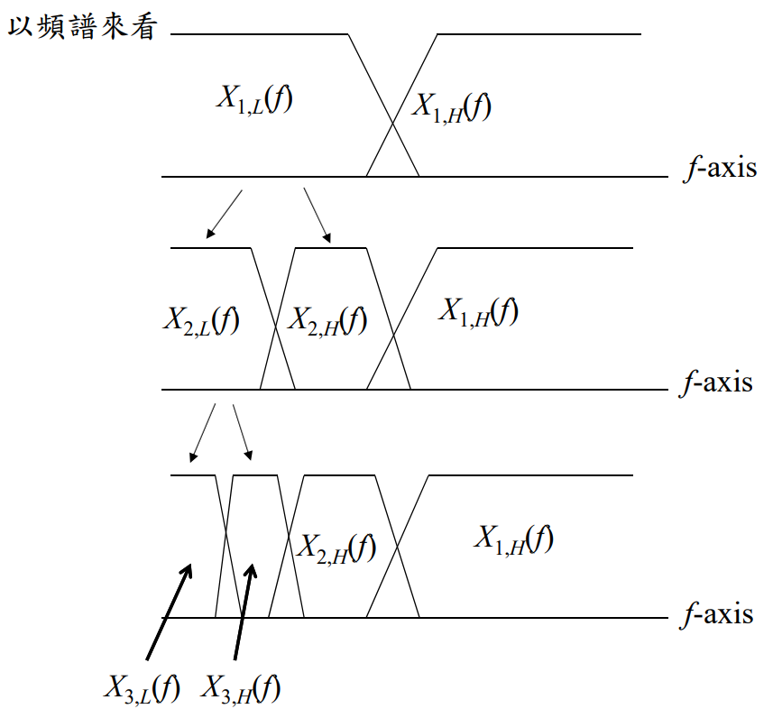
Fig 36: From course material p.464, which shows the frequency split during DWT decomposition
Each decomposition will generate coefficients $A_{j}:Approximation$ and $D_{j}:Detail$
The frequency range for$A_{j}:0\sim \frac{FS}{2^{j+1}}$, for$D_{j}:\frac{FS}{2^{j+1}}\sim \frac{FS}{2^{j}}$, $j=0, 1, 2…$ for level 1, 2, 3…

Experiment 4 – Classification with Machine Learning
My naïve method is to first do WPD decomposition for$level=l$and get$2^{l}$decomposed coefficients, which is done on 6 electrodes that can best represent the whole brain neural activity:
$$channels=[F3, F4, C3, C4, Cz, Pz]$$
This electrode subset contains left and right hemispheres as well as frontal, central, and parietal lobes.
Then I concatenate these coefficients into$C×H×W$tensor for each sample, where:
$$C=2^{l}=8:different frequency sub bands for level=3$$
$$H=6:6 different electrodes;W=1250:50 seconds, SR=200, downsample for 3 times$$
The model architecture consists of several convolutional blocks. At the last it passes through pooling layer and classifier head and output logits.
$$labels= [GPD, GRDA, LPD, LRDA, Other, Seizure]$$
GPD | Generalized Periodic Discharges | LRDA | Lateralized Rhythmic Delta Activity
GRDA | Generalized Rhythmic Delta Activity | Seizure | Epilepsy occurs
LPD | Lateralized Periodic Discharges

Loss function: $criterion\left(logits z, GT label=y\right)=-log⁡(\frac{e^{z_{y}}}{\sum_{j}{e^{z_{j}}}})$

Experimental Results and Analysis

Case Study
A random sample with eeg_id = 1169016983:
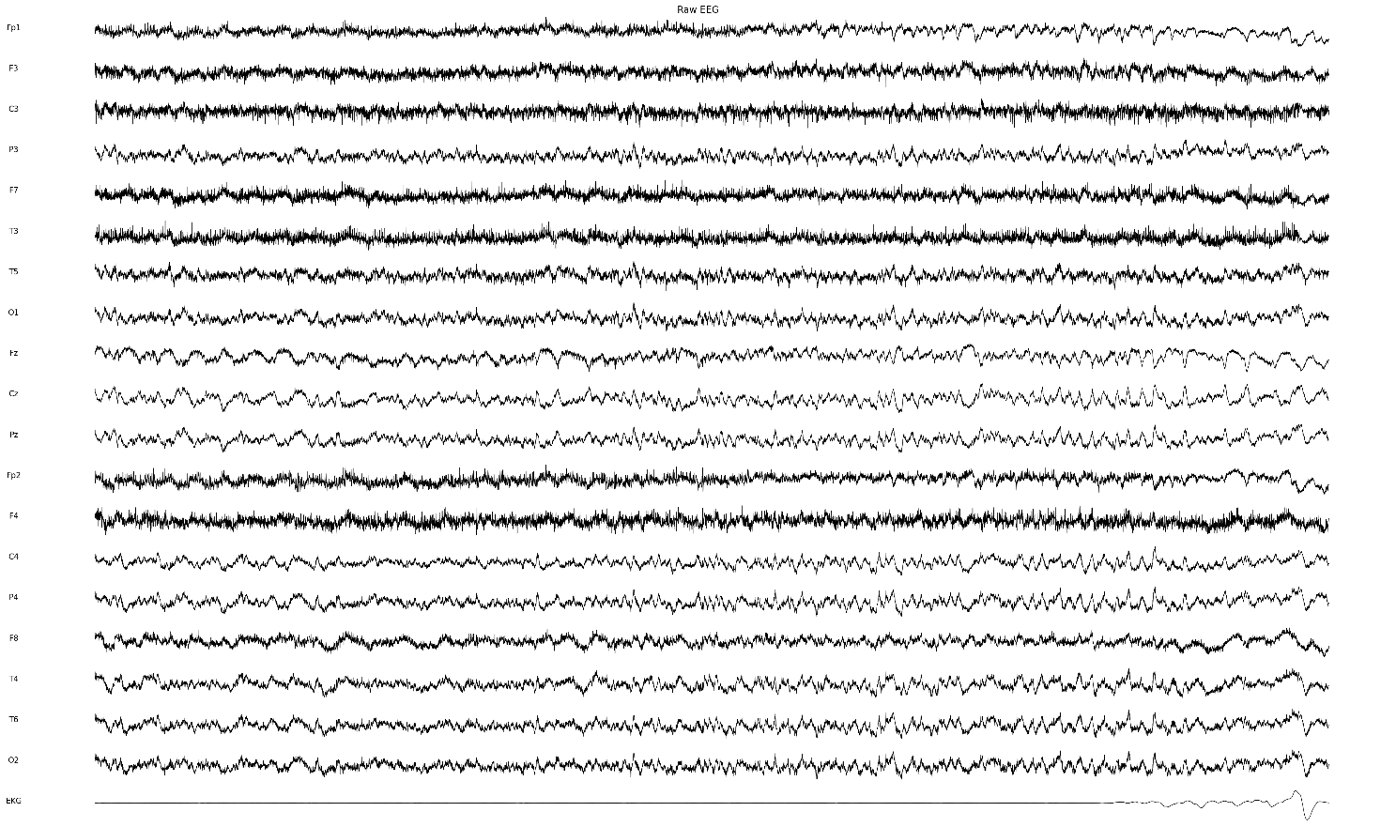
Fig 37: Raw EEG signal
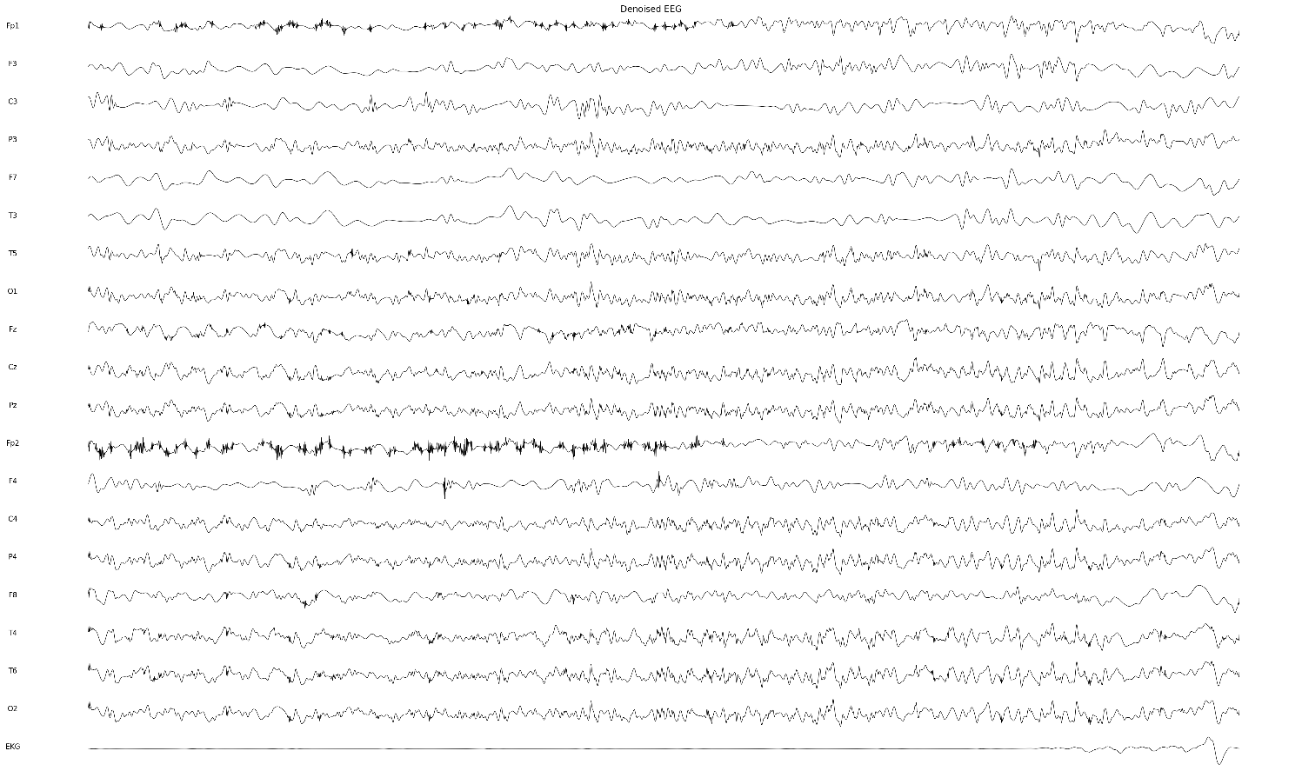
Fig 38: Denoised EEG signal
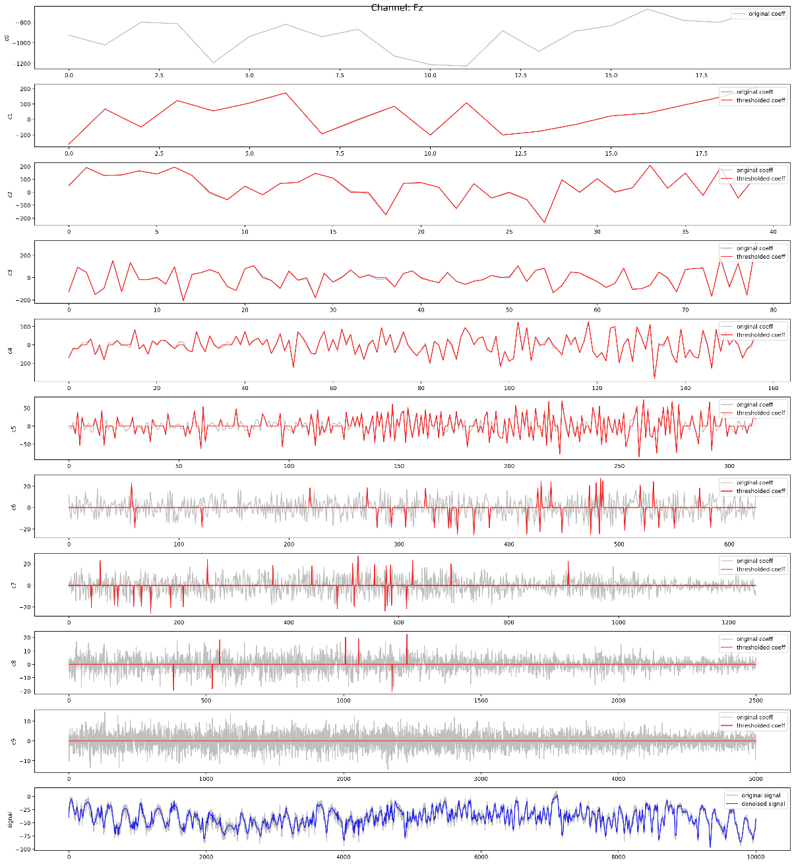
Fig 39: Denoising visualization for electrode Fz
If we compare the EEG signals before and after denoising, we can clearly identify the disappearance of high-frequency components, which is exactly what wavelet filtering does. From the denoising visualization for electrode Fz, it shows in default mode, 9-level WDT decomposition is conducted and thus get 9 detail coefficients (c1 to c9) and 1 approximation coefficient in the end (c0). Red curve is after thresholds while gray one is original coefficients. As we can see, higher frequency components are filtered out more. Even though, the denoised signal still keeps all main information and signal structure, but with far less noise and delicate fluctuations, which shows the effectiveness of wavelet denoising.

Randomly select electrode T3 to analyze its 4-level WPD/DWT decomposition before/after denoising:
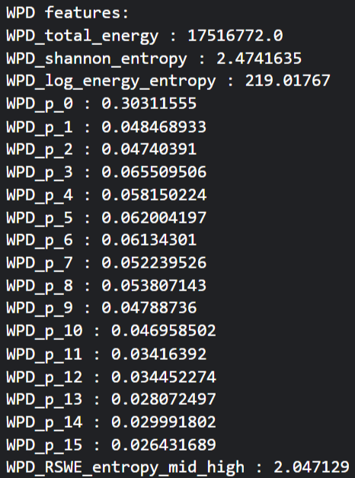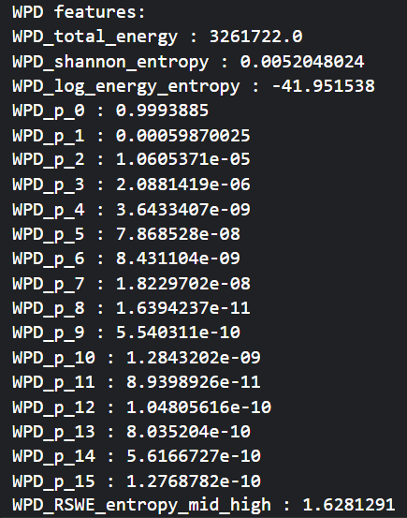
Fig 40: The energy and entropy distribution before / after denoising
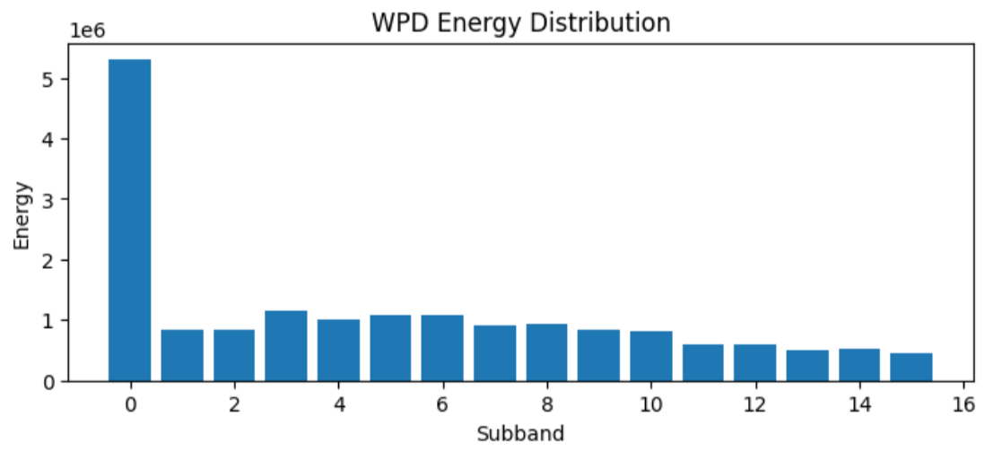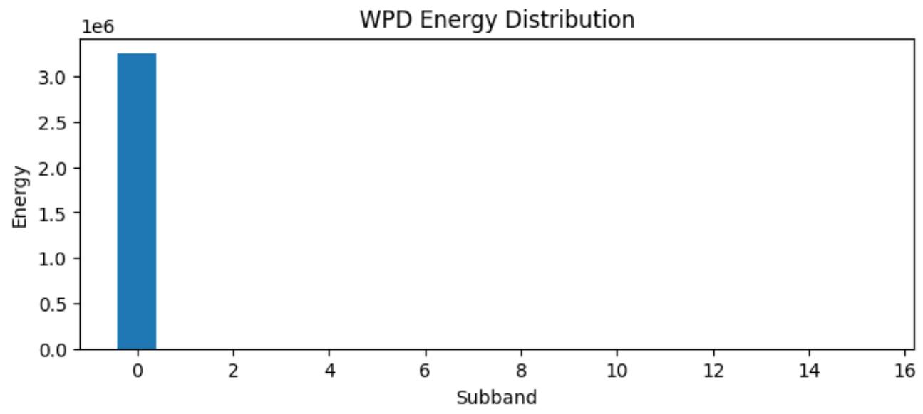
Fig 41: The bar chart for 4-level WPD 16 frequency bands energy distribution before / after denoising
From the above 2 diagrams, it shows the energy distribution of 16 sub frequency bands from 4-level WPD. The calculation method is: WPD_p_i$=p_{i}=\frac{E_{i}}{\sum_{j}{E_{j}}}$, which can also be used as relative energy. Entropy is calculated based $p_{i}, i=0, 1, …, 15$, while RSWE is further calculated on middle to high frequency range. As we can see, high frequency bands are filtered out after denoising process.
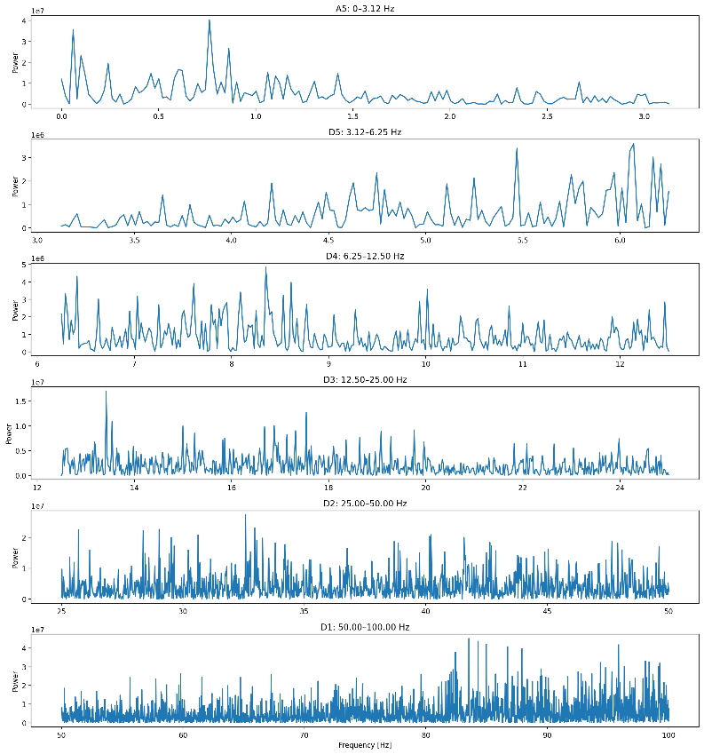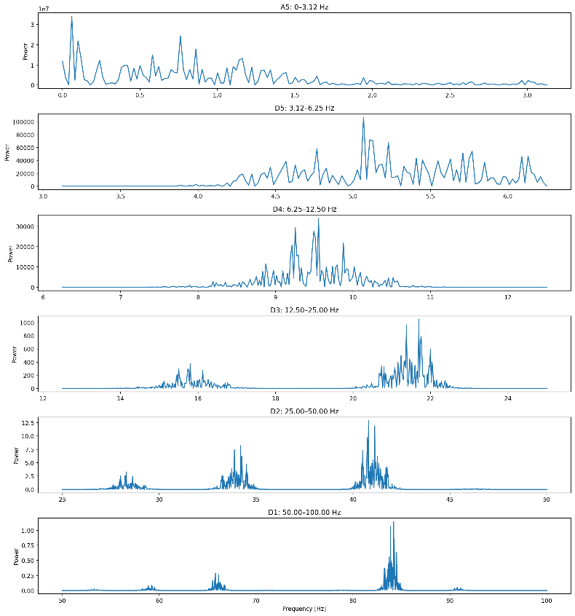
Fig 42: The FFT visualization on 4-level DWT decomposition of 1 approximation coefficient and
4 detailed coefficients before / after denoising
After denoising, from the above image we can find that only main lobes on frequency distribution remain.

Entropy / Energy Group Study
Study on randomly 15000 samples of the dataset, aims to study the distribution of EEG signal with different labels on different evaluation metrics. (After denoising)
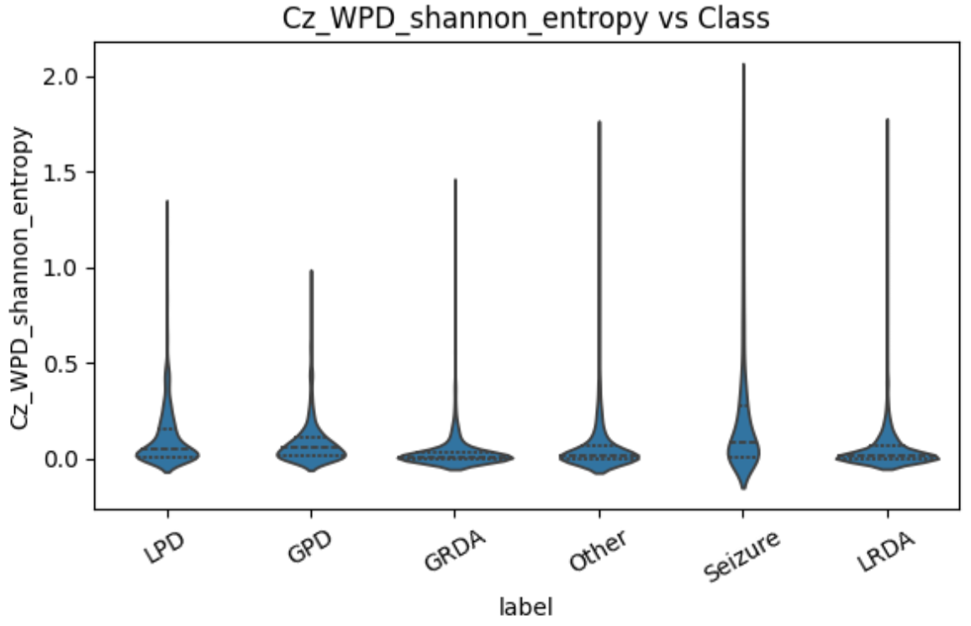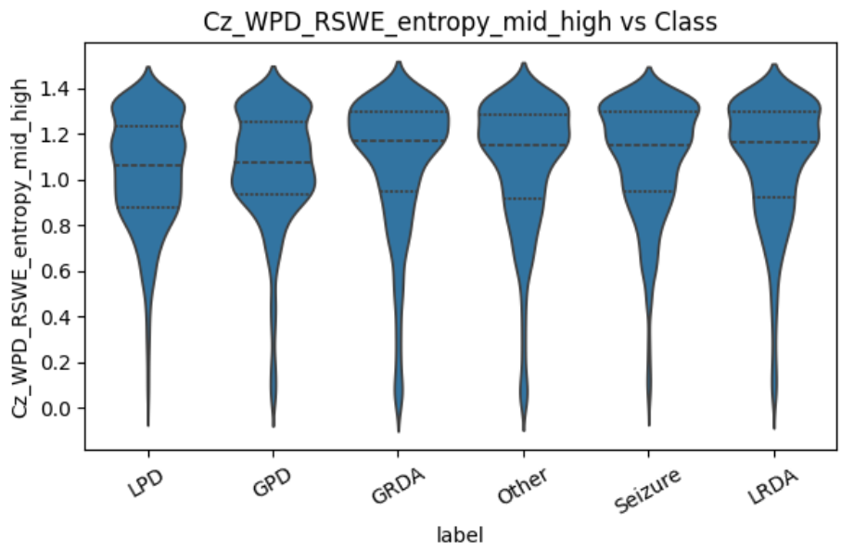
Fig 43: Violin plots for WPD entropy / RSWE on Cz electrode
From the left image of Fig 43: Violin plots for WPD entropy / RSWE on Cz electrode, overall value concentrates near 0, which means the distribution is very sharp, but with long tails. Since WPD entropy calculation will take the low frequency components into consideration, while they always take largest portion of energy. If we only consider middle to high frequency bands as right image, RSWE is relatively higher. For class LPD and GPD, they have wider distribution of RSWE, compared with classes GRDA and Other. For class Seizure and LRDA, they have higher median, which shows that they may have a more average distribution within middle to high frequency range. However, the difference between them can’t be discriminated by simple observation of threshold finding method.
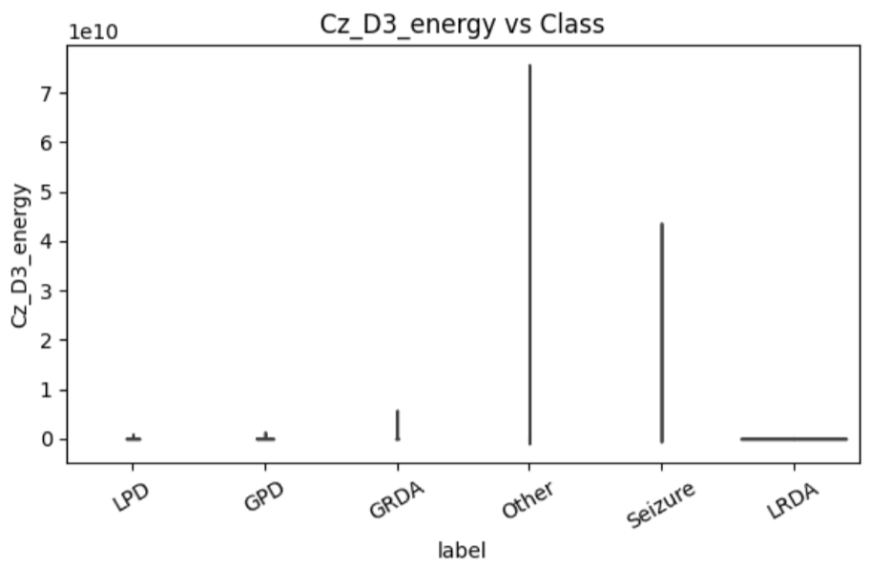
Fig 44: Violin plot for D3 energy of DWT decomposition on electrode Cz
D3 energy distribution characteristics across classes:
LPD exhibits a highly concentrated distribution near zero, appearing almost as a narrow vertical line. This indicates extremely low energy values with minimal variability across samples.
GPD shows a similar distributional pattern to LPD, with values tightly clustered near zero, suggesting consistently low energy and limited dispersion.
GRDA demonstrates a slightly wider distribution with modest elevation, indicating marginally higher energy compared to LPD and GPD, while still remaining relatively concentrated.
Other displays a markedly tall and elongated distribution with substantial spread, reflecting significantly higher energy levels and pronounced variability across samples.
Seizure also presents elevated energy values, though with a slightly narrower distribution than the Other class, consistent with high-energy transient events characteristic of epileptic activity.
LRDA shows a distribution almost entirely concentrated near zero, suggesting negligible energy contribution in the analyzed decomposition band.
Overall, the energy-based feature derived from the third level detailed coefficient of wavelet decomposition exhibits highly imbalanced distributions across classes. Several classes (LPD, GPD, and LRDA) show near-degenerate distributions concentrated close to zero, indicating that this feature carries limited discriminative information for these categories. In contrast, the Other and Seizure classes demonstrate substantially higher energy values with greater variance, suggesting sensitivity to high-amplitude or broadband activity.
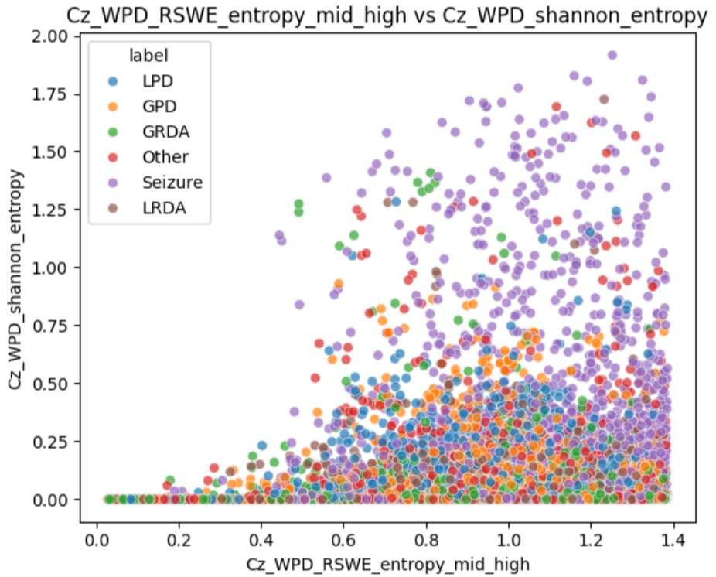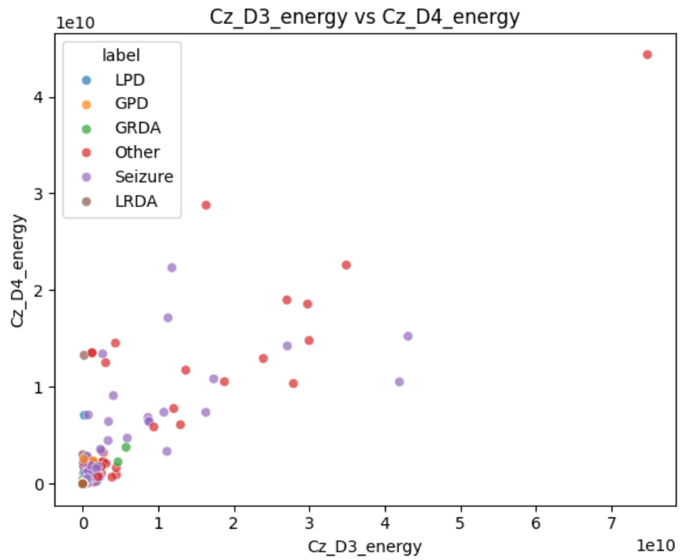
Fig 45: Scattering plot of 2 different features for electrode Cz EEG signal
As we can see, from the complexity of distribution between features, it’s predictable that traditional clustering method like K-means, random forest, or SVM may have difficulty on such difficult classification task if only based on numerical analysis characteristic results from wavelet transform. I believe the complete EEG signal or complete decomposition coefficients should directly serve as the input or guidance for Deep Learning Model, and just let the model itself to construct connections between information from different electrodes or frequency sub bands during training.

6.3 Machine Learning Result and Potential Improvements
Some training settings:
Optimizer | Scheduler | Epochs | Loss | Batch size
AdamW | ReduceLROnPlateau | 100 | Cross entropy loss | 16

Using 15000 samples as training and validation set (4:1), and trian for 100 epochs. For each sample, consider its 3-level WPD on EEG signal of electrode ['F3', 'F4', 'C3', 'C4', 'Cz', 'Pz'] as concatenated tensor map for model input.
Training accuracy increases from 0.21 to 0.75, while for validataion accuracy, it starts from 0.18 to about 0.29, but now showing obvious improvement but great fluctuation.
Best classfication accuracy on validation set is 0.285 at training epoch 96.
The classificaion results are shown below:
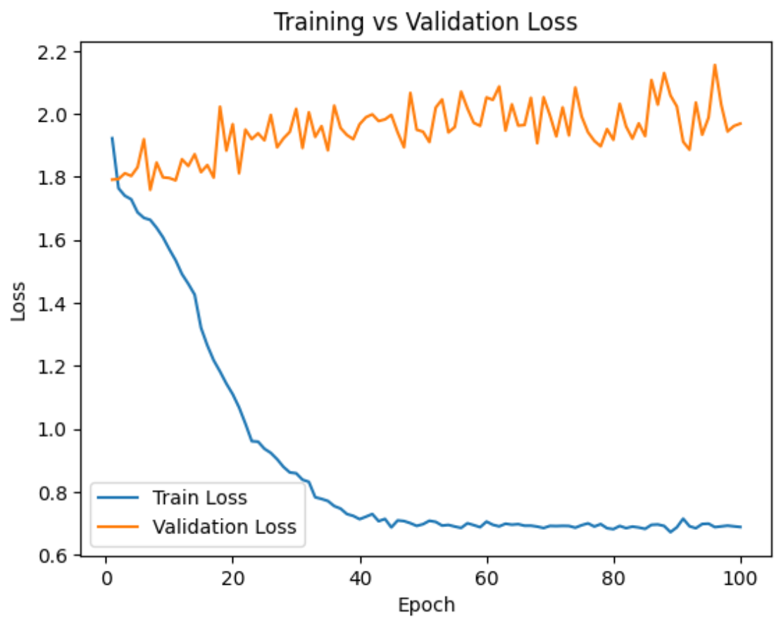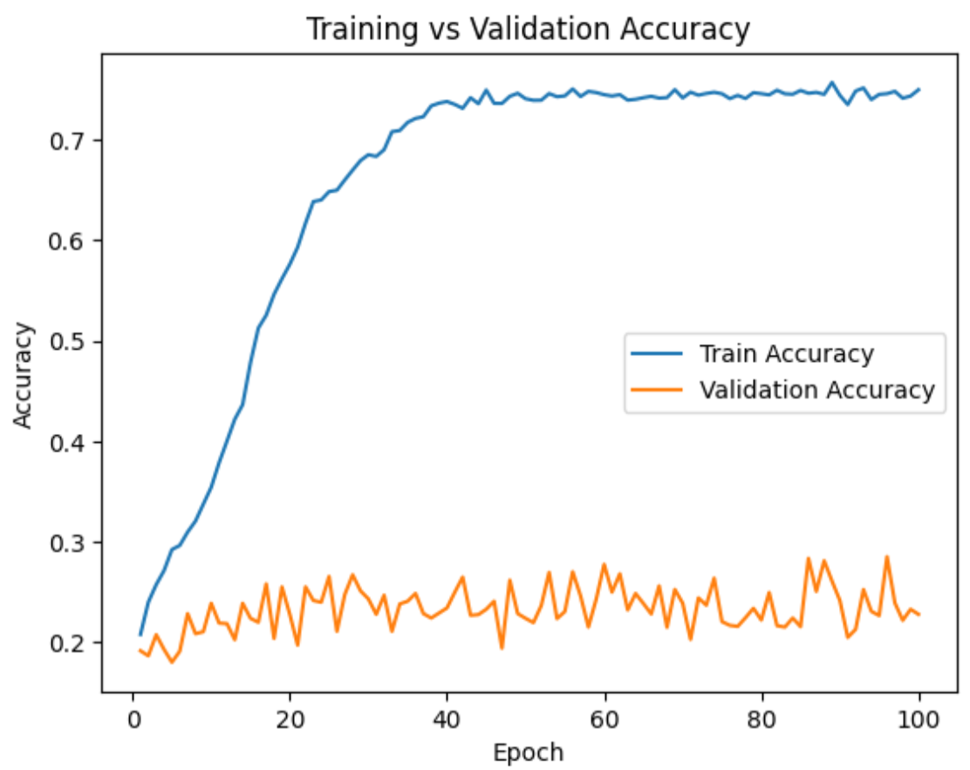
Fig 46: The train/val loss and accuracy during 100 epochs training
There is clearly overfitting since training loss decreases evidently while validation loss increases. I provide some possible improvements below:
- Increase the data size. If RAM size for CPU/GPU is allowable, we can increase the batch size and data size to support our training process.
- Redesign the model architecture. The semantic alignment between input tensor map and convolutional blocks is not robust. It’ll be prospective if we introduce self and cross attention layers. In other words, use transformer-based models instead of pure CNN network.

EEG-Based Brain-Computer Interfaces (BCI)

Overview of Brain-Computer Interfaces
Brain–Computer Interfaces (BCIs) represent a transformative class of neurotechnology that enables direct communication between the human brain and external devices without relying on conventional neuromuscular pathways. By translating neural activity into machine-interpretable commands, BCIs provide a novel interaction paradigm that fundamentally redefines how humans can control and interact with computers, robotic systems, and intelligent environments.
At their core, BCIs operate by acquiring neural signals—most commonly electroencephalography (EEG) in noninvasive settings—followed by signal preprocessing, feature extraction, pattern recognition, and command generation. This pipeline allows latent cognitive states, intentions, or sensory responses to be decoded and mapped to actionable outputs. Unlike traditional human–computer interaction, which depends on overt physical actions, BCIs exploit the intrinsic dynamics of brain activity, enabling communication even in the absence of voluntary movement.

A defining challenge in BCI research lies in the nonstationary, low signal-to-noise nature of brain signals. Neural activity exhibits substantial temporal variability, subject-specific characteristics, and sensitivity to physiological and environmental factors. Consequently, robust time–frequency analysis methods—such as wavelet transforms—have become indispensable tools for capturing the transient and multiscale properties of brain dynamics. These methods enable BCIs to extract meaningful features associated with canonical neural oscillations (e.g.,$δ$,$θ$,$α$,$β$, and$γ$bands) that are closely linked to cognitive and behavioral states.
BCIs stand at the intersection of neuroscience, signal processing, and artificial intelligence. As analytical methods and computational models continue to evolve, BCIs are poised to transition from specialized laboratory systems to pervasive technologies capable of augmenting human cognition, restoring lost neurological function, and expanding the boundaries of human–machine symbiosis.

EEG Signal Characteristics and Challenges in BCI
    - 🤖 Classification of motor imagery EEG signals using wavelet scattering transform and Bi-directional long short-term memory networks
This work proposes a new method in a fusion deep learning network. Wavelet scattering transform can deeply mine the feature information in EEG signals. In the classification stage, multiple time window features obtained in the scattering transform are sent to the BiLSTM network for classification.
Motor imagery EEG signals:
Motor imagery EEG refers to electroencephalographic signals that reflect brain activity generated when a subject imagines performing a movement without any actual physical motion.
Wavelet scattering transform (WST):
WST’s pipeline is often compared with convolutional neural network, not only because similarity on network structure, but both are extracting key information from input signals:
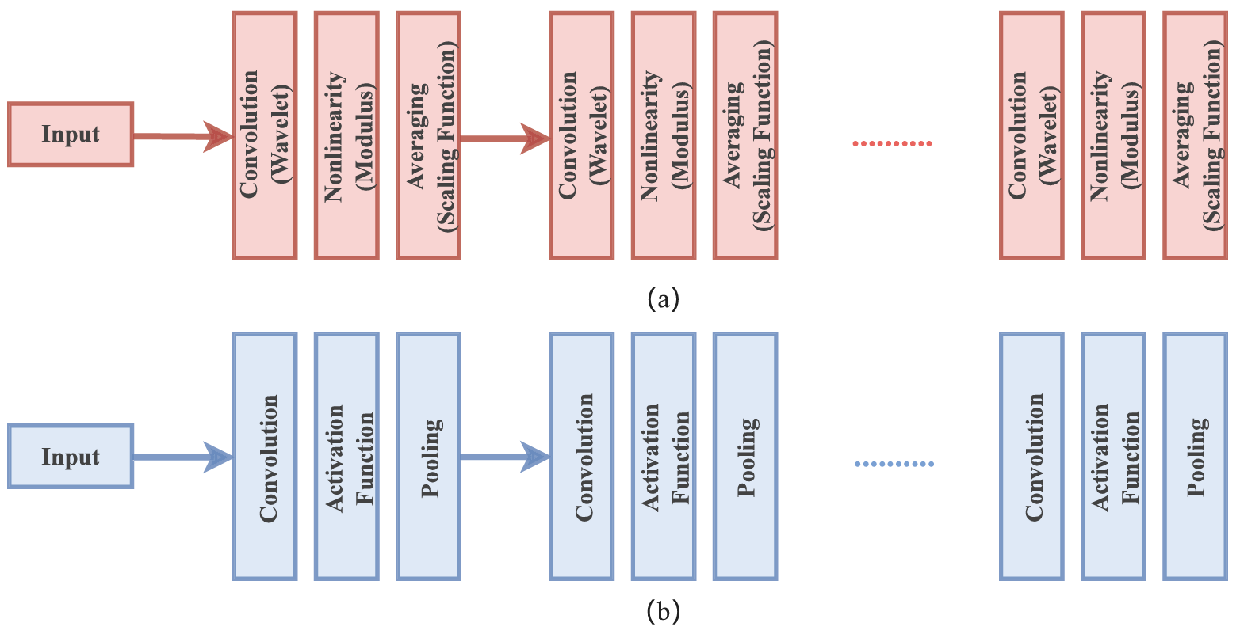
Fig 47: Structure of wavelet (a) scattering network and (b) CNN
Given a mother wavelet$ψ_{λ}\left(t\right)=λψ\left(λt\right), where λ=2^{k/Q_{i}}$, $Q_{i}$: octave frequency resolution for each network layer i. Larger$Q$means higher frequency resolution.
Scattering transform starts from$S_{0}x=x*ϕ$, where$ϕ$is scaling function (low pass filter), which is called 0-order scattering, describing the local translational invariance of the signal.
For 1-order scattering,$W_{1}x\left(t, λ_{1}\right)=x*ψ_{λ_{1}}$, and the scattering coefficient$S_{1}x\left(t,λ_{1}\right)=\left|W_{1}x\left(t,λ_{1}\right)\right|*ϕ$
where$\left|⋅\right|$means the modulus operation to eliminate phase and reserve amplitude envelope.
For n-order scattering, $S_{n}x\left(t, λ_{1},…λ_{m}\right)=\left|\left|\left|x*ψ_{λ_{1}}\right|*ψ_{λ_{2}}\right|…*ψ_{λ_{n}}\right|*ϕ$.
      - Output of one stage becoming the input of the next
Tree view of the entire algorithm is shown below:
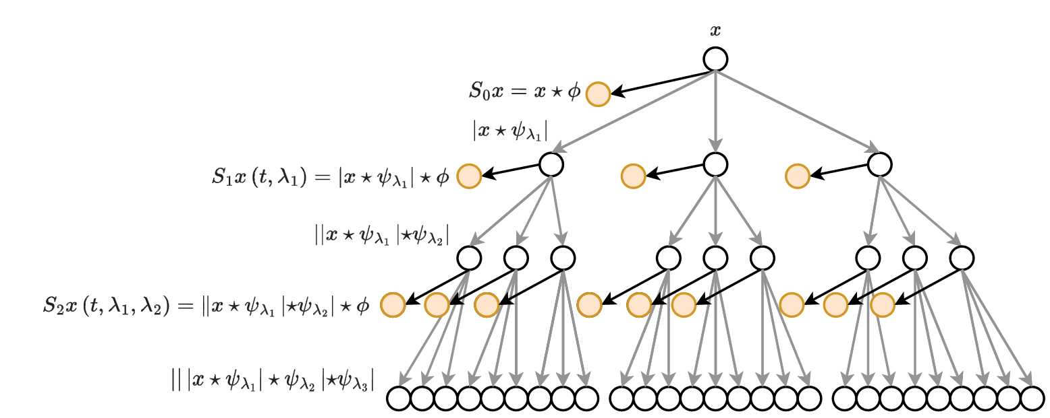
Fig 48: Tree structure of WST
Since EEG data is time-series data, recurrent neural network (RNN) can be an effective architecture to process. 75% Overlapping sliding windows can capture the input EEG signal as different segments for input to BiLSTM network.
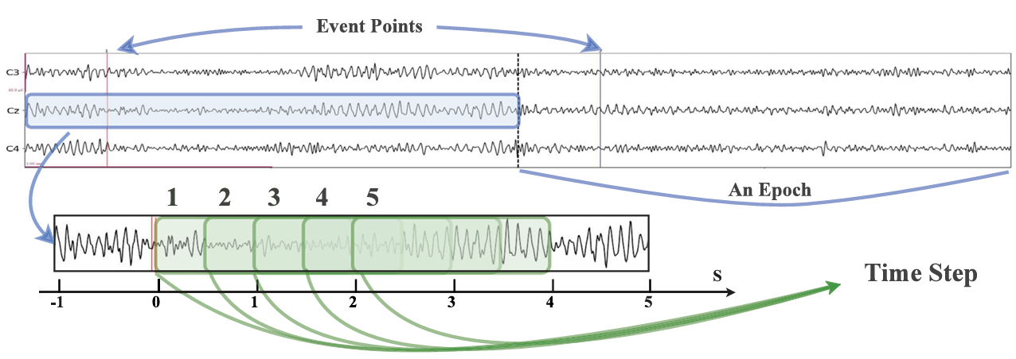
Fig 49: An overview of the time step sliding windows and the movement segments
    - 🤖 Spiking neural networks for EEG signal analysis using wavelet transform
Existing Deep Learning BCI methods faced 2 critical limitations:
- Rely on manual feature extraction/ 2. High energy consumption makes unsuitable on portable devices.
Proposed method: Combines wavelet transform for automatic feature extraction with spiking NN for energy efficient computation. Present a novel spiking transformer that integrates a spiking self-attention mechanism with DWT, termed as SpikeWavFormer.
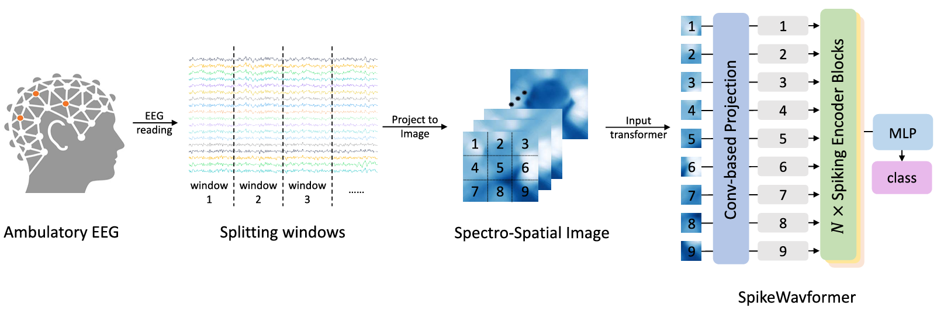
Fig 50: Workflow for SpikeWavformer method for EEG-based tasks
Haar wavelet is used due to its simplicity and computational efficiency (common chosen in DL project), characterized by a two-tap filter with minimal support.
Given multiple-channel EEG inputs $X∈R^{T×B×C×H×W}$, where$T:timesteps;B:batch size;C:EEG channels;H×W:spatial-topological 2D arrangement$
*Note: why 2D? During preprocessing, signals are projected onto 2D topographic maps thereby maintaining brain-region dependencies.
Perform 2D DWT on EEG features at each time step t:
$$\left[X_{LL}^{\left(t\right)}, X_{LH}^{\left(t\right)}, X_{HL}^{\left(t\right)}, X_{HH}^{\left(t\right)}\right]=DWT(X^{(t)})$$
$X_{LL}$ captures low-frequency components like delta, theta bands, while $X_{LH},X_{HL}, X_{HH}$ retain high-frequency components like beta, gamma bands. Then spatial local convolution enhances frequency band interactions:
$$X_{filter}^{(t)}=LIF\left(BN\left(Conv\left(Concat\left(\left[X_{LL}^{\left(t\right)}, X_{LH}^{\left(t\right)}, X_{HL}^{\left(t\right)}, X_{HH}^{\left(t\right)}\right]\right)\right)\right)\right), X_{recon}^{(t)}=IDWT(X_{filter}^{(t)})$$
where $BN\left(⋅\right), LIF(⋅)$ are batch normalization and spiking neuron layer respectively.
The result after convolution as well as the reconstruction result are used in self-attention network!
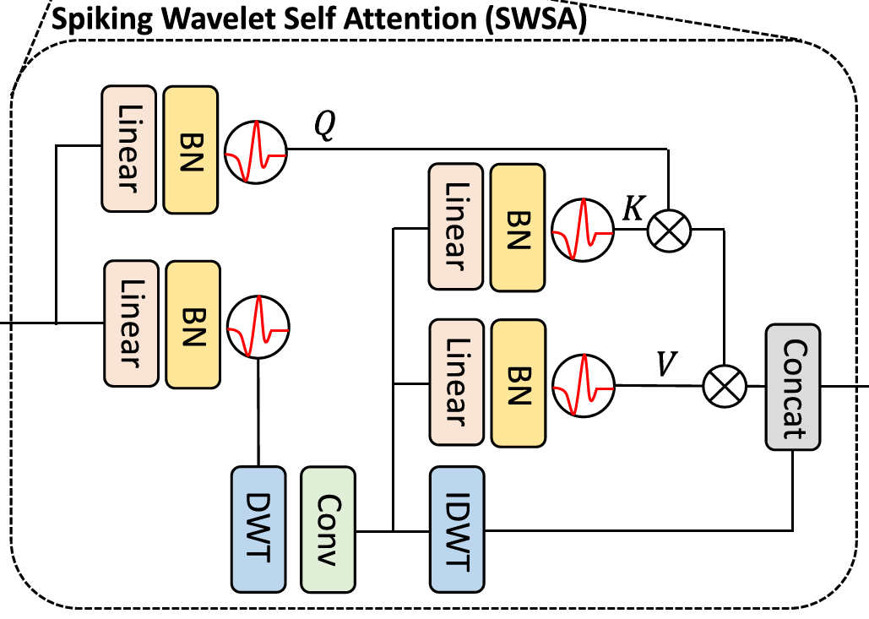
Fig 51: An impressive structure to integrate DWT with self-attention mechanism
This SWSA mechanism can be represented as:
$$SWSA\left(X\right)=F\left(Attn\left(W\left(X\right)\right)⊕W^{-1}\left(W\left(X\right)\right)\right), W:X→Y=\{(X_{LL}, X_{LH}, X_{HL},X_{HH})\}$$

8. Conclusion
After doing survey on so many related research and doing experiments on HMS dataset, Wavelet Transform serves as a mainstream, effective, and efficient multi-resolution frequency method with preserved time locality on EEG signal analysis. It can be used to do feature extraction, denoising, classification, and seizure detection. More importantly, with the prospering deep learning method, Wavelet Transform serves as a powerful pre-processing on input EEG signal. The decomposition results from different kinds of Wavelet Transform (different wavelets, different stages, different pipelines, derived methodology) can all be used by or guide the machine learning model to perform on a great variety of downstream tasks. Furthermore, DWT can itself be a block in neural networks, which can be directly integrated in the model just like an additional layer, and may become trainable in some innovative designs. I also think the future research direction regarding this field would always connect to Brain Computer Interface. There will be so many applications and commercial opportunities.

9. References
[1] Bajaj, N. (2020). Wavelets for EEG Analysis. In Wavelet Theory. London, UK: IntechOpen. https://doi.org/10.5772/intechopen.94398
[2] Blum, A. S., & Rutkove, S. B. (Eds.). (2007). The Clinical Neurophysiology Primer. Humana Press. https://doi.org/10.1007/978-1-59745-271-7
[3] Kumar, J. S., & Bhuvaneswari, P. (2012). Analysis of electroencephalography (EEG) signals and its categorization–a study. Procedia Engineering, 38, 2525–2536. https://doi.org/10.1016/j.proeng.2012.06.298
[4] Jackson, A. F., & Bolger, D. J. (2014). The neurophysiological bases of EEG and EEG measurement: A review for the rest of us. Psychophysiology, 51(11), 1061–1071. https://doi.org/10.1111/psyp.12283
[5] Grobbelaar, M., Phadikar, S., Ghaderpour, E., Struck, A. F., Sinha, N., Ghosh, R., & Ahmed, M. Z. I. (2022). A survey on denoising techniques of electroencephalogram signals using wavelet transform. Signals, 3(3), 577–586. https://doi.org/10.3390/signals3030035
[6] Zhang, H., Zhao, Z., Liu, C., Duan, M., Lu, Z., & Wang, H. (2024). Classification of motor imagery EEG signals using wavelet scattering transform and bi‑directional long short‑term memory networks. Biocybernetics and Biomedical Engineering, 44(4), 874–884. https://doi.org/10.1016/j.bbe.2024.11.003
[7] Felja, M., Bencheqroune, A., Karim, M., & Bennis, G. (2020). Removing artifacts from EEG signal using wavelet transform and conventional filters. WSEAS Transactions on Information Science and Applications, 17, 177–183. https://doi.org/10.37394/23209.2020.17.22
[8] Azim, M. R., Amin, M. S., Haque, S. A., Ambia, M. N., & Shoeb, M. A. (2010, August). Feature extraction of human sleep EEG signals using wavelet transform and Fourier transform. In 2010 2nd International Conference on Signal Processing Systems (ICSPS) IEEE. https://doi.org/10.1109/ICSPS.2010.5555506
[9] Xin, Q., Hu, S., Liu, S., Zhao, L., & Zhang, Y.-D. (2022). An attention‑based wavelet convolution neural network for epilepsy EEG classification. IEEE Transactions on Neural Systems and Rehabilitation Engineering, 30, 957–966. https://doi.org/10.1109/TNSRE.2022.3166181
[10] Murugappan, M., Nagarajan, R., & Yaacob, S. (2011). Combining spatial filtering and wavelet transform for classifying human emotions using EEG signals. Journal of Medical and Biological Engineering, 31(1), 45–51. https://doi.org/10.5405/jmbe.710
[11] Yamochi, S., Yamada, T., Obata, Y., Sudo, K., Kinoshita, M., Akiyama, K., & Sawa, T. (2024). Wavelet transform-based mode decomposition for EEG signals under general anesthesia. PeerJ, 12, e18518. https://doi.org/10.7717/peerj.18518
[12] Sayeid, A., et al. (2016). Statistical analysis of EEG signals in wavelet domain for efficient seizure prediction. American Journal of Biomedical Engineering, 6(1), 32–41. https://doi.org/10.5923/j.ajbe.20160601.05
[13] Elshekhidris, I. H., Mohamed Amien, M. B., & Fragoon, A. (2023). Wavelet transforms for EEG signal denoising and decomposition. International Journal of Advances in Signal and Image Sciences, 9(2), 11–28. https://xlescience.org/index.php/IJASIS/article/view/130
[14] Urbina Fredes, S., Dehghan Firoozabadi, A., Adasme, P., Zabala‑Blanco, D., Palacios Játiva, P., & Azurdia‑Meza, C. (2024). Enhanced epileptic seizure detection through wavelet‑based analysis of EEG signal processing. Applied Sciences, 14(13), 5783. https://doi.org/10.3390/app14135783
[15] Zahirović, S., Avdaković, S., Hadžagić‑Catić, F., Dautbašić, N., Muftić Dedović, M., Suljić, E., Sefo, H., & Omerhodžić, I. (2021). Wavelet transform as a helping tool during EEG analysis in children with epilepsy. Acta Informatica Medica, 29 (2), 104–107. https://doi.org/10.5455/aim.2021.29.104-107
[16] Yuan, L., Wei, J., & Liu, Y. (2025). Spiking neural networks for EEG signal analysis using wavelet transform. Frontiers in Neuroscience, 19, 1652274. https://doi.org/10.3389/fnins.2025.1652274

