A PRELIMINARY REPORT ON
WATERMARK-GUIDED TAMPER LOCALIZATION AND RECOVERY
A Key-Seeded Self-Embedding Fragile Watermarking Scheme with Joint Localization and Restoration Assessment
SUBMITTED TO THE SAVITRIBAI PHULE PUNE UNIVERSITY, PUNE
IN THE PARTIAL FULFILLMENT OF THE REQUIREMENTS
FOR THE AWARD OF THE DEGREE
OF
BACHELOR OF ENGINEERING
(COMPUTER ENGINEERING)
SUBMITTED BY
[STUDENT NAME 1] Exam No : [EXAM NO.]
[STUDENT NAME 2] Exam No : [EXAM NO.]
[STUDENT NAME 3] Exam No : [EXAM NO.]
[STUDENT NAME 4] Exam No : [EXAM NO.]
Under the Guidance of
Prof. [Guide Name]

DEPARTMENT OF COMPUTER ENGINEERING
AJEENKYA DY PATIL SCHOOL OF ENGINEERING
CHARHOLI BUDRUK, LOHEGAON, PUNE 412105
SAVITRIBAI PHULE PUNE UNIVERSITY
2026 - 2027

AJEENKYA DY PATIL SCHOOL OF ENGINEERING
DEPARTMENT OF COMPUTER ENGINEERING
CERTIFICATE
This is to certify that the Project Report entitled
"WATERMARK-GUIDED TAMPER LOCALIZATION AND RECOVERY"
Submitted by
[STUDENT NAME 1] Exam No : [EXAM NO.]
[STUDENT NAME 2] Exam No : [EXAM NO.]
[STUDENT NAME 3] Exam No : [EXAM NO.]
[STUDENT NAME 4] Exam No : [EXAM NO.]
are bonafide students of this institute and the work has been carried out by them under the supervision of Prof. [Guide Name] and it is approved for the partial fulfillment of the requirement of Savitribai Phule Pune University, for the award of the degree of Bachelor of Engineering in Computer Engineering.
(Prof. [Guide Name]) | (Dr. Pankaj Agarkar)
Guide | H.O.D
Department of Computer Engineering | Department of Computer Engineering

Signature of Internal Examiner: | Signature of External Examiner:

Dr. F. B. Sayyad
Principal
AJEENKYA DY PATIL SCHOOL OF ENGINEERING, Lohegaon, Pune-412105
Place : Pune Date :

ACKNOWLEDGEMENT
It gives us great pleasure in presenting the preliminary project report on "Watermark-Guided Tamper Localization And Recovery".
We would like to take this opportunity to thank our Internal Guide Prof. [Guide Name] for giving us all the help and guidance we needed. We are really grateful for the kind support, and the valuable suggestions that shaped both the design of the scheme and the way its results are reported.
We are also grateful to Dr. Pankaj Agarkar, Head of the Computer Engineering Department, ADYPSOE, Lohegaon, Pune, and to our Project Co-ordinator Dr. Amruta Chitari, for their indispensable support, suggestions and motivation during the entire course of the project.
We would also be grateful to our Principal Dr. F. B. Sayyad, who encouraged us and created a healthy environment for all of us to learn in the best possible way.
We also thank all the staff members of our college and the technicians for their help in making this project a successful one.

[STUDENT NAME 1]
[STUDENT NAME 2]
[STUDENT NAME 3]
[STUDENT NAME 4]

ABSTRACT
Region-level image manipulation is now free, fast and visually seamless, and the lossless formats in which evidence is normally stored, such as PNG, BMP and TIFF, protect nothing about content. Passive detectors, which analyze only the received image, answer half of the question at best: they may suggest that a region looks altered, but they cannot state which blocks were touched, cannot say what the region contained, and return no verdict that a third party can repeat. The problem addressed here is to localize tampering at block granularity and restore what was destroyed, for images that pass through a lossless custody chain.
This project presents a deterministic, training-free self-embedding fragile watermarking scheme. The image is divided into 8x8 blocks, and the two least-significant bit-planes of each block carry a 128-bit payload: a 32-bit keyed HMAC-SHA256 tag computed over the block's own six most-significant bit-planes, and a 96-bit recovery descriptor of a spatially distant partner block chosen by a key-seeded permutation. Verification recomputes each tag, and a mismatch flags the block. A flagged block is rebuilt from the descriptor its surviving partner carries; where that partner is also flagged, the block is marked unrecoverable rather than fabricated.
Across a 32-image corpus, embedding reaches a mean PSNR of 45.479 dB and SSIM of 0.98847. On the 1,792-trial main grid, block-level recall is 1.0000 for splicing, crop-and-refill and noise corruption, and 0.99998 for inpainting removal. The null condition, 1,802,240 verifications of unmodified images, produced no false-positive block. The recoverability rate sits 3 to 6 percentage points above its structural bound of 1 - alpha at every tamper ratio, falling from 0.9590 at 10% tamper to 0.3579 at 70%, and in-region recovery quality is 28.49 dB for Variant A and 31.13 dB for Variant C. What distinguishes the design is accountability rather than accuracy: every decision is a single recomputed keyed hash that any third party holding the key can repeat bit for bit.
Keywords: fragile watermarking; self-embedding; tamper localization; image recovery; HMAC-SHA256; image forensics; content authentication; recoverability rate

TABLE OF CONTENTS
LIST OF ABBREVIATIONS v
LIST OF FIGURES vi
LIST OF TABLES vii

Sr.No. | Title of Chapter | Page No.
01 | Introduction | 1
1.1 | Motivation of the Project | 1
1.2 | Literature Survey | 3
1.2.1 | Passive and Active Authentication | 3
1.2.2 | Self-Embedding and Its Known Failure Modes | 3
1.2.3 | Learned Proactive Watermarking | 4
1.2.4 | Market Survey and Research Gap | 5
02 | Problem Definition And Scope | 7
2.1 | Problem Statement | 7
2.2 | Goal and Objectives | 7
2.3 | Statement of Scope | 8
2.4 | Methodologies of Problem Solving and Efficiency Issues | 10
03 | Project Plan | 12
3.1 | Project Estimates | 12
3.2 | Risk Management with respect to NP-Hard Analysis | 13
3.3 | Project Schedule | 15
04 | Software Requirements Specification | 17
4.1 | Database Requirements | 17
4.2 | Software Requirements (Platform Choice) | 18
4.3 | Hardware Requirements | 19
4.4 | Analysis Models: SDLC Model to be Applied | 20
05 | System Design | 22
5.1 | System Architecture | 22
5.2 | Mathematical Model | 24
5.3 | Data Flow Diagrams | 27
5.3.1 | Level 0 (Context Diagram) | 27
5.3.2 | Level 1 | 28
5.3.3 | Level 2 | 28
5.4 | Entity Relationship Diagram | 29
5.5 | UML Diagrams | 30
5.5.1 | Use Case Diagram | 30
5.5.2 | Class Diagram | 30
5.5.3 | Sequence Diagram | 31
5.5.4 | Activity Diagram | 32
5.5.5 | State Machine Diagram | 32
5.5.6 | Component Diagram | 33
5.5.7 | Deployment Diagram | 33
06 | Other Specification | 35
6.1 | Advantages | 35
6.2 | Limitations | 36
6.3 | Applications | 37
07 | Conclusions And Future Work | 38
7.1 | Results Obtained to Date | 38
7.1.1 | Imperceptibility | 38
7.1.2 | Localization | 38
7.1.3 | Recovery | 39
7.1.4 | Comparison and Ablation | 41
7.2 | Conclusions | 42
7.3 | Future Work | 43
 | References | 44
 | Appendix A: Feasibility Assessment, Satisfiability Analysis and Complexity Classification | 47
 | Appendix B: Details of the Papers Referred | 51
 | Appendix C: Plagiarism Report | 58

LIST OF ABBREVIATIONS
Abbreviation Illustration

ADYPSOE Ajeenkya DY Patil School of Engineering
C2PA Coalition for Content Provenance and Authenticity
COCOMO Constructive Cost Model
CPU Central Processing Unit
DCT Discrete Cosine Transform
DFD Data Flow Diagram
DICOM Digital Imaging and Communications in Medicine
ER Entity-Relationship
FPR False Positive Rate
GPU Graphics Processing Unit
HMAC Hash-based Message Authentication Code
IoU Intersection over Union
KLOC Thousands of Lines of Code
LSB Least Significant Bit
MSB Most Significant Bit
PACS Picture Archiving and Communication System
PNG Portable Network Graphics
PSNR Peak Signal-to-Noise Ratio
SDLC Software Development Life Cycle
SHA Secure Hash Algorithm
SPPU Savitribai Phule Pune University
SQL Structured Query Language
SSIM Structural Similarity Index Measure
UML Unified Modeling Language
USC-SIPI University of Southern California, Signal and Image Processing Institute

LIST OF FIGURES
Figure Illustration Page No.

1.1 Passive detection against active self-embedding 2
2.1 The four tamper classes 9
3.1 Project schedule (Gantt chart) 16
4.1 The incremental SDLC model as applied 21
5.1 System architecture 23
5.2 Per-block payload layout at B = 8 25
5.3 Key-seeded block mapping 26
5.4 Data flow diagram, Level 0 (context) 28
5.5 Data flow diagram, Level 1 28
5.6 Data flow diagram, Level 2 29
5.7 Entity-relationship diagram 30
5.8 Use case diagram 30
5.9 Class diagram 31
5.10 Sequence diagram 31
5.11 Activity diagram 32
5.12 State machine diagram 32
5.13 Component diagram 33
5.14 Deployment diagram 33
7.1 Recoverability rate against tamper ratio 40
7.2 In-region and whole-image PSNR 41
7.3 Qualitative result under copy-paste splicing 41

LIST OF TABLES
Table Illustration Page No.

1.1 Summary of the surveyed literature 4
2.1 Tamper classes and tamper ratios 9
3.1 Measured size of the implementation 12
3.2 Basic COCOMO estimate 13
3.3 Risk register 14
3.4 Plan of work and status 15
4.1 Schema of the protected-image library 17
4.2 Software requirements 19
4.3 Hardware requirements 19
5.1 Per-block bit budget 24
5.2 Functional modules and responsibilities 23
7.1 Imperceptibility of watermarked images 38
7.2 Recoverability and in-region recovery quality 40
7.3 Null condition on unmodified images 39
7.4 Comparison with published schemes 41
7.5 Block-size ablation 42

CHAPTER 1
INTRODUCTION
1.1 MOTIVATION OF THE PROJECT
The evidentiary value of a digital image rests on an increasingly unsafe assumption: that the pixels presented are the pixels captured. Region-level manipulation, such as pasting an object from one photograph into another, erasing an object with an inpainting tool, or replacing a cropped region with plausible texture, is now available in free software, and diffusion-based editors require neither skill nor time. Everyday formats such as PNG, TIFF and JPEG record pixel values and protect nothing about whether they are the ones the camera or scanner produced.
The stakes are concrete. A radiological study with a lesion erased can change a diagnosis, a vehicle-damage photograph can be edited to inflate or invent an insurance loss, and a surveillance frame entered into a legal record can have a person removed from it. In each case the image is useful because of an integrity the file does not protect, and the party who relies on it usually cannot inspect the original.
Two broad families of countermeasure exist. Passive, or blind, forensics analyses the received image alone for statistical inconsistencies, and its modern instances are learned networks [2], [3]. Active approaches insert authentication information before the image is distributed, so that verification becomes a test of self-consistency rather than an inference about provenance. Fragile watermarking belongs to this second family [4], [5]. The passive detector must infer tampering from evidence the attacker may have concealed; the active scheme checks the image against information the attacker could not forge.
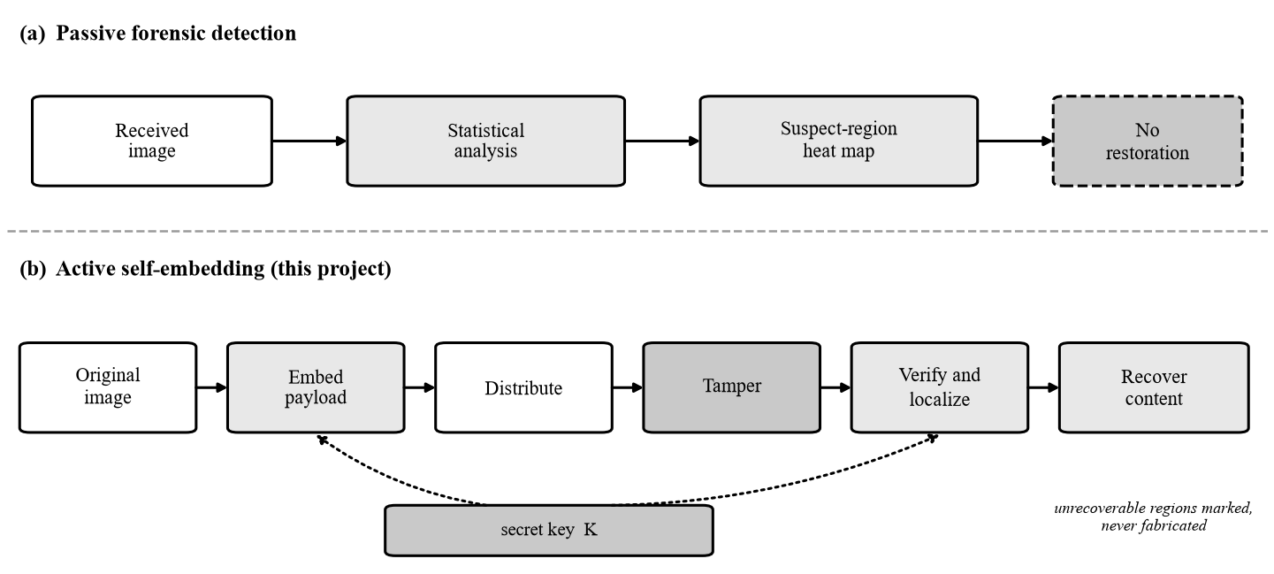
Fig. 1.1: Passive forensic detection against active self-embedding. Only the active path carries the original content forward.
Fig. 1.1 contrasts the two paths. On the passive path, statistical analysis of the received image yields a heat map of suspect regions, with no restoration. On the active path, the original image is embedded with authentication and recovery data, distributed, possibly tampered with, and verified; verification localizes the altered blocks, and recovery rebuilds them from information the image itself carries. The second path is the subject of this project. It ends not at a suspicion but at either a reconstructed block or an explicit statement that the block cannot be reconstructed, and both outcomes are verifiable against the embedded data.
Even a perfect detector answers only half of the practitioner's question, since knowing which pixels of a radiograph were altered does not restore the diagnostic content that was overwritten. Passive restoration is also necessarily generative: an inpainting network fills the region with plausible content that bears no evidentiary relationship to the original. When the artifact is evidence, that is worse than no restoration, because a fabricated region that looks natural invites trust that the detector's flag was meant to withdraw. What is required is a mechanism by which the original content, even as a coarse approximation, survives the attack.
Self-embedding, introduced by Fridrich and Goljan [1], provides exactly this: a compressed representation of each region is hidden elsewhere within the same image, so that a spatially localized attack destroys a region but not its backup. This report describes a reproducible pipeline built on that principle, which evaluates localization and recovery jointly. Two further arguments bear on deployment. Learned detectors need annotated corpora and accelerator hardware that excludes embedded devices and hospital gateways, and their output is not an argument under cross-examination, since a per-pixel confidence of 0.78 cannot be recomputed or defended line by line.
The second argument concerns reporting practice. The literature habitually reports localization and recovery separately, which lets a healthy in-region reconstruction figure flatter a scheme whose recoverable fraction is undisclosed, since it describes only the blocks that happened to be recoverable. This project therefore treats the joint report of imperceptibility, localization and recovery, with the unrecoverable fraction stated openly, as a requirement of the evaluation not an optional extra.
1.2 LITERATURE SURVEY
1.2.1 Passive and Active Authentication
Passive methods [2], [3] need no cooperation from the acquisition device, an advantage no active scheme can match. The price is annotated training corpora, GPU inference at run time, and restoration that is hallucinated rather than recovered. A learned detector also generalizes only as far as its training manipulations. Active watermarking inverts the robustness objective of Cox et al. [6] into fragility [4], because failure to verify is itself the authentication signal. The survey framing follows [5] and [25].
Pure fragility cannot separate a malicious splice from a benign re-save, since both disturb the embedded bits. The semi-fragile pattern [8] addresses this by tolerating compression-level change while still flagging content change. This project is deliberately fully fragile: it protects images inside a lossless custody chain, and the semi-fragile mode is treated as future scope.
1.2.2 Self-Embedding and Its Known Failure Modes
Fridrich and Goljan [1] are the direct ancestor of this design: block-wise compression, a key-dependent mapping of each block to a distant carrier block, and embedding in the least significant bits. Hierarchical verification [10] improves localization resolution at the cost of a higher payload per block. Security analysis [7], [9], [26] shows that a block watermark depending only on its own content lets an adversary collage a counterfeit that verifies everywhere. The authentication tag adopted here therefore binds the block content, the block index and an image-level identifier under a secret key.
A second failure mode is the tamper coincidence problem: under a one-to-one backup allocation, a block and the block that holds its backup may be destroyed together. Aminuddin and Ernawan named the problem and addressed it in AuSR3 [15] by mapping each block to the most distant available location. Their earlier AuSR1 [13] established the 2x2 recovery granularity and LSB shifting, AuSR2 [14] gave a texture-preserving variant, and [16] proposed metrics for the coincidence problem. The distant-mapping principle is theirs, not this project's.
A third line of work shares capacity across blocks. Zhang et al. [11], [19] share reference information so that reconstruction becomes the solution of a linear system, and Korus and Dziech [12] add content-adaptive allocation with a formal rate-distortion analysis. Such schemes degrade gracefully and so report far higher whole-image reconstruction at high damage than a one-to-one mapping, which fails all-or-nothing for each block. They pay with a more complex allocation and a global decoding step, whereas the one-to-one mapping adopted here keeps every block independently verifiable and every recovery a single, inspectable lookup. The limitation is real, and reference sharing is the principal upgrade path.
1.2.3 Learned Proactive Watermarking
A recent family embeds a learned watermark so that a trained network both localizes and recovers. EditGuard [17] jointly optimizes an invertible watermarking network for localization and copyright protection, and [18] reports a recent multi-feature fragile scheme. The statement that active watermarking detects but does not recover is therefore no longer accurate. This project's distinction is auditability: a decision here is one recomputed keyed hash, whereas a learned localizer's decision cannot be recomputed without the model weights, and its networks must be trained, versioned and run on suitable hardware. Table 1.1 summarizes the surveyed literature.
Table 1.1: Summary of the surveyed literature
Ref. | Author(s), Year | Technique | Limitation / gap
[1] | Fridrich and Goljan, 1999 | Origin of self-embedding; compressed backup at a distant carrier | Recovery approximate; no keyed binding of the block index
[6] | Cox et al., 1997 | Spread-spectrum robust watermark in significant coefficients | Robustness inverts authentication; cannot signal change
[7] | Holliman and Memon, 2000 | Counterfeiting attack on block-wise independent marks | An attack, not a scheme; forces index and image-ID binding
[8] | Lin and Chang, 2000 | Semi-fragile authentication via DCT coefficient-pair invariants | Tolerant to compression, weaker localization precision
[4] | Wong and Memon, 2001 | Block-wise fragile signatures in the LSBs; blind and localized | Authenticates only; no content recovery
[9] | Fridrich, 2002 | Security analysis of localizing fragile marks | Analysis only; no recovery mechanism
[10] | Lin et al., 2005 | Hierarchical multi-level verification | Higher payload cost per block
[11] | Zhang et al., 2011 | Reference sharing; reconstruction as a linear system | Higher decode complexity; needs a global solve
[12] | Korus and Dziech, 2013 | Content-adaptive self-embedding with rate-distortion analysis | Substantially more complex allocation
[13] | Aminuddin and Ernawan, 2022 | AuSR1: 2x2 recovery granularity, LSB shifting | Shifting perturbs bits that an MSB tag must cover
[15] | Aminuddin and Ernawan, 2023 | AuSR3: distant block mapping against tamper coincidence | Comparable figures not citable without re-implementation
[17] | Zhang et al., 2024 | EditGuard: learned proactive watermark; localizes and recovers | Requires training and weights; not independently recomputable

1.2.4 Market Survey and Research Gap
Deployed products fall into four groups, and none offers localization and recovery from inside the image. Provenance metadata is the first. The C2PA Content Credentials specification [24] attaches a signed manifest recording an asset's origin and edit history, but the manifest lives beside the pixels, so re-encoding or a metadata strip removes it, and it can never restore content. Controlled-capture services such as Truepic authenticate images at capture through a proprietary pipeline, depend on vendor infrastructure, and do not recover destroyed content.
Passive forensic tools such as Amped Authenticate and FotoForensics apply heuristics to arbitrary images, but require expert interpretation, carry no ground truth and offer no restoration. Whole-file digital signatures, as standardized for DICOM medical imaging, detect that a file has changed but neither localize the change nor recover from it. The market gap therefore mirrors the gap in the literature: existing products either attest to provenance externally or analyse pixels after the fact, and none embeds recoverable content inside the image.
The gap addressed here is deliberately narrow. The distant-mapping idea is credited to AuSR3 [15], and superiority over learned proactive watermarking such as EditGuard [17] is not claimed, since those systems already localize and recover. The contribution is threefold. First, determinism and auditability: any third party holding the key can repeat each detection bit for bit, with no training data, no GPU and no run-to-run variance. Second, an explicit keyed construction in which every bound field is analysed together with the attack it defeats. Third, joint evaluation of imperceptibility, localization and recovery, with the recoverability rate and the unrecoverable fraction disclosed rather than excluded, across four tamper classes and seven tamper ratios against exact ground-truth masks.

CHAPTER 2
PROBLEM DEFINITION AND SCOPE
2.1 PROBLEM STATEMENT
Given a digital image stored in a lossless container and a secret key held by the authenticating party, the problem is to embed authentication and recovery information into the image itself such that (a) any subsequent region-level modification is localized to the block grid without reference to the original image or any external database, (b) the original content of the modified region is approximately restored from information that survived within the same image, and (c) any region that cannot be restored is identified as such rather than reconstructed by inference. The statement fixes what the scheme must deliver, not how the payload is arranged.
Three standing constraints apply. Embedding must be perceptually transparent. Verification must be deterministic and independently recomputable, so any party holding the key can repeat a decision bit for bit. The pipeline must run on a commodity CPU with no trained parameters, which excludes any training set, GPU or random initialization.
Clause (a) removes the original image and any registry from the verification path, since a scheme that needs a reference copy has already assumed what it is trying to establish. Clause (b) keeps the repair information inside the same pixels, so the image is self-contained once it leaves the authenticating party. Together they reject schemes that detect without recovering and schemes that recover from a side channel that can itself be lost or altered.
Clause (c) is the least conventional and the most important for the intended use. A scheme that silently inpaints what it could not recover produces an output in which genuine and invented pixels are indistinguishable. Explicit unrecoverable marking turns a gap in the evidence into a documented gap, and that disclosure, rather than visual quality, keeps the output admissible as forensic material.
2.2 GOAL AND OBJECTIVES
The goal of the project is to build and measure a deterministic, training-free fragile watermarking scheme that localizes tampering at block granularity, restores what it can from within the image, and reports honestly what it cannot. The six objectives below decompose that goal.
- O1: Design a per-block payload that fits entirely within two least-significant bit-planes, so that embedding distortion is analytically bounded, and achieve mean imperceptibility of at least 40 dB PSNR over a standard corpus.
- O2: Construct a key-seeded block mapping that is provably bijective, free of fixed points and short cycles, and enforces a minimum spatial separation between a block and its recovery partner.
- O3: Localize region-level tampering at block granularity with block-level recall of 1.0 across four tamper classes and seven tamper ratios.
- O4: Produce zero false positives on unmodified watermarked images, verified over more than one million independent block verifications.
- O5: Reconstruct flagged regions from partner-held descriptors, report an explicit recoverability rate, and mark unrecoverable regions rather than fabricating content.
- O6: Deliver a reproducible evaluation grid and working software, gated by automated checks that must pass before any result is published.
Each objective carries its verification method: PSNR and SSIM over the 32-image corpus for O1, structural verification of the permutation for O2, the localization grid and the null condition for O3 and O4, the recoverability rate against its structural bound for O5, and the automated sanity gate, which must run before any table or figure is emitted, for O6. An objective with a threshold and a procedure can be closed or visibly left open, which an intention such as improving robustness cannot, so Chapter 7 reports against the objectives one for one, and a result that falls short is reported beside its objective and not deferred to a limitations section.
2.3 STATEMENT OF SCOPE
The project covers still images, in grayscale and three-channel color at 8 bits per channel, stored in lossless containers (PNG, BMP and TIFF). Two block sizes are supported, 8 as the main configuration and 4 for an ablation. Of three recovery descriptor variants, A and C form the main grid and B is an ablation. The evaluation applies four tamper classes, namely copy-paste splicing, object removal by inpainting, crop-and-refill, and noise corruption, each at seven tamper ratios and against exact ground-truth masks. The corpus contains 32 images, 8 from the USC-SIPI database [22] and 24 from the Kodak suite [23]. A local web application and a demonstration interface wrap the same pipeline.
The tamper ratios are nominal values, and Table 2.1 lists them beside the ratios actually achieved. Five of the seven match their nominal value within 0.005. The two highest are nominal only: the region generator cannot reliably place one compact region over that much of a frame, so a nominal 0.60 yields an achieved ratio of 0.573 and a nominal 0.70 yields 0.653. Results at those settings are reported against their nominal labels with this qualification, so the highest-ratio rows are not read as more demanding than they were.
Table 2.1: Tamper classes and tamper ratios used in the evaluation
Nominal ratio alpha | Achieved ratio (mean ± s.d.) | Pixel-level precision
0.10 | 0.100 ± 0.000 | 0.9248
0.20 | 0.200 ± 0.001 | 0.9481
0.30 | 0.300 ± 0.001 | 0.9581
0.40 | 0.398 ± 0.005 | 0.9643
0.50 | 0.492 ± 0.018 | 0.9701
0.60 | 0.573 ± 0.046 | 0.9740
0.70 | 0.653 ± 0.064 | 0.9797

Fig. 2.1 is a qualitative strip of the pipeline end to end: an image is watermarked, tampered, verified so that the affected blocks are localized, and restored, with any block that cannot be rebuilt left visibly marked, as in the quantitative grid.
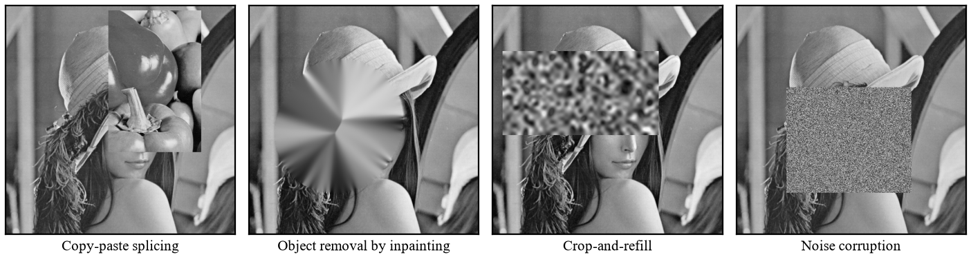
Fig. 2.1: The four tamper classes applied to a watermarked image, shown here at a 30% tamper ratio.
Several exclusions are equally deliberate. Video and audio are excluded because the block grid, the capacity budget and the ground-truth masks are defined on a single frame. Robustness to lossy re-encoding, resizing, rotation or filtering is excluded because the scheme is fully fragile by design: a watermark that survived such operations would also survive a malicious edit that mimics them. Adversaries holding the secret key are excluded because no active scheme can defend against them. Real-time camera-firmware embedding is an integration task, and competing with learned detectors on accuracy is excluded because the contribution is determinism and auditability.
2.4 METHODOLOGIES OF PROBLEM SOLVING AND EFFICIENCY ISSUES
The image is partitioned into non-overlapping blocks. The two-LSB capacity of each block is split into a keyed authentication tag and a compressed recovery descriptor of a spatially distant partner block chosen by a key-seeded permutation (detail in Chapter 5). Verification recomputes each tag and compares it with the stored value, localizing tampering to mismatched blocks. Recovery rebuilds a flagged block from the descriptor held by its surviving partner, and a flagged block whose partner is also flagged is marked unrecoverable.
The scheme is single-pass. The tag covers only the six most-significant bit-planes of the block, so writing the payload into the two least-significant planes cannot invalidate what was signed; a scheme whose authentication data depends on the pixels that carry it must iterate until the two agree. Each block costs one keyed hash [20] and one BxB transform, so the total work is O(MN) for an M by N image, with no training. On a commodity AMD x86-64 CPU, single thread and in Python, embedding a 512x512 three-channel image takes 473 ms and verification takes 197 ms, with no GPU. Memory is bounded by the image plus one permutation of K integers, where K is the number of blocks.
The design makes three efficiency trade-offs. The first is block size against localization precision and payload. Moving from B = 8 to B = 4 raises pixel-level precision from 0.9599 to 0.9794, but in-region recovery PSNR falls from 29.63 dB to 26.78 dB, a loss of 2.85 dB. Per-block payload falls from 128 to 32 bits and the tag halves from 32 to 16 bits, so the per-block false-accept probability rises from 2^-32 to 2^-16, an expected 0.25 false accepts per 512x512 image with 16,384 blocks, reported as a finding rather than hidden.
The second is LSB shifting against LSB replacement. A descriptor-carrying pixel is moved to the nearest value whose low bits already match, giving a mean distortion of approximately 0.5 LSB against approximately 1.5 LSB for replacement, at the cost of a more involved embedding routine. Tag-carrying pixels are never shifted, so the verification value is always written exactly as computed: the descriptor tolerates a small perturbation of its carrier pixel, whereas the tag tolerates none.
The third is one-to-one mapping against reference sharing. A one-to-one mapping, in the manner of the distant-mapping idea of [15], is cheap and analyzable, since the recoverability rate has a simple structural bound, but recovery fails all-or-nothing per block. Reference-sharing [11] and fountain-coded [12] schemes degrade more gracefully and reach higher whole-image reconstruction at high tamper ratios. The project accepts that cost knowingly and names reference sharing as its principal upgrade.

CHAPTER 3
PROJECT PLAN
3.1 PROJECT ESTIMATES
The project is a research-and-implementation effort whose principal deliverable is a working codebase together with a measured evaluation of it. The estimate is therefore a retrospective basic COCOMO calculation over the code as built, in place of a speculative function-point count, and it is a consistency check on effort, not a prediction. Counting only non-comment, non-blank lines of Python, the codebase measures 9,929 lines across 24 modules, which is 9.929 KLOC. Table 3.1 groups these lines by module role.
Table 3.1: Measured size of the implementation, by module group
Module group | Modules | Lines (non-comment, non-blank)
Core scheme (payload, blockmap, embed, detect, recover) | 5 | 1,478
Experiment harness (tamper, metrics, run_experiments, sanity_gate) | 4 | 1,767
Tables, plots and document builders | 5 | 2,251
Support (imageio_any, fit_variant_c, fountain, test_e2e) | 4 | 910
Applications (Flask web application, Streamlit demonstration) | 3 | 2,248
Presentation builders | 3 | 1,275
Total | 24 | 9,929

The model is basic COCOMO in organic mode, the correct choice because the team is small, the domain well understood, the requirements stable, and there are no hard real-time or rigid interface constraints. With size S in KLOC, effort E in person-months and development time D in months, the constants a = 2.4, b = 1.05, c = 2.5 and d = 0.38 give the following two relations.
E = a x S^b
D = c x E^d
Table 3.2: Basic COCOMO estimate, organic mode (a = 2.4, b = 1.05, c = 2.5, d = 0.38)
Quantity | Relation | Value
Measured size | KLOC | 9.929
Effort | E = 2.4 x KLOC^1.05 | 26.73 person-months
Development time | D = 2.5 x E^0.38 | 8.71 months
Average staffing | E / D | 3.07 engineers
Productivity | KLOC x 1000 / E | 371 lines per person-month

Substituting the measured size, the effort is E = 2.4 x (9.929)^1.05 = 26.73 person-months, and the development time is D = 2.5 x (26.73)^0.38 = 8.71 months. Dividing effort by time gives an average staffing of 26.73 / 8.71 = 3.07, that is, approximately 3 full-time engineers. Productivity is 9,929 / 26.73 = 371 lines per person-month. Table 3.2 collects these figures.
The estimate must be reconciled with the actual team: a four-student group working part-time alongside coursework across two semesters, whereas 26.73 person-months over 8.71 months implies about three people working full time. The two are consistent once part-time availability is accounted for. COCOMO was calibrated on professional projects, so it is used here as an order-of-magnitude check and not as a precise measure of student effort.
The remaining cost picture is non-monetary. Every dependency is open source, no GPU is required, no cloud compute is rented and no paid dataset is purchased, since the corpus comes from the freely available USC-SIPI [22] and Kodak [23] collections. The direct cost is effectively student time and a commodity workstation.
3.2 RISK MANAGEMENT WITH RESPECT TO NP-HARD ANALYSIS
The risk picture depends on the complexity class of the problem. Embedding and verification each perform one keyed hash and one BxB transform per block, plus O(K) work to build and apply the block mapping, where K is the number of blocks. The total is O(MN) time for an M x N image, with no iteration, optimization or training, so the problem is of class P and no NP-hard sub-problem arises anywhere in the pipeline. The full argument is given in Appendix A.
One nuance deserves honest statement. Choosing an optimal descriptor allocation, meaning the assignment of backup descriptors to host blocks that maximizes expected recoverability under arbitrary tamper geometry, is a combinatorial assignment problem, and this work does not solve it optimally. It sidesteps it with a constructive key-seeded permutation that satisfies the separation constraint by construction. With no intractable core, no part of the work depends on a search whose runtime cannot be bounded, which removes the largest schedule risk a research project can carry.
The remaining risks are ordinary engineering and research risks. Table 3.3 records each with its category, probability, impact and mitigation; the ratings are judgments, not measurements. Three either materialized or came close, and are discussed in turn.
Table 3.3: Risk register
Risk | Prob. | Impact | Mitigation and status
Tamper coincidence: a block and its recovery partner destroyed together | High | High | Minimum-separation mapping; the recoverability rate is reported rather than concealed. Structural, accepted and measured.
MSB-preserved miss: an inpainted block whose six most-significant bit-planes are unchanged | Low | Medium | Predicted by the design analysis, observed as 17 blocks across the main grid and disclosed as a soft gate warning.
Result drift between the prose and the measured grid | Medium | High | Every table and figure is generated from the result file; the gate refuses to emit them on a failure.
Capacity exhaustion at small block sizes | Medium | Medium | Bit budget is analytic; the B = 4 ablation reports the halved tag and its false-accept consequence.
Dependency or environment drift breaking reproduction | Medium | Medium | Versions pinned exactly; the corpus is pinned by SHA-256.
Scope creep into robustness or video | Low | Medium | Scope fixed in Chapter 2; the semi-fragile mode is deferred to future work.
Schedule slip from late measurement | Low | High | The full grid was completed in phase 5, before the report was written.

The first is tamper coincidence. A flagged block can be rebuilt only if its partner survives, so when the tampered region covers both a block and its partner, the descriptor is lost. The limit is structural, with expected recoverability near 1 - alpha, and no implementation effort can remove it. The minimum-separation mapping, with d_min = 0.25 x min(M,N), makes it unlikely that one compact region covers both. The recoverability rate rho is disclosed with every result: it runs from 0.9590 at a nominal ratio of 0.10 to 0.3579 at 0.70.
The second is the MSB-preserved-miss block. The tag binds only the six most-significant bit-planes, so a modification that leaves those planes unchanged escapes detection. The design analysis predicted this residual and measurement confirmed it: 17 blocks across the main grid were missed, all under inpainting, which lowers recall for that class to 0.99998. The sanity gate reports it as one of its two soft warnings, and the project documents it instead of hiding it.
The third is result drift, in which a number is copied into the report, the experiment is rerun and the two then disagree. The mitigation is mechanical. Every table is generated from the result file output/runs.csv, and no table or figure is emitted unless the automated gate runs, with 25 of 27 checks passing.
3.3 PROJECT SCHEDULE
The work is organized as ten phases. Phases 1 to 6 and phase 8 are complete. Phase 7, paper preparation and internal review, is in progress. Phase 9, the reference-sharing extension, and phase 10, the final report, demonstration and viva, are planned. The sequence is not strictly linear, since phase 8 was completed while phase 7 remains open and the two are independent. Table 3.4 lists each phase with its activity, deliverable and status.
Table 3.4: Plan of work and status
Phase | Activity | Deliverable | Status
1 | Literature survey and problem formulation | Survey and gap statement | Complete
2 | Scheme design: bit budget, tag construction, block map | Design specification | Complete
3 | Implementation of the core pipeline | Embed, detect and recover modules | Complete
4 | Tamper harness and metrics | Four tamper classes with exact masks | Complete
5 | Full experimental grid and validation | 3,232-row grid; 25 of 27 gate checks | Complete
6 | Applications and adversarial testing | Web application; two defects found and fixed | Complete
8 | Variant C consolidation into the reported grid | Updated tables and figures | Complete
7 | Paper preparation and internal review | IEEE-format manuscript | In progress
9 | Reference-sharing extension | Prototype and comparison | Planned
10 | Final report, demonstration and viva | Report, presentation, demonstration | Planned

Fig. 3.1 presents the same schedule as a Gantt chart, which shows the overlap between phases and the remaining work concentrated at the end. The schedule is deliberately front-loaded: the full experimental grid was completed before the report was written, so every claim in Chapter 7 was measured before it was described. This avoids the familiar failure in which the text is written first and the experiments are bent to fit it.
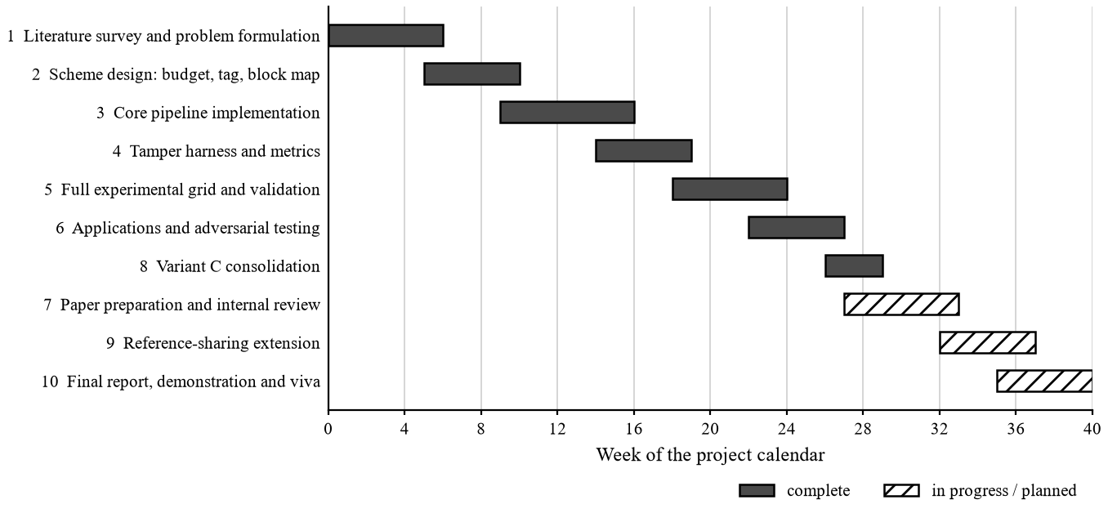
Fig. 3.1: Project schedule. Shaded bars are complete; hatched bars are in progress or planned.
Phase 9 follows from the central finding of the evaluation, that mapping coverage and not descriptor fidelity limits recovery quality. It is planned and not yet started, and its absence does not weaken any measured result here. Phase 10 depends on phase 7, because the demonstration and final report reuse the tables and figures that phase produces.

CHAPTER 4
SOFTWARE REQUIREMENTS SPECIFICATION
4.1 DATABASE REQUIREMENTS
The core scheme is stateless. Verification needs only the received image, the secret key and the image identifier, with no original image, no reference database and no network call, so a third party holding the key can repeat any verdict on an isolated machine. Persistence exists only for the local web application, which keeps a library of protected images for retrieval and re-verification. The library is a single SQLite table named protected, held in the file webapp/library.db. Table 4.1 gives its schema.
Table 4.1: Schema of the protected-image library (SQLite, single table protected)
Column | Type | Purpose
id | INTEGER PK AUTOINCREMENT | Record identifier
name | TEXT NOT NULL | Original file name
created_at | TEXT NOT NULL | Timestamp of protection
height, width | INTEGER NOT NULL | Image geometry
block | INTEGER NOT NULL | Block size used
variant | TEXT NOT NULL | Descriptor variant
key | TEXT NOT NULL | Secret key for this record
key_encrypted | INTEGER NOT NULL DEFAULT 0 | Whether the stored key is encrypted
image_id | BLOB NOT NULL | Image identifier bound into every tag
png | BLOB NOT NULL | The watermarked image itself
sha256 | TEXT NOT NULL | Digest of the stored PNG
psnr, ssim | REAL | Imperceptibility of this record
blocks | INTEGER | Number of blocks carried
deleted_at | TEXT | Soft-delete marker; the row is retained
Indexes | idx_shape (height, width, block); idx_sha (sha256) | Lookup by geometry and by content digest

Each row records one protected image. The columns name, created_at, height, width, block and variant describe it and its protection configuration; image_id holds the identifier bound into every authentication tag, png the protected image as a lossless PNG, and sha256 its digest. The nullable columns psnr, ssim and blocks record quality figures measured at protection time. Two indexes, idx_shape on (height, width, block) and idx_sha on sha256, serve lookups by geometry and by content digest.
One field is security-relevant. The key column stores the secret key beside its image, and the key_encrypted flag, which defaults to zero, records whether it is stored encrypted. Storing the key beside the image is acceptable only for a single-user local demonstration, where the person who protects an image is the person who verifies it and the database file never leaves the machine. In any deployment the key would have to move to an external key store, because anyone able to read the database could re-embed a forged image. This limits the demonstration application, not the scheme.
Retention is soft. The deleted_at column is null for a live record and holds a timestamp once the user deletes it, so a record can still be audited after removal; the stored image bytes therefore persist after deletion, a privacy consideration beyond the demonstration. Nothing else depends on the database, and losing the file does not affect verification of any exported image whose key is known.
4.2 SOFTWARE REQUIREMENTS (PLATFORM CHOICE)
The platform keeps the trust path short and the evaluation reproducible. Python is the implementation language because the scientific stack lives there and its standard library supplies hashlib, hmac and struct, so the keyed SHA-256 construction [20] is computed, and the payload bits packed, with no third-party cryptographic dependency. The minimum interpreter version is Python 3.10. An auditor therefore has one fewer package to review before trusting a positive detection, which is the property the scheme exists to provide.
NumPy 2.1.2 provides the vectorized block arithmetic on which the per-block cost depends. OpenCV-headless 5.0.0.93 and scikit-image 0.26.0 supply the transforms and the SSIM implementation [21], and Pillow 10.4.0 handles lossless formats such as PNG, BMP and TIFF without re-encoding. Matplotlib 3.11.1 draws the evaluation figures. No library performs any part of the authentication.
Flask serves the local web application because it is small enough to audit in full, which matters for a tool holding secret keys. Streamlit 1.61.1 provides the demonstration interface over the same pipeline. SQLite stores the library because the requirement is one table on one machine, and a heavier database would add attack surface without adding any capability this project uses.
Every dependency version is pinned exactly so that the grid reproduces on another machine, as every corpus file is pinned by SHA-256. No machine-learning framework appears in the stack and the scheme has no trained parameters, which is what allows any verdict to be repeated bit for bit. Table 4.2 lists the software requirements with their roles.
Table 4.2: Software requirements
Category | Requirement
Language | Python 3.10 or later. Cryptographic primitives from the standard library (hashlib, hmac, struct); no third-party cryptography on the trust path.
Core libraries | NumPy 2.1.2, OpenCV-headless 5.0.0.93, scikit-image 0.26.0, Pillow 10.4.0 - pinned exactly.
Interface libraries | Flask (web application); Streamlit 1.61.1 (demonstration interface); Matplotlib 3.11.1 (figures).
Storage | SQLite, for the local protected-image library.
Document build | tectonic and pandoc, optional, only to rebuild the manuscript.
Machine learning | None. No framework, no trained parameters, no model weights.
Operating system | Platform independent; developed and tested on Windows.

4.3 HARDWARE REQUIREMENTS
The scheme needs any commodity x86-64 or ARM CPU and runs on a single thread. No GPU or other accelerator is used at any stage, including evaluation. Memory is bounded by the image itself plus one permutation of K integers, where K is the number of blocks, which is 4,096 for a 512x512 image at B = 8. Disk is needed only for the corpus and result grid, a few gigabytes in all.
Runtimes were measured on a commodity AMD x86-64 CPU, single thread, for a 512x512x3 image. Embedding takes 473 ms and verification takes 197 ms, less than half of embedding. These interpreted-implementation figures are reported as measured, not as a limit on the scheme. Table 4.3 summarizes the hardware requirements.
Table 4.3: Hardware requirements
Category | Requirement
Processor | Any commodity x86-64 or ARM CPU, single-threaded.
Accelerator | None. No GPU is required at any stage.
Memory | Bounded by the image plus one permutation of K integers; under 1 GB for the evaluation corpus.
Storage | A few gigabytes for the 32-image corpus, the 3,232-row result grid and the generated figures.
Measured runtime | 512 x 512 x 3 image on a commodity AMD x86-64 CPU: embedding 473 ms, verification 197 ms.
Network | None. Verification makes no network call.

The scheme can therefore run inside an embedded capture device or a hospital gateway, where a learned detector cannot: it needs a trained model and usually a GPU, which fit neither a camera body nor a clinical network appliance. A deterministic scheme with a few hundred milliseconds of single-thread work per image fits both, and a gateway or an auditor can check images with the key alone on an ordinary laptop, with no inference runtime.
4.4 ANALYSIS MODELS: SDLC MODEL TO BE APPLIED
The project follows an incremental and iterative model, not a waterfall, for an empirical reason. The payload design, the mapping construction and the descriptor variants were each validated against measurement before the next increment was built, and two defects found during adversarial testing of the web application fed back into the core library. Seven increments were delivered in sequence, each adding one capability to a pipeline that already ran end to end.
- Core payload and tag: key derivation, bit budget, MSB projection, the keyed tag and the descriptor encoding.
- Block mapping: the key-seeded single-cycle permutation with minimum-separation repair.
- Embedding and detection: LSB packing with shifting, and tag recomputation with block localization.
- Recovery: rebuilding flagged blocks from surviving partners and reporting the recoverability rate.
- Tamper harness and metrics: four tamper classes with exact ground-truth masks.
- Full grid and automated gate: the complete experiment and the sanity checks on its output.
- Applications: the Flask web application and the Streamlit demonstration interface.
Every increment ends in a runnable end-to-end test, and none is complete until the sanity gate runs clean on the results it produces. A finding from the harness or the gate returns to the earlier increment that caused it, which is corrected and re-verified before work moves forward. Fig. 4.1 shows the model as applied here.
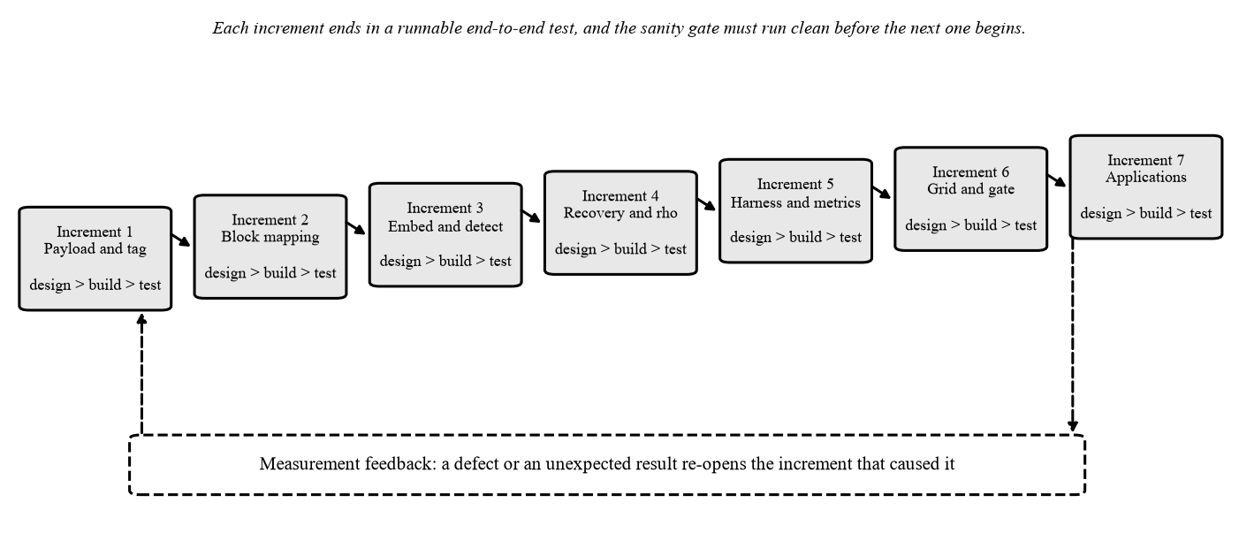
Fig. 4.1: The incremental model as applied: each increment carries its own design, build and test cycle, and measurement feeds back into the increment that caused a defect.
A waterfall sequence would have served this project badly, discovering the tamper coincidence behavior only at the end, when the mapping design could no longer be changed. Under the incremental model it appeared while the mapping and recovery increments were still open, which is why the minimum-separation repair pass and the disclosure of the recoverability rate are part of the design and not afterthoughts.

CHAPTER 5
SYSTEM DESIGN
5.1 SYSTEM ARCHITECTURE
The system is organized as four decoupled stages. Stage one is embedding, which runs at or near acquisition and turns an original image into a watermarked one. Stage two is distribution, during which the image may be stored, copied, transmitted and, in the adversarial case, tampered with; the harness simulates it with four tamper classes and exact ground-truth masks. Stage three is verification and localization, which any party holding the key can run at any later time. Stage four is recovery, which repairs flagged content where the surviving watermark allows. The stages communicate only through the image and a block mask, so each can be developed, tested and replaced independently. Stages one, three and four depend on the key; distribution needs no cooperation from the system, so an image can travel through ordinary channels provided they are lossless.
The decisive property of the architecture is what stage three does not need. Verification requires only the received image, the secret key and the image identifier: no original image, no reference database, no network call and no model weights. Every positive detection reduces to one recomputed keyed hash compared against a stored value, so a third party holding the key can repeat the decision bit for bit. This is the practical advantage of an active scheme inside an institutional custody chain.
Fig. 5.1 shows the data path. The upper row embeds: the original image I passes through block partition, descriptor encoding, the key-seeded block map and the keyed tag (HMAC) to give the watermarked image Iw. The lower row verifies and recovers: the received image I' passes through LSB extraction, tag recomputation and the tamper mask, then the recovery engine. A dashed path from Iw to I' represents distribution, and the key and identifier feed the block map and the tag.
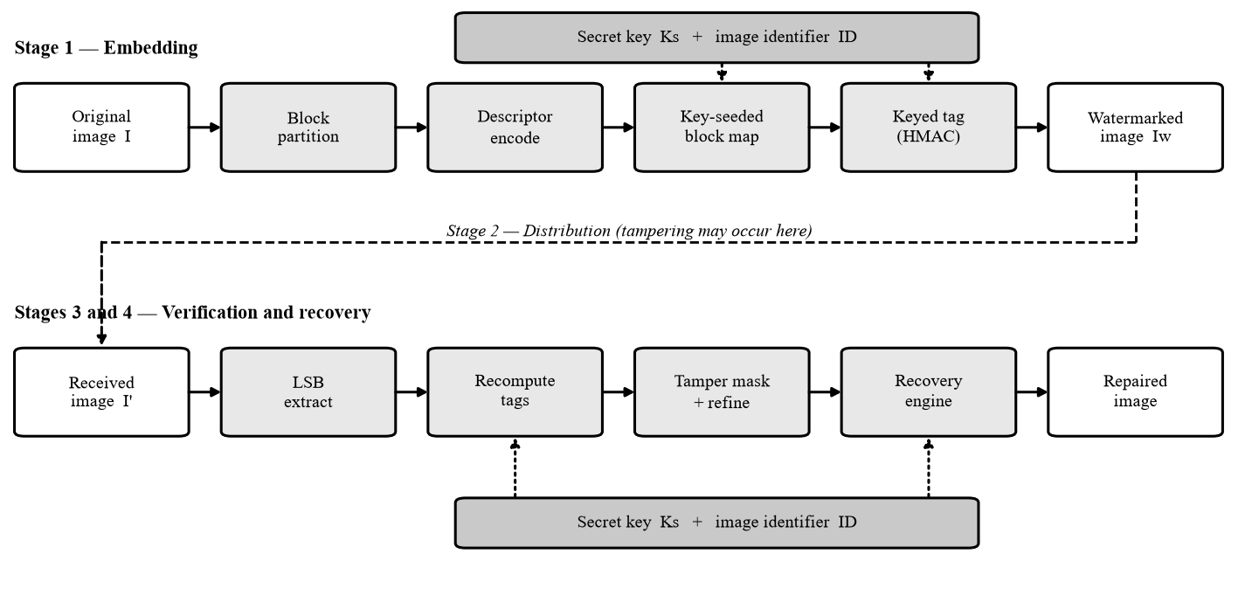
Fig. 5.1: System architecture. The key and the image identifier seed both the block map and the tag; the dashed path carries the distributed image, which may be tampered before verification.
The software mirrors this decomposition. The payload module is the foundation imported by all others, holding key derivation, the bit budget, the MSB projection, tag computation, descriptor coding and LSB packing. The blockmap module builds the key-seeded permutation, the embed, detect and recover modules implement stages one, three and four, and sanity_gate validates the grid that run_experiments produces before any table or figure is built; tamper and metrics support evaluation. Two applications sit over the same pipeline: a Flask web application with a SQLite library, and a Streamlit demonstration interface. Table 5.2 summarizes the responsibilities.
Table 5.2: Functional modules and their responsibilities
Module | Responsibility
payload | Key derivation, bit budget, block geometry, MSB projection, tag computation, descriptor encode and decode, LSB packing. Imported by every other module.
blockmap | Builds the key-seeded single-cycle permutation, enforces the minimum separation, verifies R1 to R3.
embed | Stage 1. Computes descriptors, permutes them, computes the binding tags, writes both into the two LSB planes.
detect | Stage 3. Extracts the payload, recomputes tags, produces and refines the block-level tamper mask, expands it to a pixel mask, exposes a per-block audit record.
recover | Stage 4. Splits the flagged set into recoverable and unrecoverable, rebuilds from partner descriptors, marks the rest, reports rho.
tamper | Generates the four tamper classes with exact ground-truth masks and the achieved ratio.
metrics | PSNR, SSIM, confusion counts, localization scores, in-region recovery metrics.
run_experiments | Executes the full grid and writes the result file.
sanity_gate | Validates the result grid against expected bands and refuses to emit tables or figures on any failure.
Applications | A local Flask web application over SQLite and a Streamlit demonstration interface, both over the same core library.

5.2 MATHEMATICAL MODEL
Let I in {0,...,255}^(MxN) be the host image, Ks the secret key and ID an image identifier. The image is partitioned into non-overlapping BxB blocks in raster order, and b_i denotes the i-th block for i = 0,...,K-1, with c(i) its center coordinate. Dimensions that are not a multiple of B are cropped rather than padded, so no synthetic content is ever authenticated. The model follows the order of use: bit budget, projection, mapping, descriptor, tag, and finally recoverability and cost.
The first quantity is block capacity. Two bit-planes of B^2 pixels give 2B^2 bits, of which the tag takes at most half and the descriptor the rest.
cap(B) = 2B^2, t(B) = min(32, cap(B)/2), d(B) = cap(B) - t(B)
At B = 8 the triple (capacity, tag, descriptor) is (128, 32, 96) bits. At B = 4 the capacity falls to 32 bits and the tag shrinks accordingly, which is the cost of finer localization examined in the ablation. Table 5.1 gives the per-block budget, and Fig. 5.2 shows how the 128-bit payload is divided into a 32-bit authentication tag and a 96-bit recovery descriptor. The descriptor in turn consists of 12 quantized DCT coefficients of 8 bits each, and the whole payload is written into the two least-significant bit-planes of the block's 64 pixels.
Table 5.1: Per-block bit budget
Block size B | cap(B) = 2B^2 | Tag t(B) | Descriptor d(B) | Tag false-accept probability
8 (main) | 128 bits | 32 bits | 96 bits | 2^-32
4 (ablation) | 32 bits | 16 bits | 16 bits | 2^-16

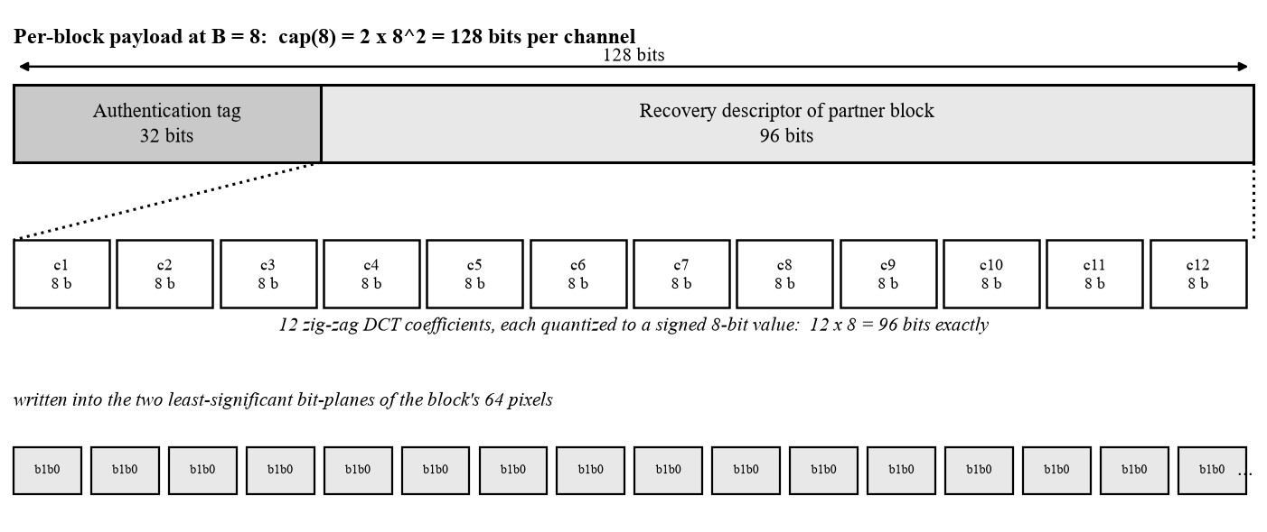
Fig. 5.2: Per-block payload layout at B = 8.
A most-significant projection separates what is signed from what is overwritten.
MSB(a) = a AND 0xFC
The projection zeroes the two least-significant bits of a pixel value and is idempotent. Embedding writes only to those two bit-planes, so it cannot alter the content that the tag was computed over. That is what makes the scheme single-pass: no embed-and-verify loop is needed, and the tag computed before embedding is the tag verification will recompute afterwards.
The block map decides which block carries which descriptor, and must satisfy three requirements.
(R1) m bijective; (R2) ||c(i) - c(m(i))||_2 >= d_min; (R3) m is a single K-cycle
The separation is d_min = (1/4) min(M, N). R3 is obtained by construction, not rejection sampling. A cryptographically seeded Fisher-Yates shuffle produces a cycle order of the K blocks, and m is read off that order directly, sending each block to its successor in the cycle. Fixed points and mutual pairs are therefore impossible, and bijectivity holds without a check. A repair pass then enforces R2 by exchanging offending positions, after which all three properties are verified. Fig. 5.3 illustrates the result.
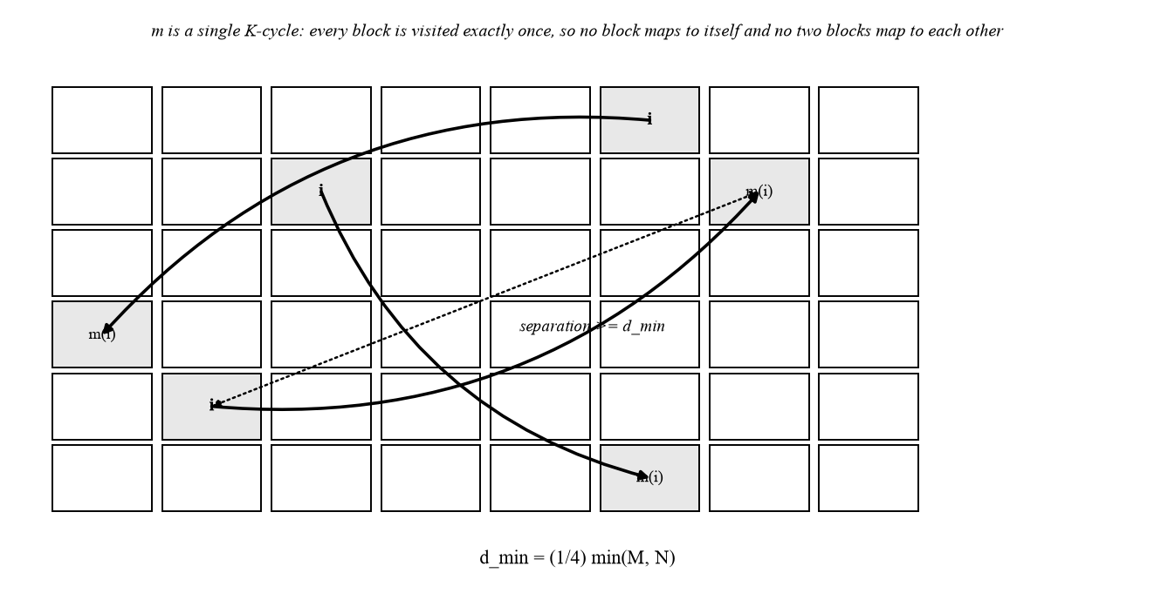
Fig. 5.3: The key-seeded block mapping i -> m(i).
The descriptor is a low-frequency summary of the block's projected content. For Variant A it is the quantized leading portion of the transform.
q_hat(i,l) = clip( round( C_i(sigma(l)) / Delta_l ), -128, 127 ), l = 1,...,12
Here C_i is the orthonormal two-dimensional DCT of the level-shifted projected block, sigma(l) is the zig-zag index and Delta_l the step size of band l. No retained coefficient can clip. By the Cauchy-Schwarz inequality the magnitude of any coefficient is at most 1024 at B = 8, and every step size is large enough that the quantized magnitude stays inside the signed 8-bit range. Variant C uses the same 96-bit layout with an adaptive, rate-distortion-fitted allocation.
Authentication binds the block's content, its position and the descriptor it carries.
a_i = Trunc_32( HMAC-SHA256_Ks( ID || i || MSB(b_i) || r_{m^-1(i)} ) )
The primitive is HMAC over SHA-256 [20], truncated to 32 bits. Each bound field answers a specific attack. MSB(b_i) makes the tag independent of the bits embedding will write, so the tag survives its own insertion. The block index i and the identifier ID defeat the collage attack of [7], in which blocks from different positions or different images are recombined because each block is authenticated in isolation. The last field, r_{m^-1(i)}, is the descriptor this block physically carries on behalf of another block; binding it prevents an attacker from replacing recovery data without detection, since any substituted descriptor changes the recomputed tag.
Recovery quality is summarized by the recoverability rate. With T the flagged set and U the subset of T whose partner is itself flagged,
rho = 1 - |U| / |T|, U = { i in T : m(i) in T }
A flagged block is unrecoverable exactly when the block carrying its descriptor is also flagged. If the position of m(i) were independent of the tampered region, that probability would equal the tampered fraction alpha, giving the structural bound E[rho] approximately 1 - alpha. The bound is a baseline of the one-to-one allocation, not a guarantee, and the evaluation chapter compares it with measured values.
Finally, the cost of the scheme is linear in the image size.
T(M,N) = O(MN)
Embedding and verification each need one keyed hash and one BxB transform per block, plus O(K) work to build the mapping. There is no iteration, optimization or training, and no NP-hard sub-problem arises anywhere in the pipeline, so the problem is of class P. Memory is likewise proportional to the image; the only whole-image quantity is the permutation.
5.3 DATA FLOW DIAGRAMS
The data flow diagrams decompose the system from its external boundary down to the detector and the recovery engine, each level refining the one above under the same names. The secret key is an input supplied by the user at each operation, not data owned by the pipeline.
5.3.1 Level 0 (Context Diagram)
Fig. 5.4 treats the whole system as one process, the Watermark-Guided Tamper Localization and Recovery System, with two external entities. The Content Owner supplies an original image and a key and receives the watermarked image; the Verifier supplies a received image and a key and receives a tamper map, a repaired image and an audit record. A single data store, D1 Protected Image Library, holds the protected images.
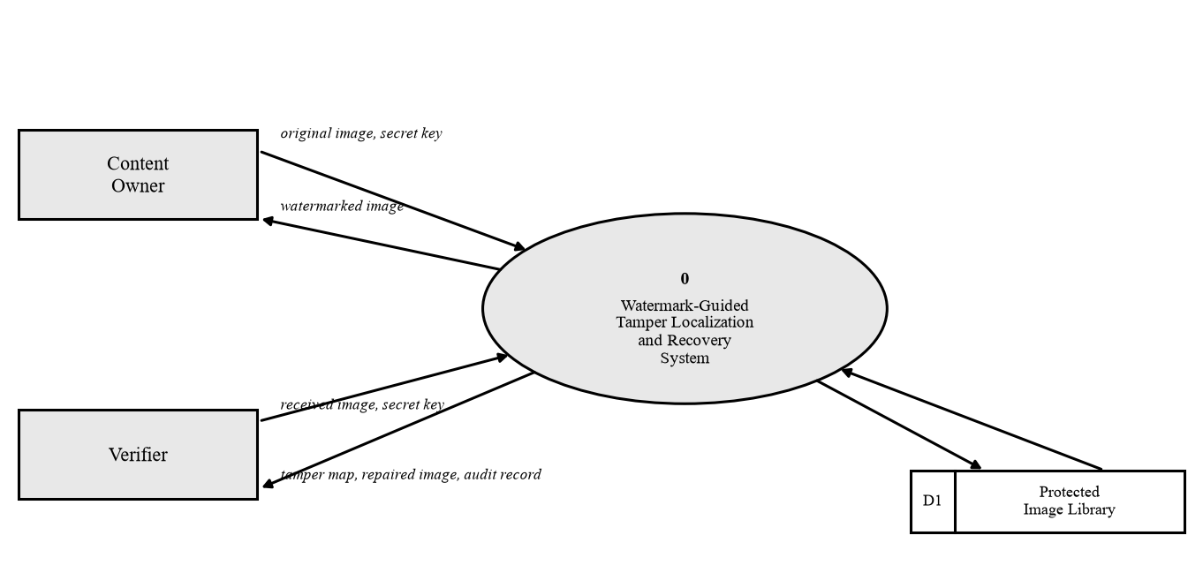
Fig. 5.4: Data flow diagram, Level 0 (context diagram).
5.3.2 Level 1
Fig. 5.5 opens the single process into four: 1.0 Embed Watermark, 2.0 Store and Distribute (into D1), 3.0 Verify and Localize, and 4.0 Recover Content. The key and identifier enter 1.0, 3.0 and 4.0, the block mask passes from 3.0 to 4.0, and the audit record leaves 3.0 toward the Verifier.
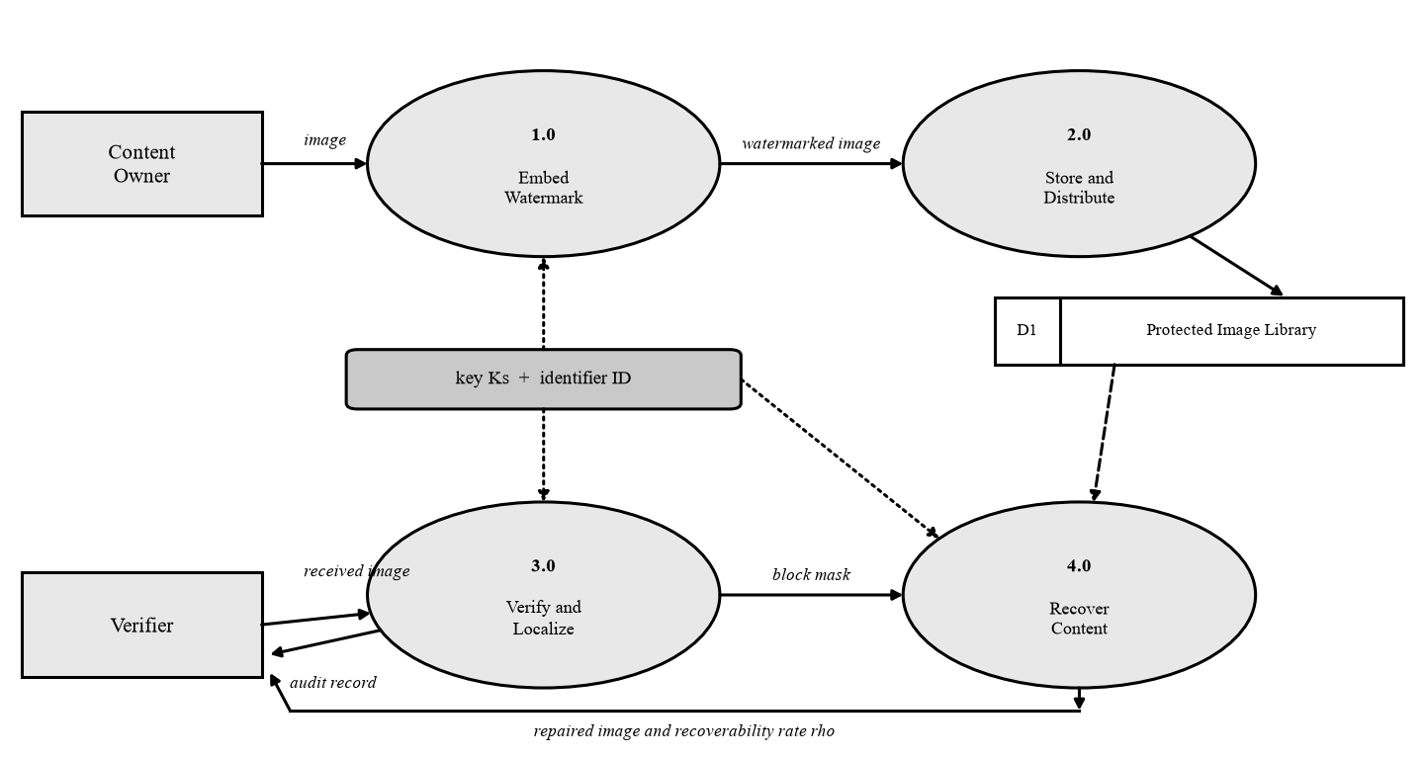
Fig. 5.5: Data flow diagram, Level 1.
5.3.3 Level 2
Fig. 5.6 decomposes 3.0 and 4.0 into 3.1 Extract LSB Payload, 3.2 Recompute Tags, 3.3 Compare and Build Block Mask, 3.4 Refine and Expand to Pixel Mask, 4.1 Partition Flagged Set, 4.2 Decode Partner Descriptor, 4.3 Write Recovered Pixels and 4.4 Mark Unrecoverable Blocks. Tags are compared per channel and combined by an OR rule, so a tamper touching any single channel flags the block. Refinement examines each unflagged block whose neighbors are mostly flagged, with a threshold that scales with the number of valid neighbors, so border blocks are not penalized. Flagged blocks with an intact partner are rebuilt from its descriptor; those whose partner is also flagged are marked explicitly, never inpainted and never left in place silently, so a viewer can always tell reconstructed from unrecovered content.
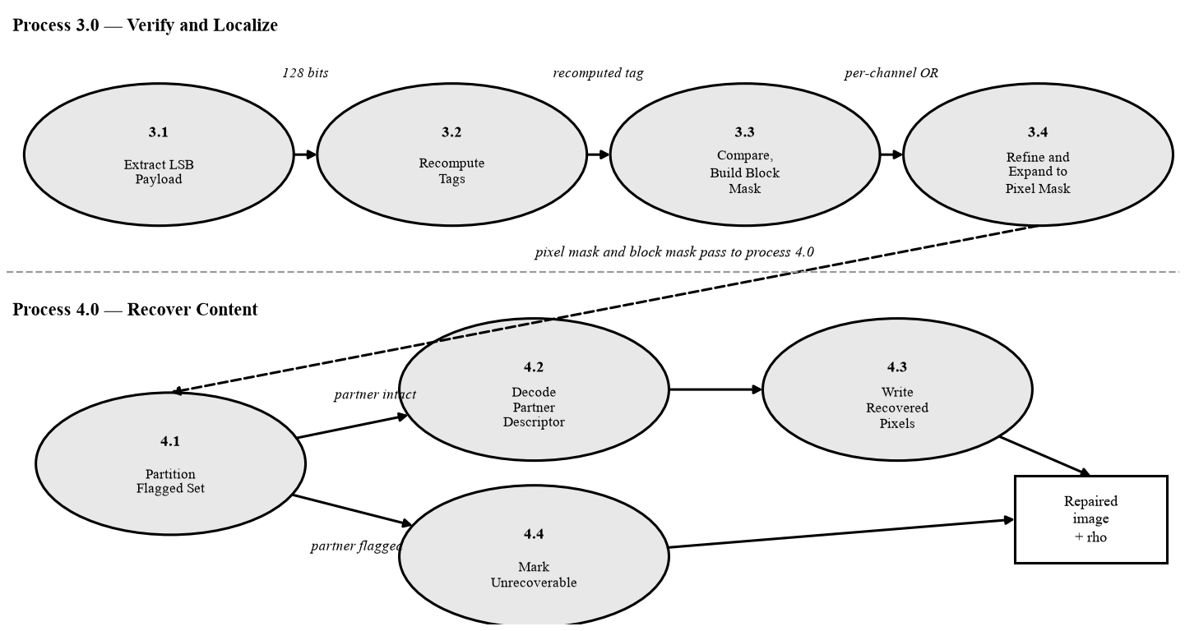
Fig. 5.6: Data flow diagram, Level 2: decomposition of processes 3.0 and 4.0.
5.4 ENTITY RELATIONSHIP DIAGRAM
Fig. 5.7 shows the data model. The central entity is PROTECTED_IMAGE, with primary key id. Its attributes record the image and its protection configuration, the key with an encryption flag, the image bytes and content hash, the quality scores and a soft-deletion timestamp. In the implementation it is a single SQLite table with indexes on the image shape and on the hash.
Two further entities are drawn and marked conceptual. VERIFICATION_EVENT is related to PROTECTED_IMAGE one-to-many, since an image is embedded once under one key but may be checked repeatedly by different parties; KEY_PROFILE is related many-to-one, since many images may share one key. Only PROTECTED_IMAGE is persisted in the current build. The conceptual entities are drawn because an archive or ingest deployment would need a record of each verification and a managed key store, not because the software provides them: verification results are returned and not stored, and keys are held as an attribute of the image record.
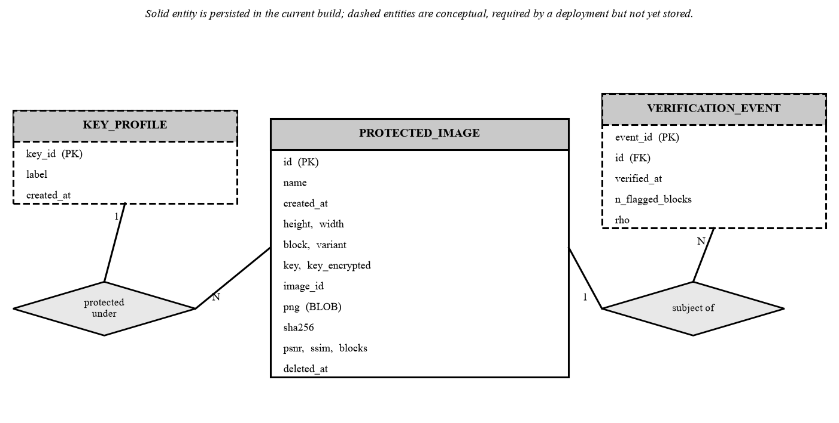
Fig. 5.7: Entity-relationship diagram of the protected-image library.
5.5 UML DIAGRAMS
5.5.1 Use Case Diagram
Fig. 5.8 models three actors, the Content Owner, the Verifier and the Administrator, and the operations each may invoke. Repair Image extends Verify Image, since repair is only offered after verification has flagged blocks.
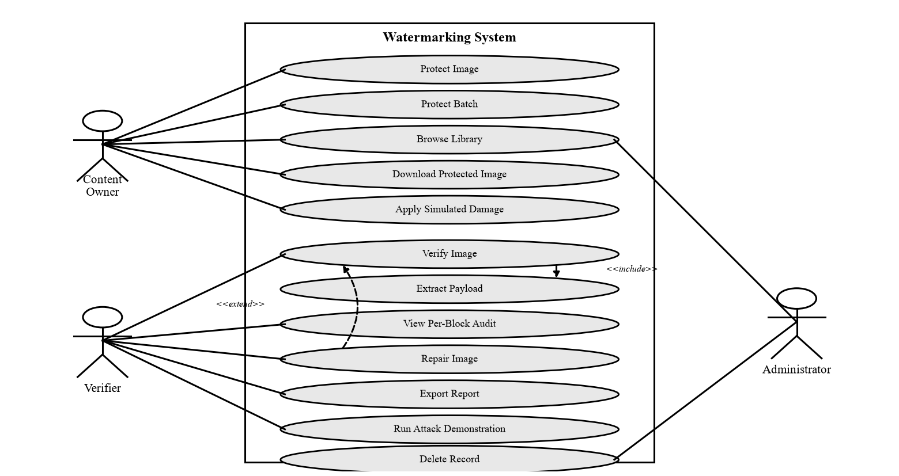
Fig. 5.8: Use case diagram.
5.5.2 Class Diagram
Fig. 5.9 presents the principal classes. PayloadCodec and BlockMap form the foundation on which both Embedder and Detector depend, and RecoveryEngine consumes the DetectResult that Detector returns. TamperHarness, Metrics, ImageIO and LibraryStore support evaluation, file handling and persistence.
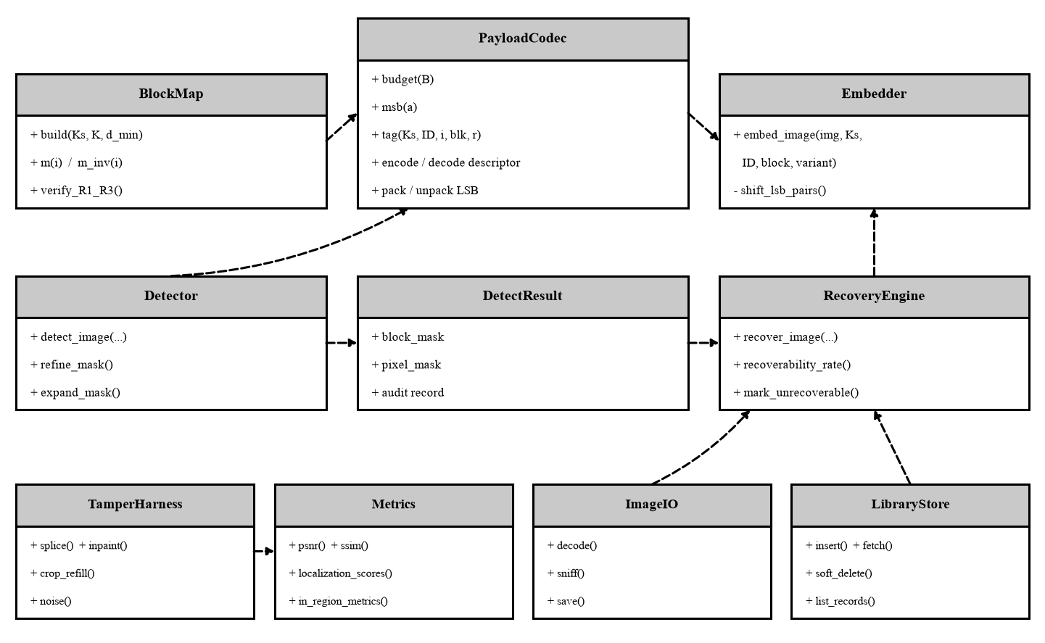
Fig. 5.9: Class diagram. Dashed arrows are dependencies and point at the class whose operations are used.
5.5.3 Sequence Diagram
Fig. 5.10 follows one round trip through the web application, from upload through embedding, storage, simulated damage, verification and repair. The recoverability rate is returned to the user with the repaired image.
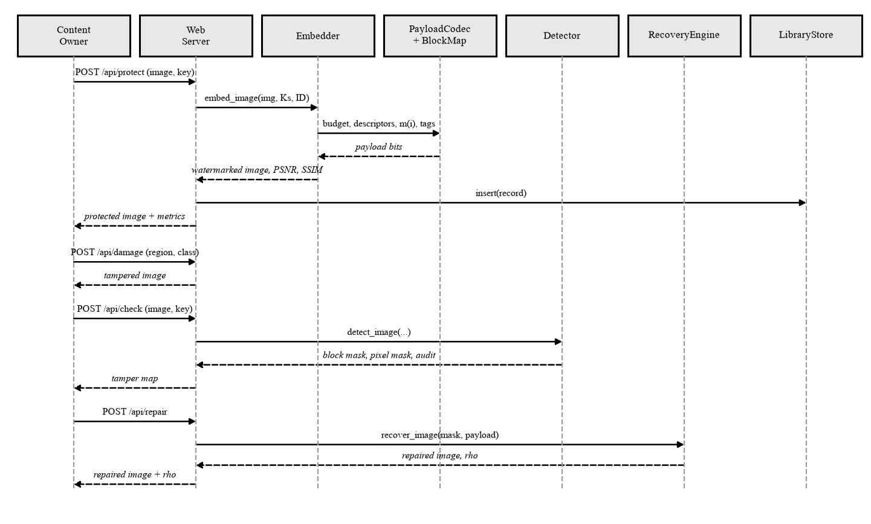
Fig. 5.10: Sequence diagram for the protect, damage, verify and repair round trip.
5.5.4 Activity Diagram
Fig. 5.11 shows verification and recovery as an activity flow with two decision nodes, one testing whether each block's recomputed tag matches and one whether a flagged block's partner is intact. An intact partner leads to reconstruction and a flagged partner to an unrecoverable mark.
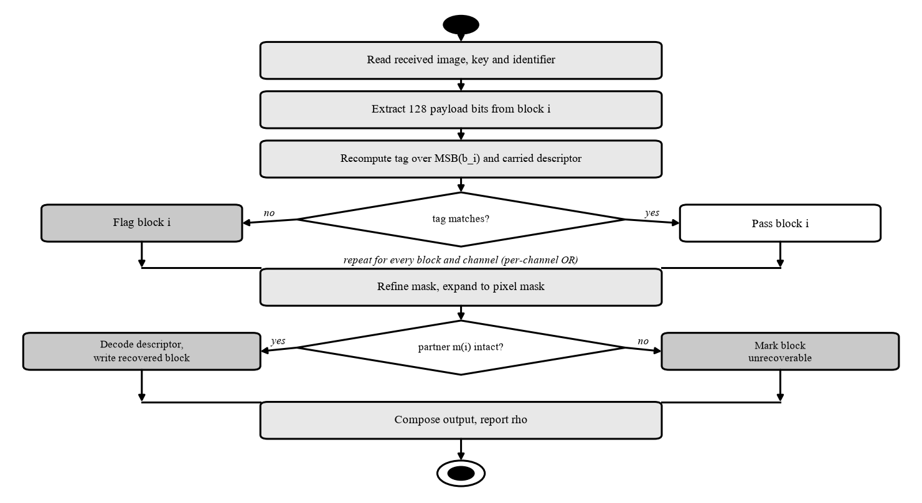
Fig. 5.11: Activity diagram for verification and recovery.
5.5.5 State Machine Diagram
Fig. 5.12 describes the lifecycle of an image through eight states: Unprotected, Protected, Distributed, Under Verification, Authentic, Tampered, Recovered and Archived. Verification leads to Authentic when no block is flagged and otherwise to Tampered, which repair moves to Recovered, and either outcome may end in Archived.
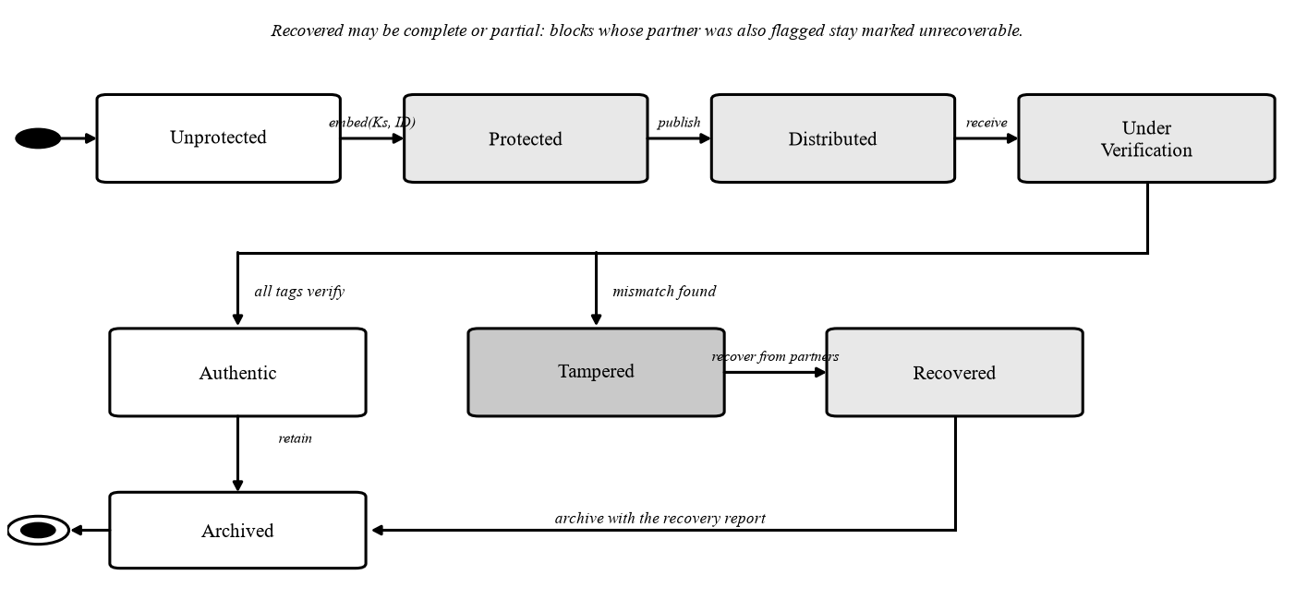
Fig. 5.12: State machine diagram: the lifecycle of a protected image.
5.5.6 Component Diagram
Fig. 5.13 groups the software into components with provided and required interfaces. The Core Library provides the embedding, detection and recovery interfaces, which the Experiment Harness, the Flask Web Application and the Streamlit Demonstration Interface all require, so no application has its own copy of the algorithm. The web application also requires the SQLite Library.
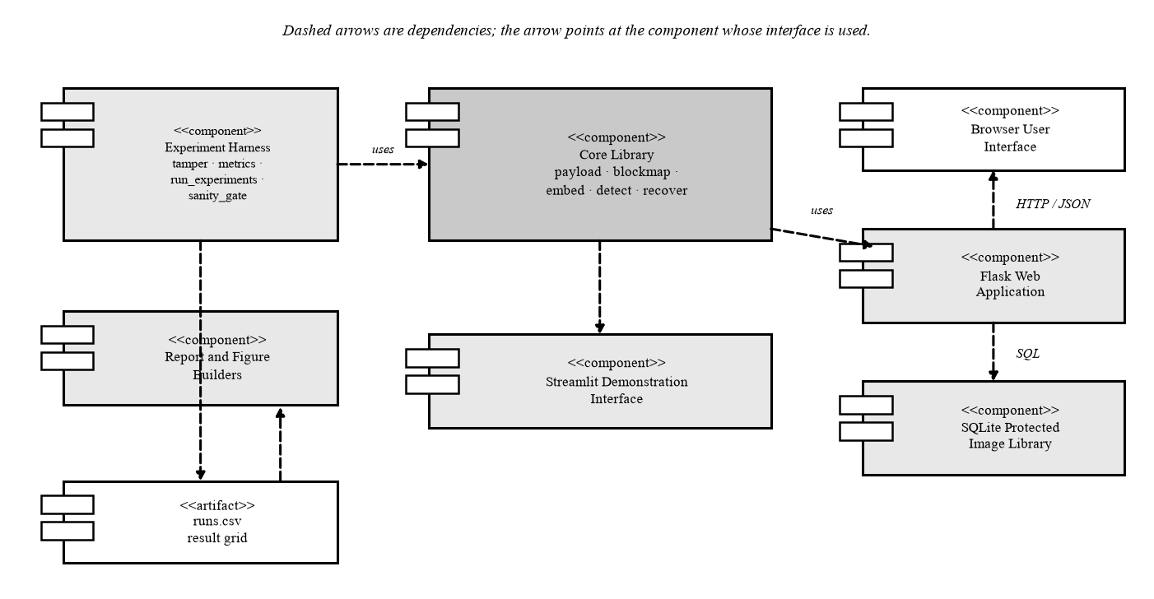
Fig. 5.13: Component diagram.
5.5.7 Deployment Diagram
Fig. 5.14 shows a deployment on a single commodity workstation hosting the core library, Flask server, SQLite file and browser client, plus an offline experiment-harness node that produces the result grid. No server, accelerator or network service is required, which matches a locally controlled custody chain.
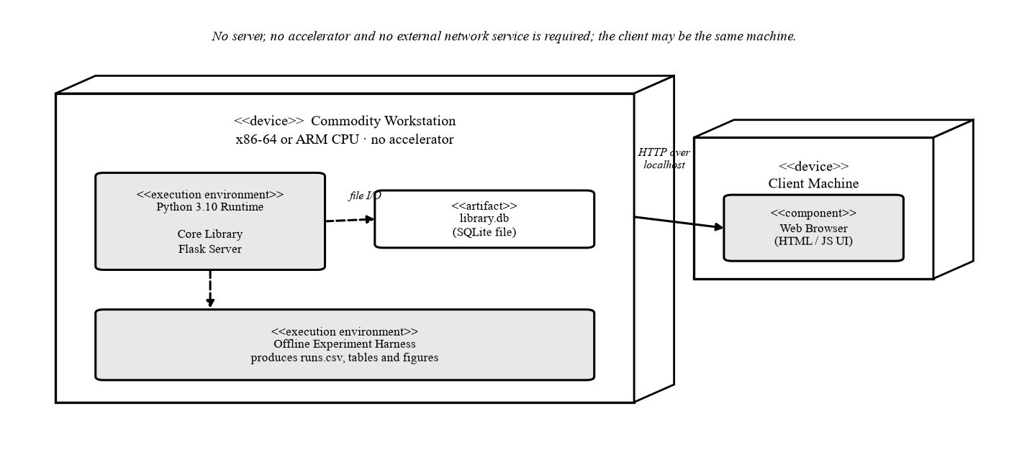
Fig. 5.14: Deployment diagram.

CHAPTER 6
OTHER SPECIFICATION
6.1 ADVANTAGES
The advantage that matters most is auditability. Every positive detection reduces to a single recomputed keyed hash comparison: the verifier extracts the stored 32-bit tag from a block's two least-significant bit-planes, recomputes HMAC-SHA256 [20] over its six most-significant bit-planes, the image identifier, the block index and the partner block's descriptor, and compares the two. Any third party holding the key can repeat that bit for bit, with no training data, accelerator or run-to-run variance, which an evidentiary application requires and a learned detector, whose decision is a score from a trained network [17], cannot offer.
Determinism extends to the whole evaluation. Embedding, verification and recovery contain no iteration, optimization or random initialization beyond the key-seeded permutation, so the 3,232-row grid reproduces exactly on the same pinned corpus. At one keyed hash and one block transform per block, the scheme is in problem class P with O(MN) cost. A disagreement between two verifiers can therefore only come from a different key, a different image or a defect, never from chance. The null-condition result is likewise reproducible across five independent keys, two descriptor variants and thirty-two images, and the corpus is pinned by SHA-256 so an examiner can rebuild it exactly.
Secondary advantages are listed below.
- Self-containment: verification needs only the received image, the key and the image identifier.
- No accelerator: 473 ms to embed and 197 ms to verify a 512x512 colour image on a commodity single-thread CPU.
- Measured imperceptibility: mean PSNR of 45.479 dB for Variant A and 45.492 dB for Variant C, with a minimum SSIM of 0.97831 over the whole B = 8 set.
- Exact block-granularity localization: block-level recall of 1.0000 for three tamper classes and 0.99998 for inpainting, with no false-positive block in 1,802,240 null-condition verifications.
- Honest recovery: regions whose partner block was also destroyed are marked unrecoverable, not filled with fabricated content.
- Analytic predictability: the recoverability rate has a closed-form structural bound, 1 - alpha, against which every measurement can be checked.
6.2 LIMITATIONS
Each limitation is classed as structural, following from this scheme's design choices, or as an engineering gap, closable within the same design, and names where Chapter 7 proposes a remedy.
- Full fragility is structural: any lossy re-encode, resize or filter destroys the watermark, so only images inside a lossless custody chain are protected. Section 7.3 proposes a semi-fragile mode tolerant of benign JPEG re-encoding.
- One-to-one backup allocation is structural and fails all-or-nothing per block, whereas reference-sharing [11] and fountain-coded [12] schemes degrade gracefully and reach far higher whole-image reconstruction at high tamper ratios. Section 7.3 names reference sharing as the highest-value upgrade.
- Recovery is a structural low-frequency approximation from 12 DCT coefficients, not the original block. Section 7.3 addresses this through the same allocation change, which raises coverage.
- Pixel-level precision is capped by block quantization at 0.9599 for B = 8, a structural limit that cannot improve without a finer grid. Section 7.3 proposes hierarchical grids.
- The two highest tamper ratios are an engineering gap: the region generator cannot reliably place one compact region over 60 to 70 percent of a frame, so they are nominal only, at achieved values of 0.573 and 0.653. No scheme change is needed, and Chapter 7 proposes none.
- At B = 4 the tag halves to 16 bits, a structural trade-off raising the per-block false-accept probability from 2^-32 to 2^-16, about 0.25 expected false accepts per 512x512 image. Section 7.3 proposes finer grids avoiding the full tag cost.
- Security rests entirely on key secrecy, which is structural: an adversary holding the key can re-embed a forged image. Section 7.3 proposes a formal security proof of the keyed construction.
- Capacity is fixed and structural: the two LSB planes of a 512x512 colour image hold 1,572,864 bits, or 192 KB. Section 7.3 proposes hierarchical grids to spend it more efficiently.
6.3 APPLICATIONS
The scheme fits applications in which an image is captured once, stored losslessly and may later be challenged. A forensic evidence archive is the clearest case: the keyed tag makes every stored image a self-verifying record, and the per-block audit trail shows which blocks failed. Media authentication at ingest uses the same property, with an organization marking an image as it enters its asset system and verifying it at each reuse. Both depend on determinism, since a result must be repeatable by a party who did not run the original check.
Medical imaging integrity in a picture archiving and communication system (PACS) fits because lossless containers are already the norm for diagnostic images and localization says which region of a scan was altered. Legal and official document scans fit because a scan is produced once under controlled conditions, and a tamper that changes a figure or a signature is localized and, where the partner block survives, partly reconstructed. Insurance claim verification benefits from needing no accelerator, since a claims office can verify photographs on ordinary hardware.
Self-authenticating camera or scanner firmware is the most direct deployment, because embedding at capture removes any gap between acquisition and protection and the firmware carries no trained parameters to maintain or certify. All six domains share the precondition that makes an active scheme viable: an acquisition pipeline under institutional control. An image found on the open internet cannot be protected retroactively, because the watermark must be present before the tampering occurs.

CHAPTER 7
CONCLUSIONS AND FUTURE WORK
7.1 RESULTS OBTAINED TO DATE
The evaluation grid holds 3,232 rows in output/runs.csv. The main grid contributes 1,792 (32 images, four tamper classes, seven nominal tamper ratios from 0.10 to 0.70, two descriptor variants, A and C, at B = 8), the null condition 320 (32 images, two variants, five keys), and the remaining 1,120 are ablations covering B = 4 and Variant B. The 32 colour images, 8 from USC-SIPI [22] and 24 from the Kodak suite [23], are pinned by SHA-256. An automated gate passes 25 of 27 checks; the two soft warnings are the inpainting MSB-preserved-miss category and three rows with slightly elevated coincidentally unchanged pixels.
7.1.1 Imperceptibility
Over the 32-image corpus Variant A reaches a mean PSNR of 45.479 dB and a mean SSIM [21] of 0.98847, and Variant C 45.492 dB and 0.98841. The minimum SSIM over the whole B = 8 set is 0.97831, so no image is visibly degraded. The weakest named image is Tiffany at 44.07 dB for Variant A, against 45.64 to 45.73 dB for the other named images (Table 7.1).
Table 7.1: Imperceptibility of watermarked images (32-image corpus, B = 8, LSB shifting)
Descriptor variant | Mean PSNR (dB) | Mean SSIM | Minimum SSIM
Variant A (DCT, 12 coefficients) | 45.479 | 0.98847 | 0.97831
Variant C (adaptive DCT, main default) | 45.492 | 0.98841 | 0.97831
AuSR1 [13], as published | 45.57 | approx. 0.99 | -

AuSR1 publishes 45.57 dB [13]; the measured 45.479 dB for Variant A is within 0.1 dB of it. LSB shifting, which moves a descriptor-carrying pixel to the nearest value whose low bits already match, closes most of the gap to plain replacement, cutting mean distortion from about 1.5 LSB to about 0.5 LSB.
7.1.2 Localization
Block-level recall is 1.0000 for copy-paste splicing, crop-and-refill and noise corruption, and 0.99998 for object removal by inpainting. Across the 1,792 main-grid trials, 17 blocks were missed because the inpainting preserved their most-significant bit-planes, a predicted residual of the design. Pixel-level precision is 0.9599 as a main-grid mean, rising with tamper ratio: 0.9248, 0.9481, 0.9581, 0.9643, 0.9701, 0.9740 and 0.9797 at ratios 0.10 through 0.70. The shortfall from 1.0 is the 8x8 block-quantization penalty. Neighborhood refinement flagged only 2 blocks out of 10,092,544 verified. Block-level precision is deliberately not headlined: a block counts as tampered if the region covers any of its pixels, so a block-level false positive is structurally impossible and the metric reads 1.000 regardless of detector quality, so pixel-level precision is the honest measure.
The null condition tests unmodified watermarked images: across 320 rows, 1,802,240 independent block verifications produced 0 false-positive blocks, a rate of 0.000000 with a rule-of-three 95% upper bound of 1.66e-6. This is a determinism and consistency check across images, variants and keys, not a measurement of the 2^-32 cryptographic false-accept probability, which no experiment of this size could resolve (Table 7.3).
Table 7.3: Null condition: unmodified watermarked images
Quantity | Value
Null-condition rows | 320
Images x variants x keys | 32 x 2 x 5
Independent block verifications (n) | 1,802,240
False-positive blocks (sum) | 0
Block-level false-positive rate | 0.000000
Pixel-level false-positive rate | 0.000000
Rule-of-three 95% upper bound, 3 / n | 0.00000166

7.1.3 Recovery
The recoverability rate rho is 0.9590, 0.8584, 0.7479, 0.6371, 0.5335, 0.4437 and 0.3579 at nominal ratios 0.10 to 0.70, against structural bounds of 0.90, 0.80, 0.70, 0.60, 0.50, 0.40 and 0.30. It is monotone, near-linear and 3 to 6 percentage points above its own bound at every ratio. The main-grid mean is 0.6482. Table 7.2 lists the values, and Fig. 7.1 plots the curve with error bars against the dashed 1 - alpha bound and the shaded margin.
Table 7.2: Recoverability rate and in-region recovery quality by tamper ratio (main grid, mean over four tamper classes)
alpha | Achieved | rho measured | Bound 1 - alpha | Margin | In-region PSNR (dB)
0.10 | 0.100 | 0.959 | 0.90 | +0.059 | 30.15
0.20 | 0.200 | 0.858 | 0.80 | +0.058 | 29.70
0.30 | 0.300 | 0.748 | 0.70 | +0.048 | 29.79
0.40 | 0.398 | 0.637 | 0.60 | +0.037 | 29.74
0.50 | 0.492 | 0.533 | 0.50 | +0.033 | 29.67
0.60 | 0.573 | 0.444 | 0.40 | +0.044 | 29.84
0.70 | 0.653 | 0.358 | 0.30 | +0.058 | 29.78

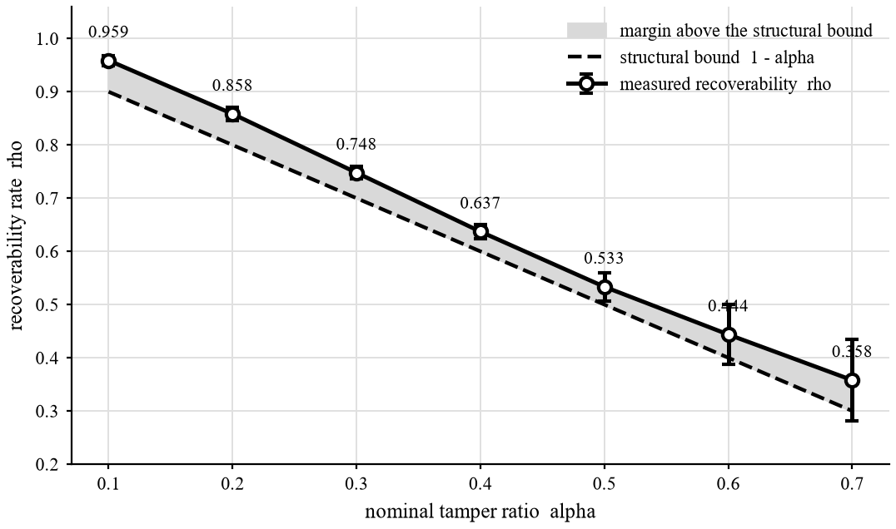
Fig. 7.1: Recoverability rate against tamper ratio. The measured curve stays above its own structural bound at every ratio.
In-region PSNR, by contrast, stays flat across ratios, at 28.49 dB for Variant A and 31.13 dB for Variant C, with a main-grid mean of 29.81 dB, while whole-image PSNR under the unmarked convention falls with coverage to a Variant A mean of 21.40 dB. A recovered block is about as good at high tamper ratios as at low; what changes is how many can be recovered, so mapping coverage, not descriptor fidelity, is the dominant constraint. Fig. 7.2 plots these PSNR values against tamper ratio.
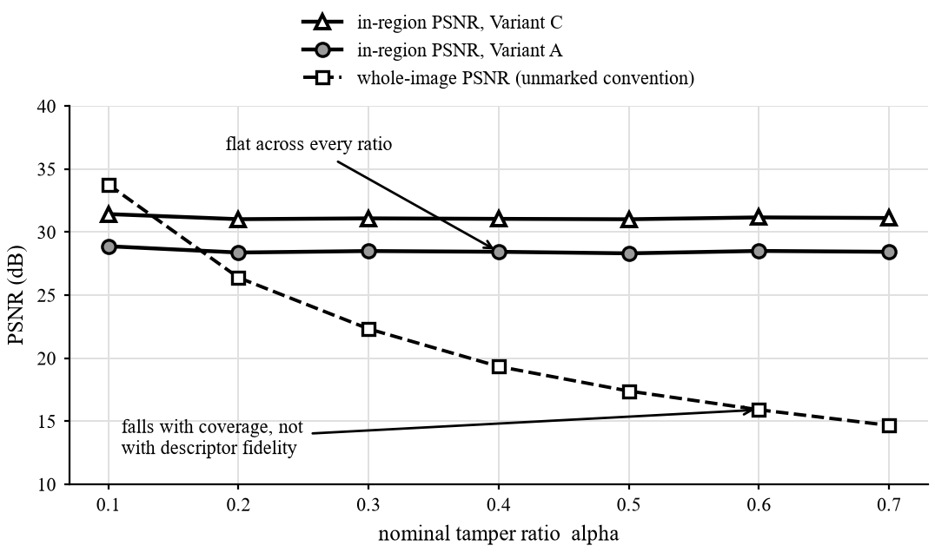
Fig. 7.2: In-region and whole-image PSNR against tamper ratio.
Fig. 7.3 is a qualitative strip from original to recovered image: the mask follows the tampered region within a block-wide margin, and recovered content is a smooth low-frequency approximation, with fine texture lost and unrecoverable blocks marked, not invented.
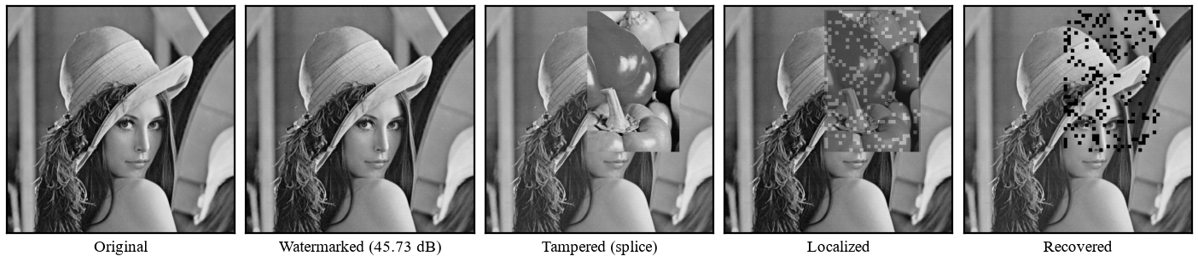
Fig. 7.3: Qualitative result on Lena under copy-paste splicing. The speckles in the recovered panel are blocks marked unrecoverable, not noise.
7.1.4 Comparison and Ablation
Table 7.4 compares the scheme with published figures, cited and not re-implemented, so it is indicative only. The entry for this project uses the whole-image unmarked convention, 17.39 dB at 50% tamper for Variant A, the only quantity comparable to the published numbers; the default output, which marks unrecoverable regions rather than fabricating content, gives 12.40 dB at 50% tamper, about 5 dB lower. Fountain-coded reconstruction [12] at 37 dB and the multi-feature scheme of Wu et al. [18] at above 30 dB are well ahead of this scheme on recovery; the contribution here is auditability, not reconstruction.
Table 7.4: Comparison with published self-embedding schemes
Method | WM PSNR (dB) | WM SSIM | Recovered PSNR (dB) | Notes
AuSR1 [13] | 45.57 | approx. 0.99 | 27.64 | worst case reported; 2x2 blocks
Wu et al. [18] | > 41 | - | > 30 at 50% tamper | 0% FPR and FNR reported
Korus and Dziech [12] | - | - | 37 at 50% damage | fountain codes; over 10,000 images
This work (Variant A, measured) | 45.48 | 0.9885 | 17.39 at 50% tamper | block precision 1.0000, block recall 1.0000, pixel precision 0.9599; the honest marked output is 12.40 dB

Table 7.5 shows the cost of a finer grid. Reducing B from 8 to 4 raises pixel-level precision from 0.9599 to 0.9794 but lowers in-region PSNR from 29.63 dB to 26.78 dB, a loss of 2.85 dB. Payload falls from 128 to 32 bits per block and the tag from 32 to 16 bits, so the per-block false-accept probability rises from 2^-32 to 2^-16, an expected 0.25 false accepts per 512x512 image with 16,384 blocks.
Table 7.5: Block-size ablation: the resolution against payload trade-off
Block size | Pixel precision | In-region PSNR (dB) | Payload per block | Tag length
8 x 8 (main) | 0.9599 | 29.63 | 128 bits | 32 bits
4 x 4 (ablation) | 0.9794 | 26.78 | 32 bits | 16 bits

Against the six objectives of Section 2.2, O1, O2, O3, O4 and O6 are met by the measurements above. O5, recovery, is met with the rate disclosed at every ratio, the unrecoverable fraction marked and the structural limitation stated beside the result.
7.2 CONCLUSIONS
This project built a deterministic, training-free self-embedding fragile watermarking scheme in which each 8x8 block carries, in its two least-significant bit-planes, a 32-bit keyed HMAC-SHA256 tag and a 96-bit descriptor of a distant partner block chosen by a key-seeded single-cycle permutation. The implementation is 9,929 lines of Python across 24 modules, plus a local web application and demonstration interface, with no machine-learning framework.
Across 3,232 rows and 32 images, imperceptibility is 45.479 dB for Variant A, block-level recall is 1.0000 for three of four tamper classes, there is no false-positive block in 1,802,240 null verifications, and recoverability is 3 to 6 percentage points above its structural bound. In-region recovery, at 29.81 dB, is modest, and whole-image figures trail fountain-coded and reference-sharing schemes.
The claim is narrower than accuracy: the design offers accountability, since each verification decision is one keyed hash comparison any key holder can reproduce bit for bit. The distant-mapping idea is not claimed as new, nor is superiority over learned proactive watermarking. The scheme is fully fragile, protecting images only inside a lossless custody chain; its one-to-one backup allocation fails all-or-nothing per block, capping whole-image reconstruction at high tamper ratios; and security rests on key secrecy. Section 7.3 addresses these limits.
7.3 FUTURE WORK
Five directions follow from the measurements and Section 6.2.
- Reference sharing or fountain-coded descriptor allocation is the highest-value upgrade, since mapping coverage and not descriptor fidelity limits recovery quality (Section 7.1.3).
- A semi-fragile mode tolerant of benign JPEG re-encoding would relax the lossless-custody restriction, the largest deployment limit.
- Finer or hierarchical localization grids that avoid the full tag cost would raise pixel-level precision beyond 0.9599 without the penalties of B = 4.
- Integration into capture firmware and PACS or DICOM ingest would test the applications of Section 6.3 and measure embedding cost on constrained hardware.
- A formal security proof would replace the present argument from the standard properties of HMAC-SHA256 [20] with a stated reduction covering every bound field.

REFERENCES
[1] J. Fridrich and M. Goljan, "Protection of digital images using self-embedding," in Proc. Symp. Content Security and Data Hiding in Digital Media, Newark, NJ, USA, May 1999.
[2] P. Zhou, X. Han, V. I. Morariu, and L. S. Davis, "Learning rich features for image manipulation detection," in Proc. IEEE/CVF Conf. Computer Vision and Pattern Recognition (CVPR), Salt Lake City, UT, USA, Jun. 2018.
[3] Y. Wu, W. AbdAlmageed, and P. Natarajan, "ManTra-Net: Manipulation tracing network for detection and localization of image forgeries with anomalous features," in Proc. IEEE/CVF Conf. Computer Vision and Pattern Recognition (CVPR), Long Beach, CA, USA, Jun. 2019.
[4] P. W. Wong and N. Memon, "Secret and public key image watermarking schemes for image authentication and ownership verification," IEEE Trans. Image Process., vol. 10, no. 10, pp. 1593-1601, Oct. 2001.
[5] C. Rey and J.-L. Dugelay, "A survey of watermarking algorithms for image authentication," EURASIP J. Appl. Signal Process., vol. 2002, no. 6, pp. 613-621, 2002.
[6] I. J. Cox, J. Kilian, F. T. Leighton, and T. Shamoon, "Secure spread spectrum watermarking for multimedia," IEEE Trans. Image Process., vol. 6, no. 12, pp. 1673-1687, Dec. 1997.
[7] M. Holliman and N. Memon, "Counterfeiting attacks on oblivious block-wise independent invisible watermarking schemes," IEEE Trans. Image Process., vol. 9, no. 3, pp. 432-441, Mar. 2000.
[8] C.-Y. Lin and S.-F. Chang, "Semi-fragile watermarking for authenticating JPEG visual content," in Proc. SPIE 3971, Security and Watermarking of Multimedia Contents II, 2000, pp. 140-151.
[9] J. Fridrich, "Security of fragile authentication watermarks with localization," in Proc. SPIE 4675, Security and Watermarking of Multimedia Contents IV, San Jose, CA, USA, Jan. 2002, pp. 691-700.
[10] P.-L. Lin, C.-K. Hsieh, and P.-W. Huang, "A hierarchical digital watermarking method for image tamper detection and recovery," Pattern Recognit., vol. 38, no. 12, pp. 2519-2529, Dec. 2005.
[11] X. Zhang, S. Wang, Z. Qian, and G. Feng, "Reference sharing mechanism for watermark self-embedding," IEEE Trans. Image Process., vol. 20, no. 2, pp. 485-495, Feb. 2011.
[12] P. Korus and A. Dziech, "Efficient method for content reconstruction with self-embedding," IEEE Trans. Image Process., vol. 22, no. 3, pp. 1134-1147, Mar. 2013.
[13] A. Aminuddin and F. Ernawan, "AuSR1: Authentication and self-recovery using a new image inpainting technique with LSB shifting in fragile image watermarking," J. King Saud Univ. - Comput. Inf. Sci., 2022.
[14] A. Aminuddin and F. Ernawan, "AuSR2: Image watermarking technique for authentication and self-recovery with image texture preservation," Comput. Electr. Eng., vol. 102, art. 108207, 2022.
[15] A. Aminuddin and F. Ernawan, "AuSR3: A new block mapping technique for image authentication and self-recovery to avoid the tamper coincidence problem," J. King Saud Univ. - Comput. Inf. Sci., vol. 35, no. 9, art. 101755, 2023.
[16] A. Aminuddin, F. Ernawan, D. Nincarean, A. Amrullah, and D. Ariatmanto, "TCBR and TCBD: Evaluation metrics for tamper coincidence problem in fragile image watermarking," Eng. Sci. Technol. - Int. J., vol. 56, art. 101790, 2024.
[17] X. Zhang, R. Li, J. Yu, Y. Xu, W. Li, and J. Zhang, "EditGuard: Versatile image watermarking for tamper localization and copyright protection," in Proc. IEEE/CVF Conf. Computer Vision and Pattern Recognition (CVPR), 2024.
[18] Q. Wu, H. Li, M. Li, and M. Wang, "Multi-feature fragile image watermarking algorithm for tampering blind-detection and content self-recovery," Computers, Materials & Continua, vol. 86, no. 1, 2026.
[19] X. Zhang and S. Wang, "Fragile watermarking with error-free restoration capability," IEEE Trans. Multimedia, vol. 10, no. 8, pp. 1490-1499, Dec. 2008.
[20] National Institute of Standards and Technology, "Secure Hash Standard (SHS)," FIPS Publication 180-4, Aug. 2015.
[21] Z. Wang, A. C. Bovik, H. R. Sheikh, and E. P. Simoncelli, "Image quality assessment: From error visibility to structural similarity," IEEE Trans. Image Process., vol. 13, no. 4, pp. 600-612, Apr. 2004.
[22] University of Southern California, Signal and Image Processing Institute, "The USC-SIPI Image Database." [Online]. Available: https://sipi.usc.edu/database/
[23] Eastman Kodak Company, "Kodak Lossless True Color Image Suite." [Online]. Available: https://r0k.us/graphics/kodak/
[24] Coalition for Content Provenance and Authenticity, "C2PA Technical Specification." [Online]. Available: https://c2pa.org/specifications/
[25] "A recent survey of self-embedding fragile watermarking scheme for image authentication with recovery capability," EURASIP J. Image Video Process., 2019.
[26] "Security analysis of a self-embedding fragile image watermark scheme," arXiv:1812.11735, 2018.

APPENDIX A
FEASIBILITY ASSESSMENT, SATISFIABILITY ANALYSIS AND COMPLEXITY CLASSIFICATION
A.1 FORMAL SYSTEM DEFINITION
The scheme is defined as a tuple of eleven elements, over which three functions operate. The tuple is
S = { I, Ks, ID, B, K, m, r, a, T, U, F }
where I is the host image, a member of {0,...,255}^(MxN) for each colour channel; Ks is the secret key from which all key material is derived; ID is the image identifier bound into every tag; and B is the block size, 8 in the main configuration. K = (M/B)(N/B) is the number of blocks, and m is the block mapping, a permutation of {0,...,K-1} under which the descriptor of block i is stored in block m(i).
The remaining elements are derived from these. The descriptor set r = { r_i } holds one summary per block, with r_i in {0,1}^96, and the tag set a = { a_i } holds one authentication tag per block, with a_i in {0,1}^32. T is the flagged block set produced by verification, and U = { i in T : m(i) in T } is the subset of T whose descriptors are held in blocks that are themselves flagged, and which therefore cannot be rebuilt. F is the set of functions {embed, detect, recover}, with the following signatures.
- embed: (I, Ks, ID, B) -> (I', m, r, a), where I' differs from I only in its two least-significant bit-planes.
- detect: (I*, Ks, ID, B) -> T, the flagged set, with a per-block audit record, where I* is the received image.
- recover: (I*, T, m, Ks, ID) -> (I^, U), the restored image and the unrecoverable set, whose blocks are marked and not filled.
Success is stated in set terms. Let G be the ground-truth tampered block set. The system succeeds on an input when T = G and U is reported alongside the restored image. It fails when T differs from G, or when any block in T was flagged although its recomputed tag verified correctly. The 17 MSB-preserved-miss blocks of the main grid are the measured residual of the first failure mode.
A.2 SATISFIABILITY ANALYSIS
The design is treated as a constraint system, and its satisfiability is shown by exhibiting an assignment that meets every constraint, not by assertion. The constraints are as follows.
- C1, capacity: t(B) + d(B) <= 2B^2, where t is the tag length and d the descriptor length. At B = 8 this reads 32 + 96 <= 128.
- C2, bijectivity: m must be a permutation of {0,...,K-1}.
- C3, separation: ||c(i) - c(m(i))||_2 >= d_min for all i, where c(i) is the centre of block i and d_min = (1/4) min(M, N).
- C4, no fixed points and no two-cycles, which is implied by C5.
- C5, single-cycle structure: m must consist of one K-cycle.
- C6, single-pass consistency: the tag must be computable before the payload is written and must remain valid after it is written.
A satisfying assignment exists. C1 holds by the budget arithmetic, and holds with equality, so the payload is exactly capacity-tight with no spare bit. C2, C4 and C5 hold by construction, because m is read directly off a cryptographically seeded Fisher-Yates cycle order. No rejection sampling is needed, and the assignment is found in O(K) time.
C6 holds because the tag is computed over MSB(b_i) = b_i AND 0xFC, and embedding writes only the two least-significant bits. The signed quantity is therefore invariant under embedding, and the tag computed before writing is the tag verified afterward.
C3 is the only constraint that the cycle construction does not guarantee. It is enforced by a repair pass over the cycle. That pass is a local heuristic, not a global optimum, which is sufficient here because C3 is a lower bound and not an objective: any assignment that meets the bound is acceptable. The constraint system is therefore satisfiable, and a satisfying assignment is constructed in linear time for every key.
A.3 COMPLEXITY CLASSIFICATION
Embedding performs, per block, one BxB DCT, one HMAC-SHA256 evaluation and a fixed number of bit operations. Verification performs the same work, and the mapping costs O(K). With K = MN/B^2 blocks, the total running time is
T(M, N) = O(MN)
with no iteration, no optimization and no training, and memory is O(MN + K). The decision problem "does block i verify under key Ks" is answered by one deterministic hash computation and one comparison, and it is therefore in P. No NP-hard or NP-complete sub-problem arises anywhere in the pipeline. The measured timings, 473 ms to embed and 197 ms to verify a 512x512 colour image on a single CPU thread, are consistent with this linear classification.
A related problem is combinatorially hard, however, and the report should not hide it. Choosing a descriptor allocation that maximizes expected recoverability over an unknown tamper geometry is equivalent to choosing a permutation that maximizes the expected size of the set of flagged blocks whose partners survive. This is an assignment problem over K! candidate permutations, closely related to quadratic-assignment formulations that are NP-hard in general.
This project does not solve that optimization. It sidesteps it with a constructive permutation that satisfies a separation lower bound, and it reports the resulting recoverability rate as a measurement, without claiming optimality. Reference-sharing and fountain-coded allocations [11], [12] change the structure of this problem rather than solving it, which is why they are listed as future work.
A.4 FEASIBILITY ASSESSMENT
A.4.1 Technical Feasibility
The pipeline is implemented and measured. It runs on a commodity CPU, embedding a 512x512 colour image in 473 ms and verifying it in 197 ms with no GPU, and it uses only standard-library cryptography. The complete evaluation grid, 3,232 rows over 32 images, has already been produced, so every claim in this report rests on measurement and not on projection.
A.4.2 Economic Feasibility
No licensed software, GPU, cloud compute or paid dataset is required. The corpus is public and pinned by SHA-256 hash, so it reproduces byte for byte. The direct cost is student time and a commodity workstation, and the software stack is entirely open source.
A.4.3 Operational Feasibility
Verification requires only the received image, the key and the image identifier. The operational burden is therefore key management, which is the one genuine operational precondition of the scheme: an adversary holding the key can re-embed, so custody of the key is custody of the evidence.
A.4.4 Schedule Feasibility
The experimental work was completed before this report was written, which removes the usual end-of-project measurement risk. The remaining work is the reference-sharing extension and the final submission, neither of which alters the measured baseline reported here.

APPENDIX B
DETAILS OF THE PAPERS REFERRED
[1] J. Fridrich and M. Goljan, "Protection of digital images using self-embedding," in Proc. Symp. Content Security and Data Hiding in Digital Media, Newark, NJ, USA, May 1999.
Summary: The paper introduces self-embedding: a reduced-quality version of the image is hidden in the image's own least significant bits, so that a cropped or replaced region can be approximately restored from the surviving area. It is the origin of the recovery line of work, and this project inherits the idea that an image carries its own repair data.
[2] P. Zhou, X. Han, V. I. Morariu, and L. S. Davis, "Learning rich features for image manipulation detection," in Proc. IEEE/CVF Conf. Computer Vision and Pattern Recognition (CVPR), Salt Lake City, UT, USA, Jun. 2018.
Summary: A two-stream network combines an RGB stream, which looks for visible tampering artifacts, with a noise stream, which looks for inconsistencies in local noise statistics, to detect and localize manipulated regions. It represents passive detection, which analyzes the received image alone. This project cites it as the contrast case: detection without any embedded reference, and without any recovery.
[3] Y. Wu, W. AbdAlmageed, and P. Natarajan, "ManTra-Net: Manipulation tracing network for detection and localization of image forgeries with anomalous features," in Proc. IEEE/CVF Conf. Computer Vision and Pattern Recognition (CVPR), Long Beach, CA, USA, Jun. 2019.
Summary: ManTra-Net learns features that describe how locally anomalous each pixel is relative to its surroundings, which lets one network handle many forgery types and localize them at pixel level. Like [2], it is a passive detector that cannot restore content. It is cited to show why a tamper-localization result alone does not answer the recovery requirement of this project.
[4] P. W. Wong and N. Memon, "Secret and public key image watermarking schemes for image authentication and ownership verification," IEEE Trans. Image Process., vol. 10, no. 10, pp. 1593-1601, Oct. 2001.
Summary: The scheme computes a keyed cryptographic hash over each image block, together with block-specific information, and hides the result in the least significant bits of that same block, giving block-level localization of tampering. It established the block-wise fragile authentication template. This project follows the block-and-tag structure, and its tag construction answers the weaknesses later shown against it.
[5] C. Rey and J.-L. Dugelay, "A survey of watermarking algorithms for image authentication," EURASIP J. Appl. Signal Process., vol. 2002, no. 6, pp. 613-621, 2002.
Summary: The survey classifies authentication watermarks by what they tolerate, separating fragile schemes that flag any change from semi-fragile schemes that survive acceptable processing such as compression, and it lists the requirements of localization and security. It supplied the taxonomy used to place this project among fragile schemes, and to state why compression tolerance is deliberately not claimed.
[6] I. J. Cox, J. Kilian, F. T. Leighton, and T. Shamoon, "Secure spread spectrum watermarking for multimedia," IEEE Trans. Image Process., vol. 6, no. 12, pp. 1673-1687, Dec. 1997.
Summary: A watermark is spread across the perceptually significant frequency components of the image, which makes it hard to remove without visibly damaging the content. This is the robust watermarking tradition, designed to survive processing for ownership claims. It is cited as the opposite design goal: this project wants a mark that breaks on any alteration, not one that persists.
[7] M. Holliman and N. Memon, "Counterfeiting attacks on oblivious block-wise independent invisible watermarking schemes," IEEE Trans. Image Process., vol. 9, no. 3, pp. 432-441, Mar. 2000.
Summary: When each block is marked independently of its position and of the rest of the image, an attacker holding several marked images can assemble a forgery from valid blocks (the vector quantization or collage attack). The paper shows that independence between blocks is the vulnerability. It forces the tag in this project to bind the block index and an image identifier.
[8] C.-Y. Lin and S.-F. Chang, "Semi-fragile watermarking for authenticating JPEG visual content," in Proc. SPIE 3971, Security and Watermarking of Multimedia Contents II, 2000, pp. 140-151.
Summary: Authentication bits are derived from relationships between quantized DCT coefficients that survive JPEG recompression, so the mark rejects malicious edits while accepting lossy compression. It is the standard example of semi-fragile design. This project sits on the strict side of that trade: it reports compression as a tamper, and does not claim the tolerance this paper achieves.
[9] J. Fridrich, "Security of fragile authentication watermarks with localization," in Proc. SPIE 4675, Security and Watermarking of Multimedia Contents IV, San Jose, CA, USA, Jan. 2002, pp. 691-700.
Summary: The paper analyzes fragile localizing schemes and shows that the finer the localization, the more easily block-level independence can be exploited, so small blocks and strong security pull against each other. It argues for dependence between blocks and across the image. This project cites it for the security argument behind tying each tag to other blocks and to an image identifier.
[10] P.-L. Lin, C.-K. Hsieh, and P.-W. Huang, "A hierarchical digital watermarking method for image tamper detection and recovery," Pattern Recognit., vol. 38, no. 12, pp. 2519-2529, Dec. 2005.
Summary: Detection is arranged in levels, from larger regions down to small blocks, so that a block missed at one level can be caught at the next, and recovery data for each block is stored in a different, mapped block. The hierarchy reduces false negatives. This project cites it as an early combined detection-and-recovery scheme and as a source of the mapped-storage practice.
[11] X. Zhang, S. Wang, Z. Qian, and G. Feng, "Reference sharing mechanism for watermark self-embedding," IEEE Trans. Image Process., vol. 20, no. 2, pp. 485-495, Feb. 2011.
Summary: Reference data are shared among blocks through a redundancy-style mechanism, so recovery degrades gradually as the tampered fraction grows, and quality stays acceptable when the damage is large. It is one of the two works that define the graceful-degradation benchmark. This project does not yet meet that benchmark, and the report states the gap plainly.
[12] P. Korus and A. Dziech, "Efficient method for content reconstruction with self-embedding," IEEE Trans. Image Process., vol. 22, no. 3, pp. 1134-1147, Mar. 2013.
Summary: Reference information is split into several shares and embedded so that content can be reconstructed from the pieces that survive, and quality falls smoothly as more of the image is destroyed. Together with [11], it sets the graceful-degradation benchmark for self-embedding. This project falls short of that benchmark, and the report treats it as the main direction for future work.
[13] A. Aminuddin and F. Ernawan, "AuSR1: Authentication and self-recovery using a new image inpainting technique with LSB shifting in fragile image watermarking," J. King Saud Univ. - Comput. Inf. Sci., 2022.
Summary: The paper stores recovery information with a shift of the least significant bits, which gives a larger payload at tolerable distortion, and it fills unrecovered pixels by image inpainting. It is the first of the three AuSR schemes. This project borrows the LSB-shifting idea, and credits it to this paper.
[14] A. Aminuddin and F. Ernawan, "AuSR2: Image watermarking technique for authentication and self-recovery with image texture preservation," Comput. Electr. Eng., vol. 102, art. 108207, 2022.
Summary: The second AuSR scheme adjusts the embedding so that image texture is preserved, because heavy bit modification shows up most in textured areas. It is a refinement of how watermark bits are placed, not a new recovery principle. This project cites it as the closest reference for the imperceptibility side of its design.
[15] A. Aminuddin and F. Ernawan, "AuSR3: A new block mapping technique for image authentication and self-recovery to avoid the tamper coincidence problem," J. King Saud Univ. - Comput. Inf. Sci., vol. 35, no. 9, art. 101755, 2023.
Summary: Tamper coincidence arises when a block and the block holding its recovery data are both altered, so neither can be restored. AuSR3 proposes a block mapping that places the recovery data far from the block it describes. This project credits the distant-mapping principle to this paper and does not claim it.
[16] A. Aminuddin, F. Ernawan, D. Nincarean, A. Amrullah, and D. Ariatmanto, "TCBR and TCBD: Evaluation metrics for tamper coincidence problem in fragile image watermarking," Eng. Sci. Technol. - Int. J., vol. 56, art. 101790, 2024.
Summary: The paper defines two metrics, TCBR and TCBD, that measure how much a scheme suffers from tamper coincidence, so that mapping designs can be compared on a common scale instead of by example images. This project uses it as the reference point for reporting coincidence behavior, and for stating which parts of that measurement it adopts.
[17] X. Zhang, R. Li, J. Yu, Y. Xu, W. Li, and J. Zhang, "EditGuard: Versatile image watermarking for tamper localization and copyright protection," in Proc. IEEE/CVF Conf. Computer Vision and Pattern Recognition (CVPR), 2024.
Summary: EditGuard uses a learned encoder and decoder to embed both a localization mark and a copyright message, aimed at edits made by generative models. It marks the move of watermarking toward learned, AI-era settings. This project cites it as the current learned alternative, and keeps to a classical scheme whose behavior can be inspected and verified.
[18] Q. Wu, H. Li, M. Li, and M. Wang, "Multi-feature fragile image watermarking algorithm for tampering blind-detection and content self-recovery," Computers, Materials & Continua, vol. 86, no. 1, 2026.
Summary: The scheme builds the watermark from several image features and detects tampering blindly, without access to the original, while storing information for content self-recovery. It is among the most recent entries in the line of fragile self-recovery work. This project cites it to show that the problem is still active, and it does not compare against it directly.
[19] X. Zhang and S. Wang, "Fragile watermarking with error-free restoration capability," IEEE Trans. Multimedia, vol. 10, no. 8, pp. 1490-1499, Dec. 2008.
Summary: The scheme embeds the original values of the pixels it modifies, together with authentication data, so that an untampered image can be restored exactly to its original state after verification. It targets error-free restoration of the cover image, not recovery of tampered content. This project cites it to separate those two meanings of restoration.
[20] National Institute of Standards and Technology, "Secure Hash Standard (SHS)," FIPS Publication 180-4, Aug. 2015.
Summary: The standard specifies the SHA family of hash functions, including SHA-256, which maps input of any length to a fixed-length digest that is hard to invert or to collide. It is the primitive underneath the keyed tags in this project. The tag construction relies on SHA-256 as specified here, and it does not invent a hash.
[21] Z. Wang, A. C. Bovik, H. R. Sheikh, and E. P. Simoncelli, "Image quality assessment: From error visibility to structural similarity," IEEE Trans. Image Process., vol. 13, no. 4, pp. 600-612, Apr. 2004.
Summary: The paper proposes the structural similarity index, which compares luminance, contrast and structure between two images and tracks perceived quality better than error energy alone. This project uses SSIM, alongside PSNR, to report how much the embedding changes the image and how good a recovered image is.
[22] University of Southern California, Signal and Image Processing Institute, "The USC-SIPI Image Database." [Online]. Available: https://sipi.usc.edu/database/
Summary: The database is a long-standing public collection of digitized test images, widely used as a common benchmark in image processing research. It is cited as a dataset source for the evaluation images, so that results can be compared with those in the published literature.
[23] Eastman Kodak Company, "Kodak Lossless True Color Image Suite." [Online]. Available: https://r0k.us/graphics/kodak/
Summary: The suite is a set of uncompressed color photographs released for use in image compression and processing research, and it is a common benchmark for natural color images. It is cited as the second dataset source for evaluation, so that the test material is not limited to one collection.
[24] Coalition for Content Provenance and Authenticity, "C2PA Technical Specification." [Online]. Available: https://c2pa.org/specifications/
Summary: The specification defines signed provenance metadata, called content credentials, that is attached to a media file to record its origin and edit history. The credentials sit beside the pixels and can be stripped from the file. This project cites it as the metadata-based alternative, and contrasts it with a mark carried inside the pixels.
[25] "A recent survey of self-embedding fragile watermarking scheme for image authentication with recovery capability," EURASIP J. Image Video Process., 2019.
Summary: The survey reviews self-embedding fragile schemes that authenticate an image and recover tampered regions, and organizes them by how recovery data are generated, mapped and embedded. It is the broad map of the field. This project cites it for the classification of schemes and for the open problems it identifies.
[26] "Security analysis of a self-embedding fragile image watermark scheme," arXiv:1812.11735, 2018.
Summary: The paper examines a published self-embedding fragile scheme from an attacker's side and shows that its security claims do not survive analysis. It illustrates that recovery schemes are attacked in practice, not just in theory. This project cites it as supporting evidence for treating the security of the tag construction as a design requirement.

APPENDIX C
PLAGIARISM REPORT
The plagiarism check report generated by the institute's similarity checking service is to be attached at this point, as required by clause 19 of the departmental report format. The report covers Chapters 1 to 7 and Appendices A and B of this document; the cover page, certificate, acknowledgement, table of contents, lists and references are excluded from the check in line with the usual convention.
[ATTACH THE PLAGIARISM CHECK REPORT HERE]

