VLSI DSP Course Project
Spring 2020
(Due June 30, 2020)

You have two options for this project. You may choose the advanced option. In that case, you will conduct a literature survey and probably propose some modifications on VLSI architectures on a research topic related to VLSI DSP including, but not limited to, the following topics. If you choose to work on something related to your currently research, it is also fine as long as the subject is about VLSI architecture optimization.

The following topics are just given for your reference:
  - CNN Inference/Training Accelerator (Convolutional Layer, Fully Connected Layer…)
  - RNN Inference Accelerator (GRU, LSTM…)
  - GAN Inference Accelerator
  - Sparse general matrix multiplication accelerator
  - AES encryption/decryption processor
  - RSA encryption/decryption processor
  - Elliptic curve encryption/decryption processor
  - Adaptive FIR digital filter
  - Decimation filter for a sigma-delta converter
  - FFT processor
  - DCT processor for image compression and decompression
  - Discrete wavelet transform processor
  - Fuzzy logic processor
  - IEEE 754 floating-point adder/subtractor
  - IEEE 754 floating-point multiplier
  - IEEE 754 floating-point divider
  - IEEE 754 floating-point square root processor
  - CORDIC processor
  - Graphics accelerator
  - Speech processor
  - DNA string matching processor
  - Huffman encoder/decoder
  - JPEG encoder/decoder
  - MPEG encoder/decoder (Motion estimation, variable length codec, etc)
  - Reed-Solomon encoder/decoder
  - Viterbi decoder
  - Turbo code encoder/decoder
  - LDPC encoder/decoder
  - All-digital PLL
  - QAM modulator/demodulator
  - PSK modulator/demodulator
  - OFDM modulator/demodulator
  - Finite field arithmetic processor
  - Digital filter bank

For the basic option, all details are given as follows.

1. Title: Efficient VLSI architecture of Zero-Forcing Filter for High-Data-Rate UWB Systems

2. Description: For a novel ultra-wide band (UWB) communication system (proposed by Prof. Liu at OSU), data are transmitted in burst. The received vector can be (simplified) expressed as follows,
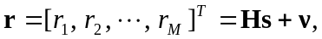 (1)
where 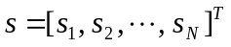represents the burst of binary data transmitted, each element of s is either +1 or -1, H is called the channel matrix with a dimension of MxN, v denote the additive white Gaussian noise(AWGN) vector with dimension of Mx1. Also M >N. The goal is to find an optimal estimation for s vector based on the received vector r and given channel matrix H. For this project, M=8, N=4, 1000 samples of H matrices are included in text file “Hdata.txt”.
3. Approach:
In theory, the least square solution can be obtained as follows,
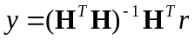, (2)
The estimated s vector will be the sign bits of y. In other words, if y(i)>0, s(i)=+1, else s(i)=-1, i=1, …, N.
Considering many issues associated with matrix inversing in VLSI implementation, we propose to use the following iterative process to obtain vector y.
------ MATLAB code for this algorithm -------------------------------------------
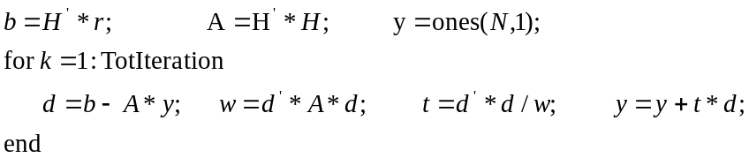
----------------- end of Matlab code ------------------------------------------

4. Tasks
a) Perform extensive finite word-length analysis to optimize the wordlengths for all variables in the algorithm. You need to decide how many iterations you need. Please note the more iterations, the better performance and the lower sample rate.

The maximum performance loss is limited to 0.15 dB. The target signal-to-noise-ratio (SNR) is assumed to be in the range of [-6, +2] dB. With the model described in Equation 1, the stand deviation of each noise element is computed as the following,
sigma=sqrt(0.5/(10^(SNR/10))) (3)

Each noise element is expressed as N(0, sigma). You only need to simulate a few cases for the considered SNRs, e.g., SNR=-6, -4, -2, 0, and +2 dB. To be more accurate, to achieve the same target BER (bit-error-rate), the FWL implementation should work on an environment of no more than 0.15 dB higher SNR than the case using double precision with Equation 2. You are supposed to generate 5000 (or more) bursts of data. In other words, you need to generate 20000 random information bits for each SNR. You calculate how many bits in total are estimated wrong. Make an average, you will get the BER. Please note you are only given 1000 random H matrices. So you need to re-use those H matrices 5 times. In the log domain, please plot the simulation results as BER vs. SNR, estimate the horizontal gap between two simulation curves. That largest gap should be no more than 0.15 dB.

The following figure (BER vs. SNR) is for your reference,
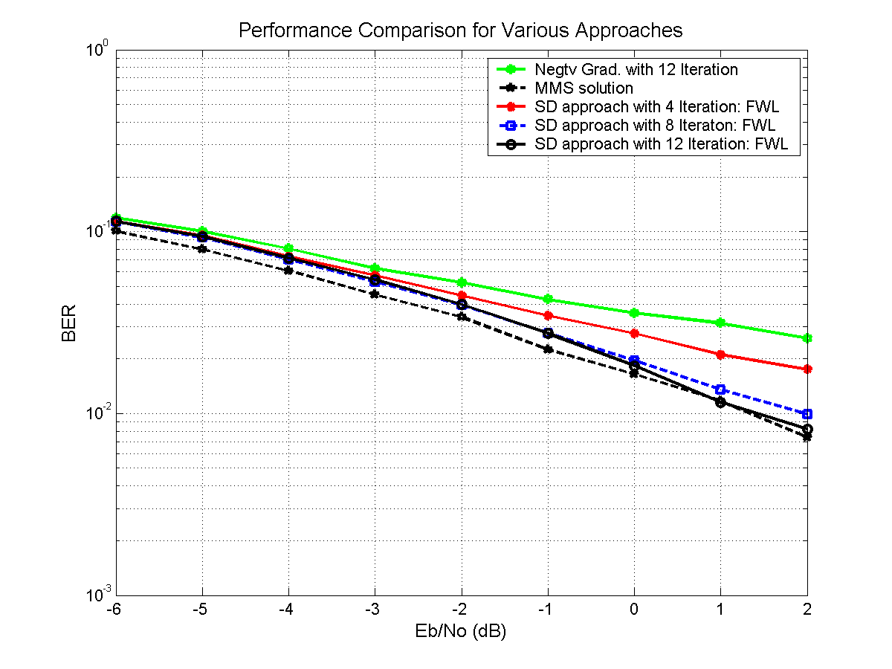

- Try to perform some algorithmic transformations to reduce the design complexity. Especially, try to find efficient ways to implement division operations.
- Define the micro-architecture (block diagram) for the system and optimize the design for low power and high sample rate, where the sample rate is the first priority.
- Roughly estimate the maximum sample rate of your design and total hardware.
--- the critical path, how many clock cycles needed to estimate one s vector
--- how many adders, multipliers, etc are needed.

5. Report
The final report must be comprehensive and is due on June 30, 2020.

Please start as early as possible!

Enjoy it!

