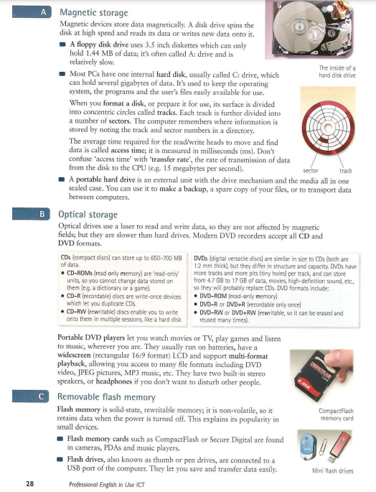

**Storage devices**

**Magnetic devices** store data magnetically and read and write it by spinning the disk.

* Floppy disk drive is a relatively slow device often called A: drive that allows to store only 1.44Mb of data, using 3.5 inches diskettes.
* Hard disk or C: drive can store several gigabytes of data and usually used to keep the operating system, programs and users files easily for use.   
  The computer remembers where the information is by noting the sector of the concentric circles called tracks.
* A portable hard drive is an external unit with drive mechanism and the media all in one that allows to make backups and transport data.

**Optical drives** are slower devices that use a laser to read and write data. Modern DVD recorders accept all CD and DVD formats.  
Portable DVD players let you to watch media, play games and listen to music, wherever you are. They usually run on batteries, have a widescreen LCD and support multi-format playback. They have two built-in stereo speakers or headphones.

**Flash memory** is solid-state rewritable non-volatile memory that’s popular in small devices.

* Flash memory cards are found in cameras, PDAs and music players.
* Flash drives are connected to a small usb port of the computer and allow you to save and transfer data easily.