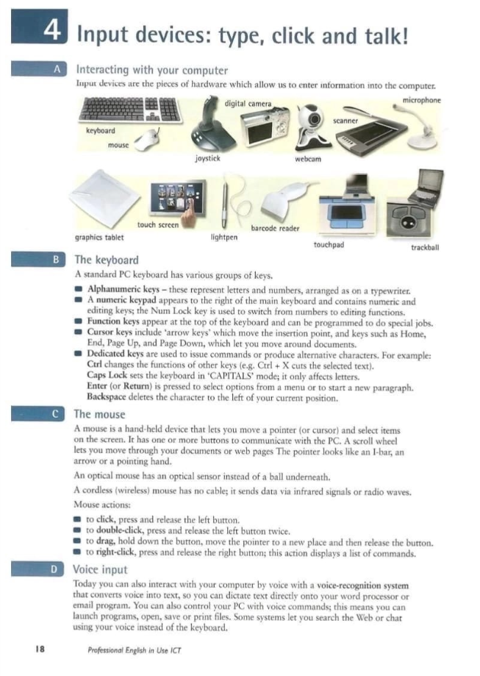

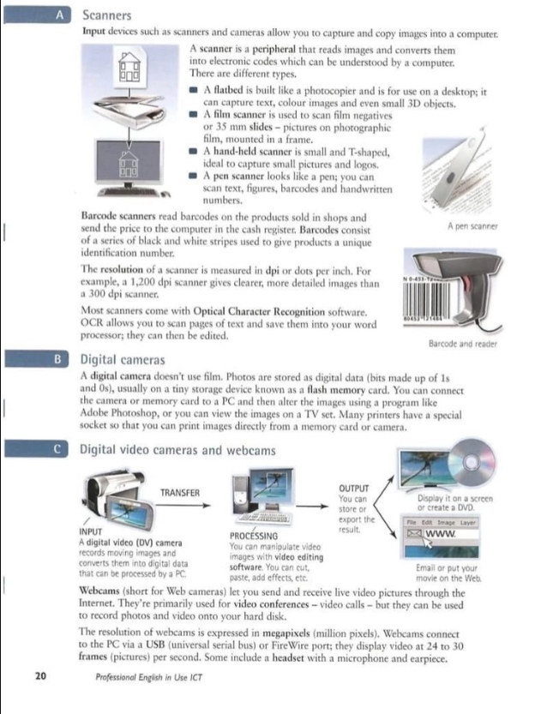

**Input devices**

Input devices are the pieces of hardware which allow us to enter information into the computer.

**The keyboard**

A standard PC keyboard has various groups of keys.

Alphanumeric keys representing letters and numbers

A numeric keypad on the right of the main keyboard containing numeric and editing keys and switching from numbers to editing functions by tapping Num Lock button.

Function keys are at the top of the keyboard and are used for special functions.

Cursor keys include 'arrow keys' and keys such as Home, End, Page Up, and Page Down, which let you move the cursor around documents.

Dedicated keys are used to issue commands or produce alternative characters.

**The mouse**

A mouse is a hand held device that lets you move a pointer and select items on the screen, to scroll the screen using the scroll wheel if its necessary and possible.

An optical mouse has an optical sensor instead of a ball underneath.

A cordless (wireless) mouse has no cable; it sends data usually via Bluetooth;

**Voice input**

Today you can also interact with your computer by voice with a voice-recognition system that converts voice into text, so you can dictate text directly onto your word processor or email program. You can also control your PC with voice commands; this means you can launch programs, open, save or print files. Some systems let you search the Web or chat using your voice instead of the keyboard.

**Scanners**

Input devices such as scanners and cameras allow you to capture and copy images into a computer.

A scanner is a peripheral that reads images and converts them into electronic codes which can be understood by a computer.

There are different types such as: flatbed scanner, film scanner, hand-held scanner, pen scanner and the barcode scanners;

The resolution of a scanner is measured in dpi.

Most scanners come with Optical Character Recognition software.

OCR allows you to scan pages of text and save them into your word processor; they can then be edited.

**Digital cameras**

The media files in digital cameras are usually stored as digital data in flash memory cards instead of film. By connecting the camera or the memory card to PC or TV set you can alter the data or watch media files. You can print images directly from a memory card or camera using special printers.

**Digital video cameras and webcams**

INPUT

A digital video (DV) camera records moving images and converts them into digital data that can be processed by a PC.

PROCESSING

You can manipulate video images with video editing software.

OUTPUT

You can store or export the result. You can manipulate video images with video editing software. Email or put your movie on the Web.

Webcams let you send and receive live video pictures through the Internet. The resolution of webcams is expressed in megapixels. Webcams connect to the PC via a USB or FireWire port; they display video at 24 to 30 fps.