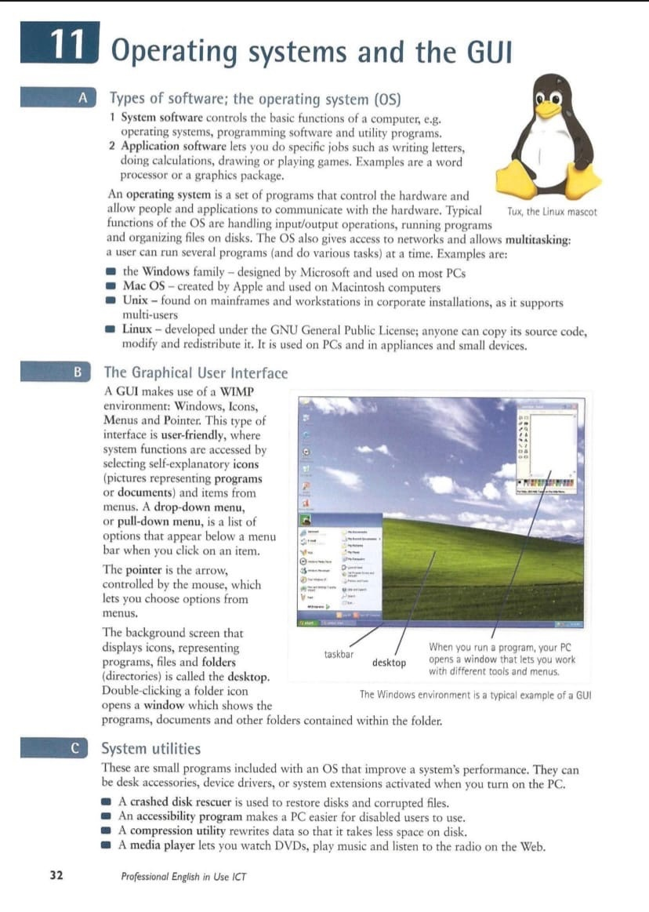

**Types of software, the operating system.**

1. **System software**, controls the basic functions of a computer.
2. Application software lets you do specific jobs.

An operating system is a set of programs that control the hardware and connect applications with it. The OS’s functions are handling input/output operations, running programs and organizing files on disks and also give access to networks and organize multitasking. Examples of the OS are the Windows family, MAC OS, Unix, Linux.

**The graphical user interface.**

A GUI makes use of WIMP enviroment. This type of interface is user-friendly, where system functions are accessed by selecting icons and items from menu. Such interfaces tipically has drop-down-menus, which is a list of options that appear bellow a menu bar; the pointer, which is the arrow and lets you choose options in menu; the desktop which is background that displays icons, representing programs, files and folders.

**System utilities.**

These are small programs included with an OS that improve a system’s performance. For example:

A crashed disk rescuer is used to restore disk and files.

A compression utility rewrites data so that it takes less space on disk.

A media player lets you watch DVD’s , play music and listen to the radio.