testing

Vorisek_CN

20 4 2022

First, load relevant packages for the network analysis:

library(tidyverse)  
library(igraph)  
library(ggraph)  
library(visNetwork)  
library(readxl)

# Analysis of Excel file

## Data import and cleaning

Import Excel file with included studies (“IncludedStudies2.xlsx”):

excel_data <- read_excel("IncludedStudies2.xlsx")

Clean data (keep only variables relevant for analysis, rename variables, reformat, …):

excel_data_clean <- excel_data %>%   
 select(Author = `Author (First)`,  
 Title,  
 Year,  
 Country = `Country (according to 1st author affiliation)`,  
 Item_mapped_keyword = `Item mapped_keyword`,  
 Goal_keyword,  
 Other_standards_keyword = `Other standards_keyword`,  
 Other_software_keyword = `Other Software_keyword`,  
 FHIR_resource_used = `FHIR Resource used`,  
 FHIR_extension_used = `FHIR extension used`,  
 FHIR_version = `FHIR version`,  
 Patients,  
 Variables,  
 Variables_count,  
 Research_category = `Research Category`,  
 Medical_area = `Medical Area`,  
 Journal,  
 Impact_factor = `Impact Factor Research)`,  
 Research_area = `Research Area`,  
 Clinical_trials = `Clinical Trials`,  
 generic,  
 SNOMED_CT = `Other standards - SNOMED CT`,  
 LOINC = `Other standards - LOINC`,  
 ICD_10 = `Other standards - ICD 10`,  
 OMOP = `Other standards - OMOP`,  
 Other = `Other standards - Other`,  
 None = `Other standards - None (nicht angegeben oder nicht verwendet)`) %>%   
 mutate(Journal = str_trim(Journal)) %>%   
 mutate(Journal = ifelse(Journal %in% c("Studies in Health technology and informatics", "Studies in Health Technology and Informatics"),  
 "Studies in health technology and informatics", Journal)) %>%   
 mutate(Journal = ifelse(Journal == "JMIR medical informatics",  
 "JMIR Medical Informatics", Journal)) %>%  
 mutate(Impact_factor = ifelse(Impact_factor %in% c("None", "-"), NA, Impact_factor)) %>%   
 mutate(Impact_factor = str_replace(Impact_factor, ",", ".")) %>%   
 mutate(Impact_factor = round(as.numeric(Impact_factor), 2)) %>%   
 mutate(Country = ifelse(Country == "USA / Switzerland", "USA", Country)) %>%   
 mutate(Research_area = ifelse(Research_area == "Clinical trials",  
 "Clinical Trials", Research_area))

### Goals

This section analyzes the most common keywords describing the goals of the articles.

Load tidytext package and get word frequencies of all words in Goal_keyword variable:

library(tidytext)  
  
# define some stop words to be excluded  
stop_words <- c("of", "and", "for", "from", "a", "an", "between",  
 "across", "on", "the", "to", "in", "into", "with",  
 "as", "or", "other", "such", "via")  
  
goal_keywords <- excel_data_clean %>%   
 select(Goal_keyword) %>%   
 unnest_tokens(word, Goal_keyword, to_lower = TRUE) %>%   
 filter(!(word %in% stop_words)) %>%   
 group_by(word) %>%   
 summarize(freq = n()) %>%   
 arrange(desc(freq))

The wordcloud shows the most common words mentioned as keywords:

library(wordcloud)

## Loading required package: RColorBrewer

wordcloud(words = goal_keywords$word, freq = goal_keywords$freq, min.freq = 1, max.words=150, random.order=FALSE, rot.per=0.10,   
 colors=c("#335a99", "#1b3051"))

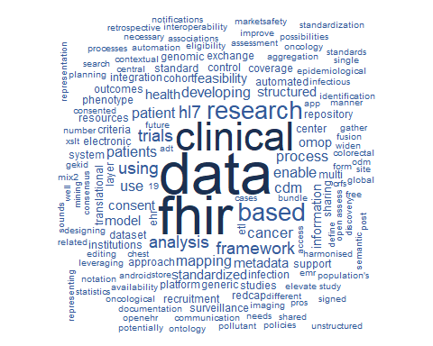

Note that there are still some typos shown in the wordcloud. (Correct all typos in the final Excel file before analysis.)