mCODE STU4
Minimal Common Oncology Data Elements
HL7 FHIR Implementation Guide v4.0.0
Summary & Analysis
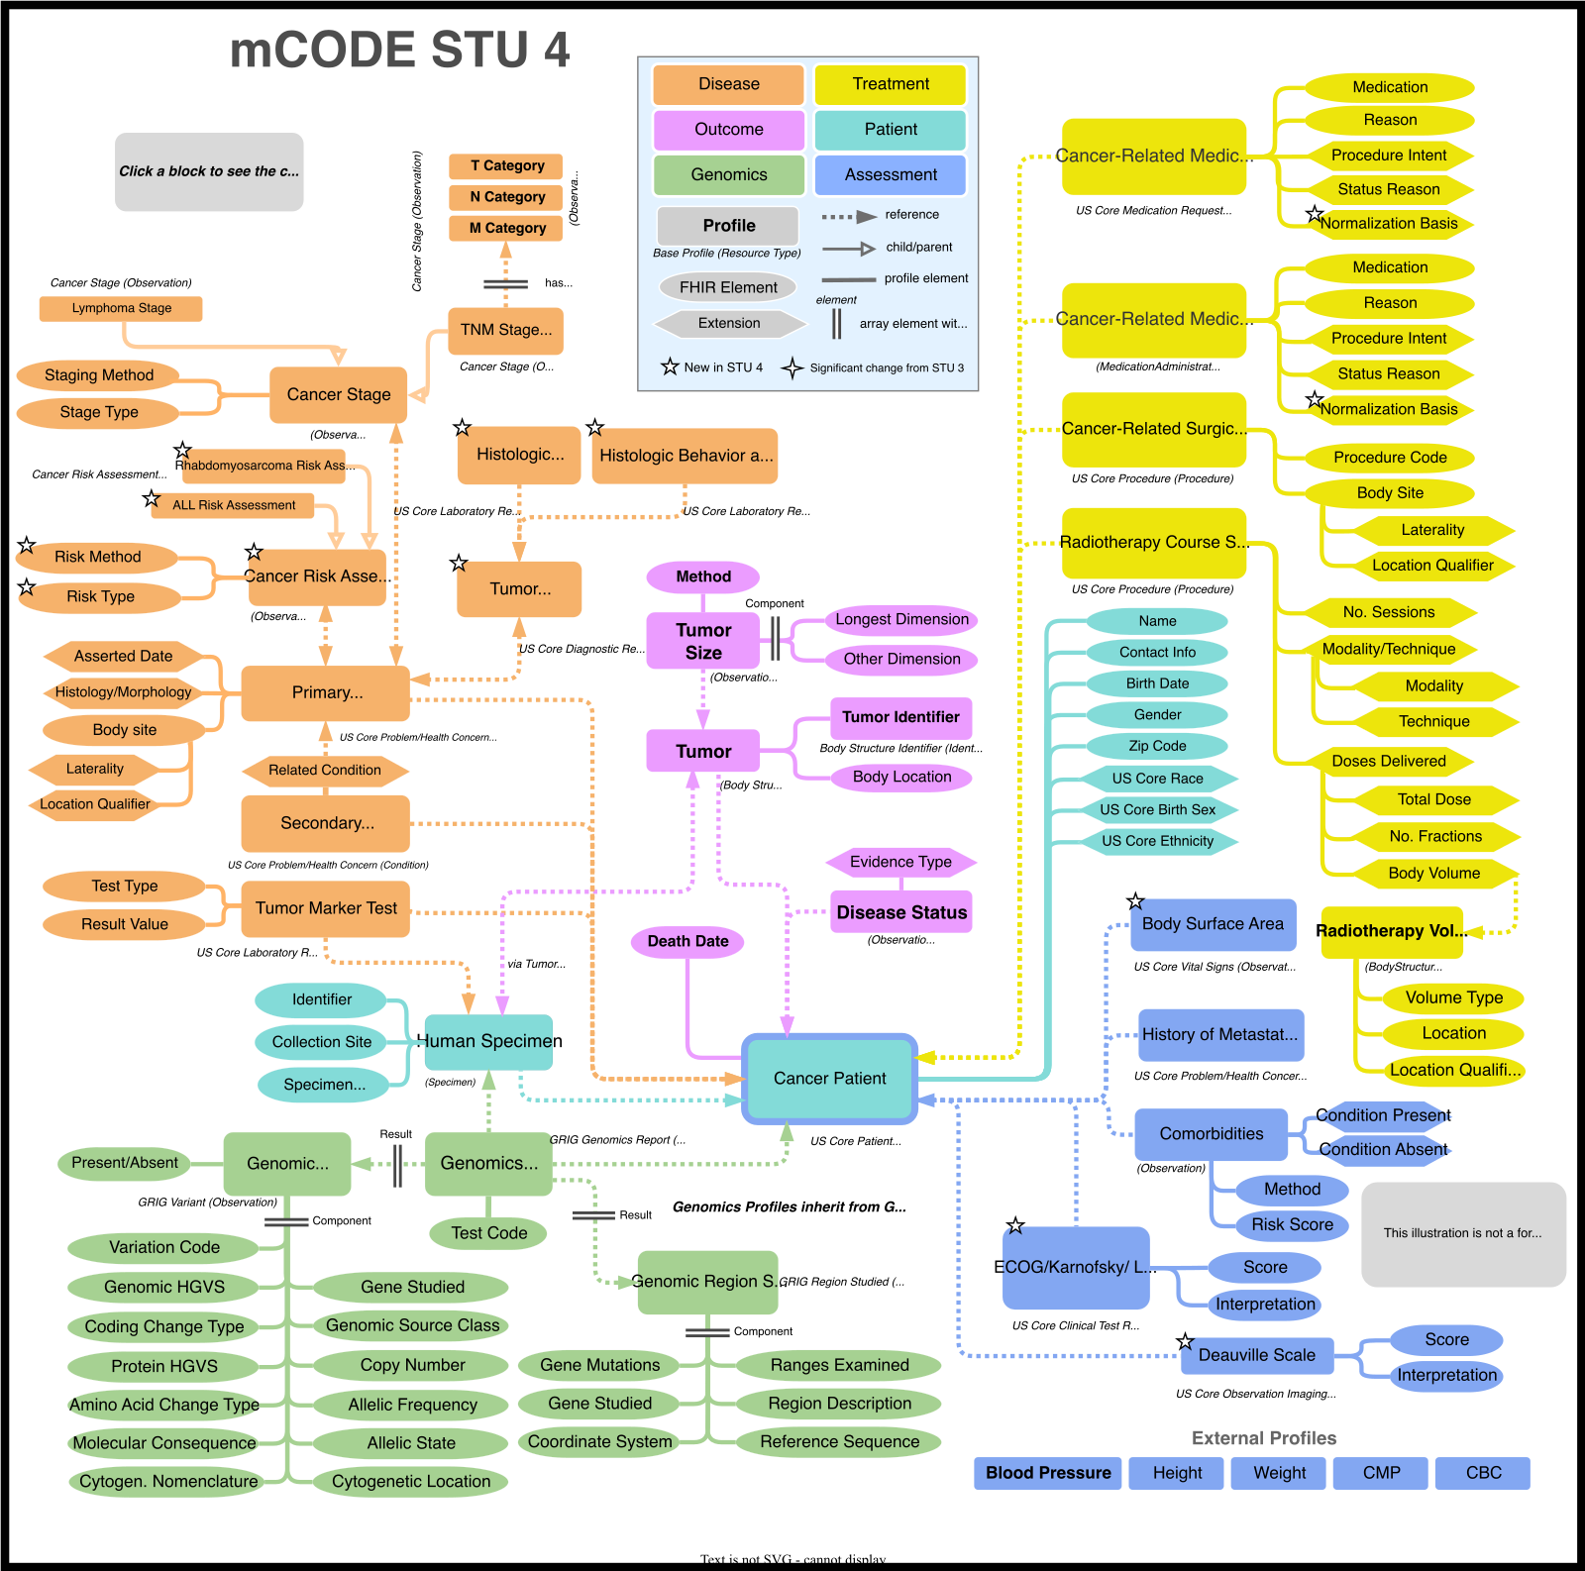

Published: February 16, 2025
FHIR R4 | US Realm | License: CC0-1.0

1. Overview
mCODE (Minimal Common Oncology Data Elements) is an HL7 FHIR Implementation Guide that defines a core set of structured data elements for oncology electronic health records. Developed by the CodeX FHIR Accelerator through MITRE Corporation and the American Society of Clinical Oncology (ASCO), mCODE aims to increase interoperability and enable comparative effectiveness research across healthcare systems.
STU4 (Standard for Trial Use 4, v4.0.0) was published on February 16, 2025, based on FHIR R4. It represents the most comprehensive release to date, with approximately 53 FHIR profiles organized into six thematic groups, over 103 value sets, and 130+ examples.

Key Facts
Version | 4.0.0 (STU4)
Published | February 16, 2025
FHIR Version | R4 (also usable with R4B)
Realm | US (depends on US Core v6.1.0)
License | CC0-1.0 (Public Domain)
Profiles | ~53 FHIR profiles across 6 domains
Value Sets | 103+ value sets, 14 external code systems
Canonical URL | hl7.org/fhir/us/mcode
Build IG | build.fhir.org/ig/HL7/fhir-mCODE-ig/

2. Conceptual Architecture
mCODE organizes oncology data into six interconnected domains, with the CancerPatient profile serving as the central hub connecting all other elements. The following diagram illustrates the overall structure:

Figure 1: mCODE STU4 Conceptual Overview (Source: hl7.org/fhir/us/mcode/STU4)
mCODE does not mandate what data must be collected for every patient. Instead, it provides patterns and templates with controlled terminologies to be used when certain data types are shared. Data not covered by mCODE profiles can still be exchanged using standard FHIR resources.

3. Domain Profiles
The following table summarizes the six mCODE domains, their key profiles, and scope:
Domain | Key Profiles | Scope
Patient Information | CancerPatient, HumanSpecimen, MCODEPatientBundle, MCODEPatientGroup | Demographics, specimens, patient bundles for data exchange
Disease Characterization | PrimaryCancerCondition, SecondaryCancerCondition, CancerStage, TNMStageGroup, TumorMarkerTest, Tumor, TumorSize, HistologicBehaviorAndType*, HistologicGrade*, TumorMorphology*, CancerRiskAssessment*, ALLRiskAssessment*, RhabdomyosarcomaRiskAssessment* | Cancer diagnosis, staging (TNM + 15 non-TNM systems), morphology, risk assessment (* = new in STU4)
Health Assessment | ECOGPerformanceStatus, KarnofskyPerformanceStatus, LanskyPlayPerformanceStatus*, DeauvilleScale*, BodySurfaceArea*, Comorbidities, HistoryOfMetastaticCancer | Functional status, pediatric performance, lymphoma response, body metrics (* = new in STU4)
Genomics | GenomicsReport, GenomicVariant, GenomicRegionStudied | Genomic testing results, variants (HGVS/ISCN), regions studied; aligned with Genomic Reporting IG
Cancer Treatments | CancerRelatedMedicationRequest, CancerRelatedMedicationAdministration, CancerRelatedSurgicalProcedure, RadiotherapyCourseSummary, RadiotherapyVolume | Medication orders/admin, surgery, radiotherapy with modality/technique/dose details
Outcomes | CancerDiseaseStatus, TumorSize | Disease trend tracking (responding, stable, progressing), tumor measurement over time

3.1 Disease Characterization
The Disease Characterization group is the largest domain, covering cancer diagnosis, staging, and morphology:
- Staging: TNM staging (AJCC) plus 15 non-TNM systems including Binet (CLL), FIGO, Rai (CLL), Breslow/Clark (melanoma), ISS/R-ISS (myeloma), Gleason (prostate), and new pediatric systems (INRGSS, INSS, Wilms, PRETEXT, retinoblastoma, rhabdomyosarcoma)
- Morphology (NEW): HistologicBehaviorAndType, HistologicGrade, and TumorMorphology profiles enable structured ICD-O-3 morphology coding
- Risk Assessment (NEW): Generic CancerRiskAssessment framework with disease-specific profiles for ALL and Rhabdomyosarcoma

3.2 Cancer Treatments
Covers the full spectrum of oncology treatment modalities:
- Medications: CancerRelatedMedicationRequest and MedicationAdministration profiles using RxNorm + NCI Thesaurus (for clinical trial drugs)
- Surgery: CancerRelatedSurgicalProcedure with ProcedureIntent extension (curative, palliative, diagnostic, etc.)
- Radiotherapy: RadiotherapyCourseSummary with detailed modality, technique, dose-per-volume, and session tracking
- NEW - NormalizationBasis extension: Supports medication dosing normalized to body surface area or weight (critical for pediatric oncology)

4. What's New in STU4
STU4 represents a major expansion driven primarily by the CC-DIRECT initiative for pediatric oncology. Key additions are organized by category:

4.1 Pediatric Oncology
- LanskyPlayPerformanceStatus - pediatric functional assessment
- ALLRiskAssessment - acute lymphoblastic leukemia risk stratification
- RhabdomyosarcomaRiskAssessment - rhabdomyosarcoma risk classification
- BodySurfaceArea - critical for pediatric dosage calculations
- NormalizationBasis extension - medication dosing based on BSA or weight
- New staging systems: INRGSS, INSS, Wilms, PRETEXT, retinoblastoma, rhabdomyosarcoma

4.2 Disease Characterization
- HistologicBehaviorAndType - ICD-O-3 morphology coding
- HistologicGrade - tumor grade assessment
- TumorMorphology - summary morphology report
- CancerRiskAssessment - generic risk assessment framework

4.3 Assessment & Response
- DeauvilleScale - PET response assessment for lymphoma
- ConditionStatusTrendVS restructured - remission codes moved to maximum value set

5. Terminology & Value Sets
mCODE leverages 14 external code systems and defines over 103 value sets. The primary terminologies are:
Code System | Usage in mCODE
SNOMED CT | Disorders, body structures, findings, qualifiers
ICD-10-CM | Cancer diagnosis coding
ICD-O-3 | Cancer morphology and topology
LOINC | Observations, laboratory codes
RxNorm | FDA-approved medications
NCI Thesaurus | Cancer-specific terminology, clinical trial drugs
HGNC / HGVS | Gene identification, variant nomenclature
UCUM | Units of measure
CPT / ICD-10-PCS | Procedure coding
Terminology selection principles: (1) Fit for purpose, (2) Conformance with US Core and FHIR, (3) Commonly used in real-world practice.

6. Conformance & Implementation
mCODE defines two participant roles:
- mCODE Data Sender: Systems that provide oncology data (e.g., EHRs, cancer registries)
- mCODE Data Receiver: Systems that accept and process mCODE-conformant data (e.g., research databases, decision support systems)

Mandatory Requirements (SHALL)
- Identify in-scope patients (all confirmed cancer diagnoses)
- Follow profile conformance requirements
- Populate and process Must-Support elements
- Support querying mCODE-conforming resources (RESTful GET)
- Publish a CapabilityStatement via GET [base]/metadata
- Comply with US Core requirements
Minimum profile support: All systems must support CancerPatient and PrimaryCancerCondition. The $mcode-patient-everything operation is recommended for retrieving complete patient bundles.

7. Use Cases & Audience

Foundational Use Cases
- Comparative Effectiveness Analysis: Enabling clinicians and patients to compare treatment outcomes across health systems for cooperative decision making
- NGS Integration: Integrating next-generation sequencing data into treatment effectiveness analysis for precision oncology

Intended Audience
- Healthcare systems and EHR vendors
- Clinical oncology researchers
- Cancer registries (aligned with NAACCR standards)
- Radiation oncology and pediatric oncology providers
- Clinical trial organizations
- Health IT interoperability stakeholders

8. Relevance for Therapy Goal Specification
mCODE STU4 is the international baseline standard for oncology data modeling. For the KIG Onko Therapy Goal specification, the following elements are directly relevant:
- Treatment Intent: The ProcedureIntent extension (curative, palliative, diagnostic, preventive, supportive, screening) provides the foundation upon which structured therapy goals can be built
- Disease Status Tracking: CancerDiseaseStatus and ConditionStatusTrendVS (responding, stable, progressing, remission) provide outcome vocabulary that therapy goals must reference
- Staging & Prognosis: Cancer staging profiles and the new risk assessment framework inform the clinical context in which therapy goals are set
- Performance Status: ECOG, Karnofsky, and the new Lansky scale are key inputs for therapy goal determination
- Gap - Therapy Goals: mCODE does not model explicit therapy goals (e.g., cure, life prolongation, symptom control, quality of life). This is the gap the KIG Onko specification aims to fill while maintaining compatibility with mCODE

9. References
mCODE STU4 Published IG
mCODE CI Build (latest)
CodeX FHIR Accelerator
mCODE GitHub Repository
mCODE Data Dictionary (STU4)

